|  |  |
| --- | --- |
| No. of Pages | **3** |
| No. of Questions | 4 |

B

**Department of Computer Science and Engineering**

**MIDTERM EXAMINATION SPRING 2016**

**CSE490/EEE453: WAN Routing and Technologies**

**Total Marks:60 Time Allowed: 55 minutes**

* Answer ALL FOUR **(4)** questions.
* Figure in bracket [] next to each question indicates marks for that question.

## Question No. 1

* 1. Refer to figure no.1 below, name the different routers and the type of LSA that they send in the separate sheet provided. [7 marks]

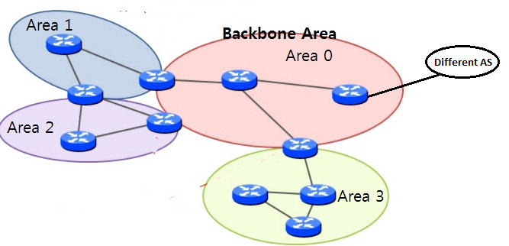

**Figure No. 1**

###### 

**Figure No. 2**

###### Refer to figure no. 2. What states will R1 and R2 go through after they are in two-way state? [5 marks]

###### Question No. 2

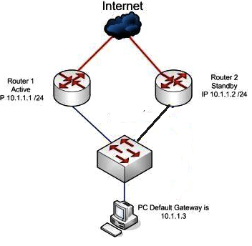

**Figure No. 3**

1. Both Router 1 and Router 2 are running HSRP, so when Router 1 fails, the PC experiences no disruption of service, why? [5 marks]
2. What is the role of AVG and AVF in GLBP? [4 marks]
3. What are the components of SNMP? [3 marks]

Question No. 3

1. In DHCPv6 differentiate between SLAAC and State-full DHCPv6. [Just draw the process diagram] [5 marks]
2. What is the purpose of the command “ip helper address 200.20.20.10”? [2 marks]

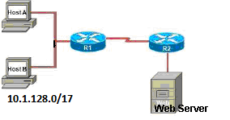

**Figure No. 4**

**Figure No. 11**

1. Configure the router R1 as a NAT server to dynamically assign global outside IP addresses from the NAT pool 132.13.13.96/30 to local inside packets attempting to access the Internet. Then any packet with an IP address from the 10.1.128.0/17 network will be translated with the rest of the pool addresses. [5 marks]

## Question No. 4

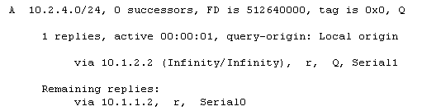

**Figure No. 5**

1. Refer to the output shown in figure no.5. Which table was the output from? Explain the first two lines. [4 marks]

**D 10.10.50.0 [90/2297856] via 172.16.10.6, 00:00:20, Serial0/1**

**[90/6893568] via 172.16.10.2, 00:00:20, Serial0/0**

1. The above output is from the routing table of a router. Why does the network 10.10.50.0 show two different costs paths? [5 marks]
2. RTP is used for all packets, true or false? [3 marks]

##### THE END