|  |  |
| --- | --- |
| No. of Pages | **4** |
| No. of Questions | 3 |

**Department of Computer Science and Engineering**

**MIDTERM EXAMINATION SPRING 2017**

**CSE490/EEE453: WAN Routing and Technologies**

**Total Marks: 45 Time Allowed: 50 minutes**

* Answer ALL THREE **(3)** questions.
* Figure in bracket [] next to each question indicates marks for that question.

## Question No. 1

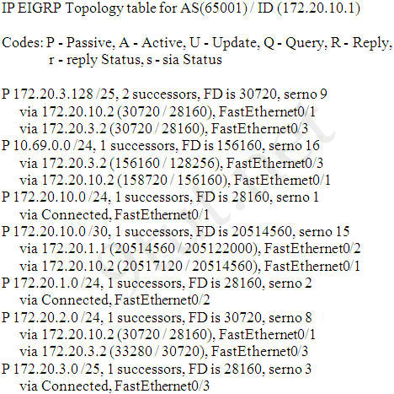

**Figure No. 1**

1. Refer to **Figure no. 1**,
   1. Which routes from the topology table above will be installed in the routing table of the router? [4 marks]
   2. Which successor routes will have backups? [3 marks]
2. Refer to the commands shown in **Figure no. 2** below, the router R2 is connected to router R1 via its G0/0 interface.
   1. But router R1 is not receiving any routing updates. Why? [2 marks]
   2. What is the purpose of the command “ipv6 unicast-routing”? [2 marks]

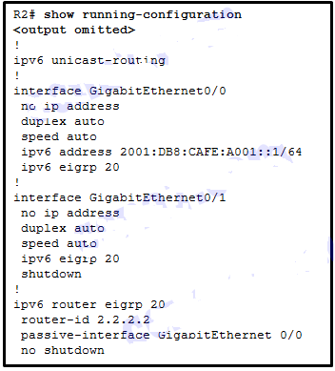

**Figure No. 2**

1. Why does EIRGP use RTP and for which packets? [4 marks]

Question No. 2



**Figure No. 3**

1. Refer to **Figure no. 3**. Which switch will be elected as the root bridge of the spanning tree topology? Give your reasons why. [4 marks]
2. How many root ports can you have in a switched network? How do you decided which are the root ports? [3 marks]
3. When an active port goes down in a switched network, how long does STP take to converge again and how long does RSTP take? [4 marks]

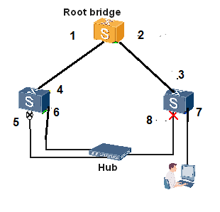

**Figure No. 4**

1. Refer to **Figure no. 4**, match the ports identified by numbers to its port roles given below:

Designated, Designated, Designated, Alternate, Backup, Root, Root and Edge port. [4 marks]

## Question No. 3

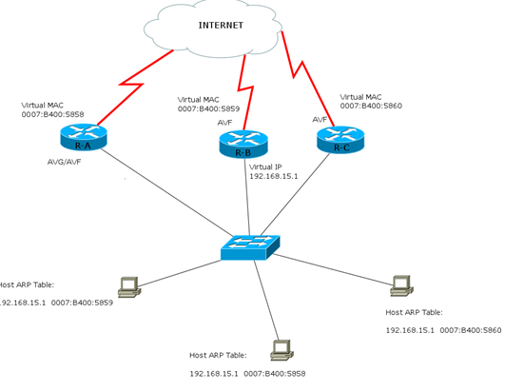

**Figure No. 5**

**Figure No. 11**

1. Refer to the above network in **Figure no. 5**,
   1. Why do the hosts have different MAC address against the same IP address 192.168.15.1 of the default gateway? [4 marks]
   2. Which router has the IP address of 192.168.15.1? [2 marks]

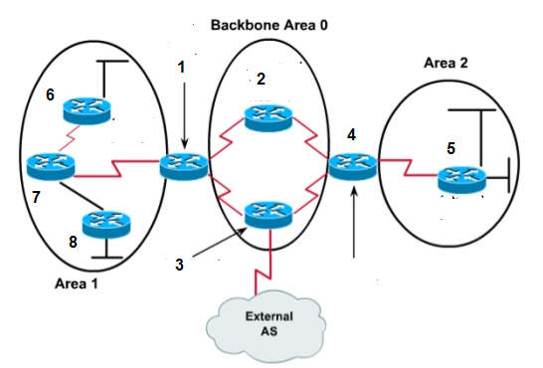

**Figure No. 6**

1. Refer to **Figure no.6**. Identify the routers starting from 1 to 8. Also show the LSA types that will be sent by the routers shown in the diagram. Use separate sheet provided [5 marks]

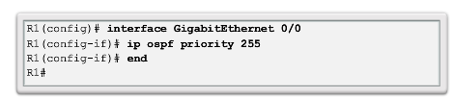

**Figure No. 7**

1. What is the purpose behind in giving the commands in the router R1 as shown in the above **Figure no. 7**? [4 marks]

##### THE END