|  |  |
| --- | --- |
| No. of Pages | **3** |
| No. of Questions | 4 |

**Department of Computer Science and Engineering**

**MIDTERM EXAMINATION SUMMER 2016**

**CSE490/EEE453: WAN Routing and Technologies**

**Total Marks: 48 Time Allowed: 60 minutes**

* Answer ALL FOUR **(4)** questions.
* Figure in bracket [] next to each question indicates marks for that question.

## Question No. 1

* 1. Differentiate between Type 4 LSA and Type 5 LSA. [4 marks]
  2. What is the function of backbone Area 0 in Multi Area OSPF and what type of routers can be seen in the backbone area? [4 marks]

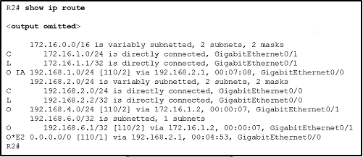

**Figure No. 1**

###### Refer to the output shown in figure no. 1. What are the different OSPF routes present? Explain briefly. [4 marks]

###### Question No. 2

RouterA(config)# **interface GigabitEthernet0/0**

RouterA(config-if)# **ip address 10.1.10.2 255.255.255.0**

RouterA(config-if)# **standby 1 ip 10.1.10.1**

RouterA(config-if)# **standby 1 priority 110**

RouterA(config-if)# **standby 1 preempt**

**Figure No. 2**

1. Refer to the commands in figure no. 2, explain the effects of the commands here. [5 marks]
2. How is the AVG (Active Virtual Gateway) router selected in GLBP and what is its role/function? [4 marks]

R1(config)#logging 192.168.1.101

R1(config)#logging trap 4

**Figure No. 3**

1. Refer to the commands shown in figure no. 3, these commands were given for Syslog. What are they for? [3 marks]

Question No. 3

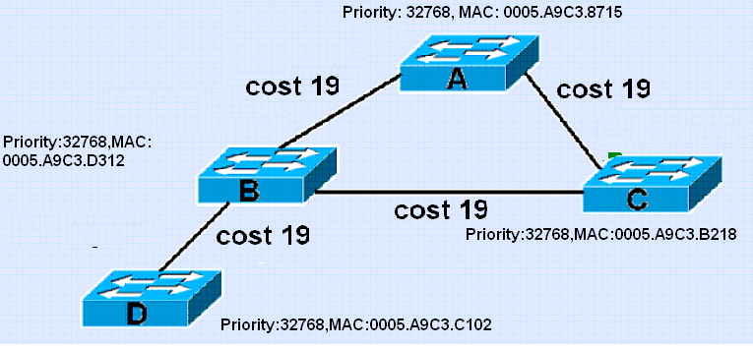

**Figure No. 4**

1. Refer to the above switched network in figure no. 4, after running STP indicate which switch is chosen as the root bridge and which ports are root ports, designated ports and blocked ports? How was the blocked port chosen, explain. [5 marks]
2. When a switch first starts up the ports stay in blocking state for 20seconds and then another 30 seconds in two other states after which the ports can go into forwarding state? What are the two other states and what is their basic difference? [4 marks]
3. In RSTP, alternate ports are usually in what state? And what is the benefit of having an alternate port? [3 marks]

**Figure No. 11**

## Question No. 4

1. A router running EIGRP finds 3 routes to the same destination.

Route A has FD 3523840 and RD 3011840

Route B has FD 2297856 and RD 39260

Route C has FD 3558000 and RD 2115200

Which route/s will become the successor and feasible successor/s? Explain your answer. [5 marks]

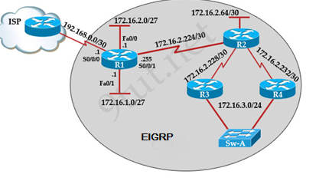

**Figure No. 5**

1. Refer to the above figure no. 5, a default route has been configured in Router R1 as “ip route 0.0.0.0 0.0.0.0 s0/0/0”. Do we have configure the same default route in each of the Routers R2, R3 and R4? [4 marks]

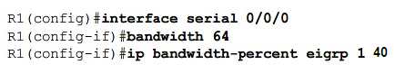

**Figure No. 6**

1. Refer to the commands shown above in figure no. 6, R1 router will use how much bandwidth to send EIGRP updates through its serial 0/0/0 link? [3 marks]

##### THE END