|  |  |
| --- | --- |
| No. of Pages | **7** |
| No. of Questions | 7 |

**Department of Computer Science and Engineering**

**FINAL EXAMINATION FALL 2016**

**CSE490/EEE453: LAN Switching and WAN Technologies**

**Total Marks:75 Time Allowed: 2.5 Hours**

* Answer any **FIVE (5)** questions out of the given **SEVEN(7)** questions.
* Figure in bracket [] next to each question indicates marks for that question.

###### Question No. 1

1. If a neighbour does not appear in the neighbour table of a router running EIGRP routing protocol, what should you check for troubleshooting? [3 marks]
2. A router is running IP, IPX and AppleTalk routing protocols simultaneously, how many tables will this router have and why? [2 marks]
3. This line shown below appears in a routing table. It is a default route, so was it configured manually in this router? [3 marks]

**D*EX 0.0.0.0/0 [170/3651840] via 192.168.10.6, 00:01:08, Serial0/1**

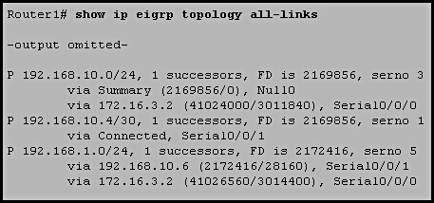

**Figure No. 1**

1. Refer to the exhibit shown in figure no. 1. What will happen if interface Serial0/0/1 goes down on Router1? [4 marks]

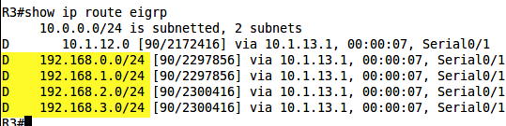

**Figure No. 2**

1. How can we make the routing table shown in figure no.2 smaller? Show how. [3 marks]

Question No. 2

1. What parameters need to match to create Ether Channels between switches? [3 marks]

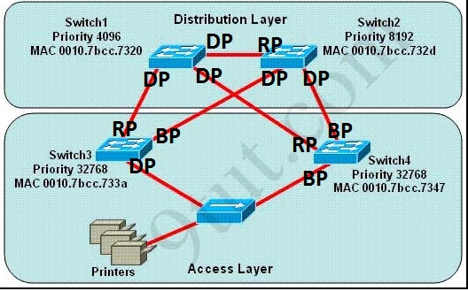

**Figure No. 3**

1. Refer to the figure no. 3 above, all switches are running STP. [2+3 marks]
   1. Why are there only designated ports present in Switch 1?
   2. How were the blocked ports chosen?
2. What is the difference between Edge and Non Edge ports? How do they make RSTP faster? [4 marks]
3. What do we have to do to make sure that a switch never becomes the root? And how can we fix root ports of a switch when there are multiple equal cost root ports? [3 marks]

## Question No. 3

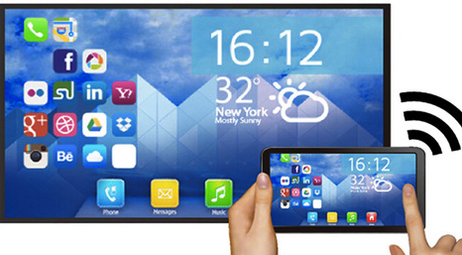

**Figure No. 4**

1. How will WIfi Miracast make our life easier as shown in figure no. 4? [2 marks]
2. List the steps followed by Passive Scanning. [2 marks]
3. Draw the two types of Infrastructural Modes found in Wireless Networks. [3 marks]
4. What is the purpose of using CTS and RTS packets? Do we always have to use them? [4 marks]
5. Explain what happens in an Evil Twin AP attack. [4 marks]

## 

## Question No. 4

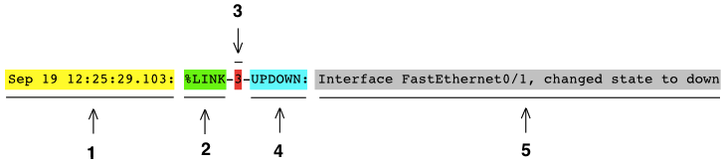

**Figure No. 5**

1. Refer to the above output above shown in figure no. 5, which networking tool produced this output? Which numbers in the figure represent the text message, timestamp, message severity, facility and mnemonic message? [3 marks]
2. What are the three components of SNMP? Draw them in a diagram. [3 marks]
3. How does the message “trap” help reduce traffic in SNMP? [4 marks]
4. Refer to the commands shown in figure no. 6 below, [1+1+3 marks]
5. Which router is active and which router is standby?
6. What will be the default gateway of all PCs connected to these two routers?
7. What does the command “preempt” do?

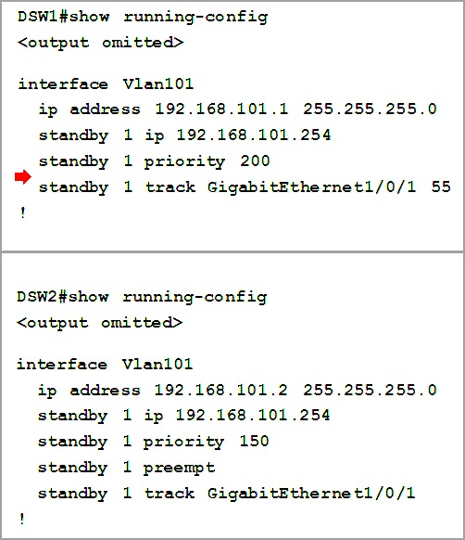

**Figure No. 6**

**Question No. 5**

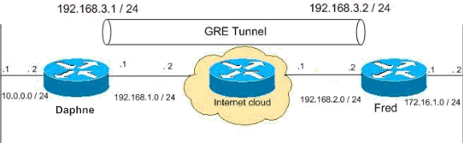

**Figure No. 7**

1. Refer to figure no. 7. Draw the IP packet that will be sent from a PC with the address 10.0.0.10 to a destination PC with the address 172.16.1.10. Show which addresses will be added in the IP packet header and in the delivery packet header of GRE. [4 marks]
2. What type of algorithm handles VPN data authentication? Explain and give an example. [4 marks]
3. Where do we use Symmetric and Asymmetric encryption and why? [4 marks]
4. How do convince your boss to use SSL over IPSec for Remote Access VPN? [3 marks]

**Question No. 6**

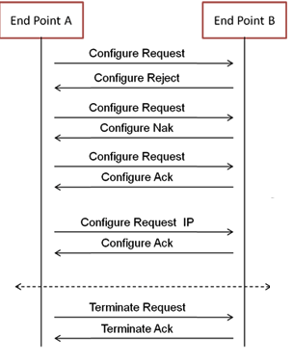

**Figure No. 8**

1. Refer to figure no. 8. Which operations are done by LCP and which are done by NCP? Why were multiple Configure Request packets sent by the End point A? [4 marks]

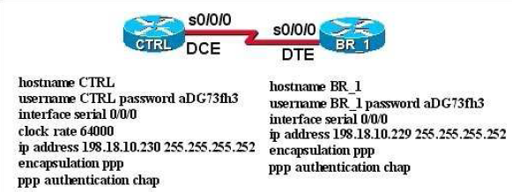

**Figure No. 9**

1. Refer to figure no. 9, CTRL and BR_1 routers are not responding to each other. Find the problem. What changes do we have to make to use PAP instead of CHAP? [4 marks]
2. What is included in the challenge packet during CHAP authentication? Why is CHAP better than PAP? [4 marks]

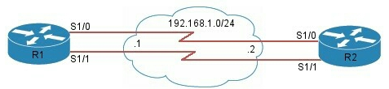

**Figure No. 10**

1. Refer to figure no. 10. What can a network administrator do if he needs to increase the bandwidth of the link between R1 and R2 without investing in hardware? Both Routers are running PPP. [3 marks]

## Question No. 7

1. How does Frame Relay Protocol use LMIs to map the DLCI number to the next hop layer 3 IP address? [3 marks]

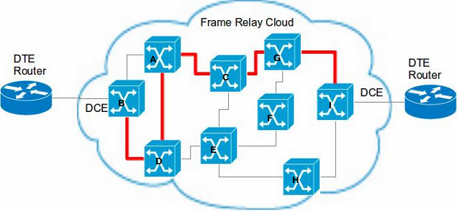

**Figure No. 11**

1. If there is congestion in the frame switch A as shown in the figure no. 11, how will it notify other switches B, D and C about the congestion? And how does it decide which packets to drop to relieve its congestion? [3+2 marks

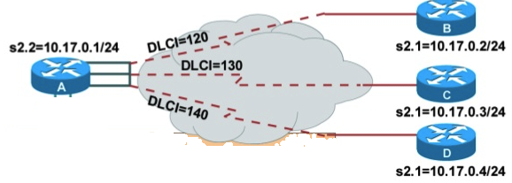

**Figure No. 12**

1. Refer to the figure no. 12 above. What type of frame relay connection does the topology have? This type of connections creates a problem regarding routing updates, what is it and how can we solve it? [4 marks]

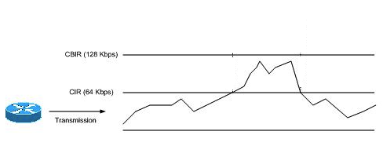

**Figure No. 13**

1. Refer to the figure no. 13 above. Explain the terms CIR and CBIR used in Frame relay [4 marks]

##### THE END