|  |  |
| --- | --- |
| No. of Pages | **3**  A |
| No. of Questions | **3** |

**Department of Computer Science and Engineering**

**MIDTERM EXAMINATION SPRING 2015**

**CSE421: Computer Network**

**Total Marks: 45 Time Allowed: 55 minutes**



* Answer ALL **THREE (3)** questions
* Figure in bracket [] next to each question indicates marks for that question



**Question 1**

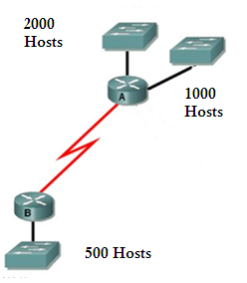

**Figure no. 1**

1. Suppose a company is given a block **200.20.96.0/20.** But you need three more sub networks for your organization and one more for the WAN Link as shown in figure no. 1. Show how you can have 4 more subnets out of the original network address as per host requirements. Do not forget to show basic calculations. [7 marks]

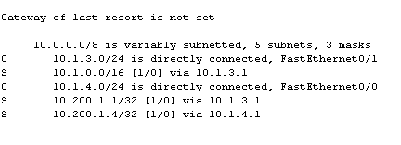

**Figure no. 2**

1. A routing table is shown in the above figure no. 2. The cost to a destination network cannot be zero; there must be some cost to send packets. But he metric of all static routes is 0, why? [4 marks]
2. In the network scenario shown below in figure no. 3, what type of static routing should be used to send packets from the 172.16.0.0/16 network to the Internet and back? [4 marks] 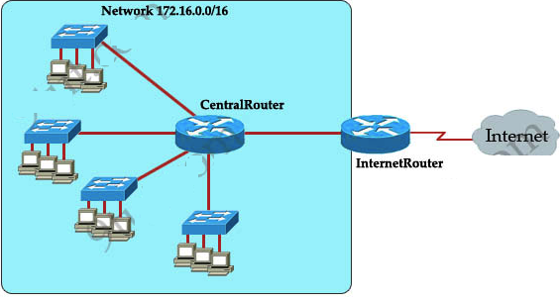

**Question 2**

**Figure no. 3**

1. Router R1 is running RIPv2 shown in figure no. 3. Summarize the following networks shown at R1 so that R1 can advertise only one summarized network in its updates instead of the 8 separate networks to Router R2. Show calculations. [4 marks]

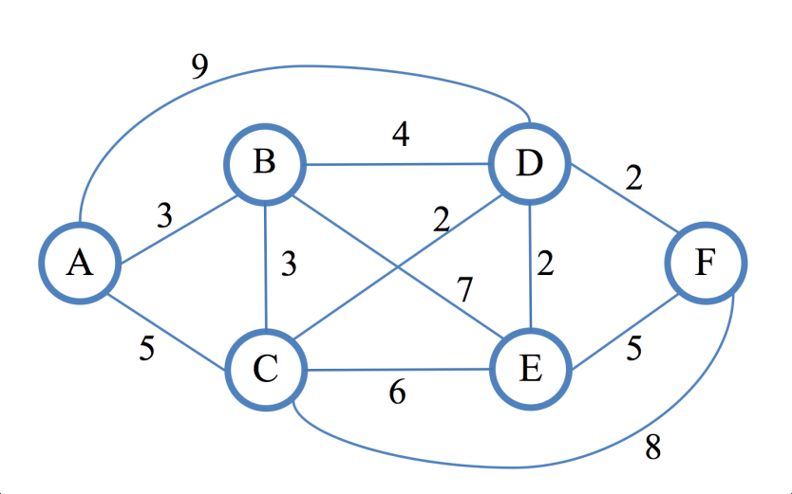

**Figure no. 4**

1. Explain how Split Horizon is used in avoiding loops? [4 marks]

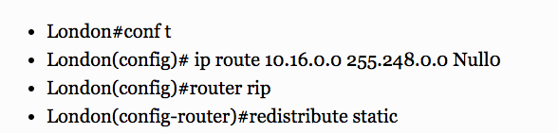

**Figure no. 5**

1. Explain the commands shown in the above output in figure no. 5. [4 marks]

**Question 3**

**Figure no. 5**

1. Link state routing protocol uses Dijkstra’s algorithm. Now using Dijkstra’s algorithm, compute the shortest path from Fto all other remote networks shown in figure no.5. Use the table provided. [5 marks]

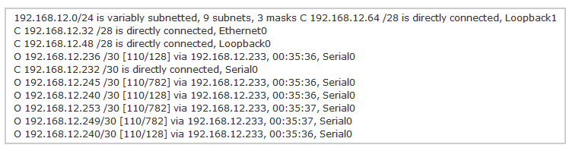

**Figure no. 6**

1. How are the value 128 calculated? [2 marks]

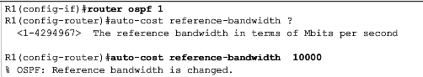

1. Refer to the commands above shown in figure no. . What is the purpose of the commands? [3 marks]

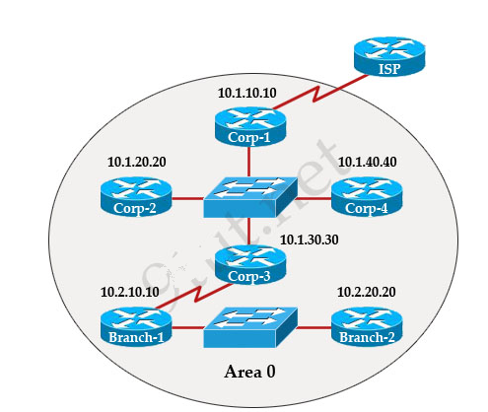

**Figure no. 7**

1. In the above figure no. all routers are running ospf routing protocol. In the above scenario where would the DR and BDR selections will be necessary and which routers are the DRs and BDRs? [5 marks]

**Figure no. 7**

**THE END**