No. of Pages | 4
No. of Questions | 8

Department of Computer Science and Engineering
FINAL EXAMINATION FALL 2010

CSE320/EEE361: Data Communications
Total Marks: 90 Time Allowed: 3 Hours

- Answer Any Six (6) questions out of Eight (8) questions.
- Figure in bracket [] next to each question indicates marks for that question.

Question No. 1

  - Draw a diagram showing the relationship between IP, TCP, HTTP, Ethernet, DNS and UDP, the diagram also should show their position in the OSI model. [3 marks]
  - Differentiate between the three addresses that are being used when data is being sent from one host to the other. [4.5 marks]
  - You write www.cricket.org in your web browser URL, but the webpage is not being displayed. Identify some common problems. [3 marks]
  - A host/PC has sent a request for its IP configuration to a DHCP server. What kind of information or parameters does the DHCP server provide to the PC? [2 marks]
  - Is a local DNS server sufficient for a medium size network like BRAC University? Yes or no, explain briefly. [2.5 marks]

Question No. 2

- Give an example of a type of data that cannot tolerate delay, but can tolerate some loss or data. This type of data would use which transport layer protocol? How does that protocol ensure faster transmission? [4 marks]
- A client host is requesting an IP address for an URL from a DNS server. [3 marks]
  - How does it choose the source port number to go in the segment header? And also what type of port number does it choose?
  - What will be the destination port number?
- If TCP is using a window size of 1000 bytes, what does this mean? It decreases the window to 500 bytes, why? [3 marks]
- Name some fields that exist in a TCP header but not in an UDP header. [3 marks]
- UDP is not connection oriented, what does it mean? [2 marks]

Question No. 3

Host IP address/subnetmask : 200.100.160.33/19
Network address
Broadcast address
First usable host IP address
Last usable host IP address

- Complete the above table. (Please show calculations.) [5 marks]
- Why are we moving towards IPv6 from IPv4? State at least two reasons. [3 marks]
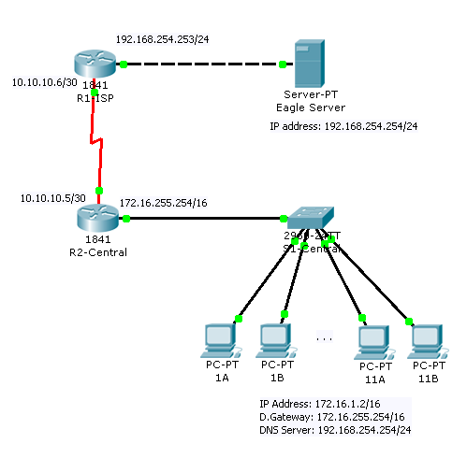
Figure No. 1
- Referring to the above figure no. 1, PC-PT 1B cannot reach the Eagle Server. How can we find the problem, what kind of applications and protocols can we use to find the problem? [4 marks]
- How do using Private addresses help in saving IP addresses to be used by new networks? [3 marks]

Question No. 4

- Why does the light stay within the core of a fiber optic cable? What happens if we make the core extremely narrow? [4 marks]
- It is recommended to use Single Mode Fiber optic cable to connect from Cox’s Bazaar’s submarine cable to provide the link towards Chittagong, why? [3 marks]
- What is the basic difference between a Straight-Through cable and a Cross-Over cable? [2 marks]
- Draw the physical structure of a coaxial cable and label its components? [3 marks]
- Shielded Twisted Pair cables are no longer preferred in data communication; explain why, by comparing it with Unshielded Twisted Pair cables? [3 marks]

Question No. 5

- How does piggy backing make the three flow control mechanisms more efficient?[3 marks]
- Draw the send and receive windows of Selective Repeat ARQ protocol with a 3-bit sequence number. [3 marks]
- In Go-Back-N ARQ, what happens when a receiver receives a damaged frame? [3 marks]
- Stop and Wait ARQ sends one frame at a time after receiving the acknowledgement, so the sender knows that receiver has received the frame properly, ensuring reliability. But Go-Back-N ARQ can send multiple frames without waiting for an acknowledgement, how does this help the system? [4 marks]
- Differentiate Stop and Wait ARQ and Selective Repeat ARQ. [2 marks]

Question No. 6

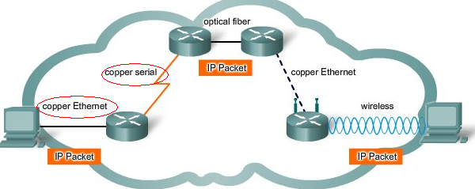
Figure No. 2
- Refer to the figure no.2, shown above, when the IP packet moves from copper Ethernet (Maximum packet size 1518 bytes) to copper serial (Maximum packet size 512 bytes), what happens to the packet at the network later? [3 marks]
Gateway of last resort is 192.168.2.2 to network 0.0.0.0

R 200.10.0.0 [120/1] via 192.168.2.2, 00:00:02, serial0/0
R 212.32.10.0[120/3] via 192.168.2.2, 00:00:02, serial0/0
C 192.168.2.0/24 is directly connected, serial 0/0
C 192.168.1.0/24 is directly connected, FastEthernet0/0
S* 0.0.0.0/0 [1/0] via 192.168.2.2

Figure No. 3
- What does “S*” shown in the above figure no. 3 represents? What happens when a router does not have the S* route? [4 marks]
- Why are the first two routes denoted by “R”, how are they different form the “C” routes? [3 marks]
- How do we know which route of a routing table is better? Suppose a router has two routes for the same destination, which one would the router choose? [3 marks]
- What is the purpose of a default gateway of a PC? [2 marks]

Question No. 7

- Why do we use bit stuffing is HDLC and not byte stuffing? What happens if there is a bit error in the bit stuffing done in a HDLC data frame? [4 marks]
- Which two frames of HDLC contain the sequence number of a frame? Why? [4 marks]
- What is the difference between Unnumbered frames and Supervisory frames? [3 marks]
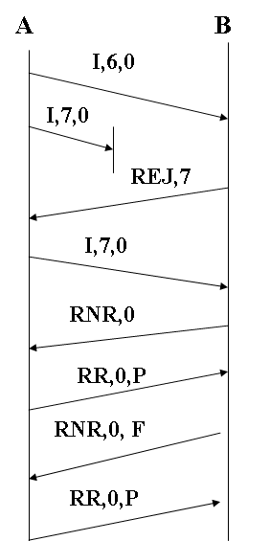
Figure no. 4
Explain only this part.

- Referring to figure no. 4 above, explain the process in the bracket shown. [4 marks]

Question No. 8

- Encode the following data stream 01001111 using Manchester, NRZ-I and Bi-Polar AMI encoding methods.(Separate sheet attached) [4.5 marks]
- Explain what happens when there is time synchronization problem between the sender and receiver? How do we solve this problem? [4 marks]
- Compare MLT-3 and Bi-Polar AMI. They share a common problem what is it and how is it solved, explain. [5 marks]
- Using Manchester is not always recommended, why? [1.5 marks]

THE END

