No. of Pages | 5
No. of Questions | 8

Department of Computer Science and Engineering
FINAL EXAMINATION FALL 2012

CSE320/EEE361: Data Communications
Total Marks: 90 Time Allowed: 3 Hours

- Answer Any Six (6) questions out of Eight (8) questions.
- Figure in bracket [] next to each question indicates marks for that question.

Question No. 1

- How do the layers of the OSI model correlate to the layers of the TCP/IP model? [2 marks]
  - Differentiate between the three addresses that are being used when data is being sent from one host to the other. [4.5 marks]
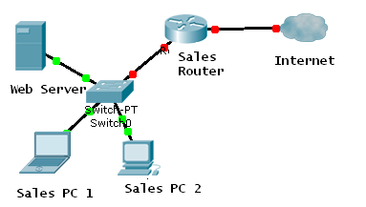
Figure No. 1
  - The above network shown in figure no.1 uses DHCP to configure the IP addresses. Should the net administrator use DHCP for all devices, why or why not? [3 marks]
  - Compare Bit Torrent and FTP. [3 marks]

- From a PC at the network administrator’s office, you wish to access a router situated on the top floor of the office to re configure it? Which application allows you to do? It has a flaw, what is it? [2.5 marks]

Question No. 2

- What is the difference between Well Known Port Numbers and Dynamic Port Numbers? [3 marks]
- Host A and Host B are sending data to each other. The window size negotiated is 2000 bytes. Host A receives two segments starting from 1001-2000 and the other starting from 2001-3000. Host A sends Host B a single acknowledgement packet for both packets. How can the Host A do that, what benefit does it bring? [3 marks]
- Referring to the same scenario in the above question no. 2(b), Host B changes the window size to 1000 bytes, what can be the reasons? [3 marks]
- During a TCP communication session, if the packets arrive to the destination out of order, what will the receiving host do? What happens if it is an UDP communication? [3 marks]
- When is SYN used and why? [3 marks]

Question No. 3

Host IP address: 192.168.32.57/21
Network address
Broadcast address
First usable host IP address
Last usable host IP address
No. of usable hosts

- Complete the above table in your script. (Please show calculations.) [5 marks]
- A network administrator is trying to configuring a PC with following configuration, but the PC is unable to communicate with any device within and out of the network. What can be the problem? [2 marks]
IP address: 172.16.3.254
Subnet mask: 255.255.255.192
Default gateway: 172.16.3.65

- BRAC University uses private addresses in all the PCs in labs. In spite of that, we can browse internet from those computers. How is that possible? [3 marks]
- What is loopback address? When is it required? [3 marks]
- Name two ways to troubleshoot network layer problems. [2 marks]

Question No. 4

- Sometimes Network layer further fragments packet into smaller pieces? Why? [3 marks]
- A packet is being sent back and forth by routers through their default routes as the destination network address in the packet does not exist. What will eventually happen to the packet? [ 3 marks]
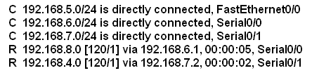
Figure No. 2

- Referring to the routing table of router R1 shown in figure no.2 above, explain the routes that starts with “R”. How are they different from the C routes? [4 marks]
- Referring to the routing table of router R1 shown in figure no.2, this router has no default route, true or false, how do you know? [2 marks]
- If a router receives information regarding a destination network 200.20.20.0/24 from two different neighboring routers, how will it decide the best path? [3 marks]

Question No. 5

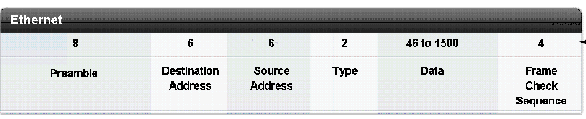
Figure no. 3

- The figure no. 3 shown above represents an Ethernet frame. A PC’s data link layer has received a packet of 35 bytes from its network layer; can the host send this packet? Why or why not? [3 marks]
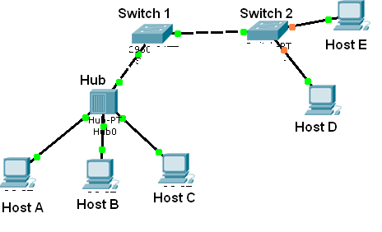
Figure no. 4

- In the figure no. 4 above Host A sends an Ethernet frame to Host D. Only host D receives that frame. True or false. The MAC address tables of the switches are empty. [4 marks]
- Host A and host C both sends a frame at the same time, what will happen? ? [3 marks]
- Referring to the same figure no. 6, host B is pinging host D. Before the ping can be sent host B needs to send an ARP request for host D, why? Mention the IP address and MAC address (source and destination both) that needed for the ARP request. [5 marks]

Question No. 6

Flag | Address | 0110000011101100011101110000011111100000111 | FCS | Flag
Figure No. 5

- When a host receives a frame above shown in figure no. 5, it incorrectly ends the frame, why? The sender did bit stuffing, then why did the receiver interpret it wrong? [3 marks]
- Which frames contain the P/F bit? What is the purpose of this P/F bit? [3 marks]
- In the figure No. 6 below, briefly explain what is happening in the steps 1 and 2? Why did the sender send a supervisory frame after time out? [5 marks]

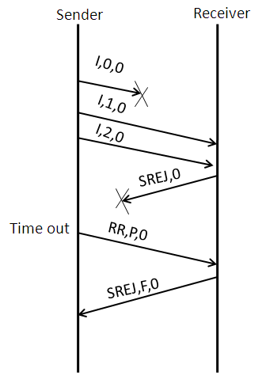
Step 1
Step 2
Figure No. 6

- Referring to the same figure no.6 above, what happens after the receiver sends the supervisory frame “SREJ,F,0”? What will be the difference if the receiver had sent a supervisory frame “REJ,F,0”? [4 marks]

Question No. 7

- What do ILD and LED stand for? Where are they used? [3 marks]
- How does the cladding in a fiber optic cable help the light to stay within the core? [3 marks]
- Compare Coaxial cables with UTP. Which type of cable has less electromagnetic interference and why? [4 marks]
- What is the basic difference between a Straight-Through cable and a Cross-Over cable? In the figure no. 7 below, state the type of cables that will be required for each of the connection.
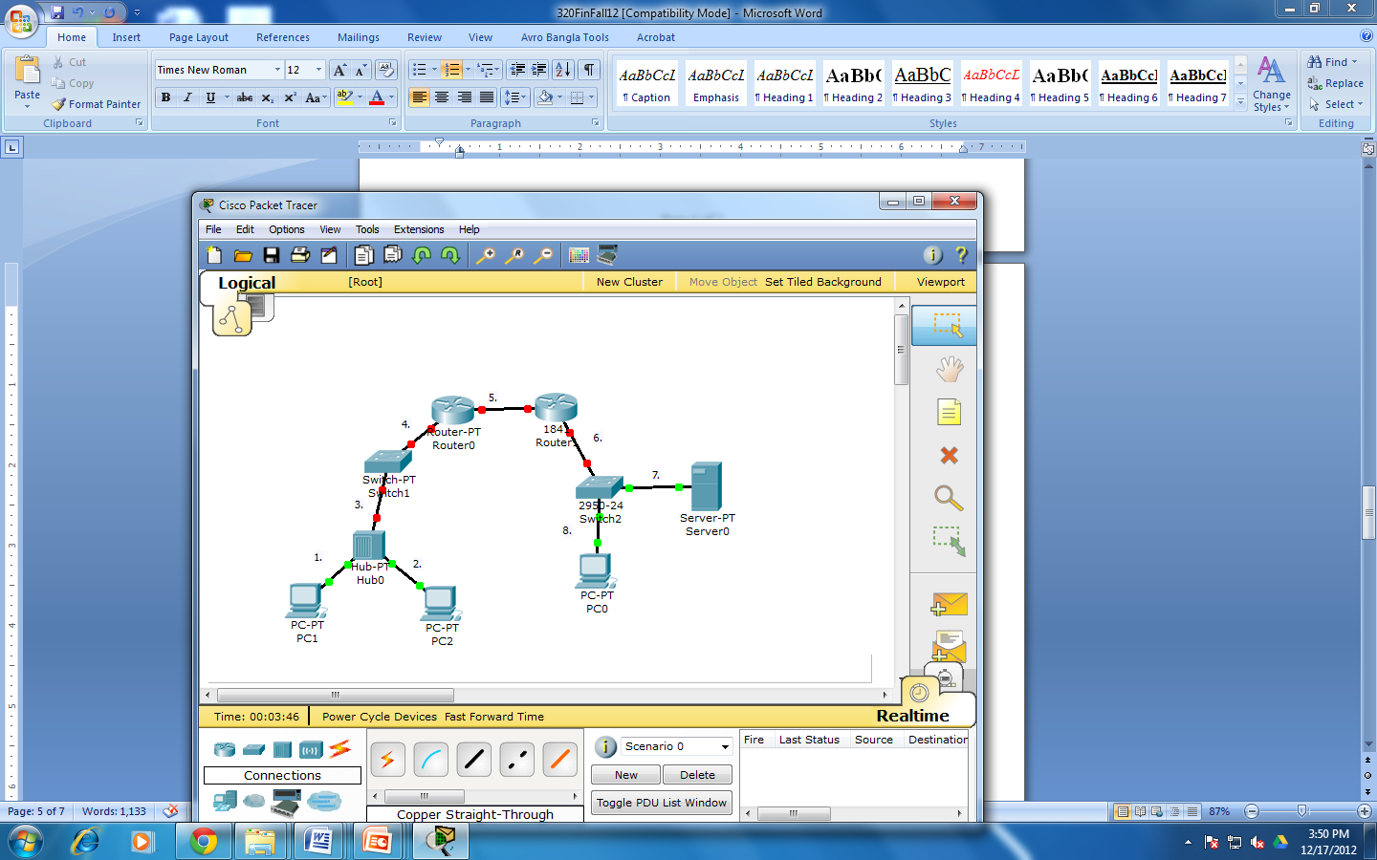
[5 marks]

Figure no. 7

Question No. 8

- Encode the binary data 10100111 using NRZ-L, Manchester and Bipolar-AMI encoding methods. (Separate Sheet attached) [6 marks]
- State the cause and effect of baseline wandering. [2 marks]
- Manchester encoding, Block coding and Scrambling can solve a common problem, what is that? Compare the processes based on the usage of bandwidth. [4 marks]
- 100BaseFX uses 4B/5B block coding and then uses NRZ-I signal encoding technique, what is the purpose of block coding before encoding the signal using NRZ-I? Explain. [3 marks]

THE END

