No. of Pages | 5
No. of Questions | 8

Department of Computer Science and Engineering
FINAL EXAMINATION SPRING 2008

CSE320: Data Communication
Total Marks: 90 Time Allowed: 3 Hours

- Answer any Six (6) questions out of the given Eight (8) questions.
- Figure in bracket [] next to each question indicates marks for that question.

Question No. 1

- Compare Internet and Data Link Layer of the TCP/IP model in terms of PDU names, addresses used and extra information that is included in the headers/trailers of the respective PDUs. [3 marks]
- Give examples of applications, services and protocols when you email to a friend. [3 marks]
- BRAC University should not use peer to peer networks, why? [3 marks]
- What are the benefits of using DHCP? Would you recommend using DHCP for devices such as printers, servers in a network, why or why not? [4 marks]
- What do ISO and OSI refer to? [2 Marks]

Question No. 2

- Match appropriate protocols with the following statements:
- A protocol that uses POST/PUT messages to upload data to a server.
- Helps you share files in your C drive with others using the Internet.
- Supports file transfer between a client and a server.
- Provides encryption during a telnet session.
- Used for file sharing in Microsoft Networks.
- Converts the ip address of 128.107.229.50 to cisco.netacad.net [3 marks]
- What kind of information do we get from issuing the commands nslookup and ip config/all ? [4 Marks]
- Compare Microwaves and Radio Waves. [3 marks]
Figure No. 1

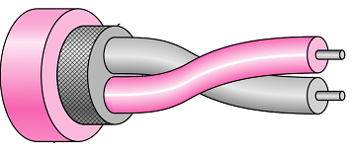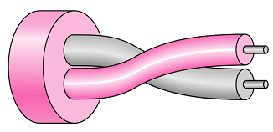
Figure No. 2
Figure No. 1

- What do the above two figures represent? How are they different, state two main points? [3 marks]
- What common problems are faced by unguided media? [2 marks]

Question No. 3

- Differentiate between TCP and UDP? How do applications choose between TCP and UDP? [4 marks]
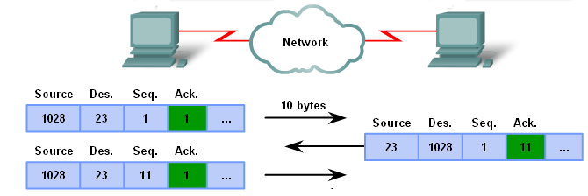
Figure No. 3
- Refer to the figure no. 3, what is happening? What is the purpose of the fields, Sequence and Acknowledgement numbers in the TCP header? [5 marks]
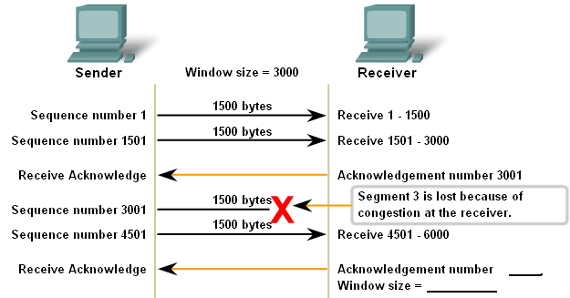
Figure No. 4
- When segment 3 is lost due to congestion at the receiver, what will the receiver do? Complete the missing information of the figure no. 4. [4 marks]
- Name some protocols in the application layer that uses TCP and some that uses UDP.
[2 marks]

Question No. 4

- List some of the common problems of a large network. [3 marks]
- If the destination network of a data packet is not listed in the routing table of a router, what are the possible actions of that router? [3 marks]
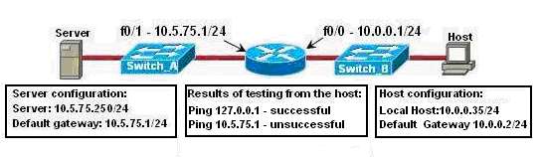
Figure No. 5
- Refer to the figure no. 5 above; a technician is trouble shooting host connectivity problem. He is unable to ping the server attached with switch A. What can be the problem? [3 marks]
- Which field in the IP PDU header prevents endless looping of IP packets? [3 marks]
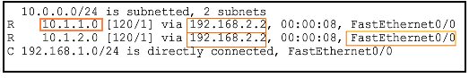
Figure No. 6
- The above figure no. 6 is a routing table of a router. What do the networks 10.1.1.0 and 192.168.2.2 represent? [3 marks]

Question No. 5

- What is the purpose of subnet mask? Why do routers need subnet mask along with destination ip addresses? [3 marks]
- Convert the following prefix into dotted decimal subnet masks. [2 marks]
  - /25
  - /19
  - /9
  - /28
- Scenario for the above figure no.7:
  - Address space: 192.168.15.0/24
  - RTA, 60 hosts and 30 hosts; RTC 28 hosts.
  - Assign subnets to the topology as required.
  - Fill in the table given separately with all necessary IP address configuration information for all devices. [10 marks]

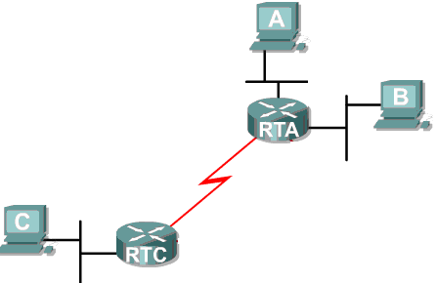
Figure No. 7
60 Hosts
30 Hosts
28 Hosts
Fa 0
Fa 1
Fa 0
S 0
S 0

Question No. 6

- Why do we encode 4 bits of data into 5 bits of code in the 4B/5B coding process? [3 marks]
- Why is Manchester encoding better than NRZ encoding? [3 marks]
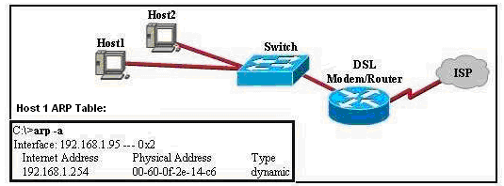
Figure No. 8
- What is the purpose of ARP? Refer to the figure no. 8 above, what will host 1 do if it needs to send a packet to 192.168.1.1 and 192.168.1.254? [3 marks]
- Compare single mode and multimode fiber optic cables. [3 marks]
- Name the appropriate type of copper cables for the following: [3 marks]

- when connecting one switch to another hub
- when connecting a router to a switch
- when connecting a host to a router

Question No. 7

- Compare the characteristics of Contention based and Controlled Media Access Control techniques? [3 marks]
- Compare bandwidth and through put. [3 marks]

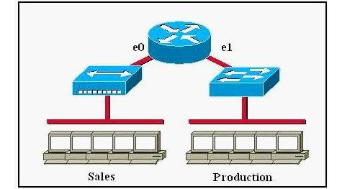
Figure No. 9
Switch
Hub

- For the above figure how many collision domains and how many broadcast domains are there? What are the benefits of replacing the Hub with a Switch? [5 marks]
- When a collision occurs in a network using CSMA/CD, what do hosts with data to transmit do? [4 marks]

Question No. 8

- What are the sub layers of the data link layer? Briefly state their functions. [4 marks]

Preamble  8 bytes | Destination  Address | Source  Address | Type | Data | Frame Check Sequence  4 bytes
Figure No. 10

- The above figure no. 10 represents an Ethernet LAN frame; briefly describe the purpose of Preamble and Frame Check Sequence. [4 marks]
- An Ethernet MAC sub layer receives 42 bytes of data from the upper layer. Can data be encapsulated in one frame? Why or why not? [3 marks]
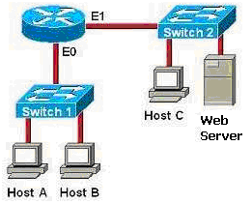
Figure No. 11
- What type of destination addresses in the transport, Internet and data link layer will Host A in figure no. 11use to communicate with the web server? [4 marks]

THE END

