No. of Pages | 5
No. of Questions | 8

Department of Computer Science and Engineering
FINAL EXAMINATION SPRING 2009

CSE320: Data Communications
Total Marks: 90 Time Allowed: 3 Hours

- Answer Any Six (6) questions out of Eight (8) questions.
- Figure in bracket [] next to each question indicates marks for that question.

Question No. 1

- Using the TCP/IP model, give examples of protocols used in each layer of the model when you sent a request for a web page from a PC of the BRACU network to a web server. [4 marks]
- When you are requesting the web page what port numbers are included in the request packet? Also, the port numbers which are included in the packet fall under which type of port numbers? [4 marks]
- Compare HTTP and FTP. [4 marks]
- Which protocol helps us access the Internet without any configuration hassle while waiting at an airport? [3 marks]

Question No. 2

- Complete the table given separately; naming the TCP/IP Layers and the respective PDUs names and the extra information they carry in the header of the PDUs. [3.5 marks]
- Consider that Host A wishes to establish a TCP connection with Host B, so Host A sends a synchronization segment with the sequence number of 100. Draw the diagram of how this connection will be established. What is it called? [4 marks]
- Name and compare the three main addresses are required to send a packet through the Internet? [4.5 marks]
- What is the difference between protocols and standards? Explain and give examples. [3 marks]

Question No. 3

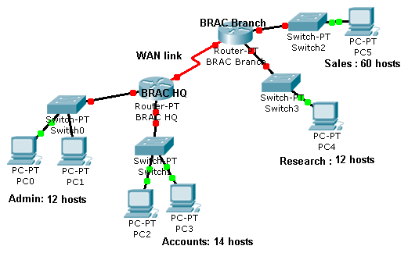
Figure No. 1

- Use variable-length subnet mask (VLSM) to support more efficient use of one assigned IP address of 193.32.10.128/25. Use the table provided in the separate sheet. [ 11 marks]

- What command is necessary to look for the IP configuration of a PC? What kind of information is shown in the IP configuration of a PC? [4 marks]

Question No. 4

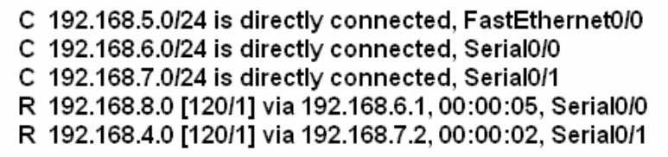

Figure No. 2

- A packet is destined for the 198.162.15.0 network arrives at the router. Using the routing table shown in figure no.2 above, will the router forward this packet? If so, which port will it use, and what is the address of the next-hop router interface? [3 marks]
- Referring to the same routing table in figure no. 2, state which routes/networks are known from using routing protocols? [2 marks]
- State two characteristics of IPv4. What type of contact does IPv4 make with the destination before sending a packet? [3 marks]
- Routers use routing table and switches use another type of table. Explain using figure no. 4, for example when Host A sends a packet to Host C, what will the switch do? [4 marks]
- Differentiate between a multicast IP address and broadcast IP address. [3 marks]

Question No. 5

  - Compare Go-Back N ARQ and Selective Reject ARQ methods. [3 marks]
  - Suppose there is heavy traffic on a CSMA/CD LAN. Among the two methods, non persistence and 1-persitance, in which system is a station more likely to wait before transmitting? Give reasons for your answer. [4 marks]
  - Explain the difference between SELECT and POLL packets in Polling. [3 marks]

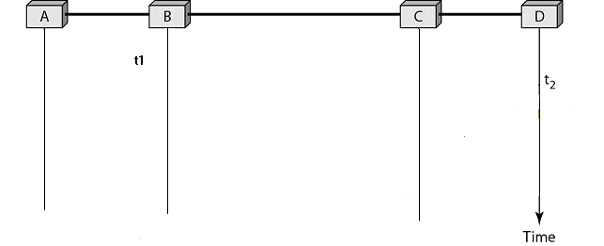
Figure No. 3
  - The above diagram (figure no. 3) shows host B started transmitting at time t1=0, and host D at time t2=2μsec using CSMA /CD. Complete the diagram (provided in a separate sheet) to show, where does the collision occur and what are the transmission times of B and D? [3 marks]
  - In the following scenario, where would you say that there is probability of collision? [2 marks]
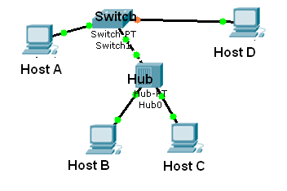
Figure No. 4

Question No. 6

- Data from the upper layer consists of the following bits, which are sent to the data link layer. Before sending it to the physical layer, how we do indicate the end of data and is there any other processing necessary on the data to distinguish it from the end of data? Data: 01101011111011100001111110011000 [3 marks]

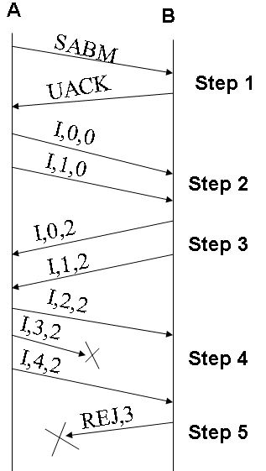

Figure No. 5

- In the above figure no. 5 shows the two-way exchange of HDLC frames. Explain briefly what is happening in the diagram (in the steps mentioned). Also state what will happen after step 5. [6 marks]
- Using the figure no. 5 in the previous question, explain where piggybacking is done and why? [3 marks]
- Using a 5 bits sequence number, what is the maximum size of send and receive windows for each of the following protocol: [3 marks]
  - Go-Back-N ARQ
  - Selective Repeat ARQ

Question No. 7

Preamble | SFD | Address | Address | Length/Type | Data and padding | CRC

Figure No. 6

- The above figure no. 6 represents an Ethernet frame. The Ethernet MAC sub-layer receives 39 bytes of data from the upper layer; it adds padding to the data, why and how much? [3 marks]
- State some functions of MAC and LLC sub layers of Data Link Layer. [4 marks]
- What is 100BaseTX? [2 marks]
- 100BaseTX uses 4B/5B block coding and then uses MLT-3 signal encoding technique, what is the purpose of block coding before encoding the signal using MLT-3, explain? [3 marks]
- Encode the following data bits 011001110 into MLT-3 encoding scheme, use the separate sheet provided. What is the advantage of MLT-3 over Manchester encoding scheme? [3 marks]

Question No. 8

- What are the reasons behind light propagating as a straight in single mode but not in multimode fiber optic cables? Why are fibre optic cables always in pairs? [4 marks]
- What protection does UTP cabling have against interference (EMI, RFI and crosstalk from other wires)? [3 marks]
- Give two reasons why the LAN link between two buildings at opposite ends of a campus should use fibre optic cables rather than twisted pair copper cables? [3 marks]
- Compare coaxial cable and twisted pair cable in terms of physical structure, uses and data rate capability. [3 marks]

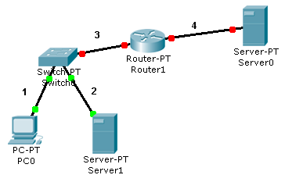
Figure No. 7

- For the above figure choose which cables to use, cross over UTP or straight through UTP. [2 marks]

THE END

