No. of Pages | 4
No. of Questions | 8

Department of Computer Science and Engineering
FINAL EXAMINATION SPRING 2011

CSE320/EEE361: Data Communications
Total Marks: 90 Time Allowed: 3 Hours

- Answer Any Six (6) questions out of Eight (8) questions.
- Figure in bracket [] next to each question indicates marks for that question.

Question No. 1

  - What is the difference between Standards and Protocols? [2 marks]
  - Compare Data Link Layer and Physical Layer. [4 marks]
  - You are writing an email to a friend from your gmail account to his yahoo account. What protocols are involved in sending and receiving this email, explain briefly. [4 marks]
  - A host/PC has sent a request for its IP configuration to a DHCP server. How does know where to send the request? And what happens next? [4 marks]
  - What is the difference between OSI and ISO? [1 marks]

Question No. 2

- Why does a PC connected to a network require port numbers? It already has an IP address and a MAC address. [3 marks]
- Explain what the following two commands will show. [3 marks]
  - ipconfig /all
  - nslookup
- Name some fields that exist in a TCP header but not in an UDP header. [3 marks]
- What is the purpose of Sequence and Acknowledge Number used in the TCP Header of a segment? [3 marks]
- Compare between HTTP and FTP. [3 marks]

Question No. 3

Host IP address/subnetmask : 172.16.6.33/22
Network address
Broadcast address
First usable host IP address
Last usable host IP address

- Complete the above table in your script. (Please show calculations.) [5 marks]
- A workstation is configured as follows. What is the problem? [3 marks]
IP address 192.168.10.33
Subnet mask 255.255.255.224
Default gateway 192.168.10.63
- When is it acceptable for two hosts to have the same IP address at the same time? If so, how are they allowed to access the Internet? [3 marks]
- When do we use PING and TRACERT? What is the basic difference between them? [4 marks]

Question No. 4

- The most common cable used today is the twisted pair copper cables. Why do manufacturers twist the cable, even though twisting the cable increases the cost? [3 marks]
- Why is the core and cladding of an optical fiber made of different densities? [3 marks]
- Where do we use a Straight-Through cable and a Cross-Over cable? [2 marks]
- Differentiate between Single mode fiber and Multimode fiber optic cable. [4 marks]
- Compare 100BASE-2 and 100BASE-T in terms of connectors, transmission media and data rate. [3 marks]

Question No. 5

- What is the purpose of bit stuffing? [3 marks]
- Draw the send and receive windows of Selective Repeat ARQ protocol with a 2-bit sequence number. [3 marks]
- In Go-Back-N ARQ, what happens when a receiver receives a frame out of sequence? [2 marks]
- In Stop and Wait ARQ, why are the frames only marked 0 and 1 alternatively? In which scenario would Stop and Wait ARQ be the most efficient? [4 marks]
- In Selective Repeat ARQ method, how does a NAK frame make the system more efficient? [3 marks]

Question No. 6

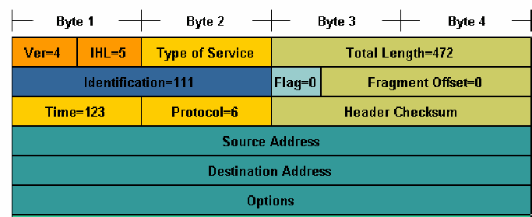
Figure No. 1
- The above figure no. 1 is the header of an IP packet. What is the purpose of the fields highlighted in the oval shape? Just give a general explanation. [3 marks]
Gateway of last resort is not set.

R 200.10.0.0 [120/1] via 192.168.2.2, 00:00:02, serial0/0
R 212.32.10.0[120/3] via 192.168.2.2, 00:00:02, serial0/0
C 192.168.2.0/24 is directly connected, serial 0/0
C 192.168.1.0/24 is directly connected, FastEthernet0/0
S 196.21.21.0/23 [1/0] via 192.168.2.2

Figure No. 2

- Using the routing table above differentiate between static routes and dynamic routes? [3 marks]
- What happens if your PC has no default gateway? [2 marks]
- Which field in the IP packet header is used to prevent undeliverable packets from circulating endlessly? How does it work, explain briefly. [4 marks]
- Packets originating from BRACU network and destined for all remote networks in the Internet should go via the ISP Router. These remote networks are not in the routing table. What should you do to forward the packets? [3 marks]

Question No. 7

- What happens when a token is destroyed in a Token Ring LAN? [3 marks]
- Both Reservation and Polling method have extra overheads, what are they? Explain briefly. [4 marks]
- A host PC connected to a network using CSMA/CD detects collision, what shall the host PC do next? [3 marks]
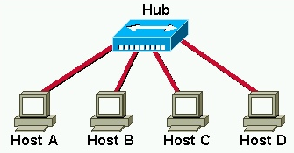
Figure no. 3

- In the figure no. 3 above Host B is sending an Ethernet frame to Host D, when Host B is nearly 50% complete, at that moment Host C also wishes to send a frame to Host D. What must Host C do? [2 marks]
- Draw the flow diagram of non-persistent method of CSMA/CD access method. [3 marks]

Question No. 8

- Encode the following data stream 10010110 using Manchester, NRZ-L and MLT-3 encoding methods.(Separate sheet attached) [4.5 marks]
- 100BASE-FX Ethernet uses 4B/5B coding and then NRZ-I encoding. Explain what is the purpose of and the steps involved in 4B/5B coding before using NRZ-I. [3.5 marks]
- Bi-Polar AMI encoding technique has two main problems, what are they and how are they solved? . [4 marks]
- In 6B/8B block coding 62 combinations of 8 bits out of 256 combinations are used for substitution. What happens to the rest of the combinations, are they used at all? [3 marks]

THE END

