No. of Pages | 4
No. of Questions | 8

Department of Computer Science and Engineering
FINAL EXAMINATION SPRING 2012

CSE320/EEE361: Data Communications
Total Marks: 90 Time Allowed: 3 Hours

- Answer Any Six (6) questions out of Eight (8) questions.
- Figure in bracket [] next to each question indicates marks for that question.

Question No. 1

  - What are the functions of presentation and session layer? Which protocol/s is responsible for the presentation layer? [4 marks]
- When you write www.games.com in the URL of a web browser, the first packet sent by your PC is to your local DNS server. But your local DNS server does not have the IP address to that URL. How does the Root DNS server help your local DNS server find the IP address of the URL. [4 marks]
- Differentiate between the MAC address and IP address of a PC. When you send an email to your friend in England state the source and destination IP addresses and MAC addresses that are included in your email PDU. [4 marks]
- P2P and FTP both are used to transfer files, but how are they different? [3 marks]

Question No. 2

- During a TCP communication session, if the packets arrive to the destination out of order, what will the receiving host do? What happens if it is an UDP communication? [4 marks]
- What is the purpose of Sequence and Acknowledge Number used in the TCP Header of a segment? How is the Sequence number of a frame being calculated? [4 marks]
- Two hosts are sending data to each other. During connection establishment, the negotiated window size was 1200 bytes. The sending host sends 3 segments starting from sequence number 101, each segment is 400 bytes. None of the segments reached the receiver; all of the segments were lost. What will the sender and receiver do next? (Mention the sequence number, acknowledgement number and window size.) [4 marks]
- UDP has few fields in its header which is only 8 bytes long, why? [3 marks]

Question No. 3

Host IP address/subnetmask : 192.68.140.1/19
Network address
Broadcast address
First usable host IP address
Last usable host IP address

- Complete the above table. (Please show calculations.) [6 marks]
- How do routers get to the information of different routes to remote numerous destinations? [3 marks]
- A router receives a packet to forward but the router has no information regarding the destination network, what will the router do? [2 marks]
- In a PC’s IP configuration, a network administrator enters the IP address:172.16.16.33, then Subnet Mask : 255.255.255.0 and then Default Gateway:172.16.16.254? What is the purpose of subnet mask and default gateway? [4 marks]

Question No. 4

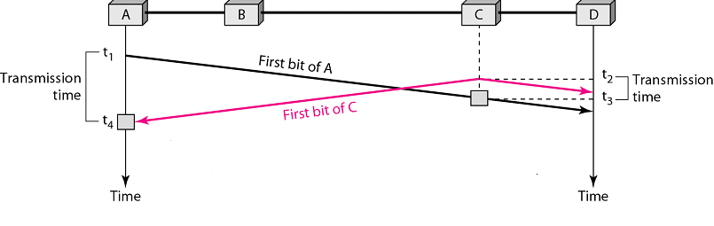
Figure No. 1
- In the above figure no. 1 shows the transmission of two stations A and C. Where does the collision occur? And at what point of time do station A and station C detect the collision and how? And what happens after they do so? [5 marks]
- How is non persistent better than 1-persistent method in CSMA/CD? [3 marks]
- In Token Passing what happens if the token is lost or destroyed? [3 marks]
- What are the purpose of SELECT and POLL functions in the Polling Method? [4 marks]

Question No. 5

- An organization has been given 4 public IP addresses from its ISP. But the organization has 50 users who require Internet access. How will these 50 PCs access the Internet simultaneously using those 4 public IP addresses? [4 marks]
- What is the difference between the addresses “255.255.255.255” and “192.168.10.255/24”?
[3 marks]
- How is “traceroute” different from “ping”? [3 marks]
- You are given a single network address 200.20.20.0/24. But you need to create three separate sub networks for your organization. What can you do? (You can explain in words or show calculations) [5 marks]

Question No. 6

- Why do we use flags at both ends of a frame? What kind of flags do HDLC use? [3 marks]
- What is the difference between the codes REJ and SREJ? Where are the codes being used? [3 marks]
- State two specific use of Unnumbered frames? [2 marks]

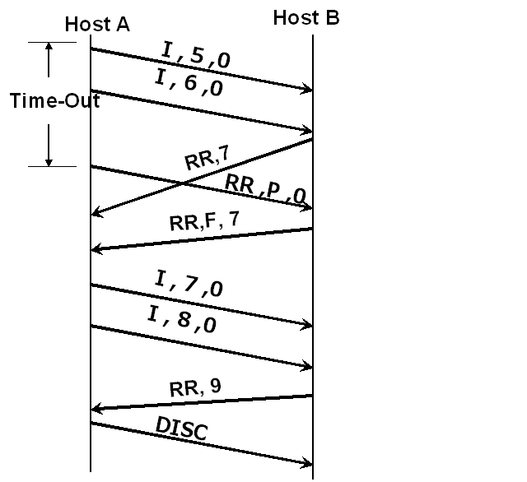
Figure no. 2
- Host A did not automatically resend the frames 5 and 6 after time out shown in figure no.2 , why? Why was the supervisory frame “RR,P,0” sent? [4 marks]
- Why do some supervisory frames have P/F bit on and some do not as shown in figure no. 2? [3 marks]

Question No. 7

- Light passes through a fiber optic cable; not electrical signals, but we send electrical pulses from our PCs. How is the conversion from light to electrical pulses done? [3 marks]
- Draw a multimode fiber optic cable and label it. [3 marks]
- State where straight-through cables, cross-over cables and roll over cables are used? [3 marks]
- Coaxial cable has less EMI (electromagnetic interference) than twisted pair, why? [3 marks]
- Twisted Pair cables cancel cross talk interference, how? [3 marks]

Question No. 8

- Encode the following data stream 111000111 using Manchester, MLT-3 and NRZ-L encoding methods.(Separate sheet attached) [4.5 marks]
- Differential Manchester encoding technique do not require block coding, why? [4 marks]
- Block coding and Scrambling both focused on long streams of 0’s rather than long streams of 1s’, why? [4 marks]
- How transitions of voltage (voltage change) in the signal sent help the receiver? [3 marks]

THE END

