No. of Pages | 5
No. of Questions | 8

Department of Computer Science and Engineering
FINAL EXAMINATION SUMMER 2009

CSE320: Data Communications
Total Marks: 90 Time Allowed: 3 Hours

- Answer Any Six (6) questions out of Eight (8) questions.
- Figure in bracket [] next to each question indicates marks for that question.

Question No. 1

- Match the following actions to one or more layers of the OSI model [3 marks]
    - Compression of audio and video files.
    - Ensures unreliable process to process data delivery.
    - Using the MAC address of the default gateway to send data.
    - Retransmission of data if data is lost.
    - Topology and cabling structure.
    - Creating connections before sending data.
  - What does TCP/IP stand for? Draw the model and give examples of protocols for each layer of the TCP/IP Model. [3 marks]
  - When you email a friend, SMTP and POP both protocols are used, why? [3 marks]
  - Bracu network uses DHCP. You come to the lab and turn your PC on. State the steps that occurs for your PC to receive an IP address automatically. [4 marks]
  - Compare Port numbers and IP addresses. [2 marks]

Question No. 2

- Why is the TCP segment header bigger than the UDP datagram header? [3 marks]
- What might make the window size smaller in TCP? [2 marks]
- When you are uploading a file to a FTP server, what kind of port numbers (source and destination both) are added in the TCP header? [3 marks]

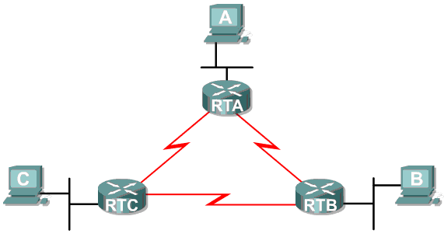
Figure No. 1
- Referring to the above figure no. 1 above, use VLSM (Variable Length Subnet Masking) to create an IP addressing scheme that wastes the least amount of address space. IGNORE THE WAN (SERIAL) LINKS!! (Must show calculations) [7 marks]
  - Address space: 192.168.1.192/26
  - RTA: 28 hosts; RTB: 14 hosts; RTC 14 hosts

Question No. 3

- IPv4 packets do not loop forever, why? [3 marks]
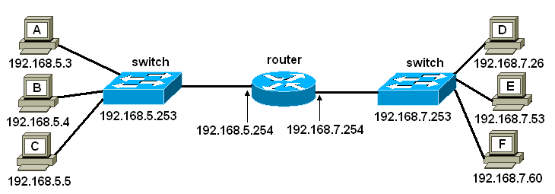
Figure No. 2

- Refer to the figure no. 2 above, for all PCs of network 192.168.5.0/24, what will be the default gateway? What is the purpose of this default gateway? How can you find the default gateway of a PC? If the default gateway configured on host A is wrong, state which hosts will host A be able to communicate with and which hosts host A will not. [5 marks]

Gateway of last resort is 192.168.2.2 to network 0.0.0.0
10.0.0.0/24 is subnetted, 2 subnets
R10.1.1.0[120/1]via 192.168.2.2,00:00:02,serial0/0
R10.1.2.0[120/1]via 192.168.2.2,00:00:02,serial0/0
C192.168.2.0/24 is directly connected, serial 0/0
C192.168.1.0/24 is directly connected, FastEthernet0/0
C192.168.3.0/24 is directly connected, FastEthernet0/1
S*0.0.0.0/0[1/0]via 192.168.2.2

Figure No. 3
- Refer to the above Figure No.3 which represents the routing table of a router; the router receives a packet destined for 10.2.1.0 network. After consulting the routing table, the router forwards the packet via serial 0/0 to the next hop interface 192.168.2.2. Why? [3 marks]

- What are dynamic routes and static routes? Explain using examples from the routing table in the above figure no. 3. [4 marks]

Question No. 4

- In a place where there is a lot of thunder storms, what kind of media would you suggest, and why? [3 marks]
- 10BASE2 uses what type of cable? Describe the cable and state how it reduces inferences from outside sources. [4 marks]
- For long distance communication, what type of fiber optic cable would you suggest, why? How does light propagate through the fiber optic cable, the one that you have suggested? [4 marks]
- Name two areas/applications where microwaves are being used? List some of the important impairments (problems) that affect this kind of transmission. Provide one solution for one of the problems. [4 marks]

Question No. 5

Preamble | SFD | Address | Address | Length/Type | Data and padding | CRC

Figure No. 4

- The above figure no. 4 represents an Ethernet frame. How is the preamble different from the SFD in an Ethernet frame? Is it required in all Ethernet types, Standard and Fast? [4 marks]
- State three features of an Ethernet MAC address. [3 marks]
- When a PC wishes to send data to all other PCs in its own network, what in included in the destination IP address and destination MAC address? What are they called? [3 marks]
- Compare 100BASETX and 10BASE5. [3 marks]
- The data link layer receives 2500 bytes from the network layer. How many frames are required to send the data? [2 marks]

Question No. 6

- Why is p- persistent method better than 1- persistent method especially in a network with heavy traffic? [3 marks]
- What extra frames (frames that are not data frames) are sent in Reservation and Polling access methods? Explain each briefly. [4.5 marks]
- Refer to the figure no.5 below, station A starts transmitting at time t1, just after 3μsec station C senses the carrier and finds it empty and so starts transmitting its own frame. So after some time a collision will occur. When will station C get to know about the collision and how? You can use the diagram provided in a separate sheet to answer the question. [3.5 marks]

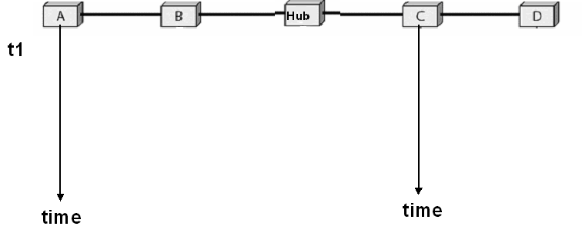
Figure No. 5
- Referring to the same figure no. 5, what actions does station C take after it knows about the collision? There is a hub between station C and A, what will the hub do after the collision? [4 marks]

Question No. 7

- Using a 3 bit sequence number, draw the send and receive windows for Go-Back-N ARQ flow control protocol. [4 marks]
- What is the difference between SREJ and REJ supervisory frames? [4 marks]

- In HDLC protocol, a connection is established before any data is sent. What kind of frames is used for this purpose? Draw the frame. [3 marks]

]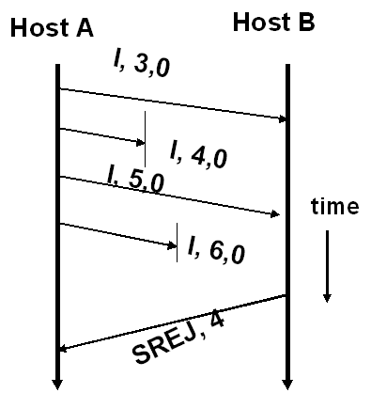
Figure No. 6

- Referring to figure no. 6 above, after Host A receives the SREJ frame, explain briefly what both hosts will do next? What type of flow control is used here? [4 marks]

Question No. 8

- Why are long streams of 0s a problem? Name the methods available to avoid the long streams of 0s, state the processes involved in one of the method briefly? [4 marks]
- Draw the constellation diagram of 16QAM. Why is it better than 16PSK? [4 marks]
- Encode the following data stream 01100011 using MLT-3 and NRZ-I. Use the separate sheet provided. [4 marks]
- The figure no. 7 below represents the Differential Manchester encoding of a data stream. What is the data stream? Why is D. Manchester better than the other encoding techniques? [3 marks]
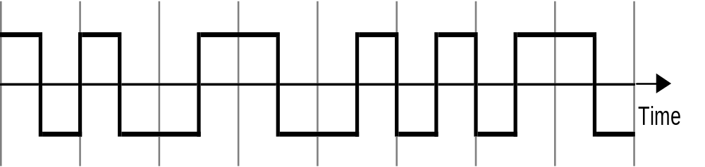

Figure No. 7

THE END

