No. of Pages | 4
No. of Questions | 8

Department of Computer Science and Engineering
FINAL EXAMINATION SUMMER 2010

CSE320: Data Communications
Total Marks: 90 Time Allowed: 3 Hours

- Answer Any Six (6) questions out of Eight (8) questions.
- Figure in bracket [] next to each question indicates marks for that question.

Question No. 1

  - What are the different addresses used in the different layers of TCP/IP data communication model? [3 marks]
  - What happens to a packet when it is received by data link layer? [2 marks]
  - When you write www.bracu.ac.bd in your web browser URL, state what roles do HTTP and DNS play in bringing you the web page that you had requested? [4 marks]
  - DHCP makes the work of a network administrator easier, how and why? [3 marks]
  - State what happens by drawing a diagram when you sent an email to a friend. Do not forget to mention the protocols being used. [3 marks]

Question No. 2

- TCP is reliable, how does TCP ensure this reliability? [3 marks]
- How do two hosts terminate their connection in TCP? [3 marks]
- When a host tries to remotely access a server via telnet, which protocol would it use; TCP or UDP? Why? [3 marks]
- For the scenario in the previous question, what kind of port numbers shall be included in the source and destination port numbers of the segment sent by the host to the server? [3 marks]
- The source host sends segments with sequence numbers 2001 to 4000. All of them arrive at the receiver. But the receiver cannot process those segments as there is no space in its buffer. What happens next? [3 marks]

Question No. 3

Host IP address/subnetmask : 199.99.97.128/18
Network address
Broadcast address
First usable host IP address
Last usable host IP address

- Complete the above table. (Please show calculations.) [5 marks]
- What is the significance of 127.0.0.1 and 10.10.10.1 IP addresses? [3 marks]
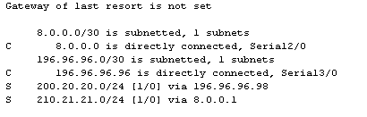

Figure No. 1
- Referring to the above figure no. 1, state which types of routes are present and which types are not present in the routing table. [4 marks]
- How can you verify that a PC in a network has a default gateway address? What would go wrong if it does not have the default gateway’s address? [3 marks]

Question No. 4

- Name and draw the light propagation modes that are used in Single Mode and Multimode Fiber Optic cables. Which propagation is better and why? [4 marks]
- Compare UTP cables with Fiber Optic cables. [3 marks]
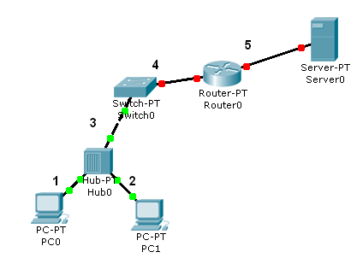
Figure No. 2
- When do you use a Straight-Through cable and a Cross-Over cable in the above figure no. 2 and why? [3 marks]
- While choosing a media what factors do we have to keep in consideration? [2 marks]
- Co-axial cables are no longer preferred in data communication, why? [3 marks]

Question No. 5

- Why do we need flow control in data communication? [3 marks]
- Compare Selective Repeat and Go-Back N ARQ. [3 marks]
- Two neighboring nodes (A and B) use a sliding-window protocol with a 2-bit sequence number. Go-back-N is used as the ARQ mechanism. Assuming A is transmitting and B is receiving, show the window positions for the following succession of events: [5 marks]
- Before A sends any frames
- After A sends frames 0, 1, 2 and B acknowledge 0, 1 and the ACKs are received by A.
- After A sends frames 3, 4 and 5 and B acknowledges 4 and the ACK is received by A.

- In Stop and Wait ARQ, why are the frames only marked 0 and 1 alternatively? In which scenario would Stop and Wait ARQ be the most efficient? [4 marks]

Question No. 6

- IEEE802.3 and IEEE802.2 are standards for what? What does the 802 number signify? [3 marks]

Figure No. 3

- What do the numbers in the above figure no. 3 can represent? Explain what the first and last 6 digits represent? [4 marks]
- Differentiate between an Ethernet broadcast address and a unicast address. [3 marks]

- 100BASE-TX uses a star topology. What is the difference when a star topology uses a hub at the center and a switch at the center of the star? [3 marks]
- Differentiate between 100BASEFX and 10BASE2. [2 marks]

Question No. 7

- In which scenarios, bit stuffing is not done? [3 marks]
- Supervisory frames do not require any data field, why? In which scenarios, we would not require supervisory frames at all? [4 marks]
- What is the difference between Unnumbered frames and Information frames? [3 marks]
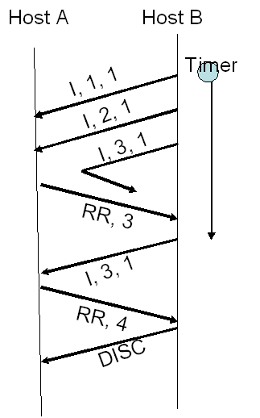
Figure No. 4
Step 1
Step 2
Step 3
- Referring to figure no. 4 above, explain the process in three steps as shown. Why are there no P/F bits in the supervisory frames? Is step 3 complete? [5 marks]

Question No. 8

- Encode the following data stream 1011101 using Differential Manchester, NRZ-I and MLT-3 encoding methods. [4.5 marks]
- Differential Manchester solves a number of common problems that occur in signal encoding processes, what are they and how are they solved? [3.5 marks]
- Some signal encoding techniques are used in conjunction with block coding, for example 100BASE TX uses 4B/5B block coding and then MLT-3, explain why? [4 marks]
- Contrast Manchester and NRZ-I encoding techniques? [3 marks]

THE END

