No. of Pages | 3
No. of Questions | 5

Department of Computer Science and Engineering
MIDTERM EXAMINATION SUMMER 2009

CSE320: Data Communications
Total Marks: 50 Time Allowed: 70 Minutes

- Answer ALL Five (5) questions.
- Figure in bracket [] next to each question indicates marks for that question.

Question No. 1

- Draw the TCP/IP model and then give examples of protocols for each layer. [3 marks]
- Data Link Layer and Transport Layer have common functions, what are they? And also state how they are different. [2.5 marks]
- Complete the frames shown below with appropriate addresses (Use the separate sheet provided). The sender is requesting a web page from the web server. The frames shown are all intended for the web server. Assume port numbers and alphabets represent MAC addresses and numbers represents IP addresses. The third frame given in the separate sheet is when Host A is sending a data to Host S. [4.5 marks]

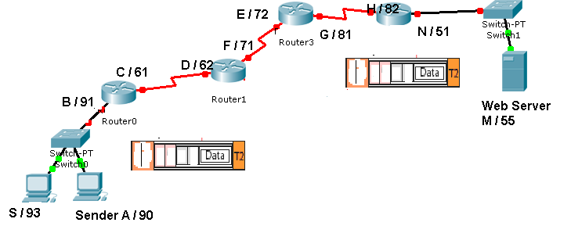
Figure No. 1
Frame 2
Frame 1

Question No. 2

- You have taken the responsibility of a network administrator of a large organization. Which protocol can save time for you in assigning the IP configurations of all devices? Will you use the protocol for all type of devices in your network? [4 marks]
- Write down the appropriate application layer protocols that matches with the statements: [ 3 marks]
  - A protocol that uses POST/PUT messages to upload data back to the server.
  - Helps you download mp3 files directly from another person’s PC using the Internet.
  - Allows you to access a switch situated in another building to configure it.
  - Allows you to upload large files.
  - Converts www.deto.com into 210.10.10.1.
  - Used for sending emails from server to PC.
- Draw the diagram that shows you sending an email to a friend. The diagram should contain MUAs, MTA/MDAs and the appropriate protocols. [3 marks]

Question No. 3

- Host A is sending data to host B. Host A sent 3 segments of 500 bytes in size ranging from 1000 to 2499. But the segments never reached host B. What will happen next? [4 marks]
- Host D is sending data to host E. Host E acknowledges the data but also reduced the window size in the acknowledge segment. Why did host E reduce the TCP window size? [3 marks]
- Name some fields that exist in TCP header but not in UDP header. [3 marks]

Question No. 4

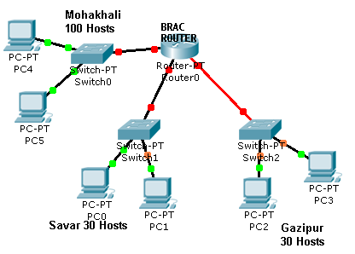
Figure No. 2
- The allocated network address for BRAC is 192.168.96.0/24. But BRAC needs separate network addresses for its offices at Savar, Mohakhali and Gazipur. How can you help?
- Note: You must subnet considering how many hosts are required for each subnet. Provide calculations and fill the table provided. [7 marks]
- What is the difference between public and private addresses? [3 marks]

Question No. 5

This is part of a routing table.

Gateway of last resort is 192.168.2.2 to network 0.0.0.0
100.0.0.0/24 is subnetted, 2 subnets
Figure No. 3
R 100.1.1.0 [120/1] via 192.168.10.2, 00:00:02, Fastethernet0/2
R 100.1.2.0 [120/1] via 192.168.2.2, 00:00:02, Fastethernet0/1
C 192.168.1.0/24 is directly connected, FastEthernet0/0
C 192.168.2.0/24 is directly connected, FastEthernet0/1
C 192.168.10.0/24 is directly connected, FastEthernet0/2
S* 0.0.0.0/0 [1/0] via 192.168.2.2

- Referring to the routing table shown above, a packet is addressed to 100.1.4.35. Will the router forward this packet? Why? [3 marks]
- Referring to the routing table in figure 3, how are the first two routes different from the last three routes of the routing table? [4 marks]
- When will IP further fragment a packet? [3 marks]

THE END

