No. of Pages | 3
No. of Questions | 4

Department of Computer Science and Engineering
MIDTERM EXAMINATION FALL 2009

CSE320: Data Communications
Total Marks: 60 Time Allowed: 1 Hour

- Answer ALL Four (4) questions.
- Figure in bracket [] next to each question indicates marks for that question.

Question No. 1

- Compare Transport and Data Link Layer of the TCP/IP model in terms of PDU names, addresses used and two functions. [4 marks]
- Referring to the figure no. 1 below, PC1 is sending a packet to PC2, state which IP addresses and MAC addresses that will be included in the packet (Source & Destination both and for indicating MAC addresses just mention the device). Is there any change in the packet if PC1 send it to the Printer with the IP address 10.0.0.253. [5 marks]
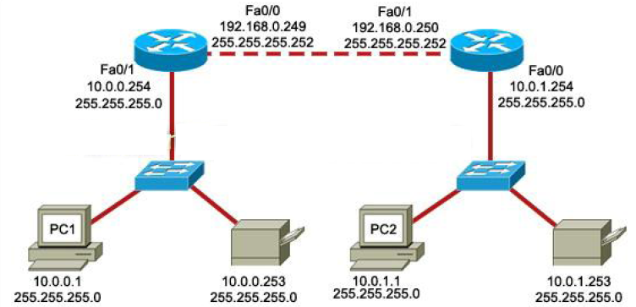
Figure No. 1

- Differentiate between IP address and MAC address. [3 marks]
- Why do we need protocols and standards in the communication world? Give examples. [3 marks]

Question No. 2

- Does IP operate differently on wired and wireless networks? [3 marks]
- Why do we need private addresses? [3 marks]
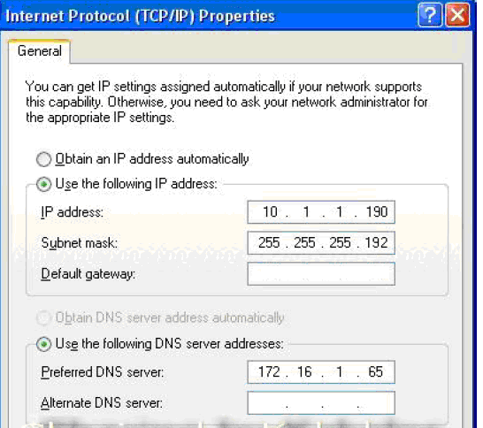
Figure No. 2

- In the above figure no. 2 you are looking at the IP configuration of a PC. Find the network address that the PC is part of? Also state the default gateway IP address. Why does the PC need a default gateway? [6 marks]
Z:\>ping 127.0.0.1

Ping 172.0.0.1 with 32 bytes of data:

Reply from 127.0.0.0: bytes=32 time<1ms TTL=128
Reply from 127.0.0.0: bytes=32 time<1ms TTL=128
Reply from 127.0.0.0: bytes=32 time<1ms TTL=128
Reply from 127.0.0.0: bytes=32 time<1ms TTL=128

Ping statictics for 127.0.0.1:
Packets: Sent = 4, Received = 4, Lost = 0(0% loss),
Approximate round trip times in milli-seconds:
Minimum = 0ms, Maximum = 0ms, Average = 0ms

[5 marks]

Figure No. 3

- In the above output shown in figure no. 3, the network administrator pings an address 127.0.0.1, what kind of address does this address represent? Also explain what does “TTL” (Time to Live) in line 3 represent? [4 marks]

Question No. 3

- Differentiate between HTTP and FTP. [3 marks]
- When you write www.yahoo.com in the URL of a web browser, what role does DNS play here? Is a local DNS server sufficient for a medium sized network’s need? [4 marks]
- Referring to figure no. 5, explain the purpose of POP3 and SMTP in the window? [4 marks]
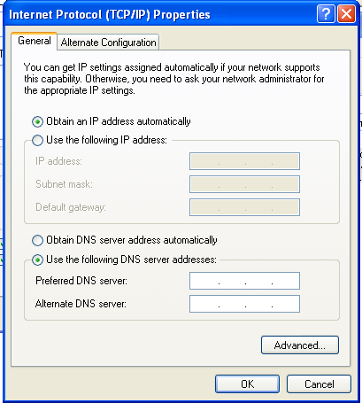
Figure No. 4

- In above figure, the option “Obtain an IP address automatically” is highlighted. What does it imply? What protocol will it be running, explain. [4 marks]

Question No. 4

  - VoIP uses UDP. Why not TCP? [3 marks]
  - A host sends data using TCP but receives no acknowledgement, what happens next? [2 marks]
  - How does a host know that it is receiving a message to close the connection? Draw the flow of segments that terminates connection on both hosts. [4 marks]
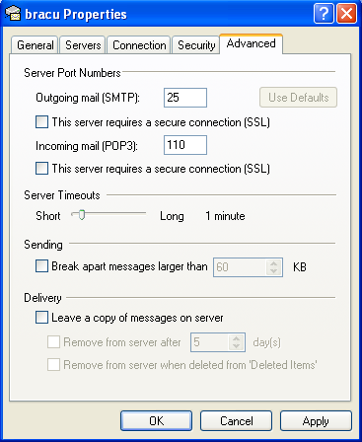
Figure No. 5

  - The above figure represents a window from Microsoft Outlook Express (Email Application). What type of port numbers are those shown? [3 marks]
  - A host receives an acknowledgement segment with a revised window size, from 3000 to 4500. What does it mean? [3 marks]

