No. of Pages | 3
No. of Questions | 4

Department of Computer Science and Engineering
MIDTERM EXAMINATION FALL 2011

CSE320: Data Communications
Total Marks: 60 Time Allowed: 70 minutes

- Answer ALL Four (4) questions.
- Figure in bracket [] next to each question indicates marks for that question.

Question No. 1
- Why were the first three layers of the OSI model combined into one layer in the TCP/IP model? Compare it with the OSI model. [3.5 marks]
- Match the following to one or more layers of the OSI model [4 marks]
    - Acknowledging received data.
    - Encryption of usernames and passwords.
    - Decides how emails are sent and received.
    - Fragmenting PDU further as the media is unable to carry the received PDU size.
    - Decides the ways devices can be connected to form a ring topology.
    - Define ways to access the different types of media.
    - Does not ensure the delivery of data.
    - Decides how signals represent 0s and 1s.
- What does ISO refer to? Why is it essential for the communication process? [3 marks]

Frame 3
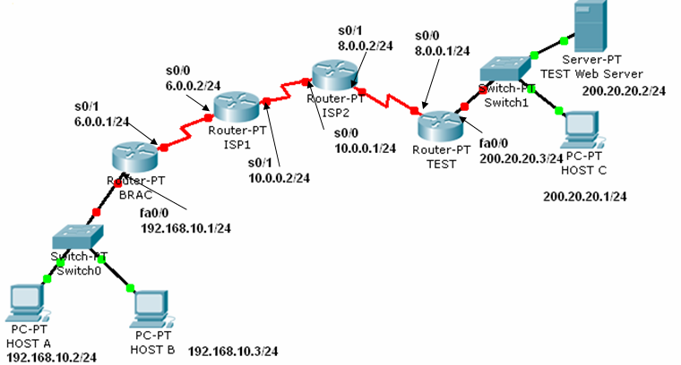
Figure No. 1
FTP Client
Web Browser
Frame 1
Frame 2

- Complete the frames (1, 2 &3) shown above with appropriate port, IP and MAC addresses (Use the separate sheet provided). The sender Host A has two applications running; one for FTP with port number of 49,168 and the other for accessing the web server with port number 49,170. The frames shown are all intended for the web server. (For indicating MAC addresses just mention the device or device interface) [4.5 marks]

Question No. 2

- IP is media independent. But one characteristic of the media affects IP, what is it? How does IP handle it? [3 marks]
- What are the reasons behind breaking a flat big network into smaller sub networks? [3 marks]
- What are the two types of static routes that can be seen in a router? How are they labeled in the routing table? [4 marks]
Gateway of last resort is not set.
R 195.10.10.0/24 [120/2] via 172.16.1.2,00:00:02, serial0/0
R 200.20.20.0/24 [120/3] via 172.16.2.2,00:00:10, serial0/0
C 172.16.1.0/24 is directly connected, serial 0/0
C 172.16.2.0/24 is directly connected, FastEthernet0/0

Figure No. 2

- Two packets arrive at the router, one has the destination IP address of 200.20.20.24/24 and the other has the destination IP address of 195.10.20.6/24. Using the figure no. 2 above, through which interfaces will the router send these two packets? Will any of the packets create a loop in the network? [5 marks]

Question No. 3

- What are the different ways that help you find the IP address of your network’s DNS server? [3 marks]
- When you write www.games.com in the URL of a web browser, the first packet sent by your PC is to your local DNS server. But your local DNS server does not have the IP address to that URL. How does the Root DNS server help your local DNS server find the IP address of the URL? [4 marks]
- TELNET helps network administrators to troubleshoot devices, how? [3 marks]
- How does FTP help you upload a file to a FTP server, explain in words or draw a diagram showing the process? [3 marks]
- Where are these protocols SMTP and IMAP used? (Be specific) [2 marks]

Question No. 4

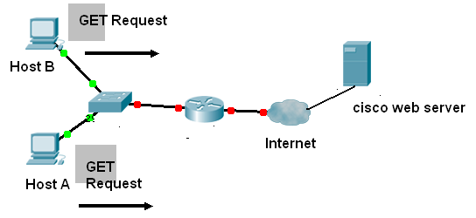
Figure No. 3
  - Host A and Host B both are sending requests to the Cisco Web server for a particular web page shown in figure no. 3. What type of port numbers will be included in the request message as source and destination port numbers? How will the server differentiate between the two requests? [4 marks]
  - What are the two ways that two hosts can terminate a TCP connection? Draw them. [4 marks]
  - Two hosts are sending data to each other. During connection establishment, the negotiated window size was 1500 bytes. The sending host sends 3 segments starting from sequence number 1, each segment is 500 bytes. The second segment never reached the receiver, it was lost in transition. After receiving the first and third segment, how will the receiver reply? Mention the sequence number, acknowledgement number and window size. [4 marks]
  - In a TCP segment header, there are 6 code bits or flags. What are the purposes of SYN, ACK and FIN code bits? [3 marks]

THE END

