No. of Pages | 3
No. of Questions | 4

Department of Computer Science and Engineering
MIDTERM EXAMINATION SPRING 2011

CSE320: Data Communications
Total Marks: 60 Time Allowed: 70 minutes

- Answer ALL Four (4) questions.
- Figure in bracket [] next to each question indicates marks for that question.

Question No. 1

- Why is standardization important in communication? [2.5 marks]
- What is the TCP/IP model for? [2 marks]
- You are requesting a web page from a web site www.cricket.org , sitting at home. State which MAC address, IP address and Port numbers (source and destination both) will be used in your request PDU. ( Hint for MAC and IP address just mention the device) [3 marks]
- Data Link Layer and Transport Layer have some common functions. How are they different? [3 marks]
- Differentiate between MAC Address, IP address and Port Numbers. [4.5]

Question No. 2

- P2P and FTP both are used to transfer files, but how are they different? [3 marks]
- What is the advantage of an iterative query over recursive query in DNS? [3 marks]
- When you request for a webpage from a web server, it responds with a page with a message “404 Not Found”, why? [2 marks]
- You have been appointed as network administrator of a vast network. You have to assign IP addresses to 600 PCs. Which protocol can help you to assign them automatically and how does it work? [4 marks]
- State at least three differences between POP3 and IMAP. [3 marks]

Question No. 3

  - For voice transmission, UDP is preferable why? [2 marks]
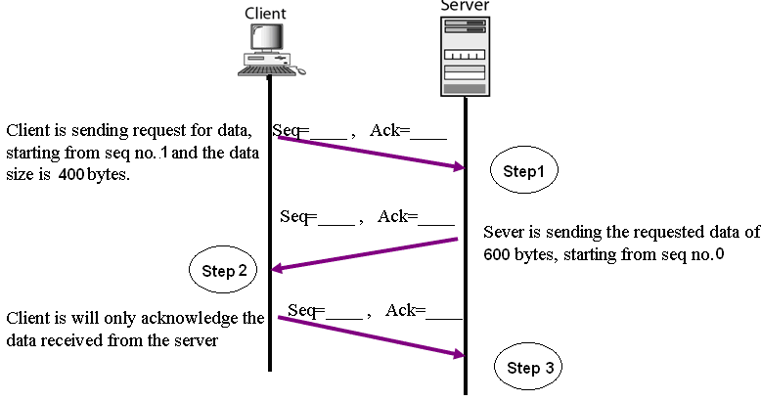
Figure No. 1
  - For the above figure no. 1 complete the sequence and acknowledgement numbers. [3 marks]
  - If TCP is using a window size of 1000 bytes, what does this mean? When is the initial window size for a transmission decided? [3 marks]
  - There are two ways that a host PC can terminate a session with another host PC. Draw both of the ways. How does the receiver host know that it has received a packet from a sender to end the connection? [4 marks]
  - A host PC receives two segments starting from 301-400 and the other starting from 501-600.The PC sends the sender three acknowledgement packets respectively for 401. Why? [3 marks]

Question No. 4

- What are the basic differences between IPv4 and IPv6? [3 marks]

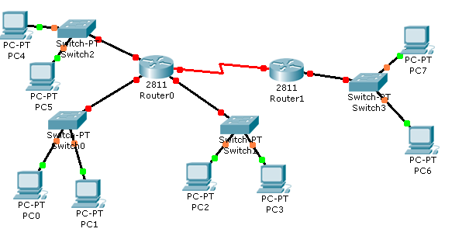
Figure No. 2
- In the above figure no. 2, find the total number of broadcast domains. If we replace Router 1 with a switch will it impact the number of broadcast domains? [3 marks]

Gateway of last resort is 192.168.10.1 to network 0.0.0.0

R 200.20.1.0/24 [120/2]via 192.168.20.1,00:00:02, FastEthernet0/0
C 192.168.10.0/24 is directly connected, serial 0/1
C 192.168.20.0/24 is directly connected, FastEthernet0/0
S 210.21.21.0/24[1/0] via 192.168.20.1
S* 0.0.0.0/0 [1/0] via 192.168.10.1

Figure No. 3

- The above figure no. 3 represents the routing table of a router. Differentiate between the two S routes. [3 marks]
- How are dynamic routes better than static routes? [3 marks]
- A router receives two different routes (paths) to one destination network from its neighbor routers. How does the router decide which path or route is better? [3 marks]

THE END

