No. of Pages | 3
No. of Questions | 4

Department of Computer Science and Engineering
MIDTERM EXAMINATION SPRING 2012

CSE320: Data Communications
Total Marks: 60 Time Allowed: 60 minutes

- Answer ALL Four (4) questions.
- Figure in bracket [] next to each question indicates marks for that question.

Question No. 1
- Compare the OSI and TCP/IP model by drawing the models. Also give examples of protocols for each layer of the TCP/IP Model. [4 marks]
- Match the following to one or more layers of the OSI model [4 marks]
    - Using checksum to detect errors in data.
    - Using physical address to send data.
    - Changing data from ASCII to Unicode.
    - Making a connection before sending data.
    - Decides how data rates 100Mbps will be implemented.
    - Decides which shortest path to take to the destination network.
    - Decides how to access a device remotely.
    - Decides the copper diameter of the wire.

Frame 1
Frame 2
Web Browser
Port : 4012
Frame 3
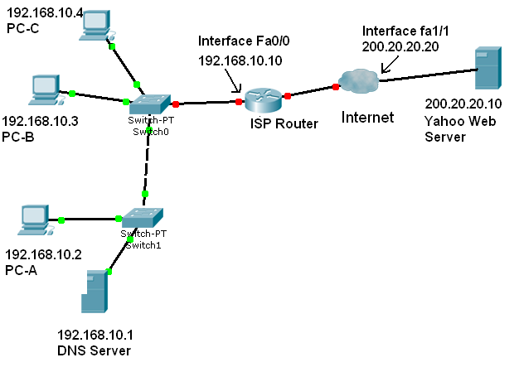
Figure No. 1

- Complete the frames (1, 2 &3) shown above in Figure no. 1 with appropriate Port Numbers (only for Frame-3), IP and MAC addresses (Use the separate sheet provided). The sender PC-C is sending a HTTP request (Frame -3) to the yahoo web server. Before PC-C can send this request, it has make an ARP request (Frame-1) for the DNS server’s MAC and then send the DNS request (Frame-2) to the DNS Server for converting the Yahoo URL to an IP address. (For indicating MAC addresses just mention the device or device interface) [7 marks]

Question No. 2

- You wish to view the webpage of www.games.org. You open your web browser and write the URL. What will be sent by your web browser and how will the web server respond using http protocol, mention several probable responses? [4 marks]
- You write www.games.org in the web browser’s URL box and press enter. Your network’s DNS server did not have the IP address of the URL. But you were still able to access the site? How is it possible? [3 marks]
- You have just subscribed to Internet connection via Wimax, All you have to do is plug in the Wimax device to your PC, and you are connected to the Internet. How does your PC get an IP address for the Internet connection? [4 marks]
- Draw the process of sending an email using yahoo mail to your friend who receives the email using gmail. Remember to indicate the devices and protocols used. [4 marks]

Question No. 3

C:\> netstat
Active Connections
Proto Local Address Foreign Address State
TCP MyPC:1518 www.google.com:http ESTABLISHED
TCP MyPC:1525 www.cisco.com:http ESTABLISHED
TCP MyPC:1538 www.game.com:80 LISTENING

Figure No. 2

- What are these entries shown in the above Figure no.2? In the above output (figure no. 2), the port numbers that are shown in the circles, what kind/type are they? [5 marks]
- A client PC is running three different applications using TCP, all three are sending data. Segments from different application are multiplexed, what does it mean? [3 marks]
- Two hosts are sending data to each other. During connection establishment, the negotiated window size was 2000 bytes. The sending host sends 2 segments starting from sequence number 1501, each segment is 1000 bytes and receives an acknowledgement from the receiver. The sending host sends another 2 segments. The receiver only receives the second segment, how will the receiver reply? Draw the whole process described above; remember to mention the sequence number, acknowledgement number and window size. [Just a diagram is required] [5 marks]
- In the above mentioned scenario, will the packets sent by the sender or receiver have any of the 6 code bits or flags turned on. If yes, which ones and why? If no, why not? [2 marks]

Question No. 4

- Does IP operate differently on wired and wireless networks? Explain. [3 marks]
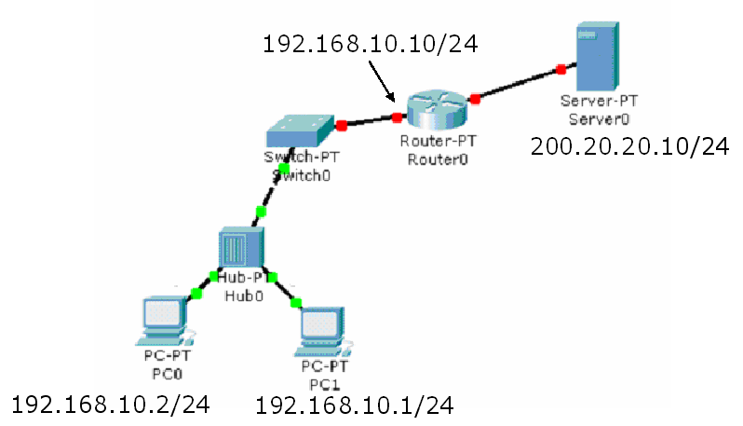
Figure No. 3

- For the network diagram above in Figure no. 3, what will be the default gateway of PC1 and PC0? PC0 can access PC1 but cannot access the server (200.20.20.10/24) shown, what is the probable reason? [4 marks]
- Using the routing table shown below in Figure no. 4, draw the router and its interfaces (connections). [3 marks]

Gateway of last resort is 192.168.2.2 to network 0.0.0.0
10.0.0.0/24 is subnetted, 2 subnets
R 10.1.1.0 [120/1] via 192.168.2.2, 00:00:02, serial0/0
R 10.1.2.0 [120/1] via 192.168.2.2, 00:00:02, serial0/0
C 192.168.2.0/24 is directly connected, serial 0/0
C 192.168.1.0/24 is directly connected, FastEthernet0/0
C 192.168.3.0/24 is directly connected, FastEthernet0/1
S* 0.0.0.0/0 [1/0] via 192.168.2.2

Figure No. 4

- Refer again to the above Figure No.4 which represents the routing table of a router; the router receives a packet destined for 10.2.1.0 network. After consulting the routing table, the router forwards the packet via serial 0/0 to the next hop interface 192.168.2.2. Which route is that? Explain briefly regarding the route and why the router chose it? [5 marks]

THE END

