No. of Pages  B | 4
No. of Questions | 3

Department of Computer Science and Engineering
MIDTERM EXAMINATION FALL 2016

CSE421/EEE465: Computer Networks
Total Marks: 45 Time Allowed: 50 minutes
- Answer ALL THREE (3) questions
- Figure in bracket [] next to each question indicates marks for that question

Question 1

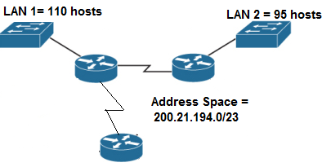
Figure no. 1

- Suppose a company is given a block 209.100.40.0/21. But you need four more sub networks for your organization as shown in Figure no. 1. Show how you can have 4 more subnets out of the original network address as per host requirements. Do not forget to show basic calculations. [8 marks]

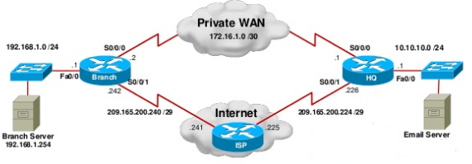
Figure no. 2

- Refer to the above Figure no. 2, a default static route has been configured in Branch router to the HQ router.
Branch(config)# ip route 0.0.0.0 0.0.0.0 s0/0/0
Now the network administrator wishes to create a back-up path from the Branch router to the HQ router in case the Private WAN goes down. So he writes the following commands in Branch router;
Branch(config)# ip route 0.0.0.0 0.0.0.0 s0/0/1
Will it work? Yes or no, and why? [4 marks]
- A router has the following information regarding the network 172.17.10.0/24, which one will it use to routes packets to that destination and why? [3 marks]
  - S 172.17.10.0/24 [1/0] via 200.20.20.1
  - R 172.17.10.0/24 [120/2] via 201.21.20.1
  - O 172.17.10.0/24 [110/784] via 202.22.20.1

Question 2

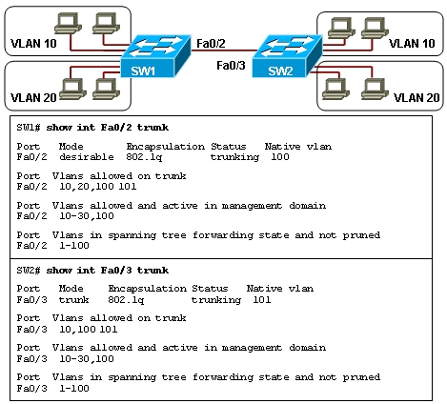
Figure no. 3

- Refer to the exhibit shown in Figure no. 3. Users on VLAN 10 and VLAN 20 on SW1 start complaining that they do not have connectivity to the users on the same VLAN on switch SW2. What should be done to remedy the problem? [3 marks]

- In a VLAN enabled network, what measures can be taken to prevent Double Tagging Attack? [3 marks]

R(config)#interface f0/1.22
R(config-subif)#encapsulation dot1q 22
R(config-subif)#ip add 192.168.10.2 255.255.255.192
R(config-subif)#interface f0/1.33
R(config-subif)#encapsulation dot1q 33
R(config-subif)#ip add 192.168.10.130 255.255.255.192
R(config-subif)#interface f0/1.45
R(config-subif)#encapsulation dot1q 44
R(config-subif)#ip add 192.168.10.66 255.255.255.192
R(config-subif)# interface f0/0
R(config-if)#no shutdown

Figure no. 4

- Refer to the exhibit shown in Figure no.4 above,
  - What type or inter VLAN routing is it?
  - Is there any problem with the configuration?
  - If the router receives a packet with the destination address of 192.168.10.70/26 and another packet with the destination address of 200.20.20.20/24, which sub-interface/s will the router use to send the packets? Explain your answer in one line. [1 mark+2 marks+4 marks]
- What is the difference between SVI and Routed Interfaces of a Layer 3 Switch? [2 marks]

Question 3

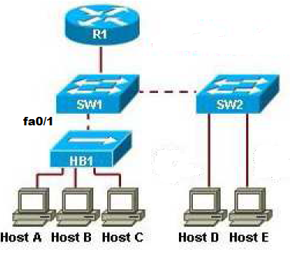
Figure no. 5

- Refer to the above Figure no. 5, how many collision domains and broadcast domains are there? Router R1 is replaced with a Layer 3 Switch and the Hub is replaced with a layer 2 switch, then how many collision domains and broadcast domains are there? [3 marks]
- When activating TELNET in a switch, what is recommended for better security? [3 marks]

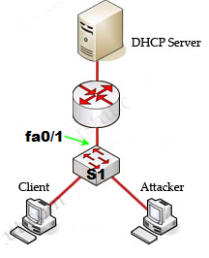
S1(config)# interface fastethernet 0/1
S1(config-if)# ip dhcp snooping trust
Figure no. 6
- Refer to Figure no. 6, what is the purpose of the commands given to the port fa0/1 of Switch S1? What will these commands prevent from happening? [3 marks]
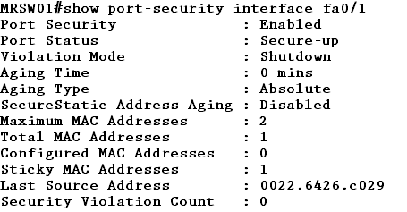
Figure 7

- Refer to output shown in Figure no. 7,
    - What is the port status?
    - A person tries to access the network using a PC with the MAC address 0001:5410:DC12 through port fa0/1. Will he be able to or not?
    - Later another person tries to access the network using a PC with the MAC address 0022:6426:c029 through port fa0/1., will he be able to? [1 marks+2 marks +3 marks]

THE END

