No. of Pages  B | 4
No. of Questions | 4

Department of Computer Science and Engineering
MIDTERM EXAMINATION SPRING 2016

CSE421: Computer Network
Total Marks: 45 Time Allowed: 55 minutes
- Answer ALL THREE (3) questions
- Figure in bracket [] next to each question indicates marks for that question

Question 1
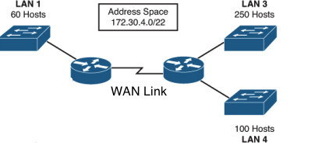
Figure no. 1

- Suppose a company is given a block 172.30.4.0/22. But you need three more sub networks for your organization and one more for the WAN Link as shown in figure no. 1. Show how you can have 4 more subnets out of the original network address as per host requirements. Do not forget to show basic calculations. [8 marks]

R1(config)#ip route 0.0.0.0 0.0.0.0 173.24.1.1
R1(config)#ip route 0.0.0.0 0.0.0.0 212.39.4.6 10

Figure no. 2
b) Refer to the above commands shown in figure no. 2, why two default static routes are being configured with two different next hop IP address in router R1? And what is this value “10”? [5 marks]

Question 2
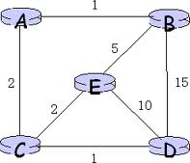
Node A Table
 | A | B | C | D | E
A | 0 | 1 | 2 | ∞ | ∞
Node B Table
 | A | B | C | D | E
B | 1 | 0 | 16 | 15 | 5
Node C Table
 | A | B | C | D | E
C | 2 | 7 | 0 | 1 | 2

Figure no. 3

- For the above figure no. 3, the tables represent the routing table of Router A,B and C initially. Router A receives updates from B and C routers. All routers are running Distance Vector algorithm. What will be the status of the routing table of Router A be after receiving the updates? (Use Dx(y) = min{c(x,y) + Dy(y), c(x,z) + Dz(y)} for explaining your answer) [7 marks]
- Differentiate the following commands “default-information originate” and “redistribute-static” in rip. [4 marks]

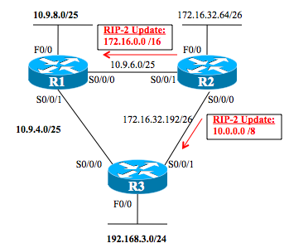
Figure no. 4

- The R2 router is sending updates as shown in figure no.4. Will these type of update create any problem? How can we solve it, if there will be a problem? [3 marks]

Question 3

Table no. 1: R1 link state database
R1 Link states:
Connected to neighbor R2 on network 192.168.4.0/24, cost 40
Connected to neighbor R3 on network 10.10.1.0/8, cost 50
Connected to neighbor R4 on network 172.16.2.0/16, cost 40
Has a loopback interface with address 212.20.20.10
Has a network on 10.10.2.0/8, cost 2

R2 Link states:
Connected to neighbor R1 on network 192.168.4.0/24, cost 40
Connected to neighbor R7 on network 202.212.0.0/24, cost 60
Has a network on 20.10.1.0/8, cost 2

R3 Link states: Router-id: 15.15.14.5
Connected to neighbor R1 on network 10.10.1.0/8, cost 50
Has a network on 20.20.1.0/8, cost 2

R4 Link states:
Connected to neighbor R1 on network 172.16.2.0/16, cost 40
Connected to neighbor R6 on network 192.168.9.0/24, cost 20
Has a network on 40.40.40.0/8, cost 2

R6 Link states:
Connected to neighbor R4 on network 192.168.9.0/24, cost 20
Connected to neighbor R7 on network 192.168.5.0/24, cost 10
Has a network on 25.25.20.0/8, cost 2

R7 Link states:
Connected to neighbor R2 on network 202.212.0.0/24, cost 60
Connected to neighbor R6 on network 192.168.5.0/24, cost 10
Has a loopback interface with address 23.23.64.7
Has a loopback interface with address 80.48.48.8
Has a network on 30.10.1.0/8, cost 2

- Refer to the figure no. above, determine the router-ids for R1, R2, R3, and R4. Is there a need for DR and BDR? If so, which of these routers will be DR and BDR? [2+2+4 marks]
- Why do you think loopback interface has priority over active physical interface during router ID selection process? [3 marks]

THE END

