No. of Pages | 5
No. of Questions | 8

Department of Computer Science and Engineering
FINAL EXAMINATION SUMMER 2012

CSE421/EEE465: Computer Networks
Total Marks: 90 Time Allowed: 3 Hours

- Answer Any Six (6) questions out of Eight (8) questions.
- Figure in bracket [] next to each question indicates marks for that question.

Question No. 1

- HTTP1.1 uses persistent connection without pipelining. So when a user requests a Web page that consists of some text and three images; draw the interactions between the server and client. Let RTT denote the round trip time between the user and the server containing the objects. [4 marks]
- In HTTP, proxy web servers are a great help. How? [3 marks]
- Why do we need MIME during send and receiving emails? Do we need it when we use web-based mails? [4 marks]
- BiTTorrent is a hybrid P2P application, true or false. Explain your answer. [4 marks]

Question No. 2

- Suppose a company is given a block 200.20.20.128/25. [9 marks]

The company needs to distribute these addresses to three branches as follows:
- The first branch needs 55 addresses
- The second branch needs 28 addresses
- The third branch needs 10 addresses
Create subnets as per requirements and show calculations.
- What are Stub AS and Multihome AS? [3 marks]
- What is Hot Potato Routing? Explain using the figure no. 1 shown below. [3 marks]

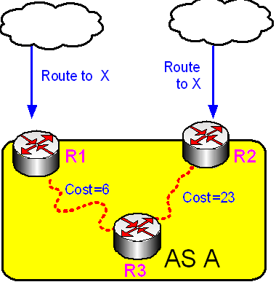
Figure No. 1

Question No. 3

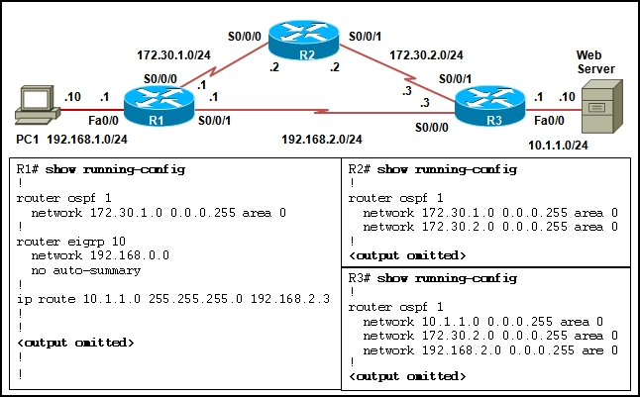
Figure No. 2

- Refer to the figure no. 2 shown above. Which route will be installed in the routing table on R1 to forward traffic from PC1 to the web server and why? [4 marks]
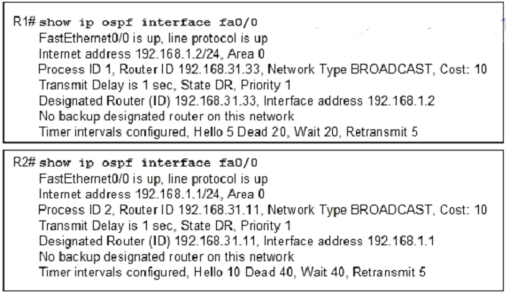
Figure No. 3
- Refer to the output shown in figure no.3, Routers R1 and R2 are directly connected through a FastEthernet link but cannot form a neighbor adjacency. What could resolve the problem? [3 marks]
- Referring to the same figure no. 3 above the router ID and the interface address is not the same, why? [3 marks]
- OSPF has three tables, what are they? [2.5 marks]
- What is the function of the OSPF LSU packet? [2.5 marks]

Question No. 4

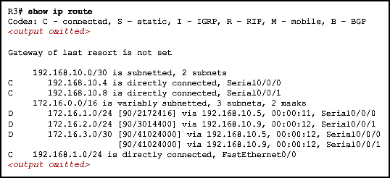
Figure No. 4

- Refer to the exhibit shown in figure no. 4. Router R3 is using which routing protocol? And why are there two entries for the destination network 172.16.3.0/30? What is the value “41024000” for and how was it calculated? [5 marks]
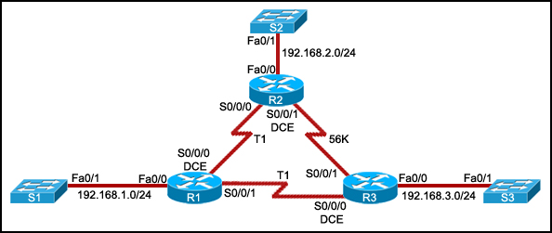
Figure No. 5

- Refer to figure no. 5 above, router R2 uses RIPv2 routing protocol? To send packets to R3 it uses the 56kbps line even though it is a slower than the combined link of two T1 links. Explain. [3 marks]
- Compare EIGRP routing protocol with RIPv2 routing protocol. [3 marks]
- For discontiguous networks, if routers are using RIPv2, then auto summary must be disabled, explain using the network shown in figure no.6 below. [4 marks]

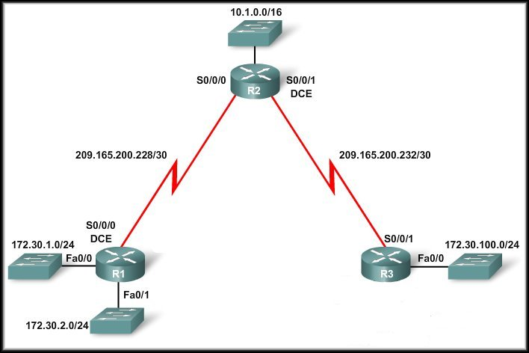
Figure No. 6

Question No. 5

- In TCP transmission, when a segment is lost, what happens next? Mention all possible courses of actions. [4 marks]
- A good acknowledgement policy means sending acknowledgement for each packet. Tue or false. Explain your answer. Is it open loop or closed loop? [4 marks]
- In TCP congestion control, what is the purpose of “ssthresh” variable? [3 marks]
- After timeout, always slow start occurs, why? What happens to the window size? [4 marks]

Question No. 6

- TTL helps reduce congestion, how? [3 marks]

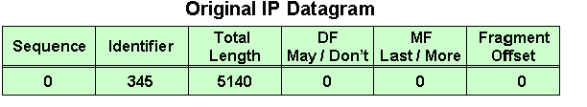
Figure No. 7

- What happens to the IP datagram shown above in figure no. 7, reaches a router that can send only 1500 bytes size packets? Create a table to show, given separately. [5 marks]
- How does Traceroute help in troubleshooting? How does the Traceroute application work? [4 marks]

Reply from 127.0.0.0: bytes=32 time<1ms TTL=128
Reply from 127.0.0.0: bytes=32 time<1ms TTL=128
Reply from 127.0.0.0: bytes=32 time<1ms TTL=128
Reply from 127.0.0.0: bytes=32 time<1ms TTL=128
Figure No. 8

- The output shown above in figure no. 8 was received from which application and which protocol? What is so special about it? [3 marks]

Question No. 7

- What is the purpose of beacon frames? What does it contain? [3 marks]
- Differentiate between Active and Passive scanning in a wireless network? [4 marks]
- What are a permanent address and a care of address in Mobile IP? [3 marks]
- In Indirect routing for mobile IP, a triangle routing occurs, what does it mean? Explain using the figure no. 9 below. Host B is trying to communicate with host A. [5 marks]
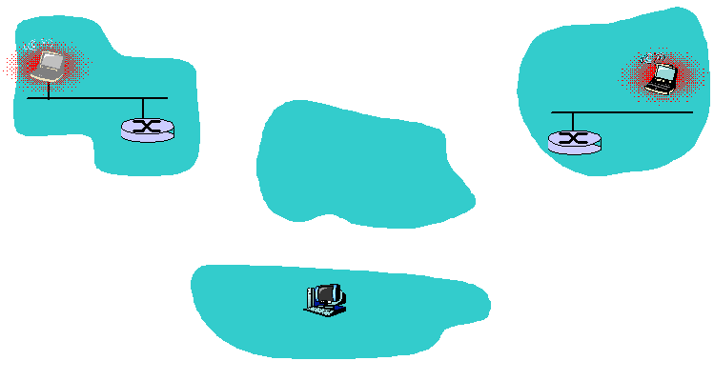
Host A
Host B
Host A
Home Network
Visiting Network
Figure no. 9

Question No. 8

- Differentiate between IPv4 and IPv6. [4 marks]
- ::FFFF/96, is an special IPv6 address, where is it being used? [3 marks]
- How does the flow label header of an IPv6 help an application sending packets? [4 marks]
- What happens in the “Tunneling process”? Is there an additional burden on routers? [4 marks]

THE END

