No. of Pages | 6
No. of Questions | 7

Department of Computer Science and Engineering
FINAL EXAMINATION FALL 2011

CSE490: LAN Switching and WAN Technologies
Total Marks:75 Time Allowed: 3 Hours

- Answer any FIVE (5) questions out of the given SEVEN(7) questions.
- Figure in bracket [] next to each question indicates marks for that question.

Question No. 1
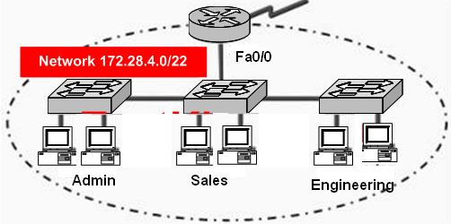
Figure No. 1
- In the network shown in figure no. 1, administrators have recently become concerned that excessive broadcasts are slowing network performance. Which change is most likely to reduce broadcast traffic on the corporate LAN? [3 marks]
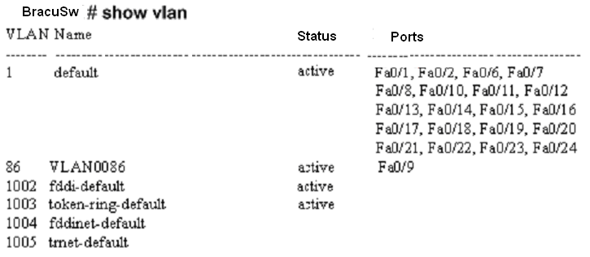
Figure No. 2
- Please study the output shown above in figure no. 2. The Bracu switch that generated this output has 24 ports. Why are some of the ports missing from VLAN1? State the purpose of those ports. [3 marks]
- Referring to the above output in figure no.2, why are most of the ports associated with VLAN 1? How can you change the associate ports to another VLAN? [3 marks]
- What is the purpose of Dynamic Trunking Protocol? Two switches are connected. If both ends of the link are ports in dynamic desirable mode, will the link be a trunk or not? [3 marks]
- What is the effect of the following two sets of commands: [3 marks]
SET 1:
SW1(config)#int fa0/12
SW1(config-if)#no switchport access vlan
SW1(config-if)#end

SET 2:
SW1(config)#no vlan 7
SW1(config)#exit

Question No. 2

- How often does a switch send out summary advertisements? Which type of VTP advertisement contains detail information about VLANs? [3 marks]
- A client and a transparent switch receives a summary advertisement with a lower configuration revision number than their own. What do they do? [3 marks]
- Is a transparent switch able to obtain VLAN information when it reboots? [1.5 marks]

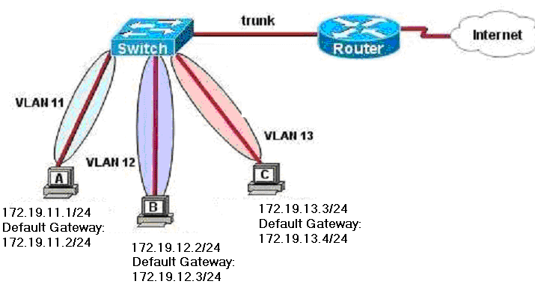
Figure No. 3

- For the above network shown in figure no.3, what commands are required at the router for the different VLANs to communicate? Does the router require a routing protocol? [4.5 marks]
- What are the common problems associated with Inter VLAN routing? [3 marks]

Question No. 3

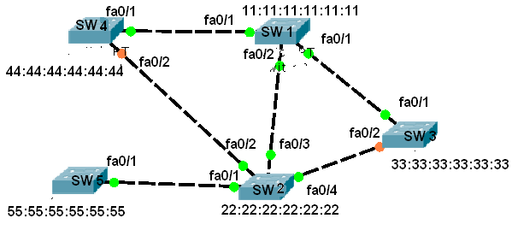
Figure No. 4

- For the above switched network shown in figure no. 4, apply spanning tree protocol and detect the root bridge, root ports and block ports. Give your reason for choosing the root bridge and block ports. [5 marks]
- Why do we have to enable STP in switches to prevent looping but not in routers? [3 marks]
- What is the difference between port priority and bridge priority? [4 marks]
- What are BPDUs? Are they exchanged after STP has converged? [3 marks]

Question No. 4

- The order of the ACL statements in an ACL list is very important, why? [3 marks]
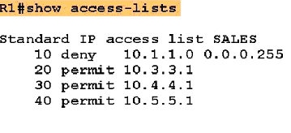
Figure No. 5
- What kind of ACL is shown in the above output in figure no. 5 ? How do the numbers 10,20,30 etc help us in editing? [3 marks]
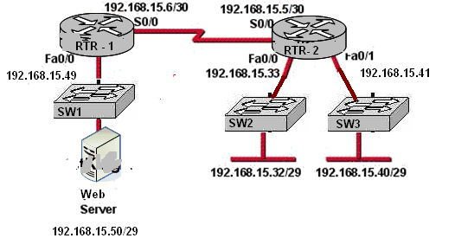
Figure No. 6

- Refer to the figure no. 6 above; write a named extended ACL to block all kinds of traffic from the 192.168.15.40/29 network from accessing the web server. But 192.168.15.32/29 network is allowed only to have web access to the webserver. And only web responses from the webserver shown should be allowed back to the 192.168.15.32/29 network. Don’t forget to apply the ACL. [4.5 marks]
- Refer to the figure no. 6 above; you are to allow telnet to the RTR-2 router only from 192.168.15.32/29 network. Do it first using a standard ACL. Then use a separate extended ACL. They can be numbered or named. [4.5 marks]

Question No. 5

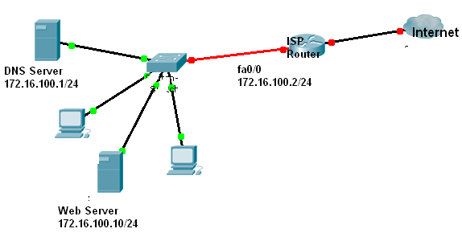
Figure No. 7
ISP(config)# ip dhcp pool ISP1
ISP(dhcp-config)# network 172.16.100.0 255.255.255.0
ISP(dhcp-config)#default-router 172.16.100.2
ISP(dhcp-config)# dns-sever 172.16.100.1

- Study the above exhibit in figure no. 7 carefully. The network administrator has set the dhcp process in the ISP router, but the network PCs are showing conflicting addresses. Can you troubleshoot and solve it? [3 marks]
- You are required to perform configurations to your organization’s (Info.com) router to enable internet access. The ISP has given you 15 public IP addresses starting from 177.20.20.193/28. Info.com has 2 sub-networks that need to have simultaneous internet access. These 2 sub-networks are 192.168.20.0/24 and 192.168.30.0/24.Write the necessary commands to enable NAT at the Info.com router. [6 marks]
- Which of the following IP addresses are private and public:

  - 10.1.2.1
  - 192.186.10.1
  - 172.4.1.2
  - 152.10.2.2
  - 172.33.1.2
  - 192.168.12.33

[3 marks]
- You have allowed all devices in your network to acquire IP addresses via DHCP. But it is not recommended, why? [3 marks]

Question No. 6

- When would a network administrator prefer using PPP over HDLC? [2 marks]
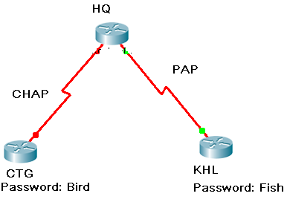
Figure No. 8
- In the figure no. 8 shown above, HQ router has PPP connections with both CTG router and KHL router. HQ does CHAP authentication with CTG and PAP with KHL router. The passwords maintained for CTG and KHL routers are shown as above. What commands will be needed on the router HQ for the authentication to work (assume commands are properly set at the CTG and KHL routers for authentication)? [4 marks]
- Referring to the same figure no. 8 above, can HQ use the password “Fish” for authentication with CTG? [3 marks]
- Alongside authentication LCP also negotiates for other parameters for a PPP link? What are they? [3 marks]
- A technician is testing the functionality of two recently installed routers. The technician is unable to ping the serial interfaces of the two routers. The technician executes the show interface serial command on the local router, bracu and receives the output below in figure no. 9. What are the probable problems and solutions? [ 3 marks]
Figure No. 9

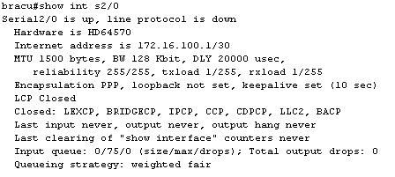
Figure No. 9

Question No. 7

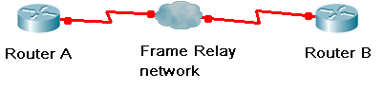
RouterA(config)#int s0/0
RouterA(config-if)#encapsulation frame-relay
RouterA(config-if)#ip address 172.16.20.1 255.255.255.0
RouterA(config-if)#frame-relay lmi-type ansi

Figure No. 10

- For figure no.10, what is the purpose of the 4th command? What are the functions of LMIs? And will the 4th command have an impact on Router B? [4 marks]

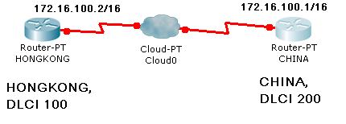
HONGKONG# show running-config
<some output text omitted>

interface serial0/0
bandwidth 64
ip address 172.16.100.2 255.255.0.0
encapsulation frame-relay
frame-relay map ip 172.16.100.1 100 broadcast

Figure No. 11

- The Router Hong Kong is connected to the router China via a new Frame Relay link shown in figure no.. However, Hong Kong is unable to communicate with China. Based on the above output shown in figure no. 11, what do you suspect as the underlying cause? What are the two ways that frame relay can be done? [4 marks]
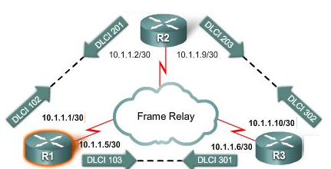
Figure No. 12

- R1, R2 and R3 routers are connected via a frame-relay switched network. R2 is the hub and R1 and R3 are the spokes. R1 router has no information of the networks belonging to R3 router. Why and what is the solution? Explain. [5 marks]
- How does the “DE” bit in Frame Relay help reduce congestion in a frame relay switch? [2 marks]

THE END

