No. of Pages | 3
No. of Questions | 4

Department of Computer Science and Engineering
MIDTERM EXAMINATION SPRING 2011

CSE490: LAN Switching and WAN Technologies
Total Marks: 60 Time Allowed: 70 minutes

- Answer ALL Four (4) questions.
- Figure in bracket [] next to each question indicates marks for that question.

Question No. 1

  - What is required in a switch before you can telnet to it from a remote location? [2 marks]
- Differentiate between Cut Through switching and Store and Forward switching? [3 marks]
SW1(config)#int fa 0/13
SW1(config-if)#switchport mode access
SW1(config-if)#switchport port-security
SW1(config-if)# switchport port-security maximum 5
SW1(config-if)# switchport port-security violation restrict
SW1(config-if)#end

Figure No. 1

The commands in figure no. 1, were issued in a switch, what do they imply? [3 marks]
- Why do network administrators recommend that you disable CDP? [3 marks]
- When do having trusted ports in switches help us? [4 marks]

Question No. 2
Figure No. 2
- A network administrator asked an assistant to remove several VLANs from a switch. When the assistant entered in the no vlan 1 command an error was received. What was the cause of the error? [2 marks]

SW1(config-if)#switchport trunk native vlan 90
SW1(config-if)#switchport trunk allowed vlan add 99,100,101

Figure No. 2

- Explain the above commands shown in figure no. 2. What difference will it make if the second command is not given? [3 marks]
- What is the difference between a voice vlan and a data vlan? [2 marks]
R(config)#interface f0/0.4
R(config-subif)#encapsulation dot1q 40
R(config-subif)#ip add 192.168.10.225 255.255.255.224
R(config-subif)#interface f0/0.5
R(config-subif)#encapsulation dot1q 50
R(config-subif)#ip add 192.168.10.193 255.255.255.224
R(config-subif)# interface f0/0
R(config-if)#no shutdown

Figure No. 3

- Explain the purpose of the “encapsulation dot1q 40” command shown in figure 3. The router receives a frame on physical interface f0/0. The destination IP address is 192.168.10.222/27. What will the router do? [4 marks]
- What is the purpose of DTP? How can the command “switchport mode dynamic auto” cause a problem in a switched network? [4 marks]

Question No. 3

- What steps should a network administrator go through before adding an old switch to an existing network? [3 marks]
- Differentiate between VTP Transparent mode and VTP Server mode. [3 marks]
- What happens when a client switch receives a summary advertisement with a higher configuration number than its own, explain? [4 marks]
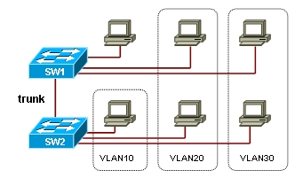
Figure No. 4
- Referring to the figure no. 4 above, VTP was enabled for the network. But is there anything else that can help to make the network more efficient? Explain briefly. [3 marks]
- How can we check whether the domains of all switches shown in figure no. 4 are the same? What happens if they are not? [2 marks]

Question No. 4

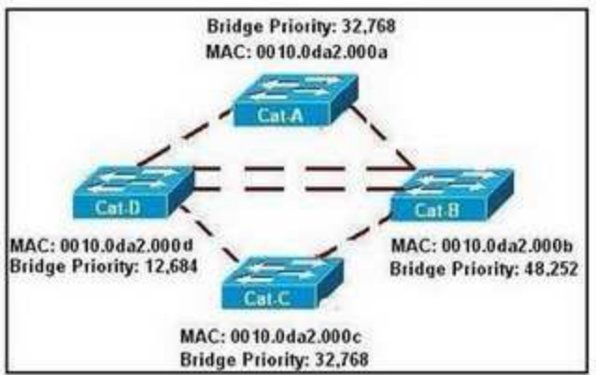
Figure No. 5

- Refer to figure no. 5. Which switch will be elected as the root bridge of the spanning tree topology? Give your reasons why [3 marks]
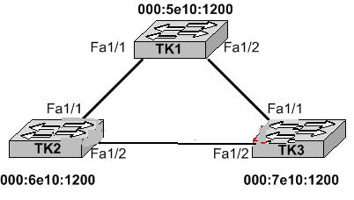
Figure No. 6
- Refer to the figure no. 6 above; all switches have the default STP configuration. Which port on which switch will Spanning Tree place in blocking mode? What are the other port states available and how long do the ports stay in those states? [4 marks]
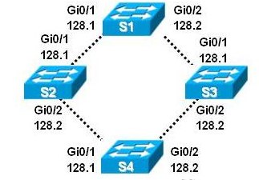
Figure No. 7
- Referring to the figure no. 7 above, what does the value 128.1 and 128.2 refer to? When is it used? [4 marks]
- If STP is disabled, state the associated problems that a network might face? Explain one briefly. [4 marks]

THE END

