No. of Pages | 4
No. of Questions | 4

Department of Computer Science and Engineering
MIDTERM EXAMINATION SUMMER 2012

CSE490/EEE453: LAN Switching AND WAN Technologies
Total Marks:60 Time Allowed: 70 minutes

- Answer ALL FOUR (4) questions.
- Figure in bracket [] next to each question indicates marks for that question.

Question No. 1

- The global configuration command ip default-gateway 172.16.100.1 is applied to a switch. What is the effect of this command? [3 marks]
- How does enabling port security help prevent MAC address flooding? [4 marks]
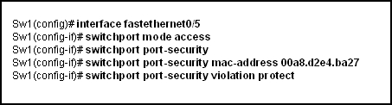
Figure No. 1

- Refer to the figure no.1 above. What happens when a frame from a source MAC address different from 00a8.d2e4.ba27 reaches switch port 0/5? [4 marks]
line vty 0 10
password 7 030752180500
login
transport input ssh

Figure No. 2

- The following output shown in figure no. 2 was taken from a configuration file of a switch. What happens when somebody telnets to that switch? How many simultaneous telnet connections can be made? [4 marks]

Question No. 2

- Which configuration changes will increment the configuration revision number on the VTP server? What should you do to an old switch before plugging it to a new switched network?
[4 marks]
- Refer to the exhibit shown in figure no. 3. Users complain that they do not have connectivity to the web server that is connected to SW1. What should be done to remedy the problem? [3 marks]

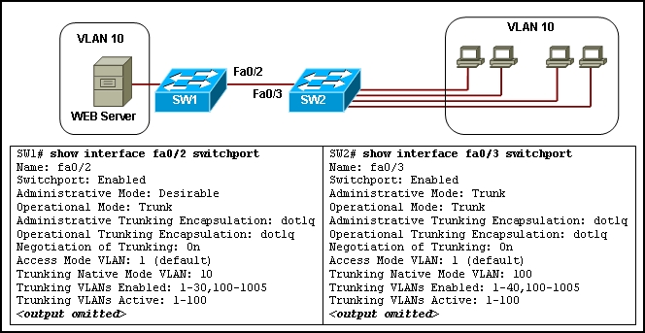
Figure No. 3

- Refer to the same diagram, a network administrator gave the following commands to SW2
SW2(config)# interface fa0/3 switchport
SW2(config-if)# switchport mode dynamic desirable
What will be the effect of these commands? [3 marks]

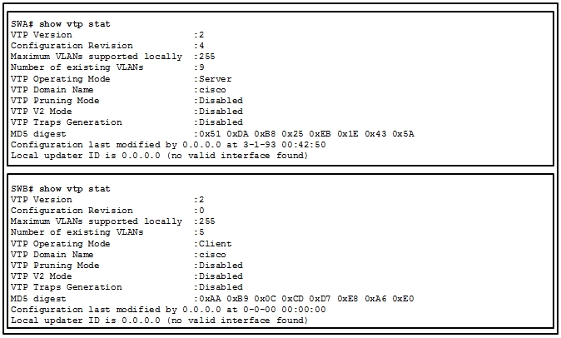
Figure No. 4

- Refer to the figure no. 4 above; Switch SWB is not responding to VTP updates from switch SWA. What is a possible cause of the problem? (Hint: Problem not visible from the output). After the problem is solved Switch SWA sends a summary advertisement to Switch SWB, what is the sequence of events? Mention the advertisements sent. [5 marks]

Question No. 3

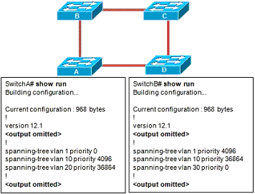 | 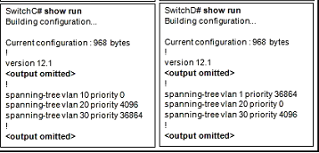
Figure No. 8

- Refer to the above switched network shown in figure no.8, each switch is configured to participate in STP for VLANs 1, 10, 20, and 30. Which switch will become the root for VLAN 10 and why? . [4 marks]
- All switches do not have root ports, true or false? Explain your answer. [3 marks]
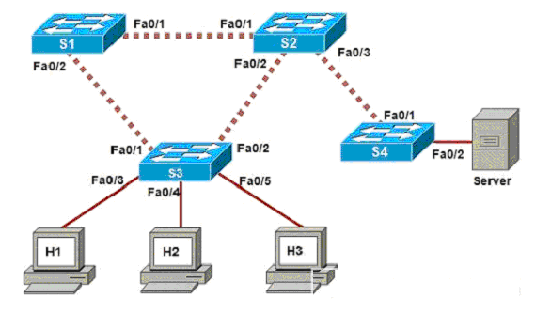
Figure No. 9

- If RSTP is running in the above switched network shown in figure no. , identify the edge ports and non edge ports. Name the states that the ports will go through due to RSTP. [5 marks]
- When is the port priority and bridge priority values of a switch used? [3 marks]

Question No. 4

- What is tagged traffic and untagged traffic? How does a switch handle these traffics? [4 marks]
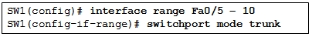
Figure No. 5

- How do the commands shown above in figure no.5 help during configuring a switch? [3 marks]
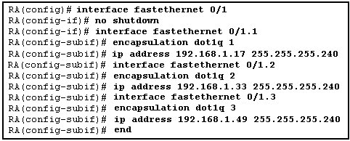
Figure No. 6
- Refer to the exhibit shown above in figure no.6. A new host needs to be connected to VLAN 2. Suggest an IP address that can be assigned to this new host? [4 marks]
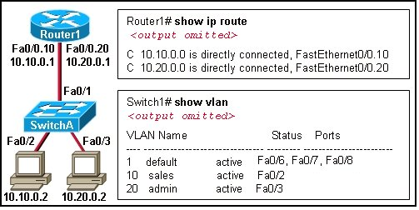
Figure No. 7

- Refer to the exhibit shown below in figure no.7. A network administrator has segmented the network into two VLANs and configured Router1 for inter-VLAN routing. If a new VLAN 30 (Guest) is to be configured for the network diagram shown below in figure no. 7, what steps should the network administrator follow for VLAN 30 to be operational. [4 marks]

THE END

