No. of Pages | 3
No. of Questions | 4

Department of Computer Science and Engineering
FINAL EXAMINATION FALL 2011

CSE490: WAN Routing and Technologies
Total Marks:60 Time Allowed: 70 minutes

- Answer ALL FOUR (4) questions.
- Figure in bracket [] next to each question indicates marks for that question.

Question No. 1

- What factors would you take into account when choosing between a layer 3 switch and a router? [4 marks]
- Which switch interface(s) should be configured with an IP address, and do you need a different IP address for each interface? [3 marks]
SW1(config)#int fa 0/13
SW1(config-if)#switchport mode access
SW1(config-if)#switchport port-security
SW1(config-if)# switchport port-security maximum 4
SW1(config-if)# switchport port-security mac-address sticky

Figure No. 1

- Explain the commands in the above figure no.1. What happens when a fifth PC is attached to this port? [4 marks]
- Compare between Store and Forward switching and Cut Through switching. [4 marks]

Question No. 2

- What is the purpose of DTP? What happens if the DTP mode of both the switches shown below in figure no. 2 is “Dynamic Auto”? [3 marks]

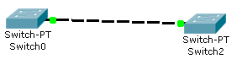
Figure No. 2

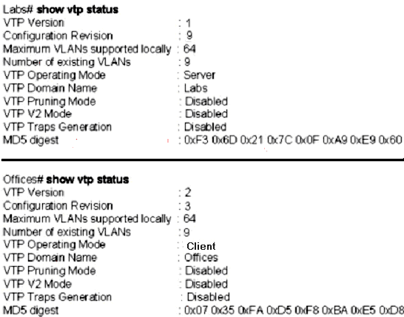
Figure No. 3

- Refer to the figure no. 3 above; the network administrator has configured the switches to use VTP. But the switches are not sharing VLAN information. Can you detect the problem/s? [4 marks]

Refer to the same figure no. 3 above, problems have been solved. Now what happens when Switch “Offices” receives a summary advertisement from Switch “Labs”? [4 marks]

- Differentiate between a Server switch and a Transparent switch. [4 marks]

Question No. 3

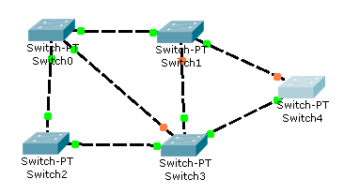
Figure No. 4

- Refer to the above switched network shown in figure no.4, after running STP indicate Switch 2 is chosen as the root bridge, Switch 1 has two same cost paths to the root. How does it decide to choose its root port? . [4 marks]
- How is the root bridge chosen if all the switches have the default priority? If the default priority of a switch is 32768, why may the priority be shown as 32769? [3 marks]
- If STP is disabled, broadcast storm might occur, how? [4 marks]
- When STP is enabled, convergence takes time due to the different states that the ports go through. What are they and how much time? What can we do to allow ports connecting PCs to not go through these different port states? [4 marks]

Question No. 4

- What is the effect of the commands shown in figure no. 5? [3 marks]
SW1(config)#no vlan 7
SW1(config)#exit

Figure No. 5

- What does a switch port on a trunk link do if it receives a frame without a tag? [3 marks]
- How is a voice VLAN different from the Data VLAN? [2 marks]
- A router was configured for intervlan routing as shown below in figure no.6. But pings to the subinterfaces are not working. Can you predict the problem? [3 marks]
R1(config-subif)#ip address 172.17.2.99 255.255.255.224
R1(config)#int f0/0.1
R1(config-subif)#encapsulation dot1q 10
R1(config-subif)#ip address 172.17.2.33 255.255.255.224
R1(config-subif)#end
R1(config)#int f0/0.2
R1(config-subif)#encapsulation dot1q 20
R1(config-subif)#ip address 172.17.2.66 255.255.255.224
R1(config-subif)#end
R1(config)#int f0/0.3
R1(config-subif)#encapsulation dot1q 30
R1(config-subif)#ip address 172.17.2.99 255.255.255.224
R1(config-subif)#end
R1(config)#int f0/0
R1(config-if)#shutdown
R1(config-subif)#end

R1(config-subif)#end
R1(config)#int f0/0
R1(config-if)#shutdown
R1(config-if)#end

\\

Figure No. 6

- Using the same configuration commands in figure no.6, what happens to a packet having the destination IP address of 172.17.2.93/27? [4 marks]

THE END

