No. of Pages | 4
No. of Questions | 5

Department of Computer Science and Engineering
MIDTERM EXAMINATION SUMMER 2012

CSE421: Computer Network
Total Marks: 60 Time Allowed: 70 minutes
- Answer ALL FIVE (5) questions
- Figure in bracket [] next to each question indicates marks for that question

Question No. 1

- A switch maintains a table to forward frames as shown below in figure no. 1. This switch remains inactive for 65 minutes. Then a ping is sent from 0040.0b78.3dcd MAC to 00do.bab1.b36a MAC. What will the switch do and why? [4 marks]

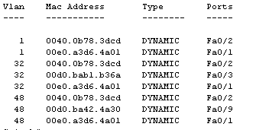
Figure no. 1

- We are sending a packet to a different network through a router. An ARP is a broadcast packet, and routers do not forward broadcast packets. So in this case what happens to the ARP process? [4 marks]
- Where is the error checking method “checksum” used? What are steps that a sender has to follow to maintain checksum method? [4 marks]
Question 2

- Distance vector routing protocol sends periodic updates but Link state does not, what is the effect of this? [3 marks]

- A router has a RIP route to 100.18.20.0 in its routing table, with metric 4 hops. It receives information that the route is down, and it starts its holddown timer. It receives another update from another router that it is 4 hops away, what will it do? What if it receives no updates even after 240 seconds? [4 marks]

- Referring to the diagram and output shown in figure no. 2 and figure no. 3, why does router R2 have two equal costs paths to 172.16.0.0 network? Diagram or topology shows otherwise. [5 marks]

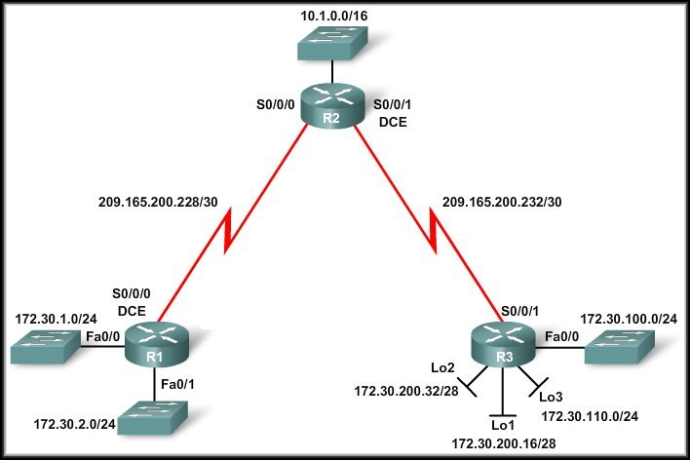
Figure no. 2

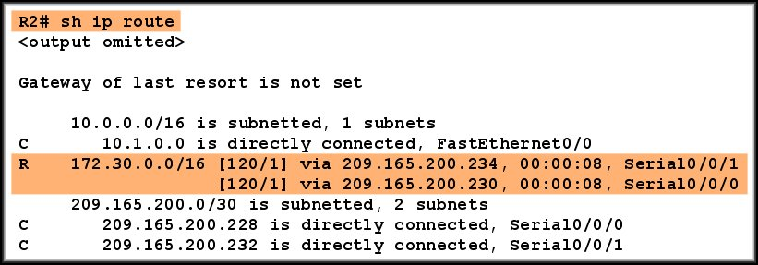
Figure no. 3

Question 3
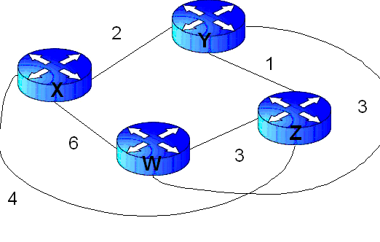
Figure no. 4

- Link state routing protocol uses Dijkstra’s algorithm. Now using Dijkstra’s algorithm, compute the shortest path from X to all other remote networks shown in Figure no.4. Use the table provided. [ 6 marks]
- What criteria are used to choose a DR and BDR? What should you do to the configuration of a router that you want to win the election for DR on a multi-access network? [3 marks]
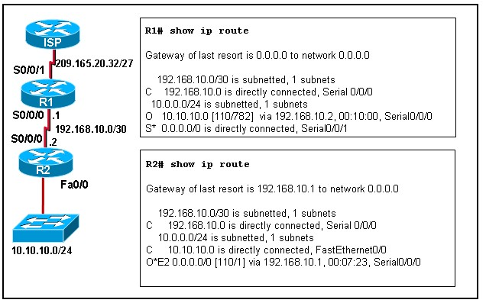
Figure no. 5
- What type of route is this O*E2 route? How did R2 learn about this route? [3 marks]

Question 4

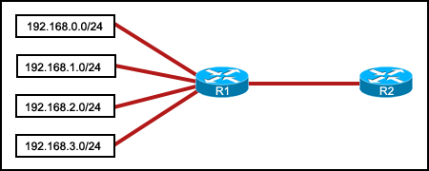
Figure no. 6

- Refer to the exhibit. Which summarization should R1 use to advertise its networks to R2? Show your calculations. [8 marks]
- In which conditions would we use the passive interface commands? [4 marks]

Question 5

- What does an EIGRP router assume if it continues to receive hello packets from a neighbor? And what if it does not? [4 marks]
- What is the advantage of EIGRP storing feasible successor routes as well as successor routes? [3 marks]
- A router running EIGRP finds 3 routes to the destination network 200.20.20.0.
Route X has FD 4123567 and RD 3011840
Route Y has FD 3678455 and RD 3045600
Route Z has FD 2965430 and RD 40680
Which route/s will become the successor and feasible successor/s? Explain your answer. How are these values FD and RD calculated? [5 marks]

THE END

