Maaz Malik Z23385841 HW 6

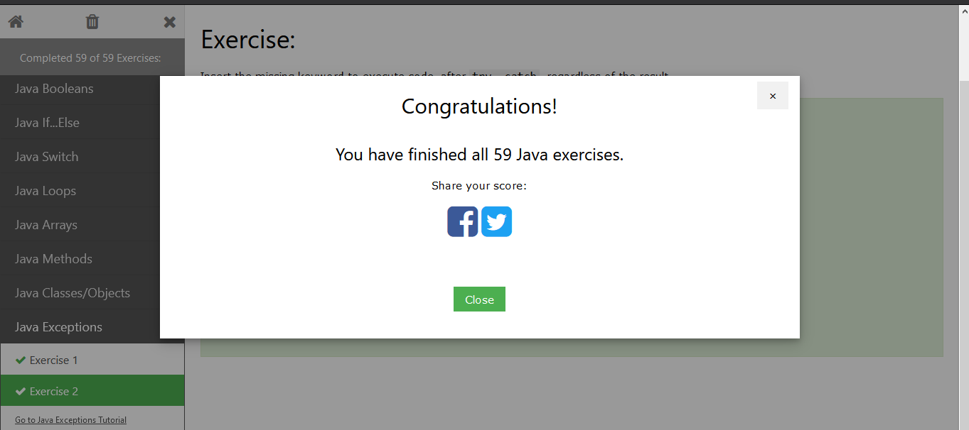

I completed all 59 and I will show them each below. I have also Learned just how important Case sensitivity is in Java cause that was one big mistake I kept making.

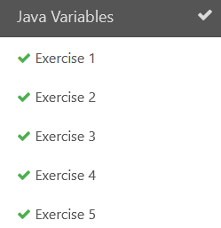­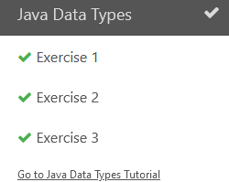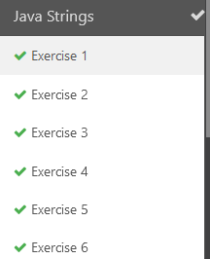

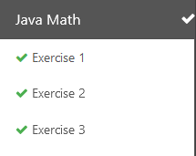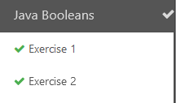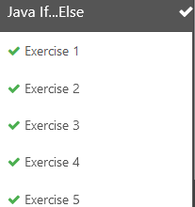

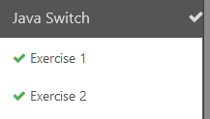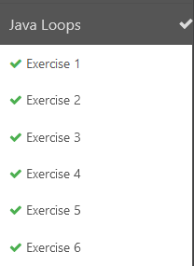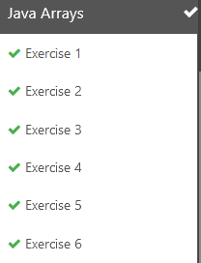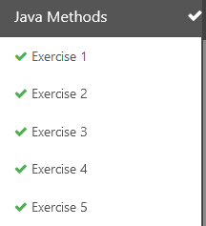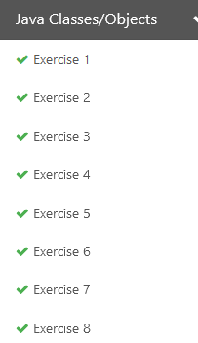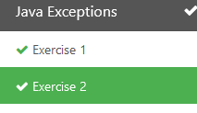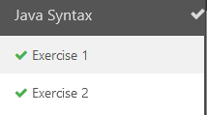

Part 2

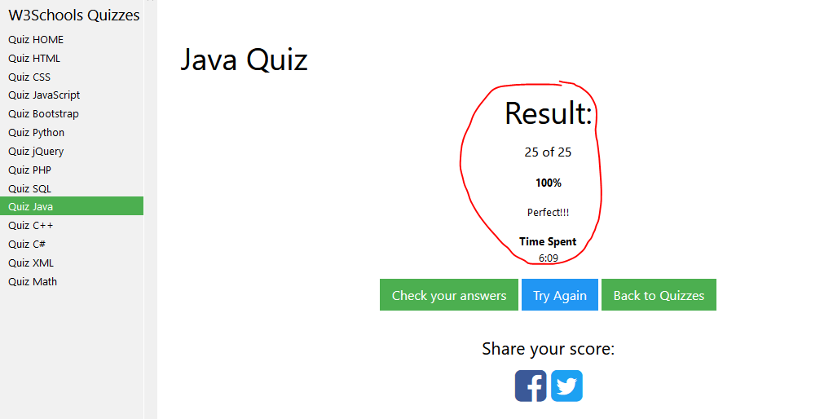

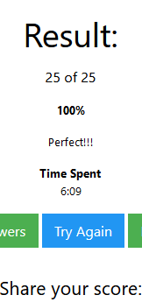 I completed the quiz after 2 trys and got a %100

Part 3

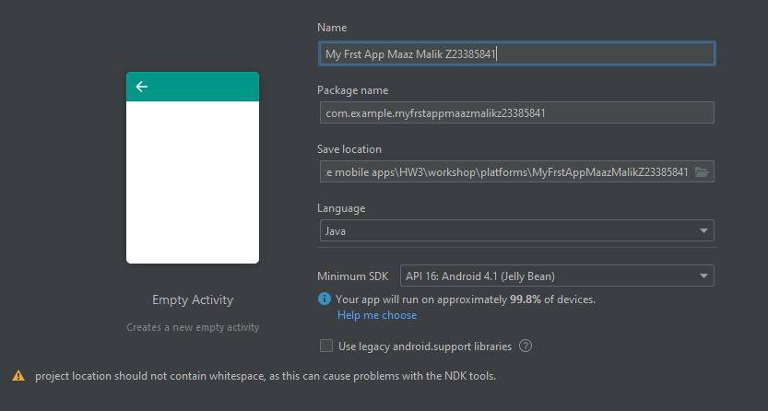

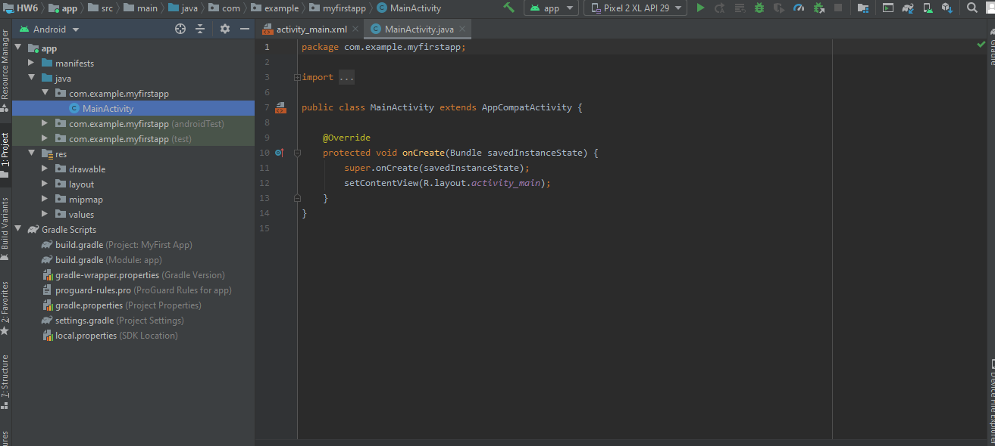

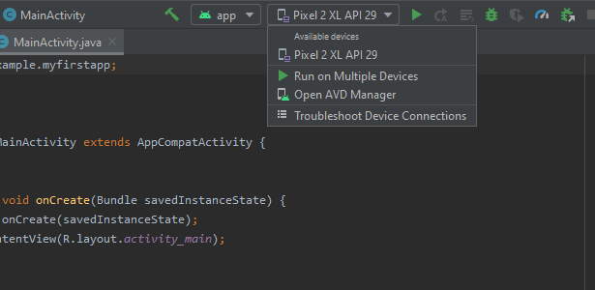

So one Issue I ran into was that My Emulator kept freezing My computer every time I ran the My First Project. I had to go into the AVG manager and tried cold Booting it.

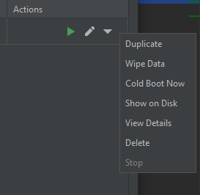

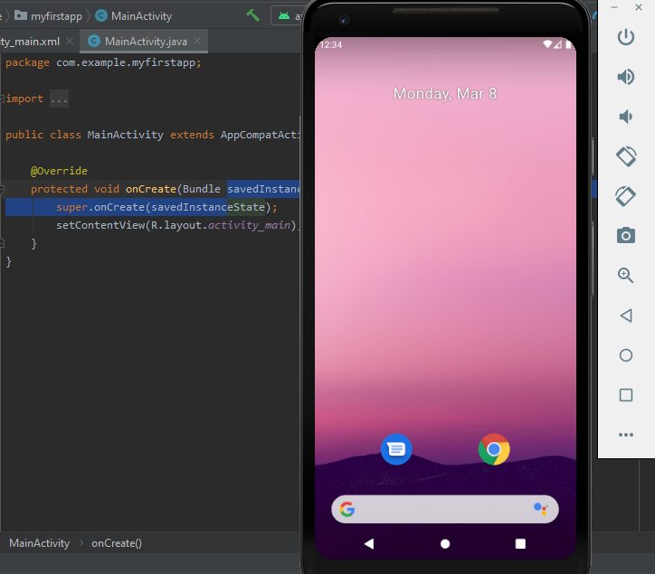

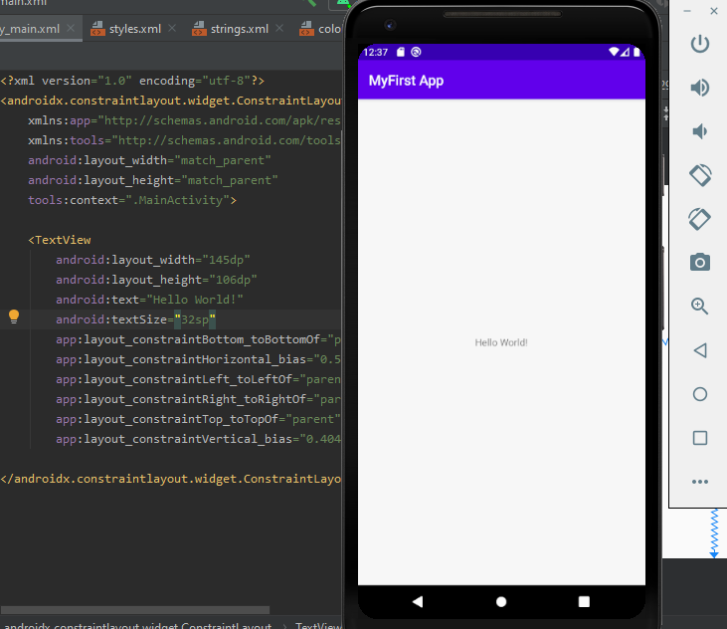

Successful Boot to The Emulator. It took A little while longer than it should have but a successful boot to the Emulator.

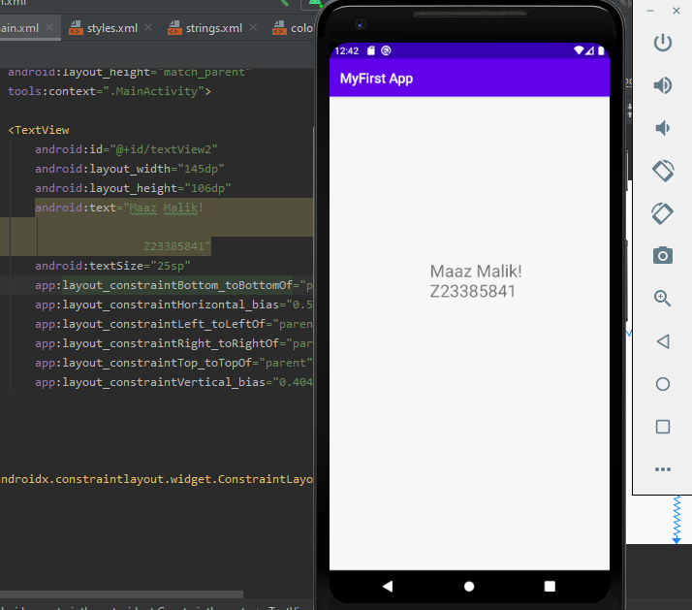

I changed the Text Size and Proceeded to Add my Name and Z number. I also ran into an issue that required me to reinstall and relaunch the app.

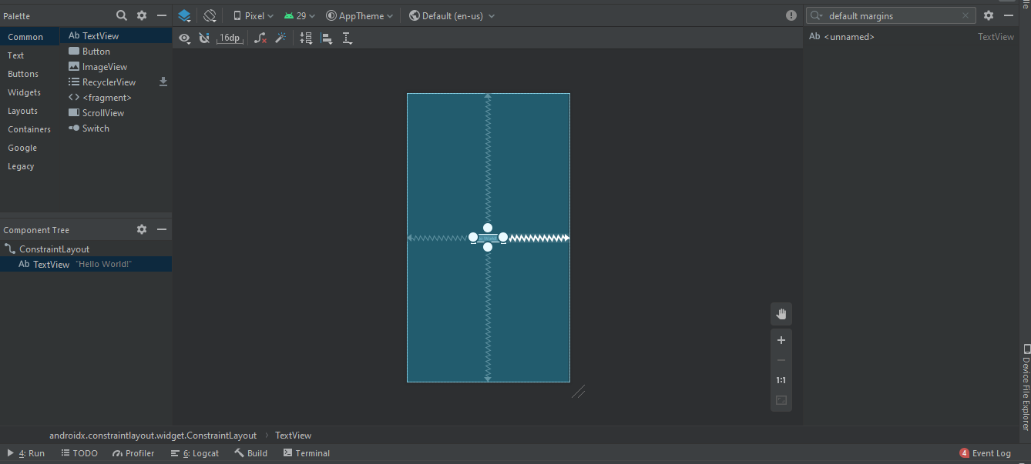

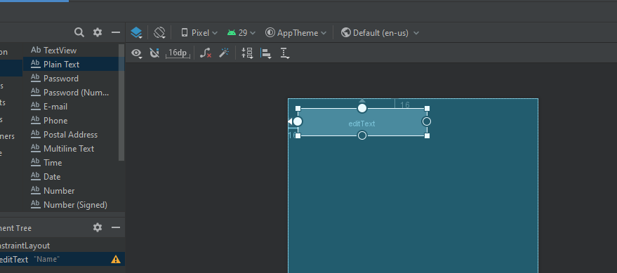

Added the Text box with Constraints.

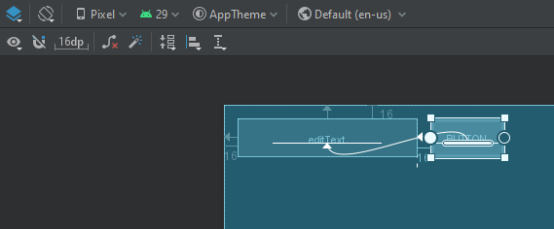

Added the Button and attached all constraints.

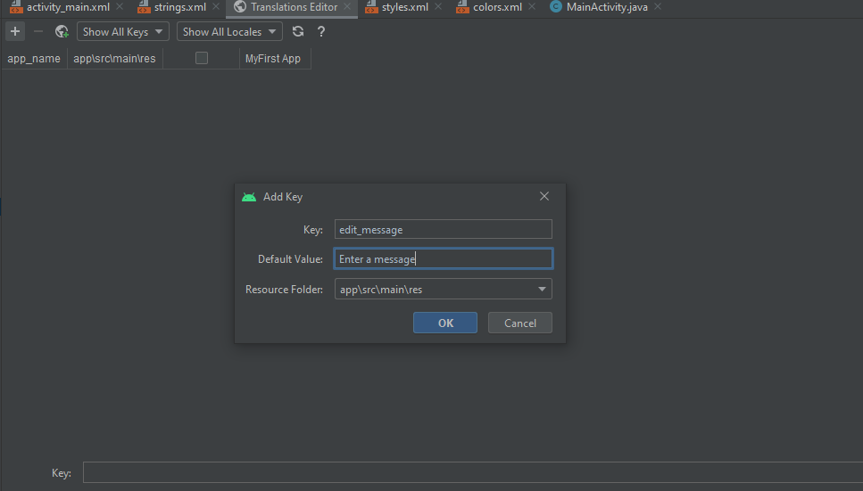

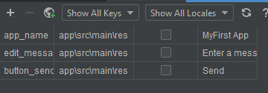

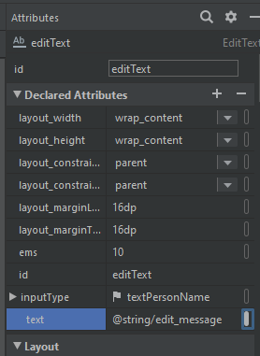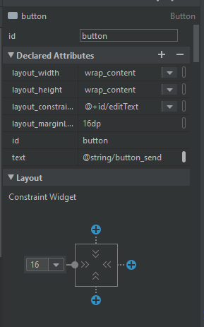

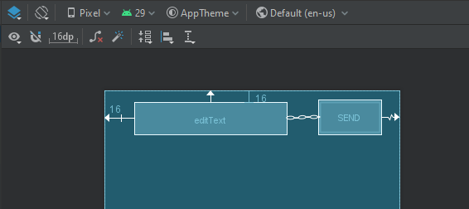

And then Adding horizontal Chain to the Constraints.

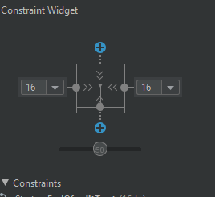 Then added constraints for the button using Constraint widget.

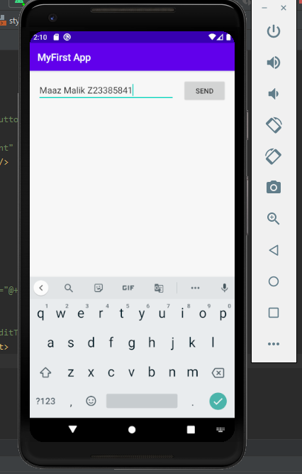 And voila, ran and added my name to The Text box to show it’s working.

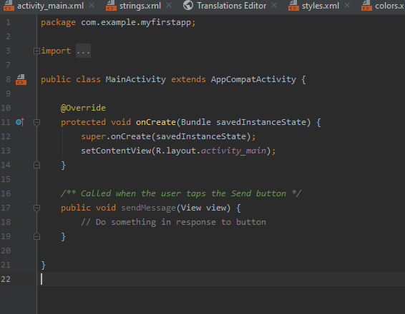

Imported class in Main Java.

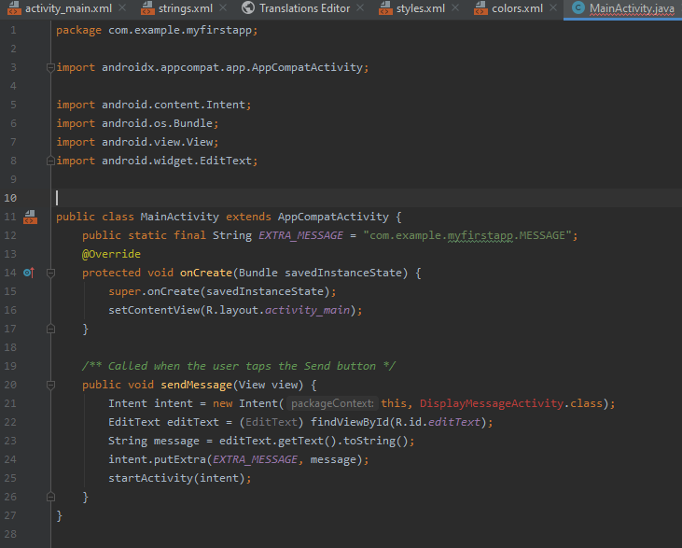

Readjusted activity main and DisplayMessage activity still shows error which is normal.

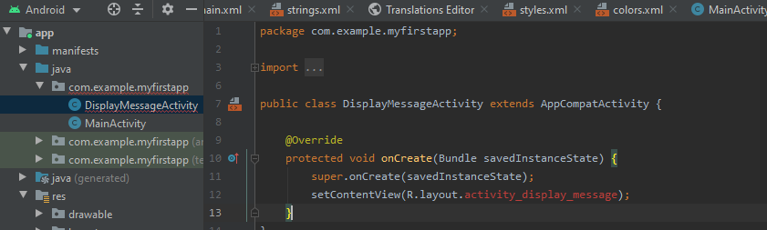

Created the Display Message Activity.

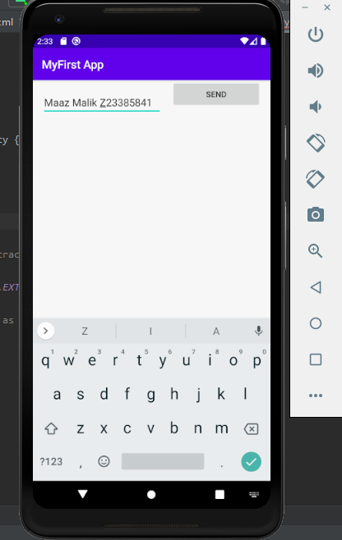

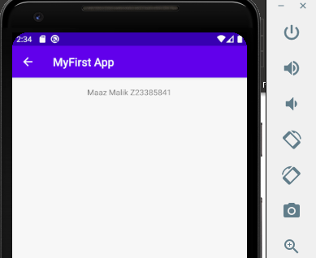

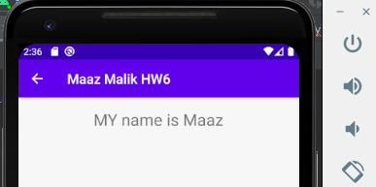

After Successful Launch I went Back and changed some Settings as well as readjusted the Sizing of the output text.

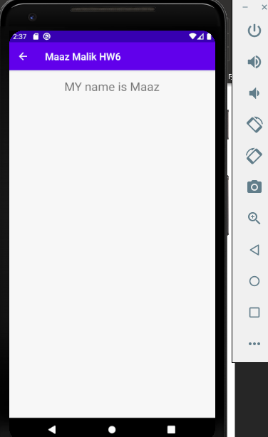

**Part 4 Calculator**

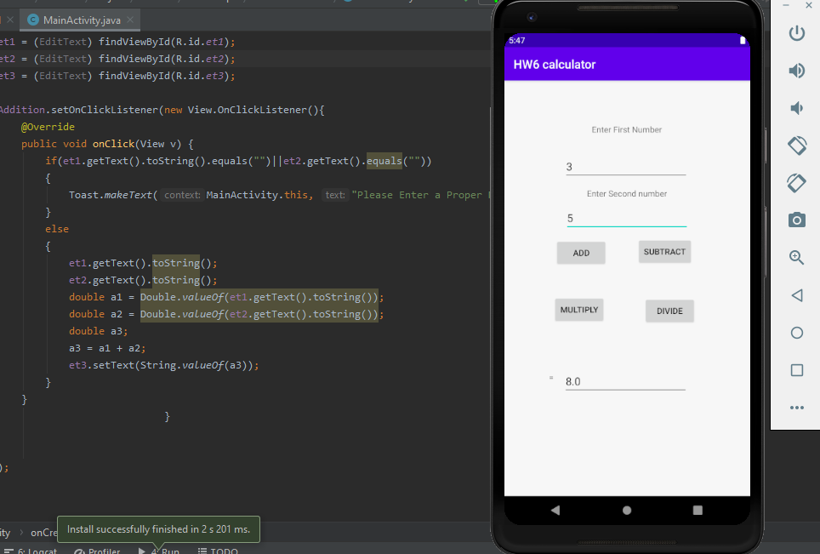

I started this part of the Assignment a little late due to time constraints. I have had basic knowledge of creating Calculators, so I know how the base functionality works.

I started by creating and testing Each function individually. I initially started with Addition just to test out and make sure that it worked and It did. I had to create 4 individual buttons first and make each button a function.

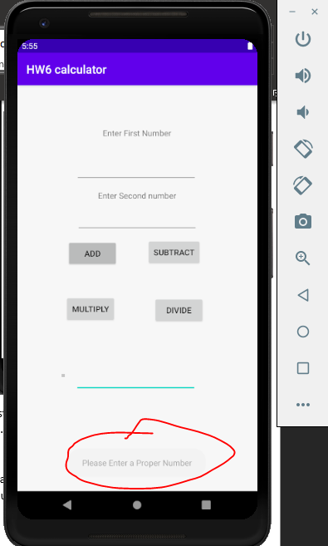 I also created an Alert Funciton for when the Numbers were left blank. I caught it while it was fading away which is why I highlighted it.

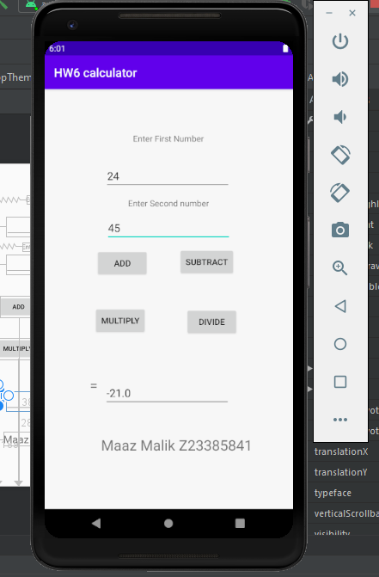

And Successful Functionality. I basically Copied and Pasted the Main activity part for the Addition Function and readjusted it for each Operand.

I don’t Know why but the First Numbers I decided to test out We’re Subtraction and it came out to a Negative so It’s good to know that it can Calculate negative numbers.

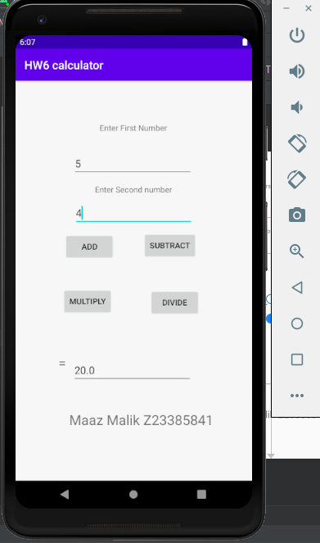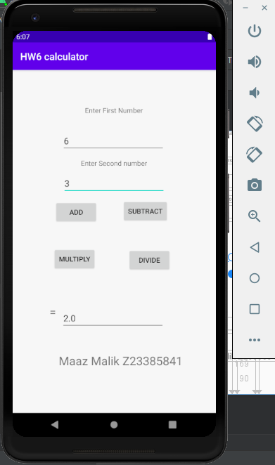

Multiply Divide

So Now that that’s done, I decided to Start Adding the Spinner into Activity XML.

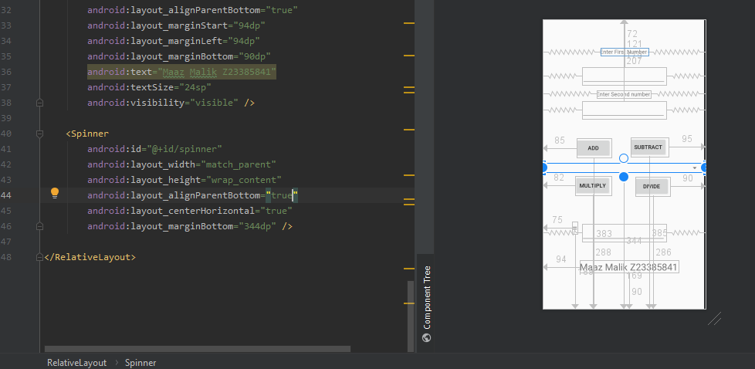

Complete

After Many Failed attempts I followed a guide through an online link that I found in the Slack Group Chat.

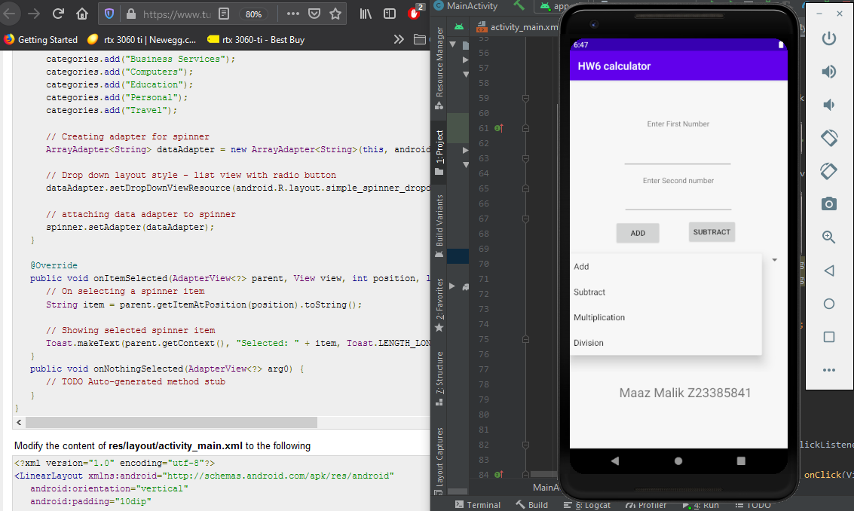

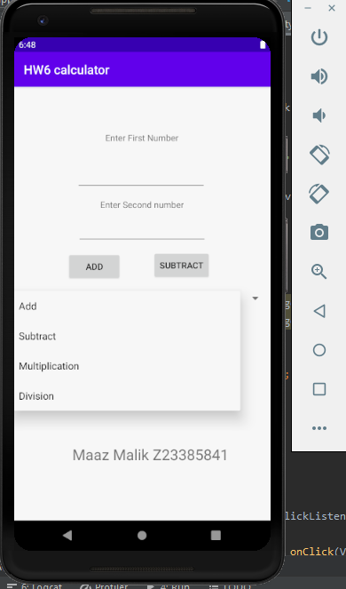 And voila the Spinner worked.

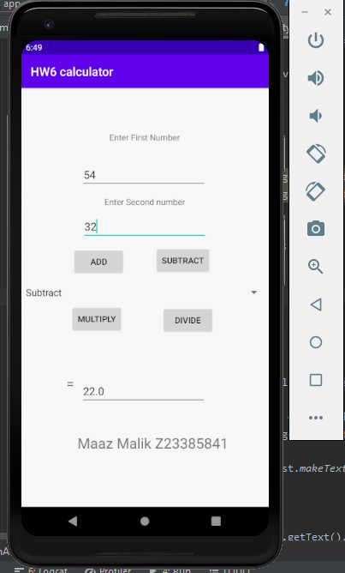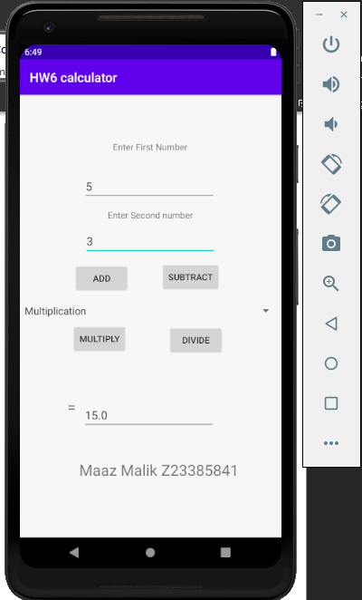

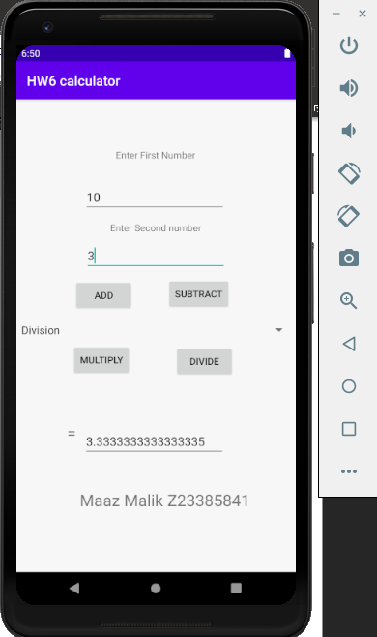

I didn’t remove the Previous buttons due to Time but As you can see in the middle of the Screen there it the Spinner drop down Menu. I have the Code posted down below so that you can take a look at it.

Activity_main.Java

package com.example.hw6calculator;  
  
import androidx.appcompat.app.AppCompatActivity;  
  
import android.os.Bundle;  
import android.view.View;  
import android.widget.AdapterView;  
import android.widget.ArrayAdapter;  
import android.widget.Button;  
import android.widget.EditText;  
import android.widget.Spinner;  
import android.widget.Toast;  
  
import java.util.ArrayList;  
import java.util.List;  
  
public class MainActivity extends AppCompatActivity implements AdapterView.OnItemSelectedListener {  
 private Button Addition, Subtraction, Multiplication, Division;  
 private EditText et1, et2, et3;  
 private Spinner spinner;  
  
 @Override  
 protected void onCreate(Bundle savedInstanceState) {  
 super.onCreate(savedInstanceState);  
 setContentView(R.layout.*activity_main*);  
 // Spinner element  
 Spinner spinner = (Spinner) findViewById(R.id.*spinner*);  
  
 // Spinner click listener  
 spinner.setOnItemSelectedListener(this);  
  
 // Spinner Drop down elements  
 List<String> categories = new ArrayList<String>();  
 categories.add("Add");  
 categories.add("Subtract");  
 categories.add("Multiplication");  
 categories.add("Division");  
  
  
 // Creating adapter for spinner  
 ArrayAdapter<String> dataAdapter = new ArrayAdapter<String>(this, android.R.layout.*simple_spinner_item*, categories);  
  
 // Drop down layout style - list view with radio button  
 dataAdapter.setDropDownViewResource(android.R.layout.*simple_spinner_dropdown_item*);  
  
 // attaching data adapter to spinner  
 spinner.setAdapter(dataAdapter);  
  
 Addition = (Button) findViewById(R.id.*btnadd*);  
 Subtraction = (Button) findViewById(R.id.*btnsubtract*);  
 Multiplication = (Button) findViewById(R.id.*btnmultiply*);  
 Division = (Button) findViewById(R.id.*btndivide*);  
 et1 = (EditText) findViewById(R.id.*et1*);  
 et2 = (EditText) findViewById(R.id.*et2*);  
 et3 = (EditText) findViewById(R.id.*et3*);  
  
  
  
 Addition.setOnClickListener(new View.OnClickListener(){  
 @Override  
 public void onClick(View v) {  
 if(et1.getText().toString().equals("")||et2.getText().equals(""))  
 {  
 Toast.*makeText*(MainActivity.this, "Please Enter a Proper Number", Toast.*LENGTH_SHORT*).show();  
 }  
 else  
 {  
 et1.getText().toString();  
 et2.getText().toString();  
 double a1 = Double.*valueOf*(et1.getText().toString());  
 double a2 = Double.*valueOf*(et2.getText().toString());  
 double a3;  
 a3 = a1 + a2;  
 et3.setText(String.*valueOf*(a3));  
 }  
 }  
 }  
  
 );  
  
  
 Subtraction.setOnClickListener(new View.OnClickListener(){  
 @Override  
 public void onClick(View v) {  
 if(et1.getText().toString().equals("")||et2.getText().equals(""))  
 {  
 Toast.*makeText*(MainActivity.this, "Please Enter a Proper Number", Toast.*LENGTH_SHORT*).show();  
 }  
 else  
 {  
 et1.getText().toString();  
 et2.getText().toString();  
 double a1 = Double.*valueOf*(et1.getText().toString());  
 double a2 = Double.*valueOf*(et2.getText().toString());  
 double a3;  
 a3 = a1 - a2;  
 et3.setText(String.*valueOf*(a3));  
 }  
 }  
 }  
  
 );  
  
 Multiplication.setOnClickListener(new View.OnClickListener(){  
 @Override  
 public void onClick(View v) {  
 if(et1.getText().toString().equals("")||et2.getText().equals(""))  
 {  
 Toast.*makeText*(MainActivity.this, "Please Enter a Proper Number", Toast.*LENGTH_SHORT*).show();  
 }  
 else  
 {  
 et1.getText().toString();  
 et2.getText().toString();  
 double a1 = Double.*valueOf*(et1.getText().toString());  
 double a2 = Double.*valueOf*(et2.getText().toString());  
 double a3;  
 a3 = a1 * a2;  
 et3.setText(String.*valueOf*(a3));  
 }  
 }  
 }  
  
 );  
  
 Division.setOnClickListener(new View.OnClickListener(){  
 @Override  
 public void onClick(View v) {  
 if(et1.getText().toString().equals("")||et2.getText().equals(""))  
 {  
 Toast.*makeText*(MainActivity.this, "Please Enter a Proper Number", Toast.*LENGTH_SHORT*).show();  
 }  
 else  
 {  
 et1.getText().toString();  
 et2.getText().toString();  
 double a1 = Double.*valueOf*(et1.getText().toString());  
 double a2 = Double.*valueOf*(et2.getText().toString());  
 double a3;  
 a3 = a1 / a2;  
 et3.setText(String.*valueOf*(a3));  
 }  
 }  
 }  
  
 );  
 }  
  
 @Override  
 public void onItemSelected(AdapterView<?> parent, View view, int position, long id) {  
 String text = parent.getItemAtPosition(position).toString();  
 Toast.*makeText*(parent.getContext(), text, Toast.*LENGTH_SHORT*).show();  
  
 Subtraction.setOnClickListener(new View.OnClickListener(){  
 @Override  
 public void onClick(View v) {  
 if(et1.getText().toString().equals("")||et2.getText().equals(""))  
 {  
 Toast.*makeText*(MainActivity.this, "Please Enter a Proper Number", Toast.*LENGTH_SHORT*).show();  
 }  
 else  
 {  
 et1.getText().toString();  
 et2.getText().toString();  
 double a1 = Double.*valueOf*(et1.getText().toString());  
 double a2 = Double.*valueOf*(et2.getText().toString());  
 double a3;  
 a3 = a1 - a2;  
 et3.setText(String.*valueOf*(a3));  
 }  
 }  
 }  
  
 else  
 {  
 et1.getText().toString();  
 et2.getText().toString();  
 double a1 = Double.*valueOf*(et1.getText().toString());  
 double a2 = Double.*valueOf*(et2.getText().toString());  
 double a3;  
 a3 = a1 + a2;  
 et3.setText(String.*valueOf*(a3));  
 }  
  
 else  
 {  
 et1.getText().toString();  
 et2.getText().toString();  
 double a1 = Double.*valueOf*(et1.getText().toString());  
 double a2 = Double.*valueOf*(et2.getText().toString());  
 double a3;  
 a3 = a1 * a2;  
 et3.setText(String.*valueOf*(a3));  
 }  
 }  
  
 Division.setOnClickListener(new View.OnClickListener(){  
 @Override  
 public void onClick(View v) {  
 if(et1.getText().toString().equals("")||et2.getText().equals(""))  
 {  
 Toast.*makeText*(MainActivity.this, "Please Enter a Proper Number", Toast.*LENGTH_SHORT*).show();  
 }  
 else  
 {  
 et1.getText().toString();  
 et2.getText().toString();  
 double a1 = Double.*valueOf*(et1.getText().toString());  
 double a2 = Double.*valueOf*(et2.getText().toString());  
 double a3;  
 a3 = a1 / a2;  
 et3.setText(String.*valueOf*(a3));  
 }  
 }  
 }  
  
 );  
  
  
  
  
  
 }  
  
  
 @Override  
 public void onNothingSelected(AdapterView<?> parent) {  
  
 }  
}

strings.xml

<resources>  
 <string name="app_name">HW6 calculator</string>  
 <string-array name="numbers">  
 <item>Add</item>  
 <item>Subtract</item>  
 <item>Multiply</item>  
 <item>Division</item>  
 </string-array>  
</resources>

Activity_main.xml

<?xml version="1.0" encoding="utf-8"?>  
<RelativeLayout xmlns:android="http://schemas.android.com/apk/res/android"  
 xmlns:app="http://schemas.android.com/apk/res-auto"  
 xmlns:tools="http://schemas.android.com/tools"  
 android:layout_width="match_parent"  
 android:layout_height="match_parent"  
 tools:context=".MainActivity">  
  
 <Button  
 android:id="@+id/btnadd"  
 android:layout_width="wrap_content"  
 android:layout_height="wrap_content"  
 android:layout_alignParentStart="true"  
 android:layout_alignParentLeft="true"  
 android:layout_alignParentBottom="true"  
 android:layout_marginStart="85dp"  
 android:layout_marginLeft="85dp"  
 android:layout_marginBottom="383dp"  
 android:text="Add" />  
  
 <Button  
 android:id="@+id/btnsubtract"  
 android:layout_width="wrap_content"  
 android:layout_height="wrap_content"  
 android:layout_alignParentEnd="true"  
 android:layout_alignParentRight="true"  
 android:layout_alignParentBottom="true"  
 android:layout_marginEnd="95dp"  
 android:layout_marginRight="95dp"  
 android:layout_marginBottom="385dp"  
 android:text="Subtract" />  
  
 <Button  
 android:id="@+id/btnmultiply"  
 android:layout_width="wrap_content"  
 android:layout_height="wrap_content"  
 android:layout_alignParentStart="true"  
 android:layout_alignParentLeft="true"  
 android:layout_alignParentBottom="true"  
 android:layout_marginStart="82dp"  
 android:layout_marginLeft="82dp"  
 android:layout_marginBottom="288dp"  
 android:text="Multiply" />  
  
 <Button  
 android:id="@+id/btndivide"  
 android:layout_width="wrap_content"  
 android:layout_height="wrap_content"  
 android:layout_alignParentEnd="true"  
 android:layout_alignParentRight="true"  
 android:layout_alignParentBottom="true"  
 android:layout_marginEnd="90dp"  
 android:layout_marginRight="90dp"  
 android:layout_marginBottom="286dp"  
 android:text="Divide" />  
  
 <EditText  
 android:id="@+id/et1"  
 android:layout_width="wrap_content"  
 android:layout_height="wrap_content"  
 android:layout_alignParentStart="true"  
 android:layout_alignParentLeft="true"  
 android:layout_alignParentTop="true"  
 android:layout_centerHorizontal="true"  
 android:layout_marginStart="100dp"  
 android:layout_marginLeft="100dp"  
 android:layout_marginTop="121dp"  
 android:ems="10"  
 android:inputType="number" />  
  
 <EditText  
 android:id="@+id/et2"  
 android:layout_width="wrap_content"  
 android:layout_height="wrap_content"  
 android:layout_alignParentTop="true"  
 android:layout_centerHorizontal="true"  
 android:layout_marginTop="207dp"  
 android:ems="10"  
 android:inputType="number" />  
  
 <TextView  
 android:id="@+id/textView"  
 android:layout_width="wrap_content"  
 android:layout_height="wrap_content"  
 android:layout_alignParentTop="true"  
 android:layout_centerHorizontal="true"  
 android:layout_marginTop="72dp"  
 android:text="Enter First Number" />  
  
 <TextView  
 android:id="@+id/textView2"  
 android:layout_width="wrap_content"  
 android:layout_height="wrap_content"  
 android:layout_alignParentTop="true"  
 android:layout_centerHorizontal="true"  
 android:layout_marginTop="179dp"  
 android:text="Enter Second number" />  
  
 <EditText  
 android:id="@+id/et3"  
 android:layout_width="wrap_content"  
 android:layout_height="wrap_content"  
 android:layout_alignParentStart="true"  
 android:layout_alignParentLeft="true"  
 android:layout_alignParentBottom="true"  
 android:layout_centerHorizontal="true"  
 android:layout_marginStart="99dp"  
 android:layout_marginLeft="99dp"  
 android:layout_marginBottom="169dp"  
 android:ems="10"  
 android:inputType="number" />  
  
 <TextView  
 android:id="@+id/textView3"  
 android:layout_width="wrap_content"  
 android:layout_height="wrap_content"  
 android:layout_alignParentStart="true"  
 android:layout_alignParentLeft="true"  
 android:layout_alignParentBottom="true"  
 android:layout_marginStart="75dp"  
 android:layout_marginLeft="75dp"  
 android:layout_marginBottom="189dp"  
 android:text="="  
 android:textSize="24sp" />  
  
 <TextView  
 android:id="@+id/textView4"  
 android:layout_width="wrap_content"  
 android:layout_height="wrap_content"  
 android:layout_alignParentStart="true"  
 android:layout_alignParentLeft="true"  
 android:layout_alignParentBottom="true"  
 android:layout_marginStart="94dp"  
 android:layout_marginLeft="94dp"  
 android:layout_marginBottom="90dp"  
 android:text="Maaz Malik Z23385841"  
 android:textSize="24sp"  
 android:visibility="visible" />  
  
 <Spinner  
 android:id="@+id/spinner"  
 android:layout_width="match_parent"  
 android:layout_height="wrap_content"  
 android:layout_alignParentBottom="true"  
 android:layout_centerHorizontal="true"  
 android:layout_marginBottom="344dp" />  
  
</RelativeLayout>

For activity Main I left the Button functionality and copied all the Operand functions into the Spinners container in the MAinActivity Java upon completing the Original Prototype calculator.