# Results:

## ANSYS CFX 16.1

### Iteration or Convergence Error

The results shown here are calculated on mesh 2 resolution with sequence of convergence targets MAX Residuals < 10-3 to 10-6. Propane mass fraction, velocity u and v profiles were compared with experimental data. Here the results are only shown for location X/D = 15.

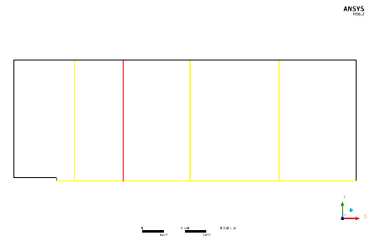

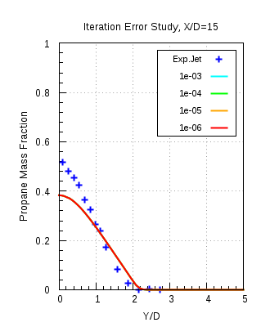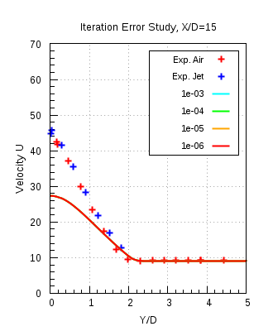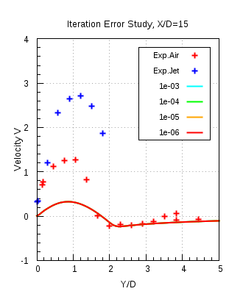

Figure 8.1(a)

Figure 8.1(a) shows the comparison of the, radial propane mass fraction, axial (U) and radial (V) velocity component profiles, obtained from numerical results with experimental data. It is seen from the plots that the results of every convergence target overlap over each other and not allowing us to decide an appropriate convergence target. Thus, differences in the propane mass fraction values amongst different convergence targets have been carried out in ANSYS CFD Post 16.1.

Propane mass fraction difference between convergence targets 10-5 and 10-6 showed the smallest difference and thus convergence criteria 10-5 was decided to be appropriate enough. In the profile plots for the mean axial velocity component there exists a noticeable difference between the numerical results and experimental data. This can be explained due to insufficient mesh resolution in mesh 2.

### Spatial discretization error

For this study the convergence criterion of 10-5 along with the conservation target of 10-3 were used. The simulations were carried out with k-ω SST model on all mesh resolutions with auto timescale. The following figures show the comparison of the numerically obtained results with the experimental data.

Figure 8.2(a) shows the variable values plotted against the accumalated time step. These plots show the residual convergence history of the simulations carried out on mesh 3 and mesh 4. It is seen that for mass and all momentum components the specified convergence target of 10-5, is achieved.

Figure 8.2(b) shows the imbalances in the conserved quantities plotted against the accumalated time step. Conservation criteria specifies that there are no imbalances existing for the conserved quantities. This assures that our flow physics has been resolved completely. It is seen from the figure that the propane mass fraction imbalance at beginning of the simulation is 100% at the outlet, as there is no propane there. After some 50 iterations it is seen that the propane mass fraction reduces and hence after 50 iterations the propane reaches the outlet. The mass fraction of propane gradually reduces to the specified conservation target and so does the other quantities. Thus the simulation are accepted as converged only when both the criteria specified are achieved by all the fuel components and flow field quantities. All meshes achieve the convergence criteria.

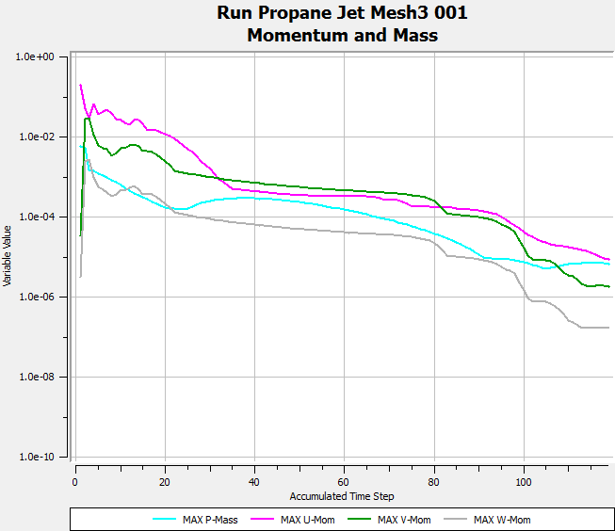 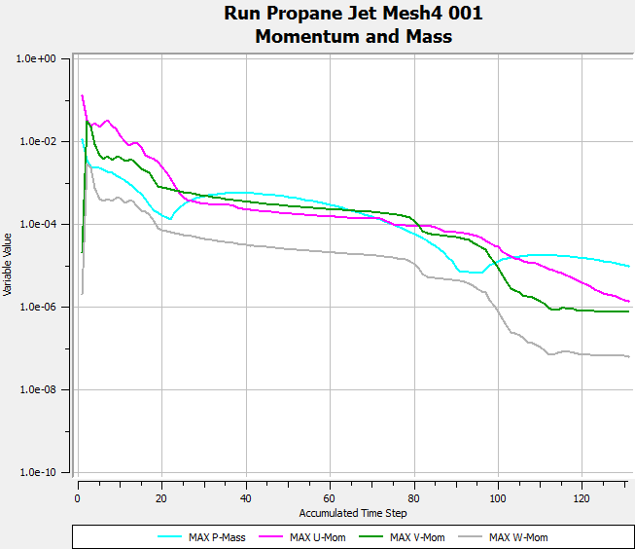

**Mesh 4**

**Mesh 3**



Fig. 8.2 (a)

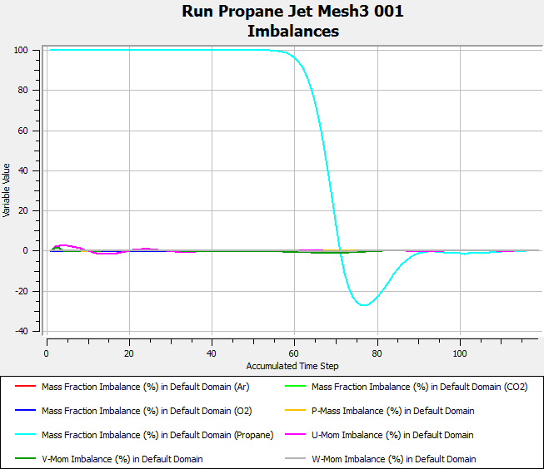 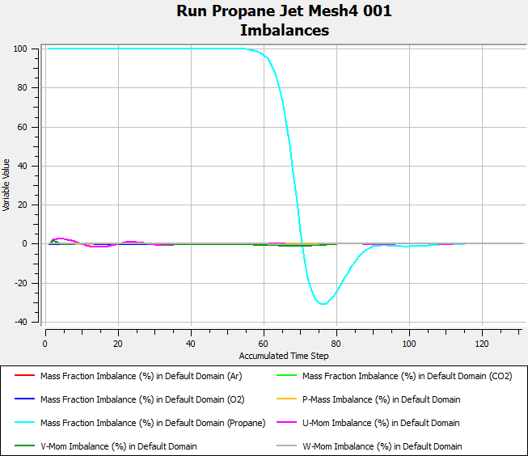

**Mesh 4**

**Mesh 3**

Fig. 8.2 (b)



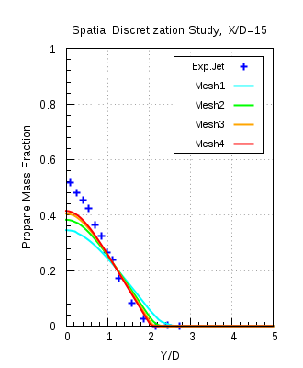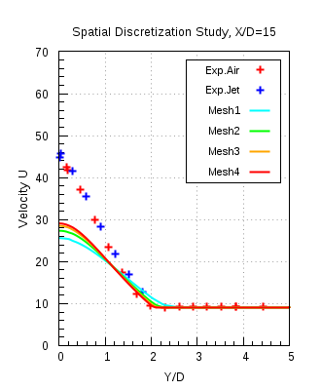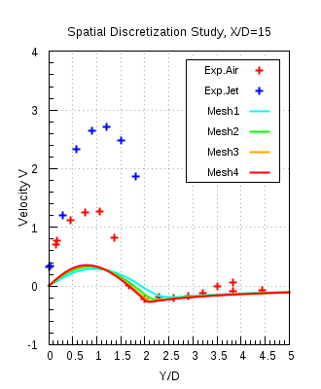

Fig. 8.2 (c)

Figure 8.2(c) shows the propane mass fraction and velocity profiles, of all meshes, compared with the experimental data. From the comparison plots shown above it is clearly seen that with the refinement of meshes the results progressively tends towards the mesh independent results. Specifically from the results of mesh 3 and 4 it is clear that on resolution of mesh 4, mesh independent solution is achieved. Important thing to notice here from the velocity profiles is that the jet loses momentum faster as compared to the experimental jet at location X/D = 15 downstream the bluff-body. This might have occurred due to the improper assumption of turbulence inlet boundary condition at jet inlet. As initial turbulent boundary conditions are considered to one of the factors which affect the downstream characteristics of the jet in a co-flow of air. Thus a study with different turbulent inlet boundary conditions at jet inlet has been carried out.

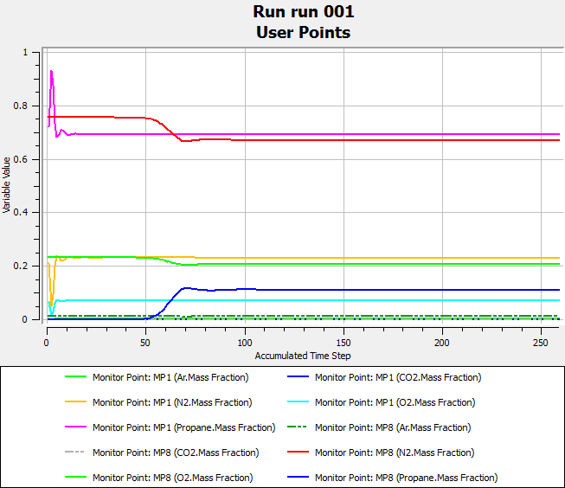

Figure 8.2 (d)

Figure 8.2(d) shows that after 120 iterations the lines of the monitoring points are straight, which indicates that no physical changes are occurring in the domain. This assures that no physical phenomenon, occurring at the small time scales, goes unresolved.

### Turbulence inlet boundary condition (TIBC):

|  |  |  |  |
| --- | --- | --- | --- |
| Test name | Turbulence model | TIBC, jet inlet | TIBC, co-flow inlet |
| CSV_SST | SST | K and ω | Fractional Intensity & Eddy Viscosity ratio |
| CSV_KEpsilon# | K-ε | K and ε | Fractional Intensity & Eddy Viscosity ratio |
| KLS_SST | SST | K and LS | K and LS |
| KLS_KEpsilon# | K-ε | K and LS | K and LS |
| PA CSV SST | SST | K and ω | Fractional Intensity* & Eddy Viscosity ratio |

Table 6

**CSV_SST** – It indicates that turbulence inlet boundary conditions have been used from interpolated profile of fully developed flow at fuel jet inlet, **KLS_SST** – It stands for the case where turbulent kinetic energy (K) and Length scale (LS) have used, as TIBC, by calculating them from the experimental data, **#** - indicates that the constant Cε1 in the dissipation equation (ε) of the standard k-ε model is modified from 1.44 to 1.6 [5], to address the round jet anomaly phenomenon, **PA CSV SST** – indicates that the inlet profiles have been used both at co-flow and fuel jet inlet along with the new value of turbulence intensity

Figure 8.3 (a) shows the axial profiles obtained from numerical results for velocity u invariant and propane mass fraction invariant compared with the experimental data. In case of velocity invariant profile it is seen that profiles with k-ω SST model over-predict the velocity decay compared to the experimental profiles, after the axial location X/D = 6. From the propane mass fraction invariant profiles it is seen that the profiles with k-ω SST are in good agreement with the experimental data. Also the change in the inlet boundary conditions with k-ω SST model shows no big influence on to the profiles for both invariants. In the case with inflow velocity profile at co-flow provides the solution with no changes in the results. Modified k-ε model from velocity u invariant plot predicts that the velocity decay which is in exact agreement with the experimental data, but at the same time under predicts the propane mass fraction decay as seen from the propane mass fraction invariant plot.

Figure 8.3(b) shows the radial profiles obtained from the numerical results, of propane mass fraction, axial and radial velocity components, compared with the experimental data. As observed for the axial profiles of k-ω SST model shows no sensitivity towards the turbulent boundary conditions. Modified k-ε model predicts the exact centerline velocities and at the same time under-predicts the mixing of jet as seen from the propane mass fraction profiles. Other radial velocity profiles can be found in appendix.

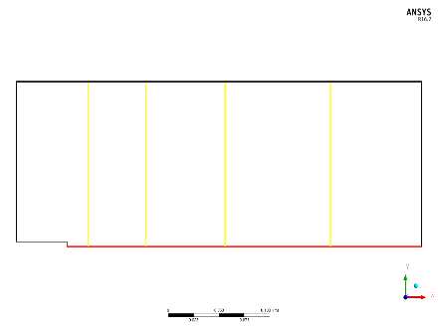

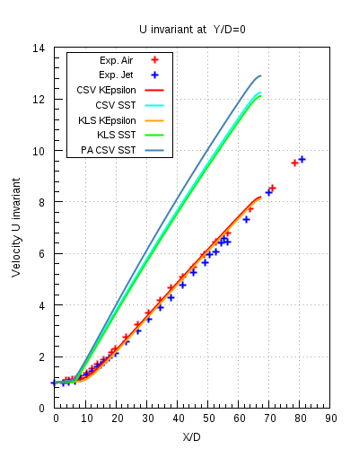 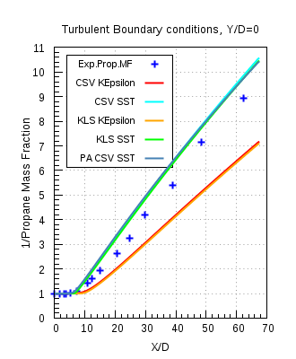

Fig.8.3 (a)



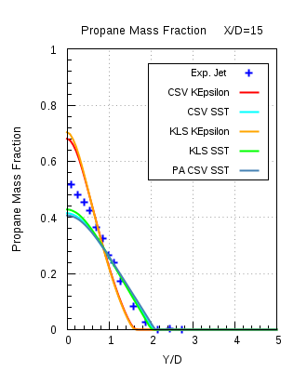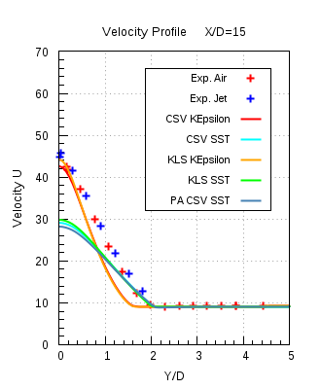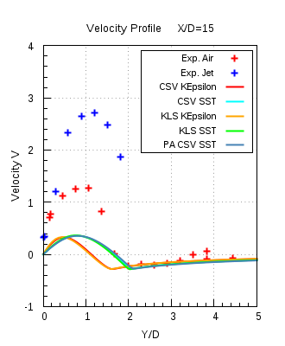

Figure 8.3 (b)

### Turbulent Schmidt number (Sct):

The results presented here were calculated with k-ω SST model, mesh 4, auto timescale and convergence criteria as decided before. In this test simulations were carried out with four different Sct numbers ranging from 0.6 to 0.9. Comparison of axial and the radial propane mass fraction profiles have been made with the corresponding experimental data.

Figure 8.4(a) shows the axial propane mass fraction and propane mass fraction invariant profiles for different Sct,compared with the experimental data. Looking at both the profiles it is clear that the Sct of 0.9 is in good agreement with the experimental data and delivers the most accurate result.

Figure 8.4(b) shows the radial propane mass fraction profiles, at X/D =4, 15 & 30, compared with the experimental data. It is seen that the Sct 0.9 is in very good agreement with the experimental data.



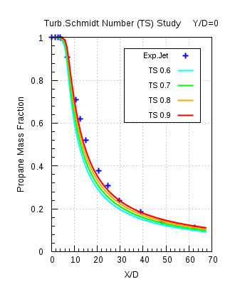 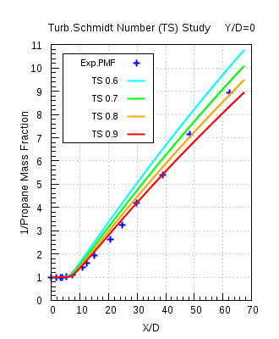

Figure 8.4 (a)

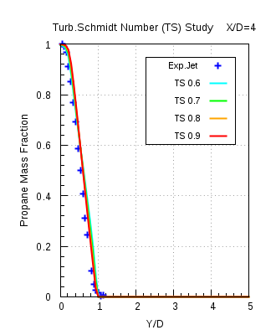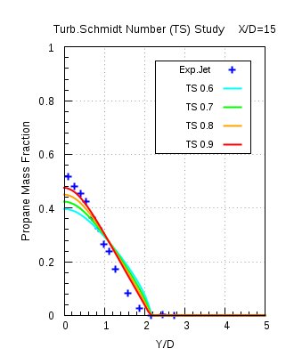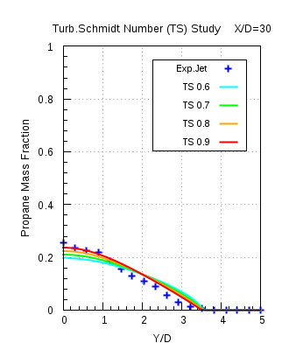

Figure 8.4(b)

### Model Error Study:

In this study all turbulence models as mentioned before have been used in combination with different mesh resolutions. The propane mass fraction and the velocity profiles obtained from the numerical results are compared with the experimental data. The comparison is shown here for the calculations carried out with mesh 4 resolution and different turbulence models. Every calculation performed satisfied all the convergence criteria. For BSL RSM model results from mesh 3 were used, as solver failed on performing calculations on mesh 4. Some additional efforts had been applied, i.e. increasing maximum number of iterations, reducing the convergence target value and reducing the time step to a smaller value, to achieve converged solutions when models BSL RSM and EARSM were used for calculations.

Figure 8.5(a) shows the axial propane mass fraction, propane mass fraction and velocity invariant profiles compared with the experimental data. It is seen from the propane mass fraction profiles that the modified k-ε model (KEpsilonmod) under-predicts the propane mass fraction decay and at the same time profiles from other models are in good agreement with the experimental data. From the profiles it is clear that k-ω SST over-predicts the velocity decay and the modified k-ε model is in good agreement with the experimental data. From the propane mass fraction invariant profiles it is seen that the modified k-ε model under-predicts the propane mass fraction decay, while other models are in good agreement with the experimental data.

Figure 8.5(b) shows the radial propane mass fraction and velocity profiles compared with the experimental data at location X/D = 15. It is seen from the comparison plots that the modified k-ε model is in good agreement with the experimental data, in case of velocity profiles, and it under-predicts propane mass fraction decay. k-ω SST and k-ε model are providing consistent results with each other and are in good agreement with the experimental data.

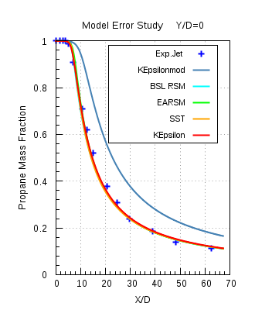

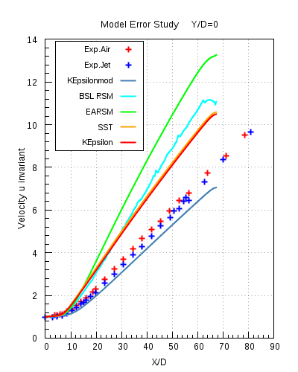 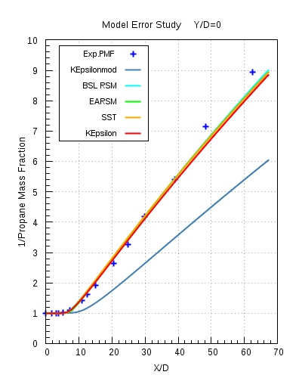

Figure 8.5(a)

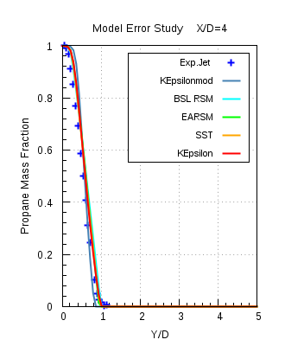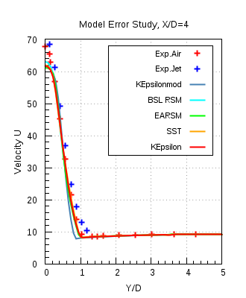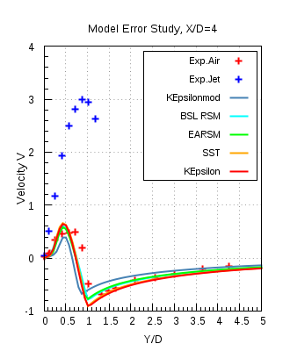

Figure 8.5(b)



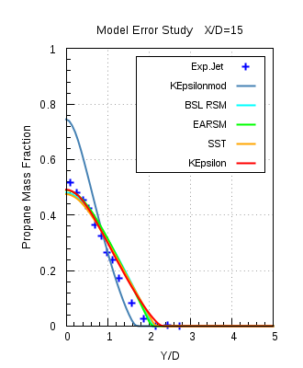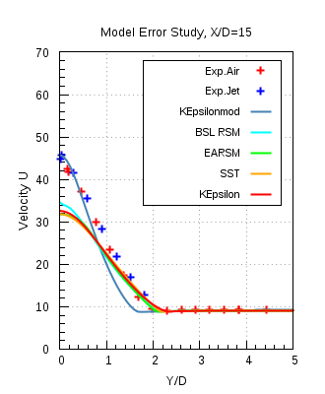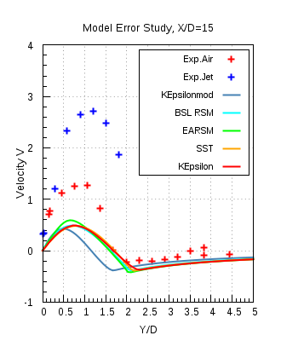

Figure 8.5(c)



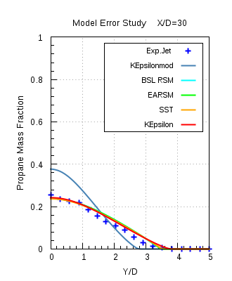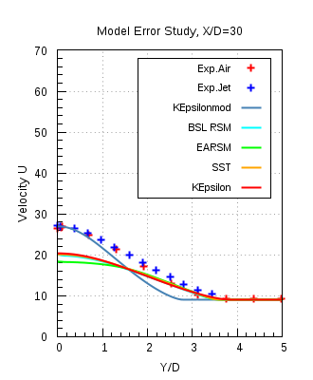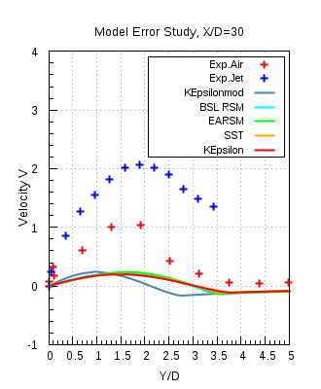

Figure 8.5(d)

## ANSYS Fluent 17.0:

Similar studies as in ANSYS CFX 16.1 have been performed with ANSYS Fluent 17.0. The iteration or convergence target has been chosen as 10-7 for ANSYS Fluent 17.0 and mesh 4 is the chosen mesh resolution for all the simulations that have been carried out. Sct was also modified to 0.9, which is 0.7 by default in ANSYS Fluent 17.0. Also in order to have a fair comparison with ANSYS CFX 16.1, the kinematic diffusivity has been also modified to the same value as in ANSYS CFX 16.1. Simulations were performed with standard k-ε, realizable k-ε, k-ω SST and standard k-ω turbulence models.

### Model Error Study:

In this study the turbulence models were combined with the different methods of defining kinematic diffusivity and also with different mesh resolutions. As per discussed results of only mesh 4 will be compared with the experimental data.

Results only for the X/D =15 will be shown here

Figure 8.6(a) shows the comparison of the radial profiles of propane mass fraction and velocity obtained from numerical results with experimental data. Refer table 7 for the naming convention of legends. Combination of different turbulence models with the two diffusivities are also compared with each other, apart from comparison with the experimental data. From the profile plots it was observed that same turbulence model with different diffusivities delivered the same results and hence their profiles are overlapping each other. Standard k-ω model delivers some different results as it was having some different implementation in ANSYS Fluent software. Apart from that k-ω SST and standard k-ε delivers almost consistent results with each other and they are in good agreement with the experimental data. Other comparison plots are shown in Appendix.

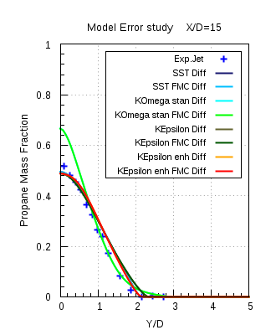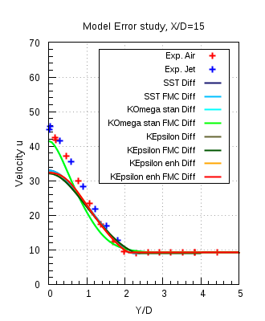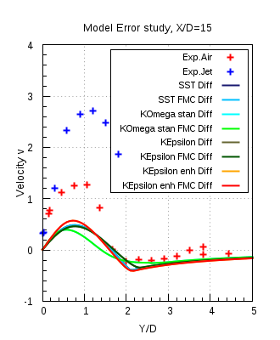

Figure 8.6(a)

## Solver Comparison between ANSYS CFX 16.1 & ANSYS Fluent 17.0:

In this study a cross comparison of the results obtained from the different turbulence models of the two solvers has been carried out with the experimental data. Turbulence models used here are mentioned below:

|  |  |
| --- | --- |
| ANSYS CFX 16.1 | ANSYS Fluent 17.0 |
| K-ω SST | K-ω SST with constant diffusivity (K-ω SST Diff) |
| K-ω SST with full multi-component diffusivity  (K-ω SST FMC Diff) |
| K-ε | K-ε constant diffusivity (K-ω SST Diff) |
| K- ε SST with full multi-component diffusivity  (K- ε SST FMC Diff) |

Table 7

K-ω SST: 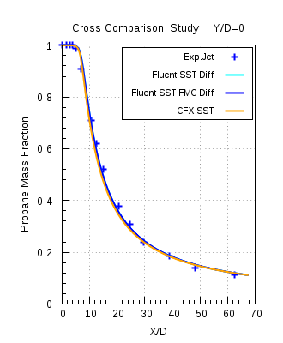

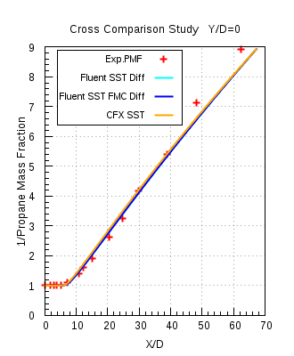 Figure 8.7(a)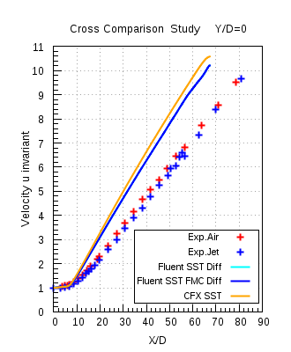



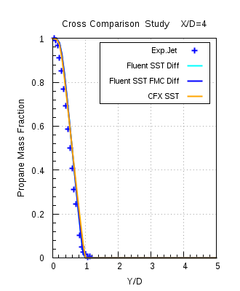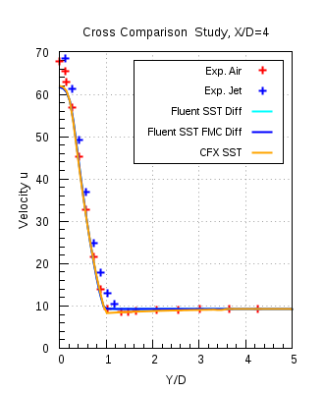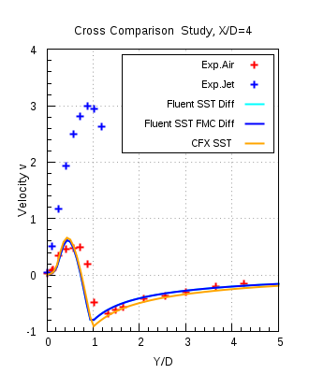

Figure 8.7(b)



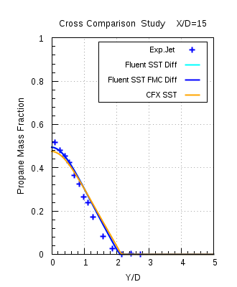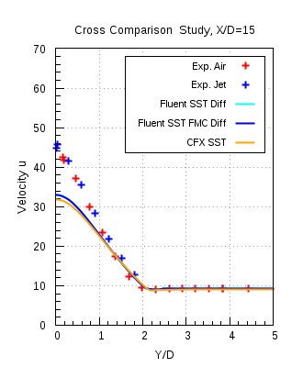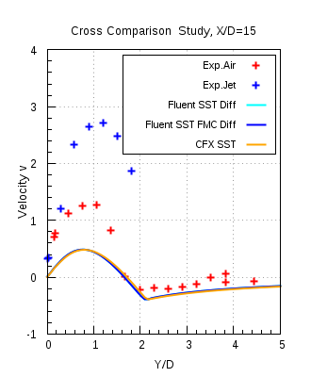

Figure 8.7 (c)



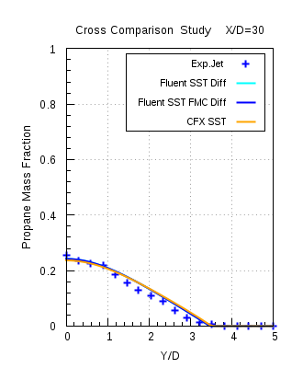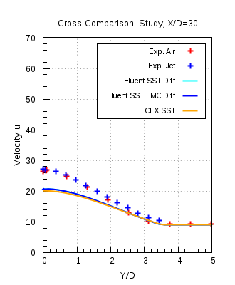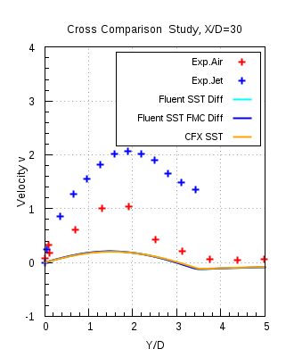

Figure 8.7 (d)

Figures 8.7(a) & 8.7(b)-(d), shows the axial and the radial profiles obtained numerically are compared with the experimental data for the k-ω SST model of both the solvers. It is seen that k-ω SST model for both the solvers are in good agreement with each other and also with the experimental data.

K-ε model:

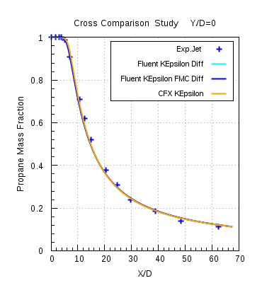

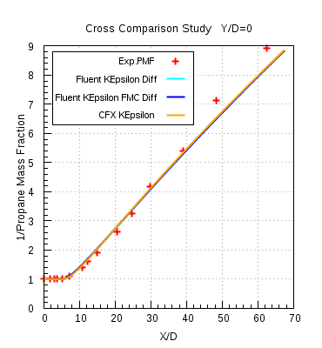 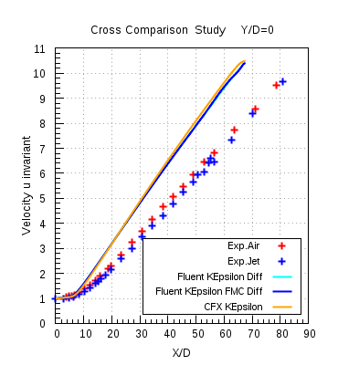

Figure 8.8 (a)



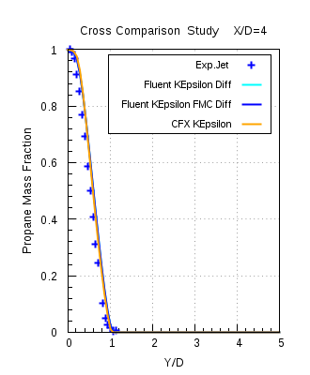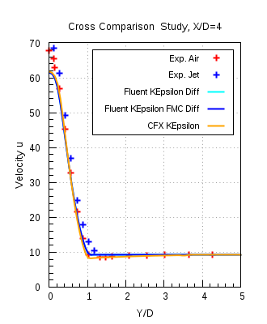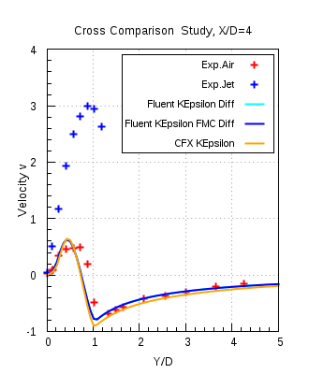

Figure 8.8 (b)



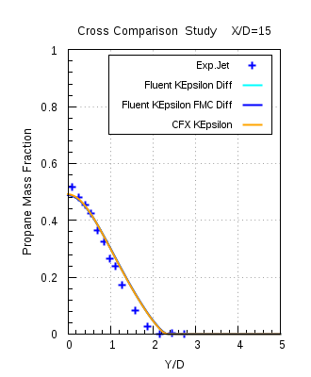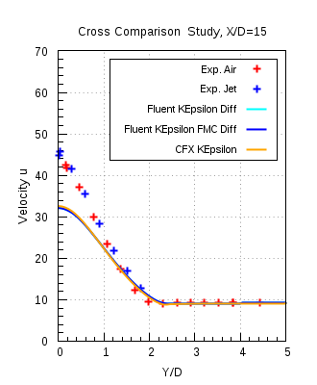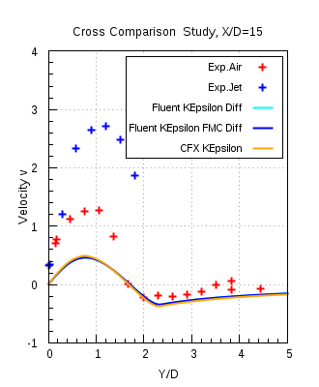

Figure 8.8 (c)



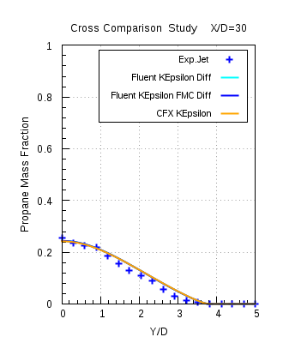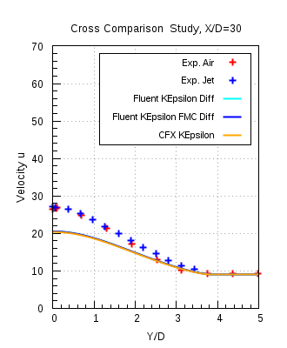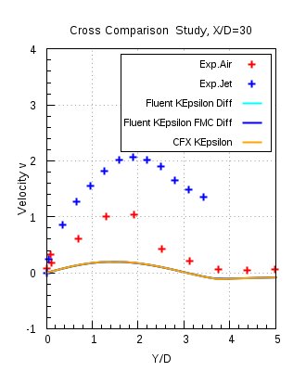

Figure 8.8(d)

Figures 8.8(a) & 8.8(b)-(d), shows the axial and the radial profiles obtained numerically are compared with the experimental data for the k-ε model of both the solvers. It is seen that k-ε model for both the solvers are in good agreement with each other and also with the experimental data.