# Turbulence

Turbulence occurs when the inertia forces in the fluid become significant compared to the viscous forces, and is characterized by the high Reynolds number. Turbulence consists of fluctuations in the flow field in time and space. It is a complex process, mainly because it is three dimensional and unsteady. Rotational flow structures, so called turbulent eddies, with a wide range of length scales are found in turbulent flows. Large turbulent eddies transfer the energy to the small eddies and the small eddies in turn dissipate the energy into thermal energy because of the action of viscous stresses.

In principle Navier-Stokes equations describe both laminar and turbulent flows without the need for additional information. But performing the calculations directly by solving these equations makes this approach, computationally, a lot expensive. An alternative approach to the approach mentioned before would be to have, some mathematical models, turbulence models which can account for all the effects of turbulence without the requirements of fine mesh and avoid solving the navier-stokes equation directly.

The following are the categories of turbulence models:

1. RANS (Reynolds averaged navier stokes equation) :

Here the attention is focused on the mean flow and the effects of turbulence on mean flow properties. Prior to the application of numerical methods the Navier–Stokes equations are time averaged (or ensemble averaged in flows with time-dependent boundary conditions). Extra terms appear in the time-averaged (or Reynolds averaged) flow equations due to the interactions between various turbulent fluctuations. These extra terms are modeled with classical turbulence models: among the best known ones are the *k*–ε model and the Reynolds stress model. The computing resources required for reasonably accurate flow computations are modest, so this approach has been the mainstay of engineering flow calculations over the last three decades.

1. LES (Large Eddy Simulation):

This is an intermediate form of turbulence calculations which tracks the behavior of the larger eddies. The method involves space filtering of the unsteady Navier–Stokes equations prior to the computations, which passes the larger eddies and rejects the smaller eddies. The effects on the resolved flow (mean flow plus large eddies) due to the smallest, unresolved eddies are included by means of a so-called sub-grid scale model. Unsteady flow equations must be solved, so the demands on computing resources in terms of storage and volume of calculations are large, but (at the time of writing) this technique is starting to address CFD problems with complex geometry.

1. DNS (Direct Numerical Simulation):

In this method the simulations compute the mean flow and all turbulent velocity fluctuations. The unsteady Navier–Stokes equations are solved on spatial grids that are sufficiently fine that they can resolve the Kolmogorov length scales at which energy dissipation takes place and with time steps sufficiently small to resolve the period of the fastest fluctuations. These calculations are highly costly in terms of computing resources, so the method is not used for industrial flow computations.

Here only the category of RANS turbulence models will be discussed.

## RANS Models:

The continuity and the momentum equations are described as below:

|  |  |  |
| --- | --- | --- |
|  |  | () |

When the time scales, which are much larger that the time scales of turbulent fluctuations, are considered the turbulent flow is said to exhibit the average characteristics, but with an additional time-varying and fluctuating component i.e. velocity component may be divided in to an average and a time varying component

Where the averaged component is given by:

Substituting the averaged quantities in the original transport equations results in the Reynolds averaged equations given below:

The continuity equation has not been altered but the momentum equation has additional turbulent flux terms in addition to the molecular diffusive fluxes. These terms - are the Reynolds stresses. They have to be modeled by additional equations of known quantities in order to achieve “closure”. Closure means that there should be sufficient number of equations for all the unknowns, including the unknowns which appear from the averaging equations.

The most common RANS turbulent models are classified depending on the number of additional equations that are required to be solved along with the averaged transport equations:

|  |  |
| --- | --- |
| No. of additional transport equations | Name |
| Zero | Mixing length model |
| One | Spalart-Allmaras model |
| Two | k-ε  k-ω  Algebraic stress model |
| Seven | Reynolds stress model |

Here the two equation model and the seven equations model will only be discussed, as they are used for the investigation

### Two equation models

A proposal from boussinesq suggested that the reynolds stresses can be related to the mean velocity gradients and turbulent viscosity by the gradient diffusion hypothesis, in a manner analogus to the relationship between the stress and strain tensors in laminar newtonian flow:

Where is the turbulent viscosity which must be modeled and k is the turbulent kinetic energy defined as

In the equation stating the boussinesq hypothesis above, indicates that only the normal components of reynolds stresses will be considered. This implies an isotropic assumption for the normal reynolds stresses.

Analogus to the turbulent viscosity hypothesis is the turbulent diffusivity hypothesis, which states that the Reynolds fluxes of a scalar are linearly related to the mean scalar gradient.

Where is defined as the turbulent diffusivity and it is written as

=

Applying the hypothesis to the avergaed momentum equation becomes:

#### k-ε model:

This model uses two additional equations, in the form of turbulence kinetic energy (k) m2/s2 and turbulence eddy dissipation (ε) m2/s3, defined as the rate at which the velocity fluctuations dissipate. This model uses the assumption, that the turbulence viscosity is linked to the turbulence kinetic energy and dissipation via the relation:

The transport equations for the k and ε, which are obtained by performing certain algebraic manipulations, are shown below:

Where,, are constants. is the turbulence production, due to the viscous forces, term.

This model does not perform well in the weak shear layers and the spreading rate of the axisymmetric jets in stagnant surroundings is severely over-predicted. Such difficulties can be overcome by modifying the model constant C. Since this model is based on the boussinesq `s assumption, of isotropic eddy viscosity, it delivers poor performance in flows with swirl, with curved boundary layers.

#### Realizable k-ε model:

Realizable k-ε model aims to improve the limitations of the standard k-ε model in specific flow types viz. flows with high strain rates. The formulation of this model differs from the standard k-ε model in the following aspects:

A new eddy-viscosity formula involving a variable originally proposed by reynolds [Ref. ANSYS Fluent]

A new model equation for the dissipation (ε) based on the dynamic equation of the mean-square vorticity fluctuation

The realizability here implies positivity of the normal stresses and fullfiling the Schwarz inequality for the shear stresses.It is achieved by the first aspect of the realizable k-ε model.This realiability is only achieved by the realizable k-ε model and not the former versions of k-ε model. The well known round-jet-anomaly phenomenon is considered to happen because of the formulation of dissipation equation and this is improved by the second aspect of the realizable k-ε model.

The two equations for k and εfor this model are as shown below:

Where C1 = max, , S = , *Gk*  represents the production of the turbulent kinetic energy, *Gb* is the generation of turbulence kinetic energy due to buoyancy. One limitation of this model is that it produces non-physical turbulent viscosities in situations where the rotating and stationary fluid zones.

#### Standard k-ω model:

This model does not require complex non-linear damping function, as required in the k-ε model, which makes it more robust and accurate. This model assumes that the turbulent viscosity is associated with the turbulence kinetic energy and turbulence frequency via the relation :

In this model the two equations used are turbulence konetic energy (k) and turbulence eddy frequency (ω) respectively:

, , , and are constants

The problem with this model is its strong sensitivity towards the free-stream condition [CFS Manual]. Also depending on the value of ω at inlet, a significant variation in the results was obtained and which was not desirable in case of external aerodynamics and aerospace.

#### Shear stress transport model (SST):

Considering the better performance of k-ε model in the free stream and better performance of the standard k-ω model in the near wall region it was suggested in the literature [] to have an hybrid model:

1. Transformation of the k-ε model to k-ω model in the near wall region
2. Standard k-ε model in the fully turbulent region far from the wall

In this model a series of modifications have been suggested by menter in order to optimize the performance of the SST model. It included modification in the model constants, Blending functions and proper limiters. Blending function was implemented in such a fashion that in the near wall region it turned to 0, means k-ω is activated there, and 1 in the free stream region, means k-ε model is activated here.

Reynolds Stress Models (RSM):

These models do not use the boussinesq`s hypothesis, but solves the transport equations for each and every reyolds stress component. They are based on the solving of the all the stress componenet equations along with the dissipation equation. Exact production term and modelling of stress anisotropies makes these models suited to more complex flows. But they are not always good compared to the two equation model.

Reynolds Stress Models are considered to be the ‘simplest’ type of model with the potential to describe all the mean flow properties and Reynolds stresses without case-by-case adjustment. Apart from that model is known for its large computing costs i.e. solving seven extra PDE`s (3D) and five (2D). Models face the problem in converging for e.g. in flows with axisymmetric jets and unconfined recirculating flows

Base line reynolds stress ω based (BSLRSM):

In this model Omega and BSL reynolds stress model are related wih each other. The reynolds stress – ω model is the reynolds stress model based on the ω-equation. The advantage of the ω based formulation here is a better near wall treatment.

The modeled equation for the reynolds stresses is as follows:

Here indicates the reynolds stresses, and indicate the shear and bouyancy [turbulence production terms of the reynolds stresses respectively, is the pressure strain tensor.

The Omega reynolds stress model

Where = 2, = 2, = 0.075, are all defined as constants

The BSL Reynolds stress model

The coefficients and of the -equation, as well as both the turbulent Prandtl numbers and , are blended between values from the two sets of constants, corresponding to the -based model constants and the -based model constants transformed to an -formulation:

Set 1 (SMC -zone):

= 2, = 0.075,

The values of correspond to the value from model.

Set 2 (SMC -zone):

= 0.856, = 0.0828,

The blending of the coefficients is done by the following equation:

Where

and

Explicit Algebraic Reynolds stress (EARSM) model:

Explicit Algebraic Reynolds stress models (EARSM) represent an extension of the standard two-equation models. They are derived from the Reynolds stress transport equations and give a nonlinear relation between the Reynolds stresses and the mean strain-rate and vorticity tensors. Due to the higher order terms, many flow phenomena are included in the model without the need to solve transport equations. The EARSM enables an extension of the current ( and BSL) turbulence models to capture the following flow effects:

* Secondary flows
* Flows with streamline curvature and system rotation

In calculations the EARSM formulation was used with the BSL model (BSL EARSM).

.

**Mesh 1**

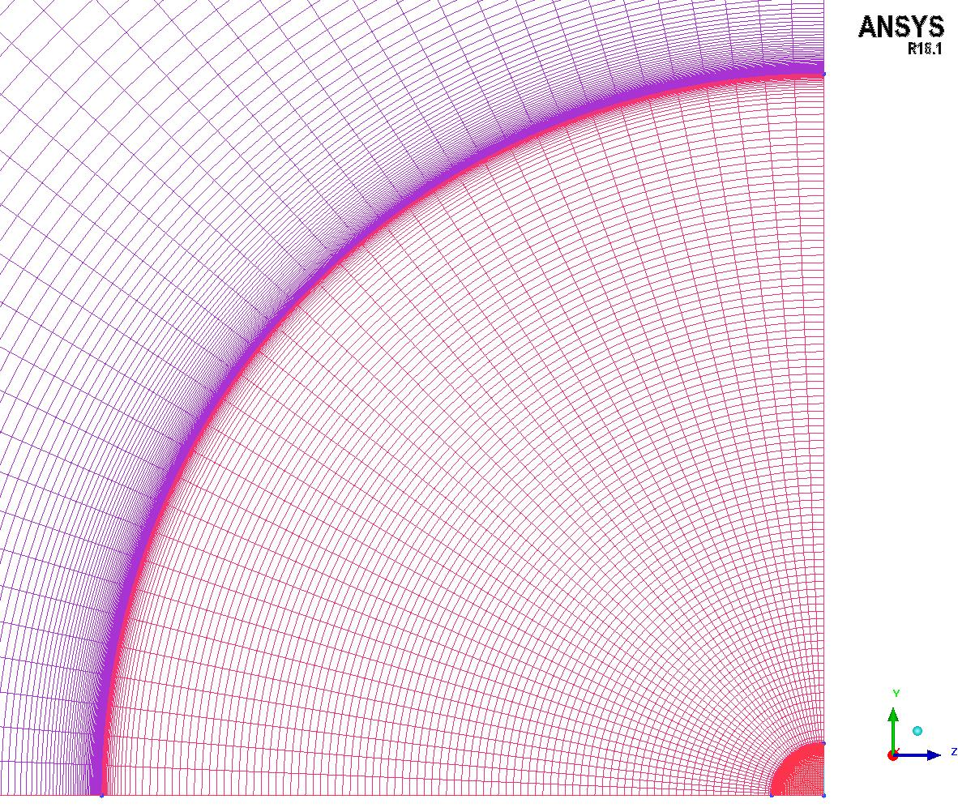

**Mesh 2**

**Mesh 3**

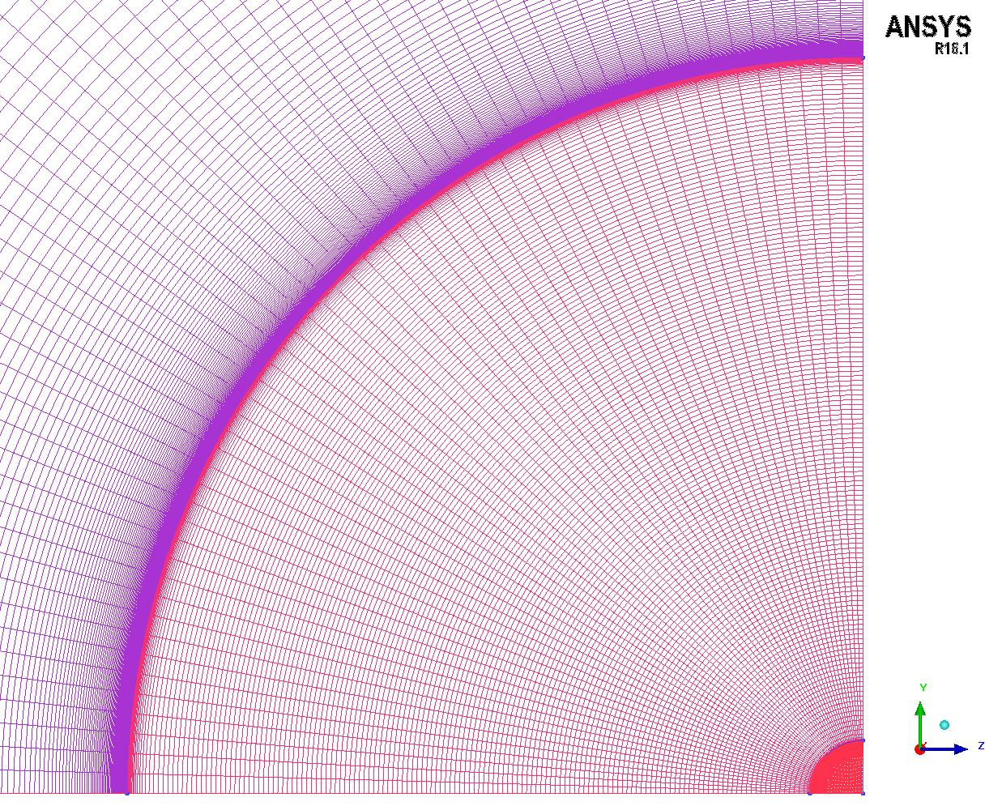

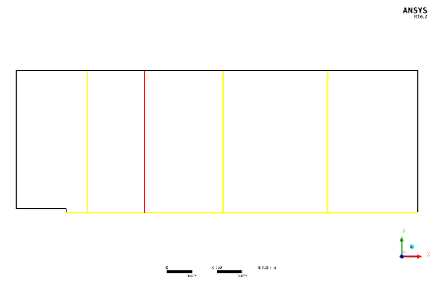

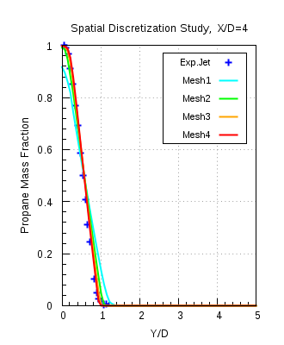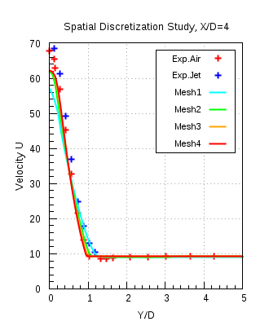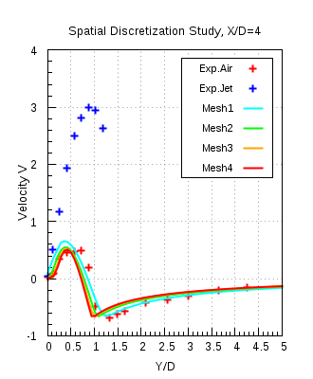

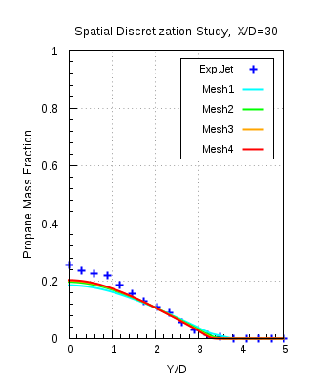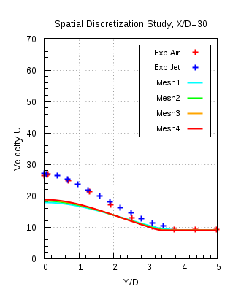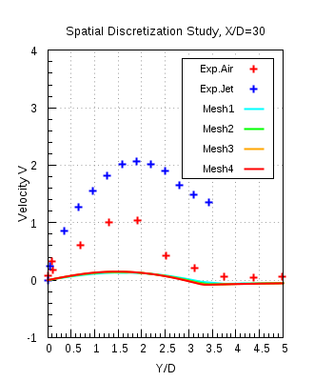

**References:**

1. R.W.Schefer and R.W.Dibble,”Mixture Fraction Field in a Turbulent Non-reacting Propane Jet”, AIAA Journal, vol.39, no.1, pp.64-72, 2001
2. R.W.Schefer, V.Hartmann and R.W.Dibble, “Conditional Sampling of Velocity in a Turbulent Nonpremixed Propane Jet”, AIAA Journal, vol.25, no.10, pp.1318-1330, 1987
3. Robert W. Schefer “Data Base for a Turbulent, Non-premixed, Non-reacting Propane-Jet Flow “, Sandia National Laboratories Research Report, pp. 1-21, 1985
4. E.J. Smith, J. Mi, G.J. Nathan and B.B. Dally, “Preliminary Examination of a" Round Jet Initial Condition Anomaly" for the k-ε Turbulence Model”, 15th Australian Fluid Mechanics Conference, 13-14 December 2004
5. S. B. Pope, “An Explanation of the Turbulent Round-Jet/Plane-Jet Anomaly”, AIAA Journal, vol.16, no.3, pp.279-281, 1978
6. The University of Sydney, Department of Mechanical and Mechatronic Engineering and Sandia National Laboratories Combustion Research Facility, “Turbulent Non premixed Combustion Data for Piloted and Bluff-Body Stabilized Flows”, http://sydney.edu.au/engineering/aeromech/thermofluids/bluff.htm
7. Dally, Bassam B., Masri, Assaad R., Fletcher, David F. “Modeling of bluff body recirculating flows”, Twelfth Australasian Fluid Mechanics Conference, The University of Sydney, Australia, pp. 529-532, 1995
8. B.B.Dally, D F Fletcher & A.R.Masri, “Flow and mixing fields of turbulent bluff-body jets and flames”, Combustion Theory and Modeling 2, pp.193-219, 1998
9. Jiyuan Tu, Guan Heng Yeoh and Chaoqun Liu, “Computational Fluid Dynamics A Practical Approach”, Elsevier, 2008
10. H K Versteeg and W Malalasekera, “An Introduction to Computational Fluid Dynamics THE FINITE VOLUME METHOD”, Pearson, 2007
11. ANSYS ICEM CFD USER GUIDE
12. ANSYS CFX THEORY GUIDE
13. ANSYS FLUENT THEORY GUIDE
14. ERCOFTAC CFD BEST PRACTICE GUIDELINES
15. Kai Liu, Stephen B. Pope, David A. Caughey, ”Calculations of bluff-body stabilized flames using a joint probability density function model with detailed chemistry”, Combustion and Flame, vol.141, pp.89-117, 2005
16. Robert W Elliott, Harry Watts, “Diffusion of some Hydrocarbons in Air: a Regularity in the Diffusion Coefficients of a Homologous Series”, Canadian Journal of Chemistry, vol.50,

pp. 31-34, 1972

1. Michael Andreas Wild, “General Purpose PDF Solution Algorithm for Reactive Flow Simulations in OpenFOAM”, ETH ZÜRICH , Doctoral Thesis, 2013
2. Christopher M. Briggs Jr., “Large Eddy Simulation of Non-Reacting Jet”, University of Maryland, Master Thesis, 2015
3. F.C.Gouldin, R.W.Schefer, S.C.Johnson, W.Kollmann, “Non-reacting Turbulent Mixing Flows”, Progress in Energy and Combustion Science, Volume 12, Issue 4, pp.257-303, 1986
4. Moss, J. B., “Simultaneous Measurements of Concentration and Velocity in an Open Premixed Turbulent Flame,” Combustion Science and Technology, Vol. 22, No. 1, pp. 119–129, 1980.
5. Driscoll, J. F., Schefer, R.W., and Dibble R.W., “Mass Fluxes Measured in a Turbulent Nonpremixed Flame,” Nineteenth Symposium (International)on Combustion, Combustion Inst., Pittsburgh, PA, pp. 477–485, 1982.
6. F.R.Menter, “Two-equation eddy-viscosity turbulence models for engineering applications”, AIAA-Journal., 32(8), pp. 1598 - 1605, 1994.
7. Yoshihide Tominagaa, Ted Stathopoulos, “Turbulent Schmidt numbers for CFD analysis with various types of flow-field”, Atmospheric Environment, Vol. 41, pp.8091-8099, 2007

**References:**

1. R.W.Schefer and R.W.Dibble,”Mixture Fraction Field in a Turbulent Nonreacting Propane Jet”, AIAA Journal, vol.39, no.1, pp.64-72, 2001
2. R.W.Schefer, V.Hartmann and R.W.Dibble, “Conditional Sampling of Velocity in a Turbulent Nonpremixed Propane Jet”, AIAA Journal, vol.25, no.10, pp.1318-1330, 1987
3. Robert W. Schefer “Data Base for a Turbulent, Non-premixed, Non-reacting Propane-Jet Flow “, Sandia National Laboratories Research Report, pp. 1-21, 1985
4. E.J. Smith, J. Mi, G.J. Nathan and B.B. Dally, “Preliminary Examination of a" Round Jet Initial Condition Anomaly" for the k-ε Turbulence Model”, 15th Australian Fluid Mechanics Conference, 13-14 December 2004
5. S. B. Pope, “An Explanation of the Turbulent Round-Jet/Plane-Jet Anomaly”, AIAA Journal, vol.16, no.3, pp.279-281, 1978
6. The University of Sydney, Department of Mechanical and Mechatronic Engineering and Sandia National Laboratories Combustion Research Facility, “Turbulent Non premixed Combustion Data for Piloted and Bluff-Body Stabilised Flows”, http://sydney.edu.au/engineering/aeromech/thermofluids/bluff.htm
7. Dally, Bassam B., Masri, Assaad R., Fletcher, David F. “Modeling of bluff body recirculating flows”, Twelfth Australasian Fluid Mechanics Conference, The University of Sydney, Australia, pp. 529-532, 1995
8. B.B.Dally, D F Fletcher & A.R.Masri, “Flow and mixing fields of turbulent bluff-body jets and flames”, Combustion Theory and Modeling 2, pp.193-219, 1998
9. Jiyuan Tu, Guan Heng Yeoh and Chaoqun Liu, “Computational Fluid Dynamics A Practical Approach”, Elsevier, 2008
10. H K Versteeg and W Malalasekera, “An Introduction to Computational Fluid Dynamics THE FINITE VOLUME METHOD”, Pearson, 2007
11. ANSYS CFX THEORY GUIDE
12. ANSYS FLUENT THEORY GUIDE
13. ERCOFTAC CFD BEST PRACTICE GUIDLINES

UJ  = 80 m/s

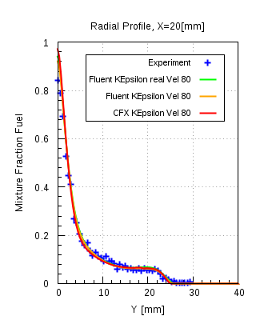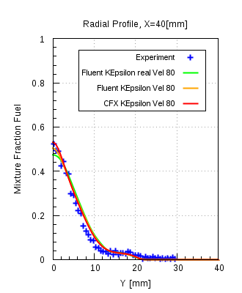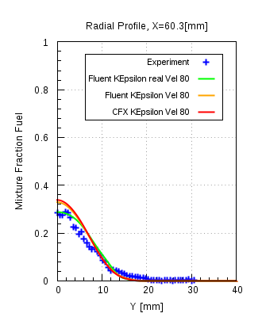

Ethylene, k-ω SST model

UJ  = 63 m/s

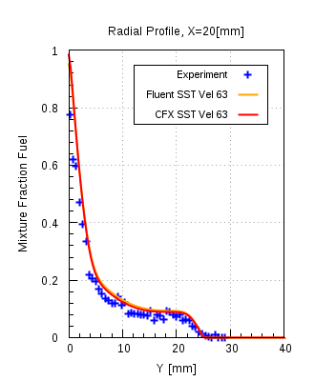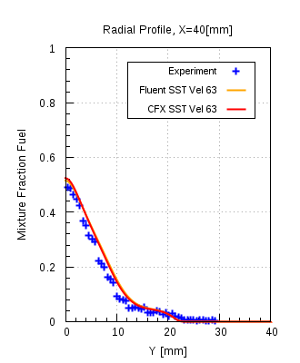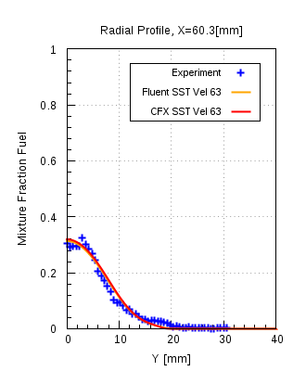

UJ  = 80 m/s

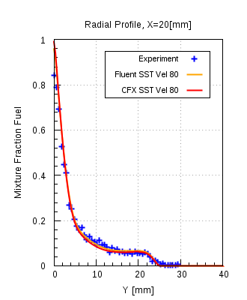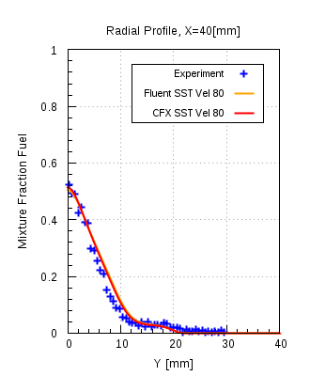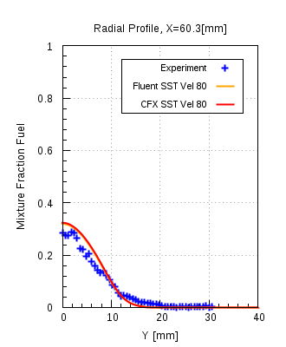

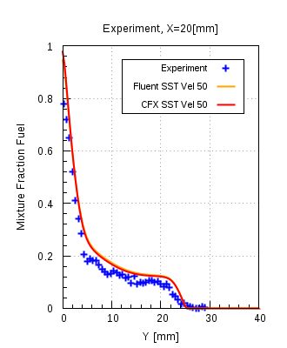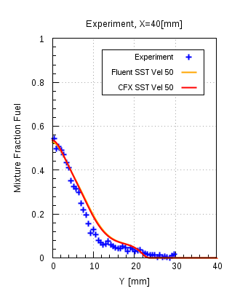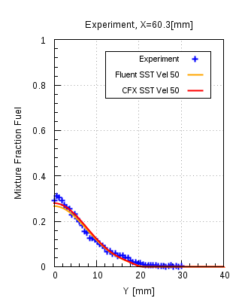

UJ = 85 m/s

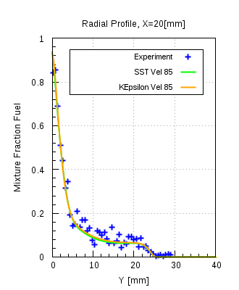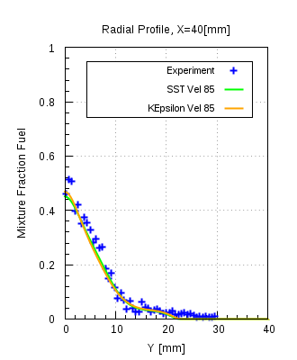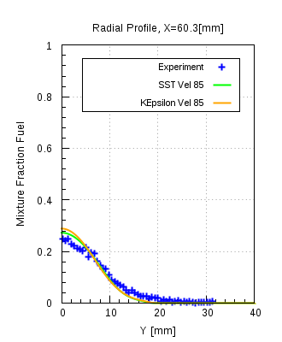



Ethylene

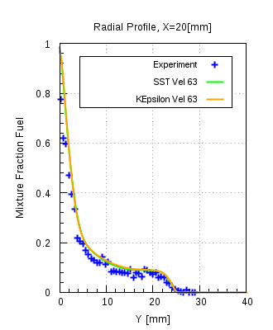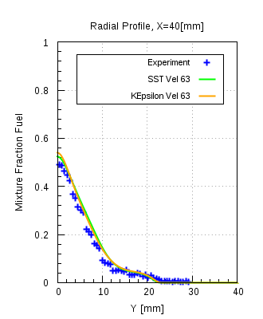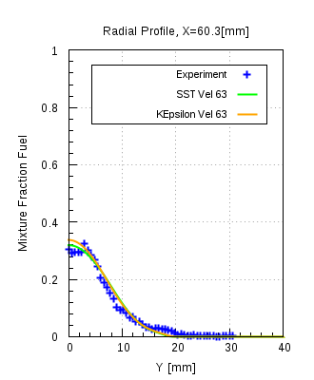

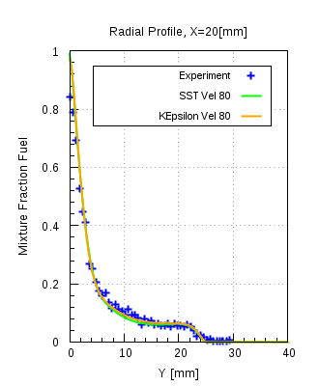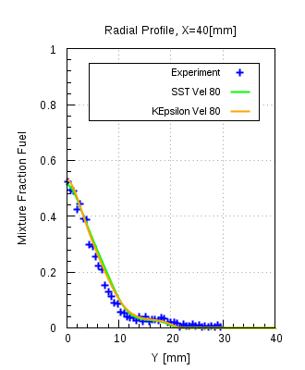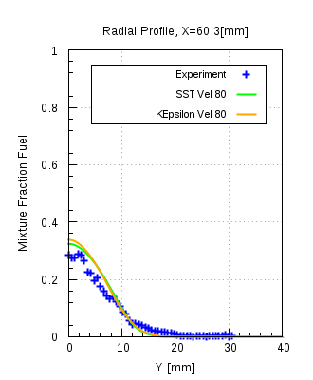

LPG:

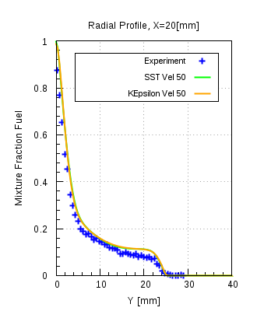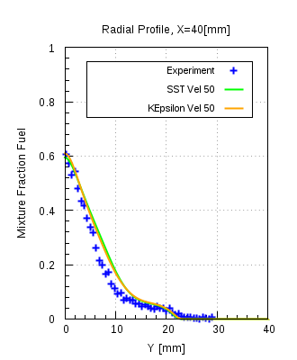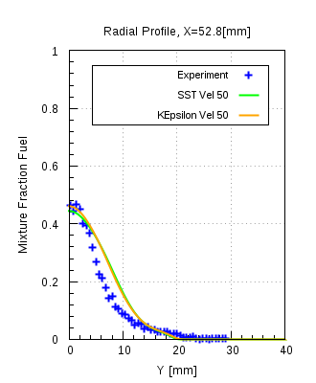

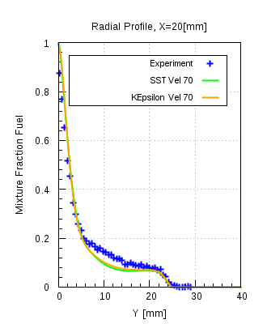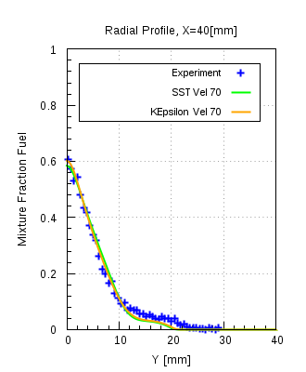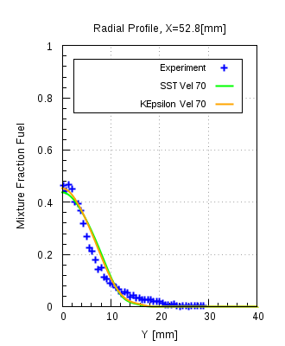

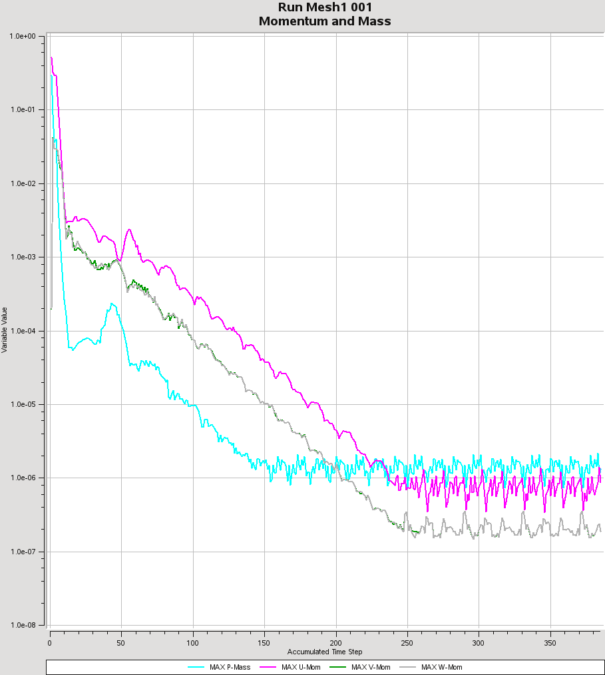

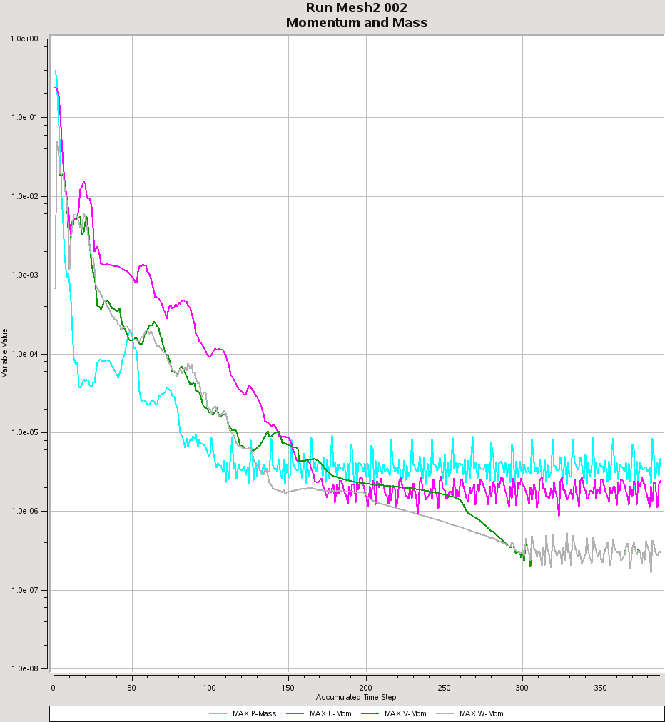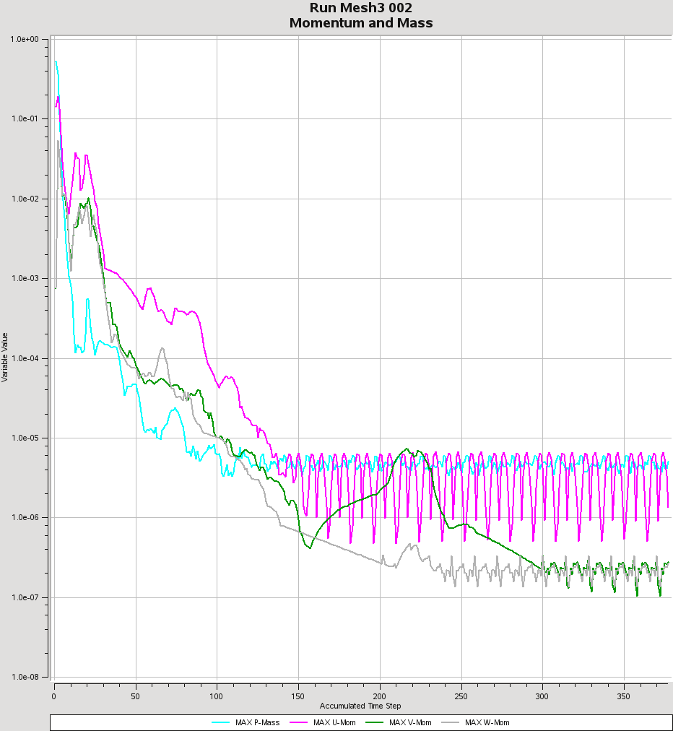

Iteration Steps

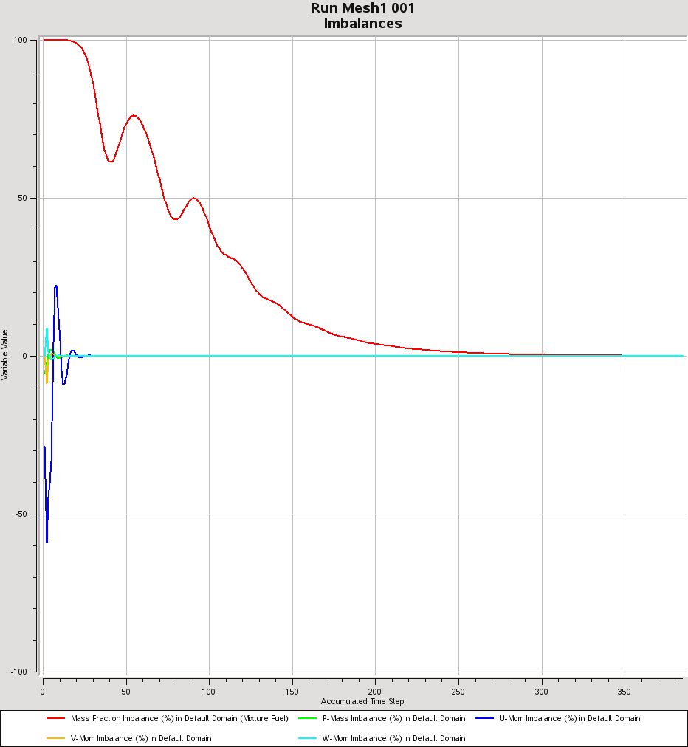

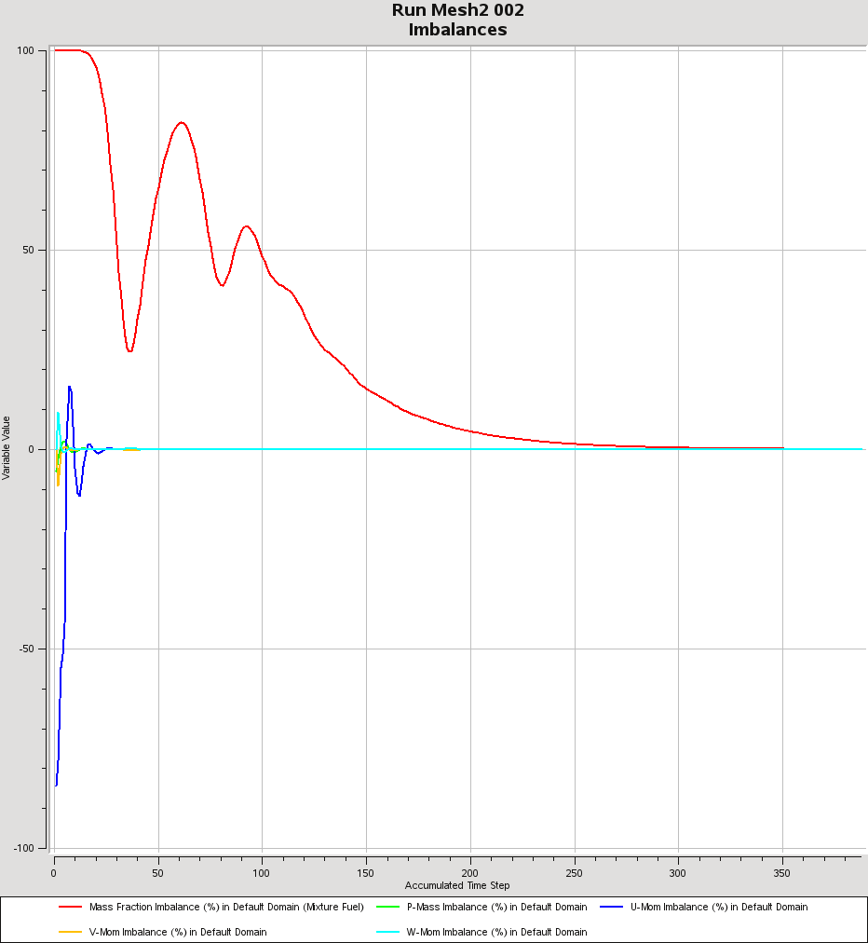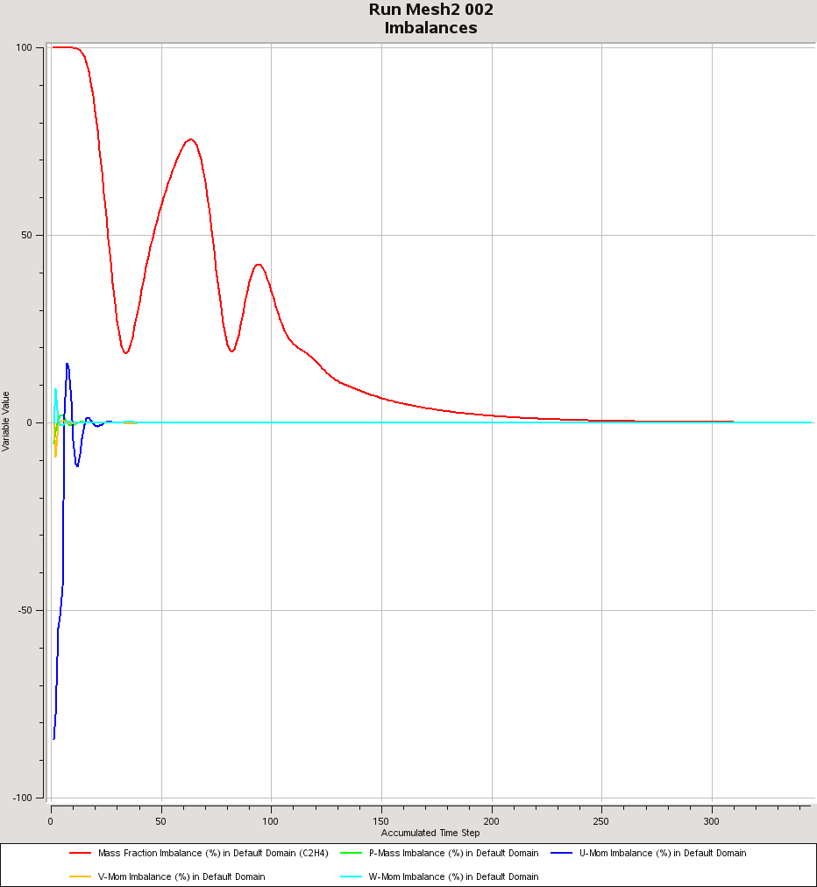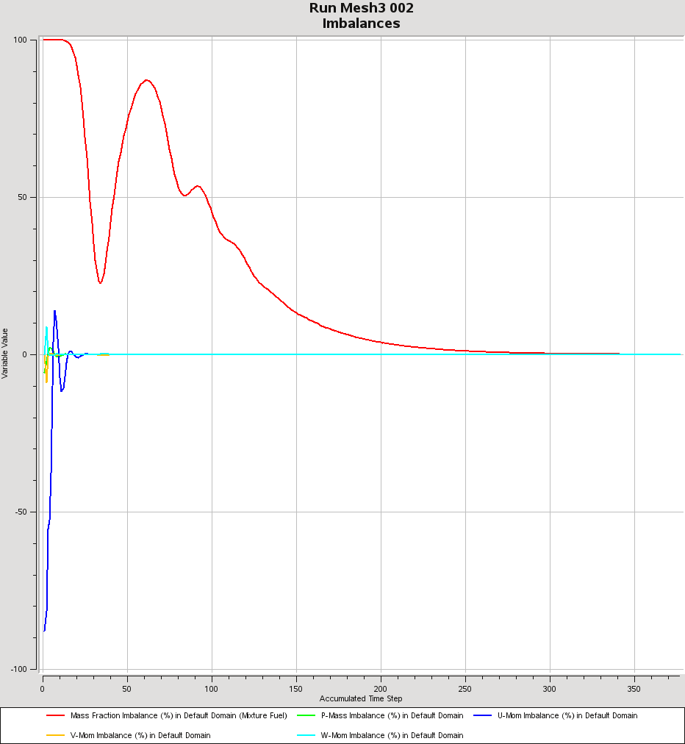

### Ethylene, k-ε model:

UJ  = 50 m/s

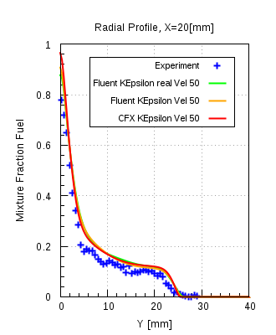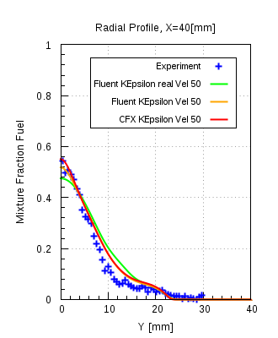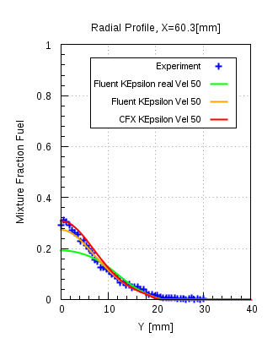

UJ  = 63 m/s

