Rajiv Gandhi University of Knowledge Technologies

IIIT .R.K Valley, YSR Kadapa (Dis)-516330

A Project Report on

Original Degree Registration(Online) Website for Graduates

Submitted By:-
M.M.Sravani(R180234)
M.Adi lakshmi (R180748)



under the guidance of Ms.M.Hima Bindu
(Assistant Professor)

Department of Computer Science Engineering

This project report has been submitted in fulfilment of the requirements for the Degreeof Bachelor of Technology in software Engineering.

August -2023

Rajiv Gandhi University of Knowledge Technologies

IIIT, R. K. Valley, YSR Kadapa (Dis)-516330



CERTIFICATE

This is tocertify that report entitled"Original Degree Registration(Online)WebsiteGraduates" Submitted by M.M.Sravani (R180234) and M.Adi lakshmi (R180748) in partial fulfilment of the requirements of the award of Bachelor of technology in computer science and engineering is a bona fide work by the under the supervision and guidance.

The report has been not submitted previously in part or full to this or any other university or
institute for the award of any degree or diploma.

GUIDE HEAD OF THE DEPARTMENT
Ms.M.Hima Bindu Mr. N.Satyanandram
Assistant Professor HOD OF CSE

Submitted for the practical examination held on………………………………………

External Examiner Internal Examiner

ACKNOWLEDGEMENT

The satisfaction that accompanies the successful completion of any task would heincomplete without the mention of the people who made it possible and who isconstant guidance and encouragement crown all the efforts success.

We would like to express my sincere gratitude to Ms.M.Hima Bindu my project guide for valuable suggestions and keen interest throughout the progress of our project.

We are grateful to Mr. N. Satyanandram HOD CSE ,for providing excellentcomputing facilities and congenial atmosphere for progressing our project.

At the outset, we would like to think Rajiv Gandhi University of KnowledgeTechnologies (RGUKT), for providing all the necessary resources and support for the successful completion of my course work.

RAJIV GANDHI UNIVERSITY OF KNOWLEDGE TECHNOLOGIES

(A.P.Government Act 18 of 2008)
RGUKT-RK Valley
Vempalli, Kadapa, Andhrapradesh-516330.

DECLARATION

We M.M.Sravani and M.Adi lakshmi are here by declare that the project report
entitled "Original Degree Registration (Online) Website for Graduates " done under
guidance Ms. M.Hima Bindu submitted in partial fulfillment for the degree of Bachelor of Technology in Computer Science and Engineering during the academic session September 2022 April 2023 at RGUKT-RK Valley. I also declare that this project is a result of our own effort and has not been copied or imitated from any source .Citations from any websites are mentioned in the references. To the best of my knowledge, the results embodied in this dissertation work have not been submitted to any university or institute for the award of any degree or diploma.

Date: M.M.Sravani (R180234)
place :RK Valley M.Adi lakshmi(R180748)

ABSTRACT

The project aims to streamline the process of original degree registration for graduate students of Rajiv Gandhi University of Knowledge Technologies (RGUKT) Andhra Pradesh (AP) through this website.
The current process is time-consuming and requires students to visit the university in person to submit their documents and complete the registration process.
The website will be designed with user-friendly interfaces to guide students through the registration process, and will be secured with strong encryption to protect the privacy and confidentiality of their personal information. By implementing this project, RGUKT AP aims to enhance the overall student experience and improve efficiency in its administrative processes.
Through this website student can register for their original degree priorly means before visiting the university.Admin process the registration and notify students about their details that includes dues to be paid,exams to be clear and so on.So that by looking into this students can plan their visit to the university accordingly and accurately by not wasting much time.

INDEX

S.NO | Title | Page No
1 | Introduction | 7
2 | System requirements | 8
3 | Purpose | 8
4 | Tools and technologies used | 8-10
5 | Proposed system | 10
6 | Diagrams | 11-14
7 | Code | 14-16
8 | Output | 17-18
9 | Conclusion | 19
10 | Reference | 20

Introduction

1.1 Purpose:

The purpose of an original degree registration website for graduates is to provide a convenient and efficient platform for graduates to register and obtain their original degree certificates. It allows graduates to submit their necessary documents and track the progress of their degree registration process online. After registration they will visit the college on certain date .By this saving time for both the graduates and the educational institution.No need to wait for the certificates in college.for this we have to do pre registration for certain period of time.If you
have any queries you can contact admin directly.

Background:
The background of an original degree registration website for graduates stems from the need to digitize and streamline the degree registration process. Traditional methods of degree registration often involve graduates physically visiting the university or college, submitting documents in person, and waiting for manual processing

1.3 Objectives:
The objective of an original degree registration website for graduates is to provide a convenient and efficient platform for graduates to register for and obtain their original degree certificates

1.4 Scope:
The scope of an original degree registration website for graduates typically includes features such as online communication channels with the educational institution.

1.5 Reference
- Google,
- Wikipedia,
- StackOverflow.

System requirements
Software requirements
- Html
- CSS
- PHP
- SQL server
- Javascript
- React js
- Node js
Hardware requirements
- Laptop

PURPOSE
By allowing students to register for their degree online, the application addresses the challenge of time-consuming campus visits.No need to wait for the certificates in college.for this we have to do pre registration for certain period of time.If you have any queries you can contact admin directly.

TOOLS AND TECHNOLOGIES USED
The various system tools that have been used in developing both front end, back end and other tools of the project are being discussed in this section.

FRONT END:

HTML, CSS, JAVASCRPIT are utilized to implement the frontend.

HTML (Hyper text markup language)
HTML is a syntax is used to format a text document on the web.

CSS (Cascading style sheets)
CSS is a style sheet language is used for describing the look and formatting of a document written in a markup language.

JAVASCRIPT
JS is a dynamic computer programming language. It is most commonly used as part of web browsers, whose implementations allow client side scripts to interact with the user, control the
browser, communicate asynchronously and alter the document content that is displayed.

REACTJS
ReactJS is an open-source JavaScript library for building user interfaces, focusing on creating dynamic, reusable components to efficiently update and render UI elements.

- Component-Based Architecture: React's core feature is its component-based structure, allowing developers to build and manage UI elements as self-contained, reusable components, streamlining development and maintenance.
- Virtual DOM: React's Virtual DOM efficiently updates only the necessary parts of the actual DOM, enhancing performance by minimizing costly re-rendering operations and enhancing user experience.
- Unidirectional Data Flow: React enforces a one-way data flow, making it easier to track and manage data changes, enhancing code predictability and reducing bugs.
- JSX (JavaScript XML): JSX enables developers to write HTML-like code within JavaScript, simplifying UI creation and providing a more intuitive way to define component structures.
- React Hooks: Hooks introduce a more functional approach to state and lifecycle management, allowing developers to use state and other React features without writing class components, promoting cleaner and more concise code.

BACKEND:

The backend is implemented using MYSQL which is used to design the databses.

MYSQL
SQL (Structured Query Language) is a vital component in web applications that rely on databases to store, manage, and retrieve data. Here are the top five features of SQL in web applications, along with brief explanations:
- Data Manipulation: SQL enables developers to insert, update, and delete data within a database. This is crucial for web applications that need to store user information, manage content, or track transactions.
- Data Retrieval: SQL provides powerful querying capabilities, allowing web applications to retrieve specific data from the database based on various conditions.
- Data Definition: SQL allows developers to define and manage the structure of the database, including creating tables, defining relationships between tables, and setting constraints to ensure data integrity. In a web application, this feature is essential for designing the underlying data architecture that supports the app's functionality.
- Data Security and Access Control: SQL supports fine-grained access control, enabling developers to restrict who can access, modify, or query specific parts of the database. This feature is crucial for web applications that handle sensitive user data, ensuring that only authorized individuals can access and modify the data.
NODE JS
Node. js is a single-threaded, open-source, cross-platform runtime environment for building fast and scalable server-side and networking applications. It runs on the V8 JavaScript runtime engine, and it uses event-driven, non-blocking I/O architecture, which makes it efficient and suitable for real-time applications.

EXPRESS JS
Express is a node js web application framework that provides broad features for building web and mobile applications. It is used to build a single page, multipage, and hybrid web application. It's a layer built on the top of the Node js that helps manage servers and routes

CORS
Cross-Origin Resource Sharing (CORS) is an HTTP-header based mechanism that allows a server to indicate any origins (domain, scheme, or port) other than its own from which a browser should permit loading resources

PROPOSED SYSTEM

The proposed system for an original degree registration website(online) for graduates would typically include features such as user pre registration before coming to the campus , admin notifies to the registered candidate about the time it takes to complete the registration process. It would also include functionalities for communication with administrators,faculty and access to thier academic results.

3.DIAGRAMS
Data Flow Diagram
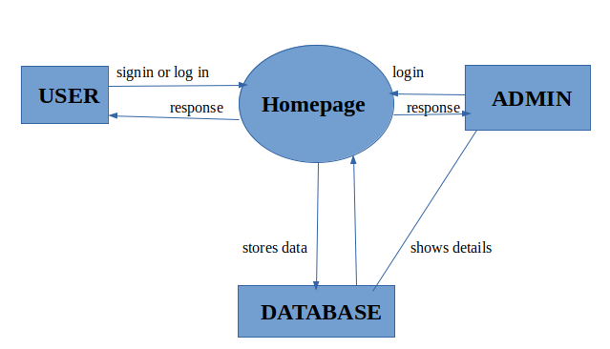

Class Diagram

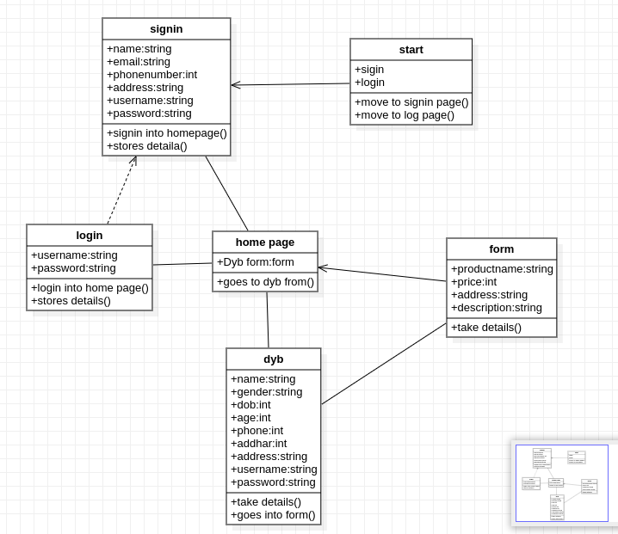

Object Diagram

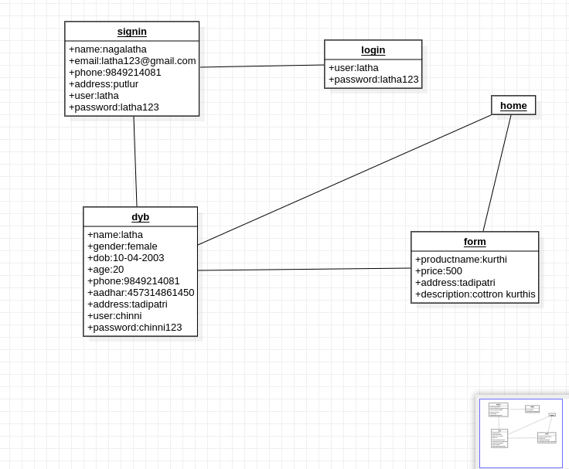

Usecase Diagram

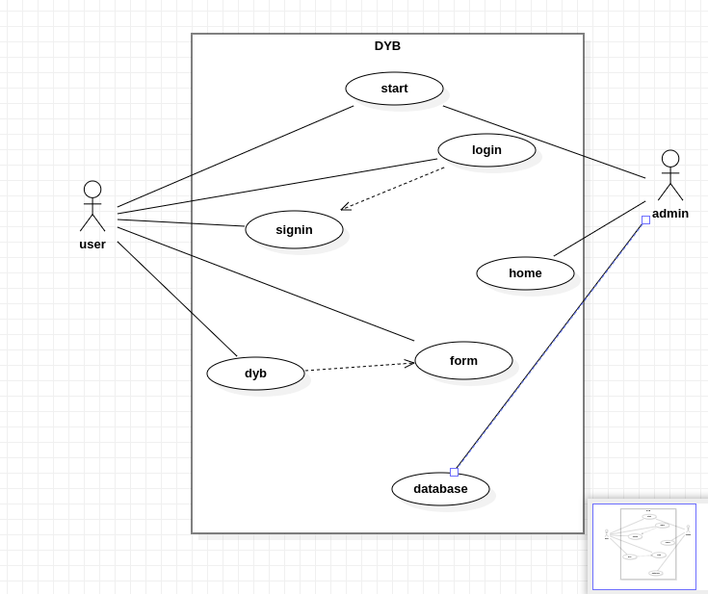

CODE
REGISTRATION PAGE

import React,{useState,useRef} from 'react';
import Axios from "axios";
import { useNavigate, Routes, Route ,Link } from "react-router-dom";
import emailjs from '@emailjs/browser';
function Registration() {
const [firstName,setFirstName]=useState('')
const [lastName,setLastName]=useState('')
const [collegeid,setCollegeid]=useState('')
const [mailId,setMailId]=useState('')
const [dateofarrival,setDateofarrival]=useState('')
const [error,setError]=useState(false)
const [cerror,setCerror]=useState(false)
const [merror,setMerror]=useState(false)
const [isSubmit, setIsSubmit]=useState(false)
const [registerStatus, setRegisterStatus] = useState("");
const form=useRef();
const handleSubmit=async(e)=>{
e.preventDefault();
if(firstName.length==0||lastName.length==0){
setError(true)
}
const rgExp = /^[RSON]{1}[0-9]{6}/
if(collegeid.length==0 ){
setCerror("cant be empty")
}
else if(!rgExp.test(collegeid)) {
setCerror("college Id is invalid")
}
else if(collegeid.length>=8) {
setCerror("college Id is invalid")
}
else{
setCerror(" ");
}
const mailExp = /^[rson0-9._%+-]+@rgukt[a-z]{3,4}\.ac\.in$/;
if(mailId.length==0) {
setMerror("cant be empty");
}
else if(!mailExp.test(mailId)) {
setMerror("MailId is invalid");
}
else{
setMerror(" ");
}

emailjs.sendForm('service_rqcwath','template_ef9s7ga',form.current,'4rxpUElcypJmEzNO-',);
console.log("okk...mailsent");
console.log("Sending data:", {
firstName,
lastName,
collegeid,
mailId,
dateofarrival,
});
Axios.post("http://localhost:3001/handleSubmit", {
firstName: firstName,
lastName: lastName,
collegeid: collegeid,
mailId: mailId,
dateofarrival: dateofarrival,
}).then((response) => {
console.log("Axios response:", response.data);
if (response.data.message) {
setRegisterStatus(response.data.message);
} else {
setRegisterStatus("SUCCESSFULLY REGISTERED");
}
})
}
return (
<div align="center" >
<h1 style={{fontSize: '15px', textAlign: 'center', marginTop: '20px'}}>{registerStatus}</h1>
<div className="regform" align="center"><br/>
<h3 id="cred">Enter your Credentials:</h3>
<form ref={form}className="formtxt"htmlFor="email_to" >
<label className="form-label" htmlFor="">First Name:<input type="text" className="form-control" name="fname" id="fname" placeholder="enter your firstname" onChange={e=>setFirstName(e.target.value)}/></label><br/>
{error&&firstName.length<=0?
<label className="error">First Name can't be Empty</label>:""}<br/>
<label class="form-label">Last Name:<input type="text" name="lname" className="form-control" id="lname" placeholder="enter your lastname"onChange={e=>setLastName(e.target.value)} /></label><br/>
{error&&lastName.length<=0?
<label className="error" >Last Name can't be Empty</label>:""}<br/>
<label class="form-label">College ID:<input type="text" name="id" className="form-control" id="id" placeholder="enter your ID" value={collegeid} onChange={e=>setCollegeid(e.target.value)}/></label><br/>
<label className="error" htmlFor="">{cerror}</label><br/>
<label class="form-label" >Email:<input type="email" name="mail" className="form-control" id="mail" placeholder="enter your mailid" value={mailId} onChange={e=>setMailId(e.target.value)}/></label><br/>
<label className="error">{merror}</label><br/>
<label class="form-label">Day of arriaval:<input type="date" className="form-control"name="date" id="date" value={dateofarrival} min={new Date().toISOString().split('T')[0]} onChange={e=>setDateofarrival(e.target.value)}required/></label><br/>
<input className="btn btn-secondary" type="submit" onClick={handleSubmit} value="Register" />
</form>
<br/></div>
</div>
)}
export default Registration;

OUTPUT:

MAIL for USERS:
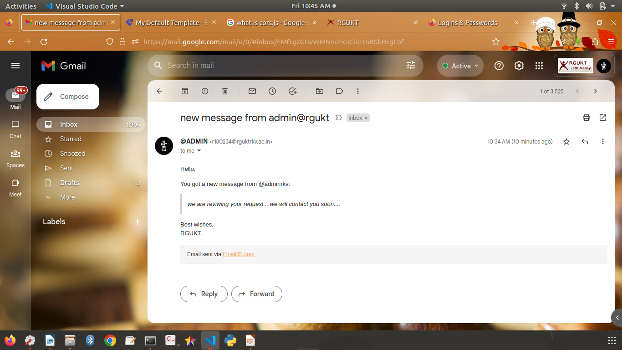

MAIL for ADMIN:
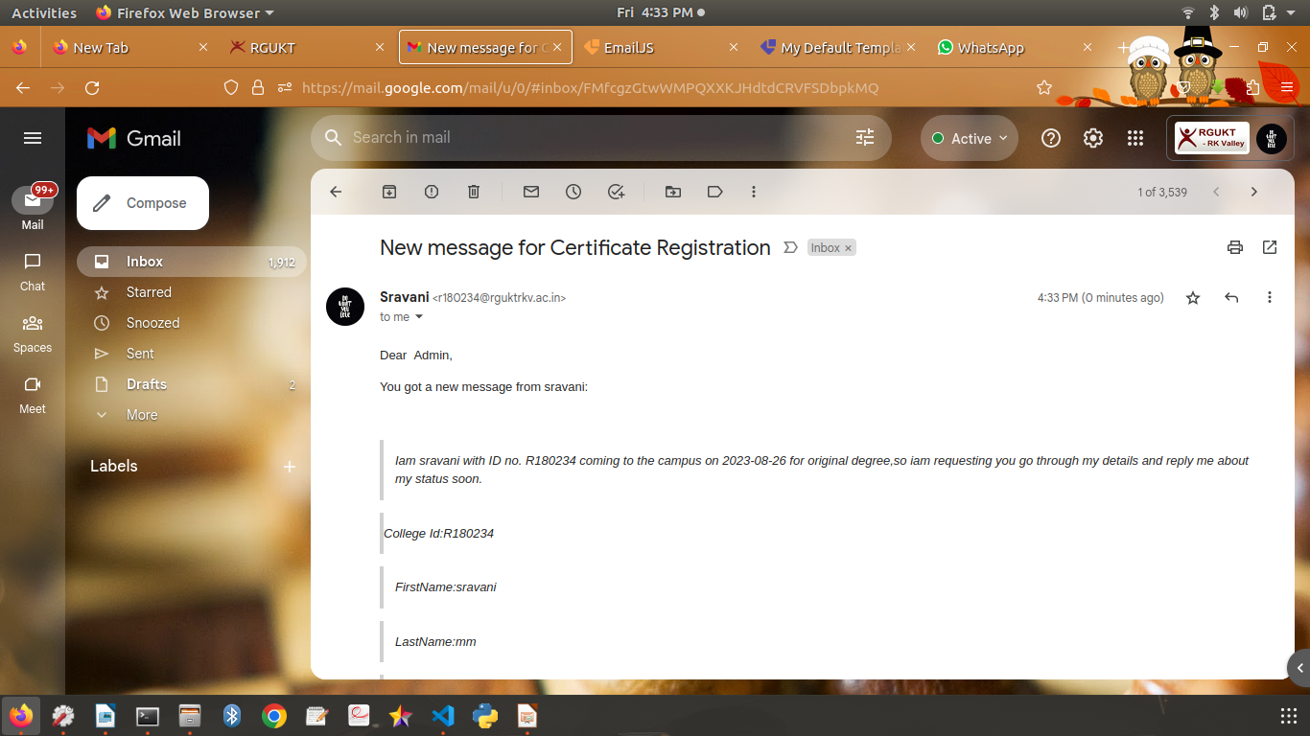

Queries Page:

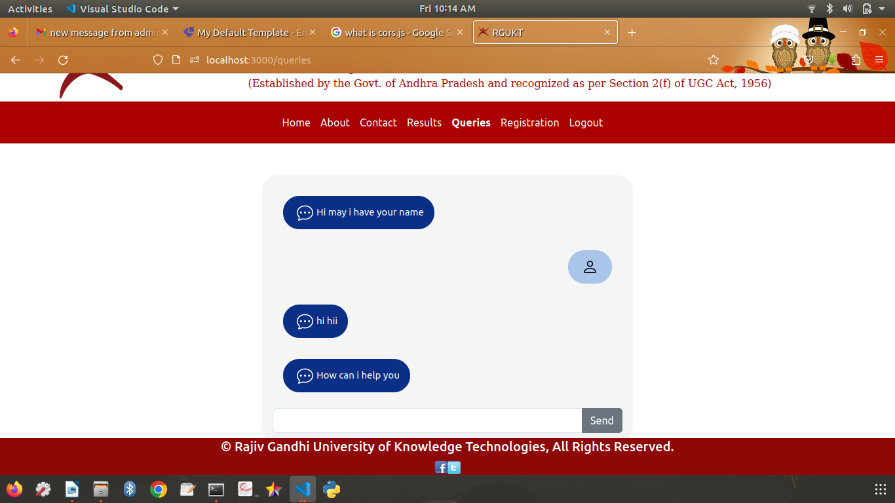

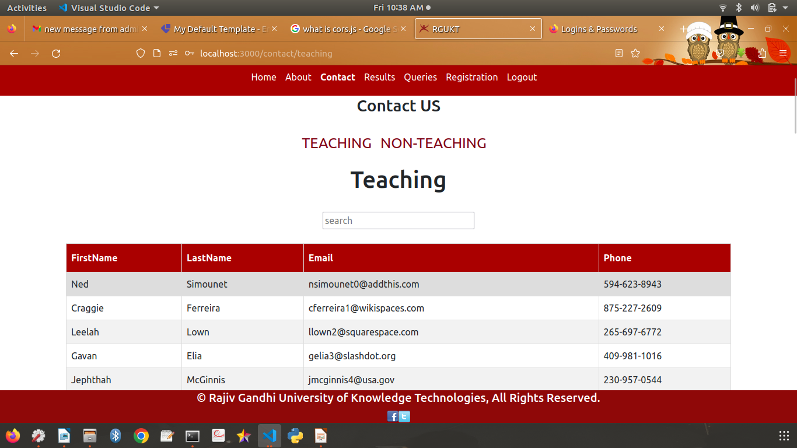
Contact Page:

CONCLUSION:

In conclusion, the online web application designed for original degree registration serves as an efficient and time-saving solution for individuals pursuing their degrees. The primary objective of this application is to minimize the time that is taken while making physical visits to the campus.
By allowing students to register for their degree online, the application addresses the challenge of time-consuming campus visits. This is achieved by notifying users about their pending dues and necessary requirements for certificate issuance. As a result, users can better plan their journey and allocate the necessary time for collecting their degree certificates.
The application's effectiveness lies in its ability to provide users with timely information, helping them to be well-prepared and informed about the steps they need to take. This proactive approach enhances the overall user experience and reduces the uncertainty and inconvenience associated with the traditional degree collection process.
It's important to note that while the application optimizes the degree collection process, it doesn't eliminate the need for a campus visit entirely. Instead, it acts as a bridge between the administrative processes and the students, ensuring smoother communication and improved planning.
In conclusion, the original degree registration web application efficiently addresses the time constraints and uncertainties associated with degree collection by providing users with essential notifications and updates.

REFERENCES:

- https://www.google.com/
- https://react.dev/
- https://stackoverflow.com/
- https://javascript.plainenglish.io/create-a-single-page-website-using-node-js-and-express-js-a0b53e396e4f
- https://www.rgukt.in/

