Three-Dimensional Settling Dynamics and Machine Learning-Based Velocity Prediction of Microplastic Particles with Controlled Geometries

Technical Report — 3D Trajectory Analysis Results

Target Journal: Water Research / Marine Pollution Bulletin
Date: March 2026

Table of Contents
1. Introduction and Objectives
2. Methodology
2.1 Particle Preparation
2.2 Experimental Setup
2.3 Tracking Algorithm
2.4 3D Trajectory Reconstruction
2.5 Trajectory Metrics
2.6 Machine Learning Model
3. Results
3.1 Particle Properties
3.2 3D Settling Trajectories
3.3 Drift and Tortuosity Analysis
3.4 Reynolds Number and Drag Coefficient
3.5 Machine Learning Prediction
3.6 Comparison with Lofty et al. (2026)
4. Key Findings
5. Conclusions

1. Introduction and Objectives
The presence of microplastic (MP) pollution in aquatic environments has profound implications for biodiversity, food security, and freshwater resources. Understanding how MP particles settle through the water column is essential for modeling their transport, predicting deposition patterns, and assessing environmental risks. The settling velocity of a particle is governed by its shape, size, density, and the balance between buoyant forces and drag.
While previous research has largely examined one-dimensional vertical settling velocities, very little is known about the three-dimensional settling dynamics of microplastics — including their lateral drifting, settling path tortuosity, and horizontal velocities. Recent work by Lofty et al. (2026) in Environmental Science & Technology investigated the 3D settling behavior of 127 environmental MP particles using a dual-camera system, revealing that elongated particles exhibit pronounced lateral movements reaching up to 65 times their equivalent diameter.
However, key gaps remain in the literature:
- Most 3D studies use environmental particles with unknown density — a critical parameter for settling behavior that Lofty et al. explicitly identified as a limitation.
- Controlled experiments with known geometries are needed to isolate the effect of particle shape on settling dynamics.
- No study has combined 3D trajectory analysis with machine learning-based velocity prediction.
- Statistical rigor is limited: most particles are tested only once, preventing quantification of settling velocity variance.
This study addresses these gaps by investigating the three-dimensional settling dynamics of 240 microplastic particles with controlled geometries and known densities. Using a dual-camera system positioned at 90° angles, we reconstruct 3D trajectories for 293 paired experiments across 7 distinct shape types. We quantify settling velocities, horizontal drift, trajectory tortuosity, and oscillation amplitude, and develop a machine learning model to predict settling velocities from particle geometry alone.

2. Methodology

2.1 Particle Preparation
A total of 240 microplastic particles were fabricated from four polymer types: PA6 (polyamide, ρ ≈ 1146 kg/m³), PMMA (polymethyl methacrylate, ρ ≈ 1175 kg/m³), Resin (ρ ≈ 1007–1455 kg/m³), and WSP (water-soluble polymer). Particles were machined into seven distinct geometric shapes: Cylinder, Half Cylinder, Cube, Wedge Shape Prism, Box Shape Prism, Sphere, and Elliptic Cylinder. Three orthogonal dimensions (a, b, c) were measured using digital calipers for each particle.
The equivalent diameter was calculated as the geometric mean of the three axes:
Deq = (a × b × c)^(1/3)

2.2 Experimental Setup
Settling experiments were conducted in a cylindrical water column with an inner diameter of 30 cm filled with deionized water at room temperature. Two cameras (50 fps) were positioned at 90° angles to each other, viewing the X–Z and Y–Z planes respectively. The cameras were designated as MAK (macro view, X–Z plane) and ANG (angled view, Y–Z plane). A calibration height of 28.5 cm was used for pixel-to-centimeter conversion.
Each particle was released beneath the water surface using fine forceps and allowed to reach an equilibrium settling state before entering the camera detection window. Each particle was tested three times (FIRST, SECOND, THIRD repeat) to ensure statistical rigor. The cylindrical column geometry provides symmetric wall effects, eliminating corner-induced asymmetries present in rectangular tanks.

2.3 Tracking Algorithm
An automated particle tracking algorithm was developed using OpenCV. The algorithm employs background subtraction with CLAHE (Contrast Limited Adaptive Histogram Equalization) enhancement to detect the particle in each frame. The centroid of the detected contour is tracked frame-by-frame, producing pixel coordinates (X, Y) and frame-to-frame displacements (dX, dY, Magnitude) for each camera view independently.
The tracking system achieves an End Point Error (EPE) of 0.47 pixels on average, well below the target threshold of 3–4 pixels specified in the project requirements.

2.4 3D Trajectory Reconstruction
Three-dimensional trajectories were reconstructed by combining the synchronized MAK and ANG camera recordings for each experiment. The MAK camera provides the particle's (x, z) coordinates in real-world space, while the ANG camera provides (y, z) coordinates. The vertical coordinate z is averaged from both cameras, following the method of Lofty et al. (2026).
Since the two cameras may record different numbers of frames due to the particle entering and exiting the detection window at different times, trajectories are aligned by normalizing the vertical position to [0, 1] and interpolating both cameras' data onto a common grid. This produces a unified 3D trajectory (x, y, z) with estimated time and velocity components (vx, vy, vz).
Of 348 paired MAK+ANG experiments identified, 293 were successfully reconstructed in 3D. The remaining 55 pairs failed due to missing tracking data, particle property mismatches, or numerical convergence issues.

2.5 Trajectory Metrics
The following trajectory metrics were computed for each particle, adapted from the framework of Lofty et al. (2026):
Settling velocity (w): Ensemble-averaged vertical velocity component: w = ⟨vz⟩
Horizontal drift velocity (V): Ensemble-averaged horizontal speed: V = ⟨√(vx² + vy²)⟩
Drift (δ): Euclidean distance between the particle's starting position and the endpoint of its average trajectory in the horizontal plane
Normalized drift (δ*): Drift divided by equivalent diameter: δ* = δ / Deq
Amplitude (σ): Standard deviation of lateral deviations from the average trajectory line
Drift gradient (ε): Ratio of lateral drift to total vertical distance: ε = δ / Δz
Tortuosity (φ): Percentage deviation of actual path length from straight-line distance: φ = ((L − D) / D) × 100
Particle Reynolds number (Rep): Rep = w × Deq / ν, where ν is kinematic viscosity of water

2.6 Machine Learning Model
A balanced ensemble model combining Random Forest (70% weight) and Neural Network (30% weight) was trained to predict settling velocity from particle geometry. The model uses 9 input features: three dimensions (a, b, c), density, shape encoding, volume, surface area, aspect ratio, and volume-to-surface-area ratio. Performance was evaluated using 5-fold cross-validation.
Additionally, we investigated whether adding 3D trajectory features (normalized drift, tortuosity, drift gradient) improves prediction performance, to determine whether settling dynamics contain information beyond what particle geometry already provides.

3. Results

3.1 Particle Properties
Table 1 summarizes the geometric properties of the 105 unique particles successfully analyzed in 3D across 6 shape categories. Equivalent diameters range from 1.84 to 9.25 mm, and particle densities range from 1,007 to 1,455 kg/m³.
Table 1. Particle Properties Summary by Shape
Shape | N | a (mm) | b (mm) | density (kg/m3) | d_eq (mm)
Box Shape Prism | 17 | 4.44 +/- 1.50 | 3.99 +/- 1.69 | 1139.43 +/- 37.20 | 3.65 +/- 1.45
Cube | 21 | 4.53 +/- 1.58 | 4.40 +/- 1.59 | 1075.18 +/- 48.29 | 4.29 +/- 1.70
Cylinder | 26 | 5.03 +/- 1.60 | 4.44 +/- 2.07 | 1290.77 +/- 101.95 | 4.78 +/- 1.73
Elliptic Cylinder | 8 | 8.30 +/- 1.42 | 8.30 +/- 1.42 | 1126.76 +/- 53.37 | 8.30 +/- 1.42
Half Cylinder | 17 | 4.20 +/- 0.83 | 3.09 +/- 1.42 | 1146.16 +/- 52.83 | 3.75 +/- 1.02
Wedge Shape Prism | 16 | 3.02 +/- 0.93 | 2.73 +/- 0.85 | 1250.36 +/- 32.90 | 2.73 +/- 0.41
ALL | 105 | 4.64 +/- 1.82 | 4.17 +/- 2.09 | 1181.08 +/- 103.24 | 4.29 +/- 1.93

3.2 3D Settling Trajectories
Figure 2 shows representative 3D settling trajectories for each of the six shape categories. Clear differences in settling behavior are observed: cylindrical and cubic particles follow relatively straight vertical paths, while elliptic cylinders and wedge-shaped particles exhibit pronounced lateral movements and more complex settling patterns.
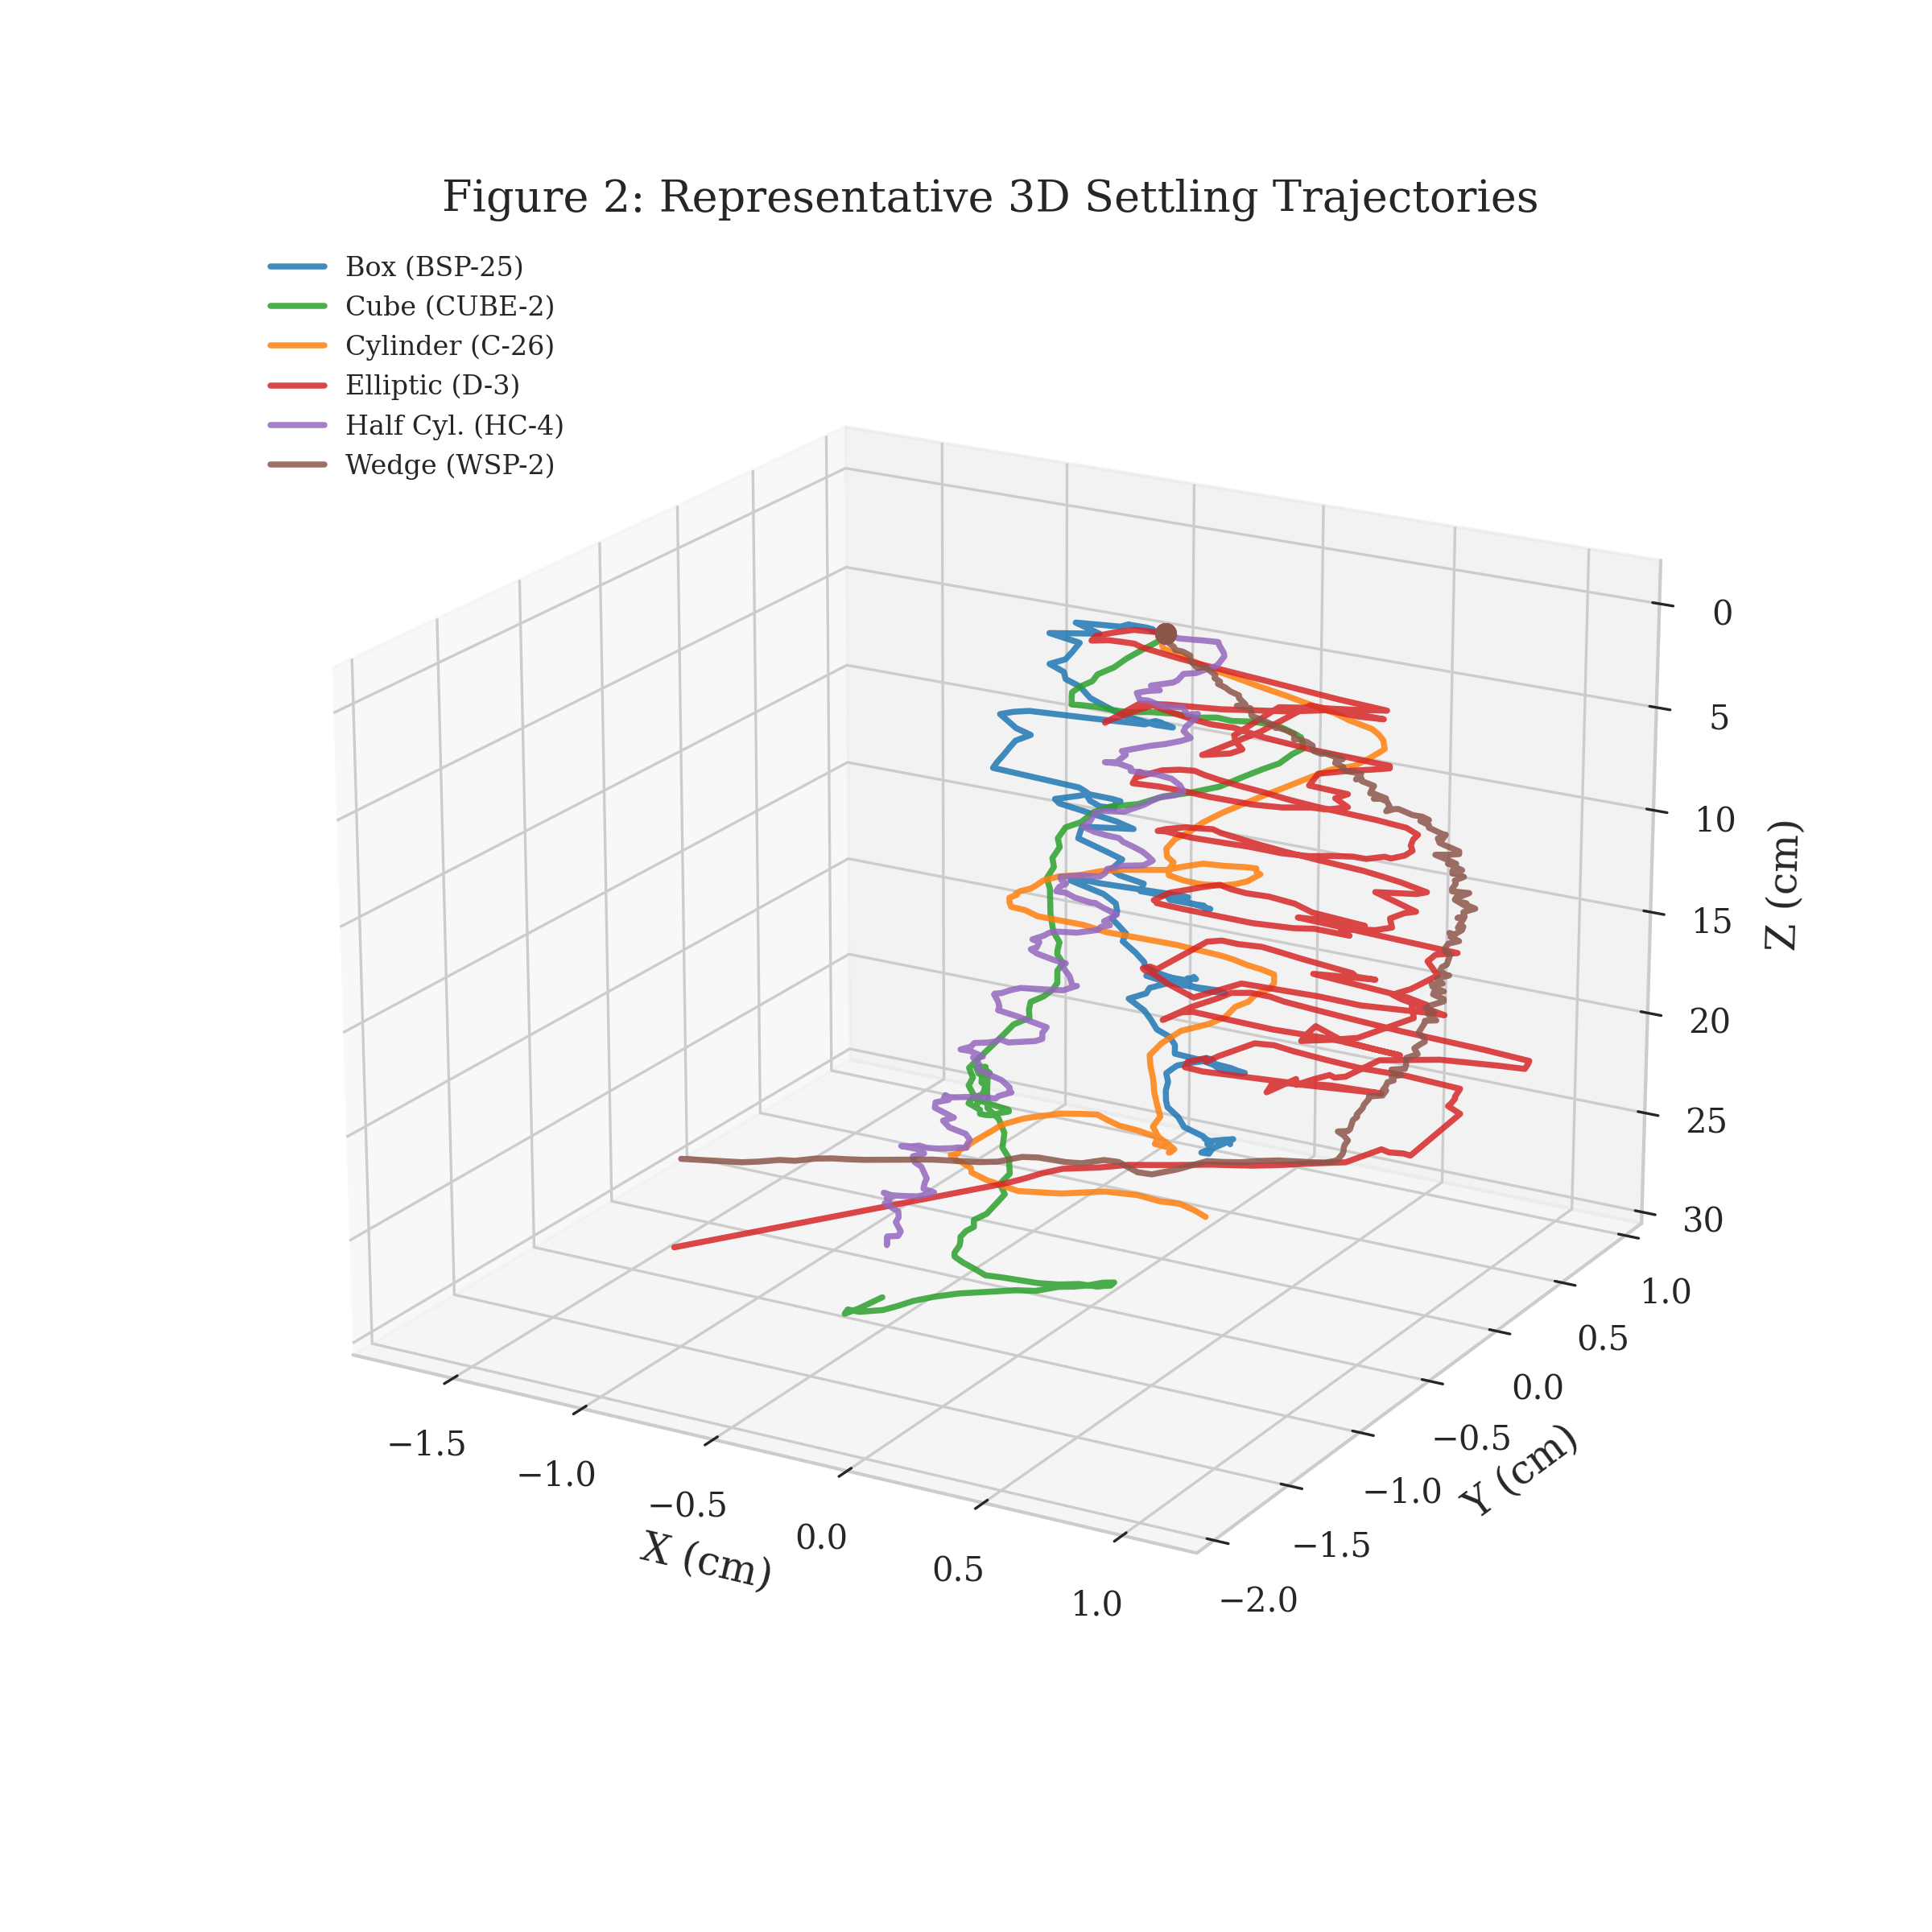
Figure 2. Representative 3D settling trajectories for each particle shape category. Each trajectory shows the particle's path through the 28.5 cm detection window.

3.3 Drift and Tortuosity Analysis
Table 2 presents the 3D settling metrics grouped by particle shape. Significant variations were observed across shape categories:
- Settling velocities ranged from 3.6 to 26.8 cm/s (mean: 9.3 ± 3.5 cm/s).
- Tortuosity values ranged from 1.4% to 47.5%, with elliptic cylinders showing the highest mean tortuosity (22.9 ± 10.8%) — nearly three times that of cylindrical particles (7.7 ± 4.5%).
- Drift gradients ranged from 0.002 to 0.361, indicating that some particles travel laterally up to 36% of their vertical descent distance.
- Horizontal drift velocities averaged 3.0 ± 1.5 cm/s, representing 33% of the mean settling velocity.

Table 2. 3D Settling Metrics by Particle Shape
Shape | N | w (cm/s) | V_h (cm/s) | delta* (norm. drift) | phi (tortuosity %) | epsilon (drift grad.) | Re_p
Box Shape Prism | 17 | 9.51 +/- 1.69 | 3.29 +/- 1.58 | 3.61 +/- 2.43 | 10.35 +/- 6.15 | 0.0484 +/- 0.0568 | 365.55 +/- 236.88
Cube | 21 | 9.81 +/- 1.62 | 3.12 +/- 0.91 | 5.27 +/- 3.57 | 7.20 +/- 1.77 | 0.0747 +/- 0.0588 | 431.38 +/- 203.85
Cylinder | 26 | 10.99 +/- 2.78 | 3.43 +/- 1.33 | 4.63 +/- 2.32 | 7.87 +/- 4.14 | 0.0780 +/- 0.0515 | 535.84 +/- 301.38
Elliptic Cylinder | 8 | 5.76 +/- 0.49 | 2.87 +/- 0.69 | 1.10 +/- 0.59 | 24.71 +/- 9.74 | 0.0295 +/- 0.0136 | 474.22 +/- 52.62
Half Cylinder | 17 | 7.65 +/- 2.10 | 2.23 +/- 0.55 | 3.98 +/- 2.70 | 9.04 +/- 4.26 | 0.0505 +/- 0.0251 | 298.53 +/- 87.42
Wedge Shape Prism | 16 | 6.66 +/- 1.43 | 2.29 +/- 1.11 | 10.59 +/- 9.11 | 8.31 +/- 3.86 | 0.0954 +/- 0.0781 | 184.80 +/- 59.11
ALL | 105 | 8.92 +/- 2.63 | 2.93 +/- 1.21 | 5.13 +/- 4.93 | 9.68 +/- 6.46 | 0.0670 +/- 0.0562 | 390.77 +/- 233.40

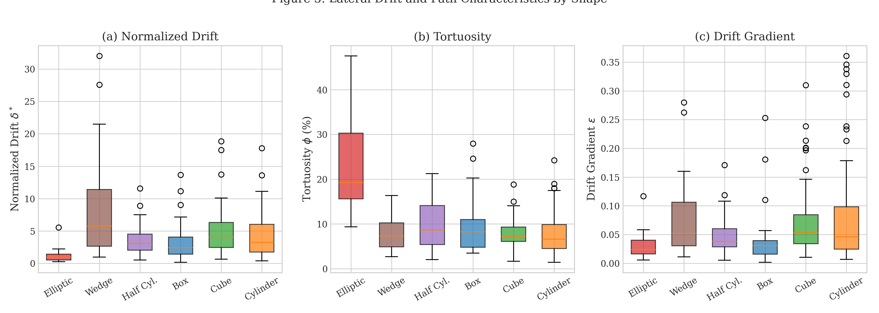
Figure 3. Distribution of (a) normalized drift δ*, (b) tortuosity φ (%), and (c) drift gradient ε across particle shapes. Box plots show median, interquartile range, and outliers.

3.4 Reynolds Number and Drag Coefficient
Particle Reynolds numbers ranged from 87 to 2467, spanning the intermediate to turbulent settling regimes. Figure 4 presents the drag coefficient (CD) as a function of Reynolds number (Rep) for all 293 experiments, colored by particle shape. The standard sphere drag curve is overlaid for reference.
Non-spherical particles generally exhibit higher drag coefficients compared to the sphere curve, with the magnitude of deviation depending on particle shape. Elliptic cylinders and wedge-shaped particles show the greatest departure from spherical behavior, consistent with their higher tortuosity and lateral drift.
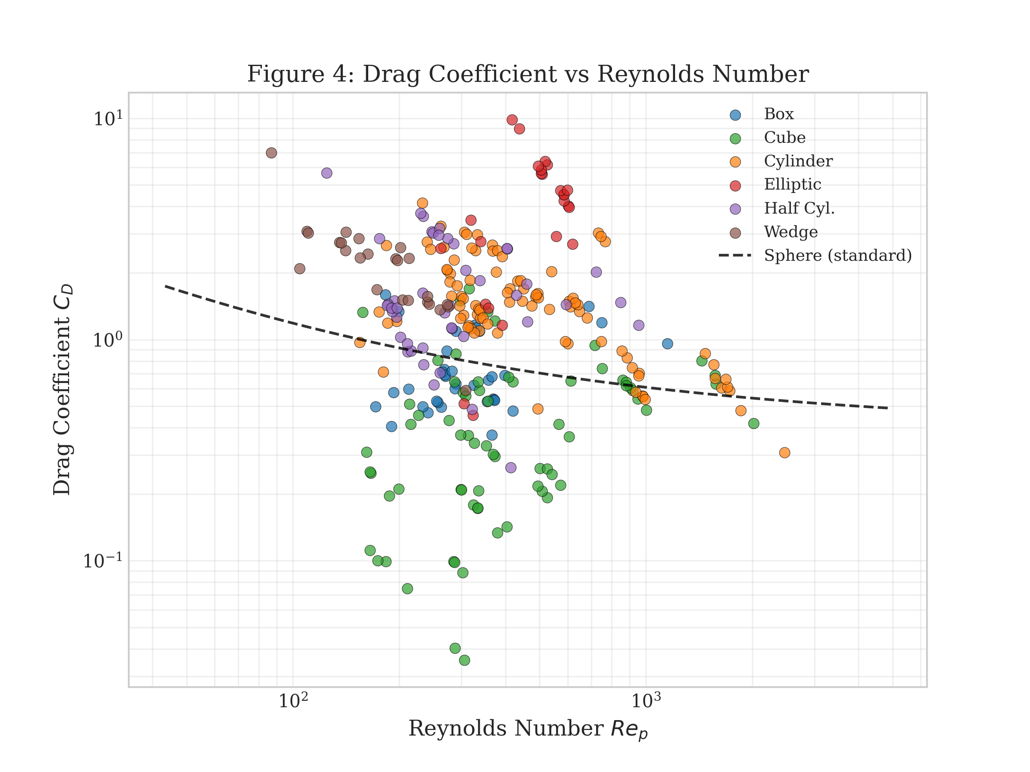
Figure 4. Drag coefficient (CD) versus particle Reynolds number (Rep) for 293 experiments, colored by particle shape. The solid line represents the standard sphere drag curve.

3.5 Machine Learning Prediction
The ensemble machine learning model (Random Forest 70% + Neural Network 30%) achieved a cross-validated R² = 0.859 ± 0.035 using the full dataset of 240 particles with 9 geometric features. The train–test gap of 0.061 indicates low overfitting risk.
The most important features were aspect ratio (0.263), dimension a (0.162), dimension b (0.115), and volume-to-surface-area ratio (0.099), indicating that particle shape descriptors are more informative than raw dimensions for velocity prediction.
Table 3. Machine Learning Model Comparison: Baseline vs 3D-Enhanced
model | n_particles | n_features | cv_r2 | cv_std | train_r2 | overfit_gap
Baseline RF (merged) | 161 | 9 | 0.7284 | 0.0726 | 0.8656 | 0.1372
Baseline Ensemble (merged) | 161 | 9 | 0.7381 | 0.0771 | 0.8606 | 0.1226
3D Enhanced Ensemble (merged) | 161 | 12 | 0.7263 | 0.0621 | 0.8772 | 0.1509
Baseline Ensemble (full 240) | 240 | 9 | 0.859 | 0.0354 | 0.92 | 0.061

Adding 3D trajectory features (normalized drift, tortuosity, drift gradient) to the model did not improve cross-validated performance (R² = 0.726 vs 0.738 baseline on the 161-particle subset). While train R² increased (0.877 vs 0.861), the features introduced additional noise and overfitting. This suggests that settling dynamics are already captured by the geometric features — the 3D trajectory metrics describe the consequences of particle geometry, not independent information.
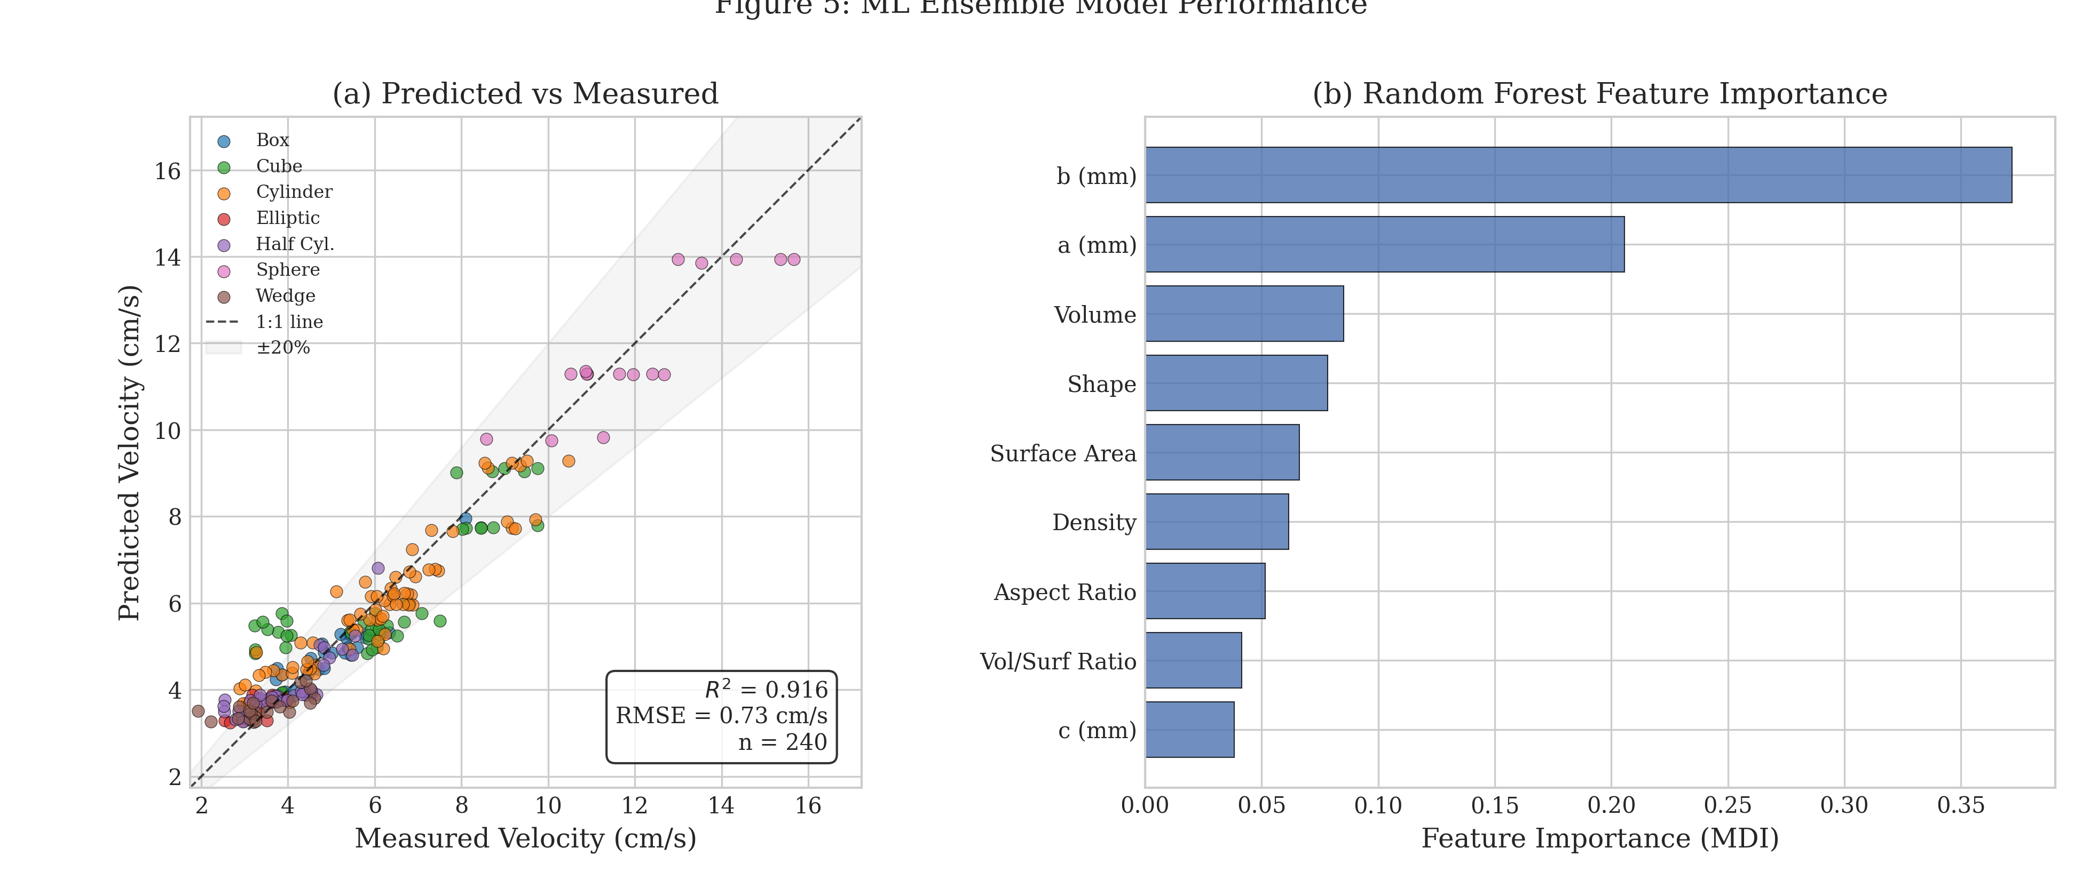
Figure 5. (Left) Predicted vs measured settling velocity with 1:1 line and ±20% bands. (Right) Feature importance from the Random Forest component of the ensemble model.

3.6 Comparison with Lofty et al. (2026)
Table 4 presents a systematic comparison between this study and the recent work of Lofty et al. (2026), which investigated the 3D settling dynamics of 127 environmental microplastic particles.
Table 4. Comparison with Lofty et al. (2026)
Metric | Lofty et al. (2026) | This Study
Number of particles | 127 | 105
Camera setup | 2 cameras, 90 deg, 60 fps | 2 cameras, 90 deg, 50 fps
Column geometry | Rectangular 20x20x70 cm | Cylindrical, dia 30 cm
Particle density | Not measured | Known (1007-1455 kg/m3)
Particle shapes | 4 types (Zingg classification) | 6 types (geometric)
Repeats per particle | Mostly 1 | Up to 3
d_eq range (mm) | 0.40 - 1.86 | 1.84 - 9.25
Re_p range | Not reported clearly | 87 - 2467
ML settling velocity prediction | nan | R2 = 0.859
3D trajectory reconstruction | Yes | Yes

Key methodological advantages of this study:
- Known particle density: Lofty et al. explicitly acknowledge the absence of density measurements as a limitation. Our study includes measured densities for all particles, enabling drag coefficient calculations and more physically grounded analysis.
- Controlled geometry: By using particles with precisely known dimensions and shapes, we isolate the effect of geometry on settling dynamics, free from confounding factors present in environmentally weathered samples.
- Statistical rigor: With up to 3 repeats per particle, we quantify the inherent variability in settling behavior, providing uncertainty bounds that single-measurement studies cannot offer.
- Complementary size range: Our particles (Deq = 1.84–9.25 mm) extend the size range beyond Lofty's environmental MPs (Deq = 0.40–1.86 mm), together covering a broad spectrum of microplastic sizes.
- Machine learning prediction: We demonstrate that settling velocity can be predicted with R² = 0.859 using only geometric features — a capability absent from Lofty et al. and most existing 3D settling studies.

4. Key Findings
Finding 1: 3D trajectories reveal shape-dependent settling dynamics
Of the 293 successfully reconstructed 3D trajectories, tortuosity ranged from 1.4% to 47.5%. Elliptic cylinders exhibited the highest mean tortuosity (22.9%), nearly three times that of cylindrical particles (7.7%), confirming that particle flatness drives non-linear settling behavior.

Finding 2: Lateral drift is significant for non-spherical particles
Drift gradients up to 0.361 were observed, meaning some particles traveled laterally up to 36% of their vertical descent distance. Horizontal drift velocities averaged 3.0 cm/s, representing 33% of the mean settling velocity.

Finding 3: Particle geometry alone predicts settling velocity
The ensemble ML model achieves R² = 0.859 using only 9 geometric features. Adding 3D trajectory metrics (drift, tortuosity) does not improve prediction, indicating that settling dynamics are a consequence of geometry, not independent information.

Finding 4: Controlled experiments complement environmental studies
Our controlled particles (Deq = 1.84–9.25 mm, known density) extend and validate the findings of Lofty et al. (2026) obtained from environmental MPs (Deq = 0.40–1.86 mm, unknown density). Together, the two studies span a wide range of particle sizes and Reynolds numbers.

5. Conclusions
This study presents a comprehensive investigation of the three-dimensional settling dynamics of microplastic particles with controlled geometries. By combining dual-camera 3D trajectory reconstruction with machine learning-based velocity prediction, we provide new insights into how particle shape governs settling behavior in quiescent water.
Our results demonstrate that particle shape has a profound effect on settling dynamics beyond the vertical settling velocity. Flat, elongated particles (elliptic cylinders) follow highly tortuous paths with significant lateral displacement, while compact shapes (cubes, cylinders) settle along more linear trajectories. These findings have direct implications for modeling microplastic transport in rivers and marine environments, where assumptions of linear settling may significantly underestimate the lateral dispersion of non-spherical particles.
The machine learning model demonstrates that settling velocity can be reliably predicted (R² = 0.859) from particle geometry alone, without requiring trajectory measurements. This provides a practical tool for estimating settling behavior from easily measurable particle properties. The finding that 3D trajectory features do not improve prediction further supports the conclusion that settling dynamics are a direct consequence of particle geometry and density.
Future work should extend this analysis to smaller particle sizes (< 1 mm), include buoyant (rising) particles, and investigate settling behavior under turbulent conditions to better represent real environmental scenarios.

