**Software Design Final Project: Garden Glory**

Name: Mecca Mae S. Umapas Date: 28/03/2020

**DOCUMENTATION**

1. Business rules of the program

* A customer may Have multiple properties.
* A property can have multiple services and service can be a maintenance, one-time or ongoing. In addition, property can have more than one or no property description.
* To conduct the service, it can involve multiple employees to accomplish the service. On the other hand, an employee can also be part of multiple services. The relation of service an employee is recorded through the task associated with specific service. Furthermore, a service can have multiple payments and its payment method can be online payment or cash payment.
* Employee can only have one experience level, employee type, and employee status. However, experience level, employee type, and employee status can have multiple employees.
* Every task can use multiple types of equipment and equipment can be used in multiple tasks. The usage of the equipment in every task is also recorded.
* Employee can only use the equipment when he/she is trained to use it. Therefore, an employee can be trained in multiple types of equipment and for certain equipment, there will be multiple employees that are trained to use it.
* Equipment can have more than one or no equipment repair.
* To access the program, an employee can have multiple accounts and must have the role of either assistant, manager, or administrator and each role has one specific access restriction to the program.

1. Enhance Entity Relation Diagram

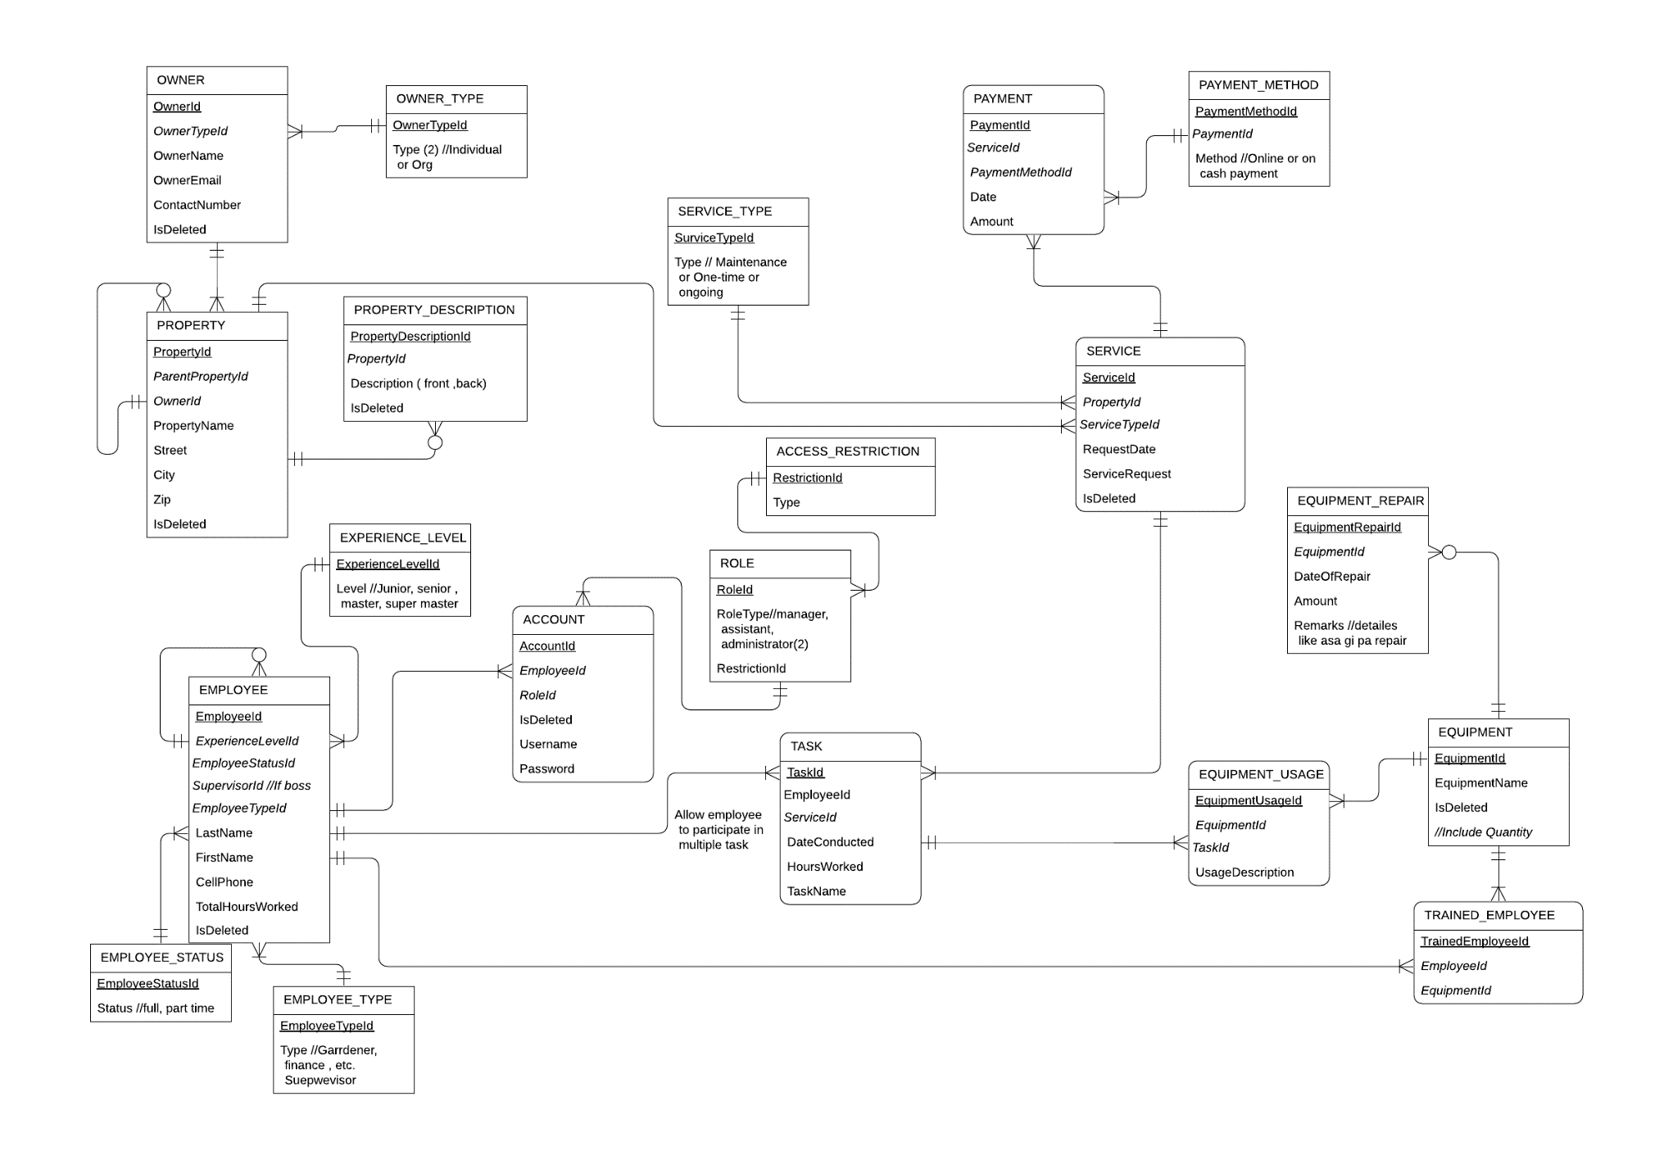

1. 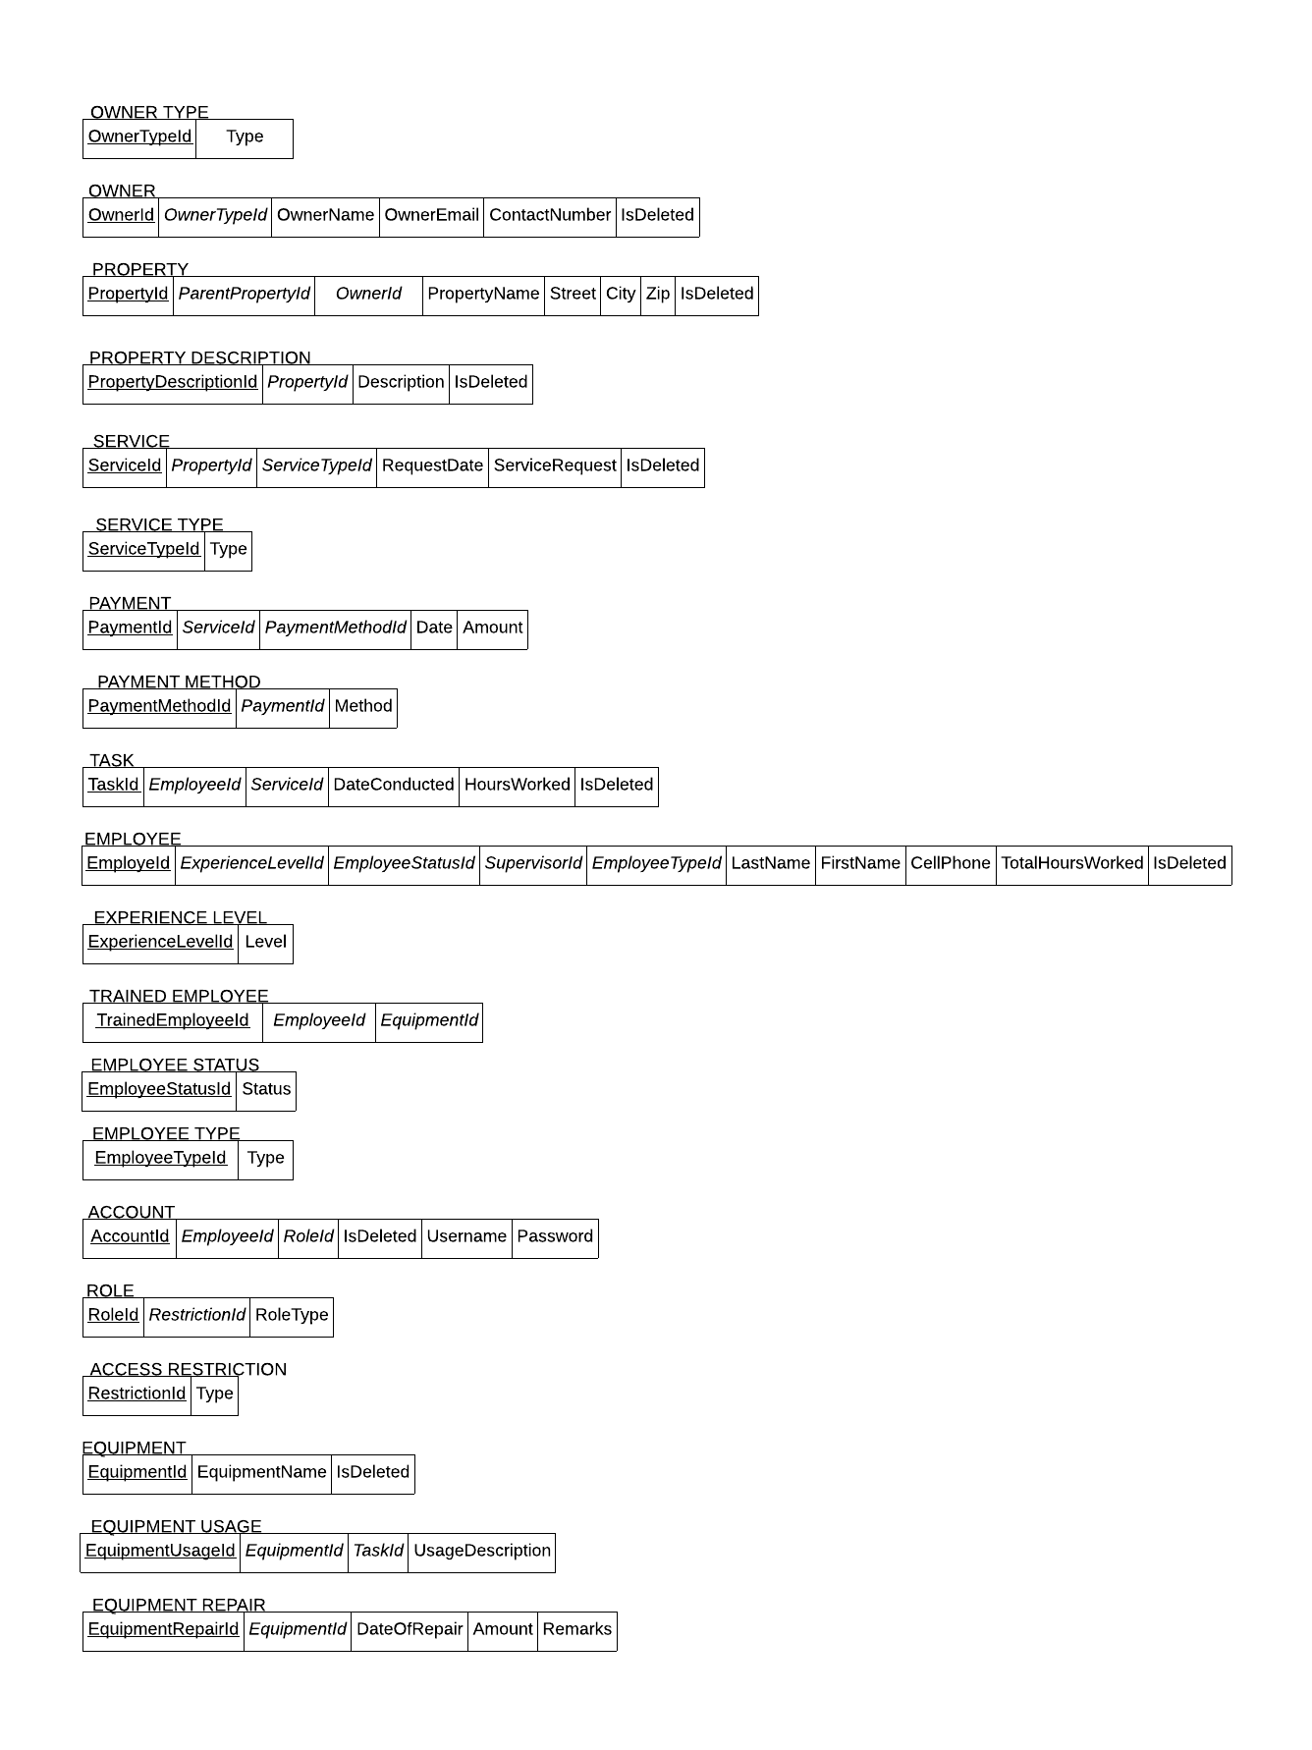Relational Schema

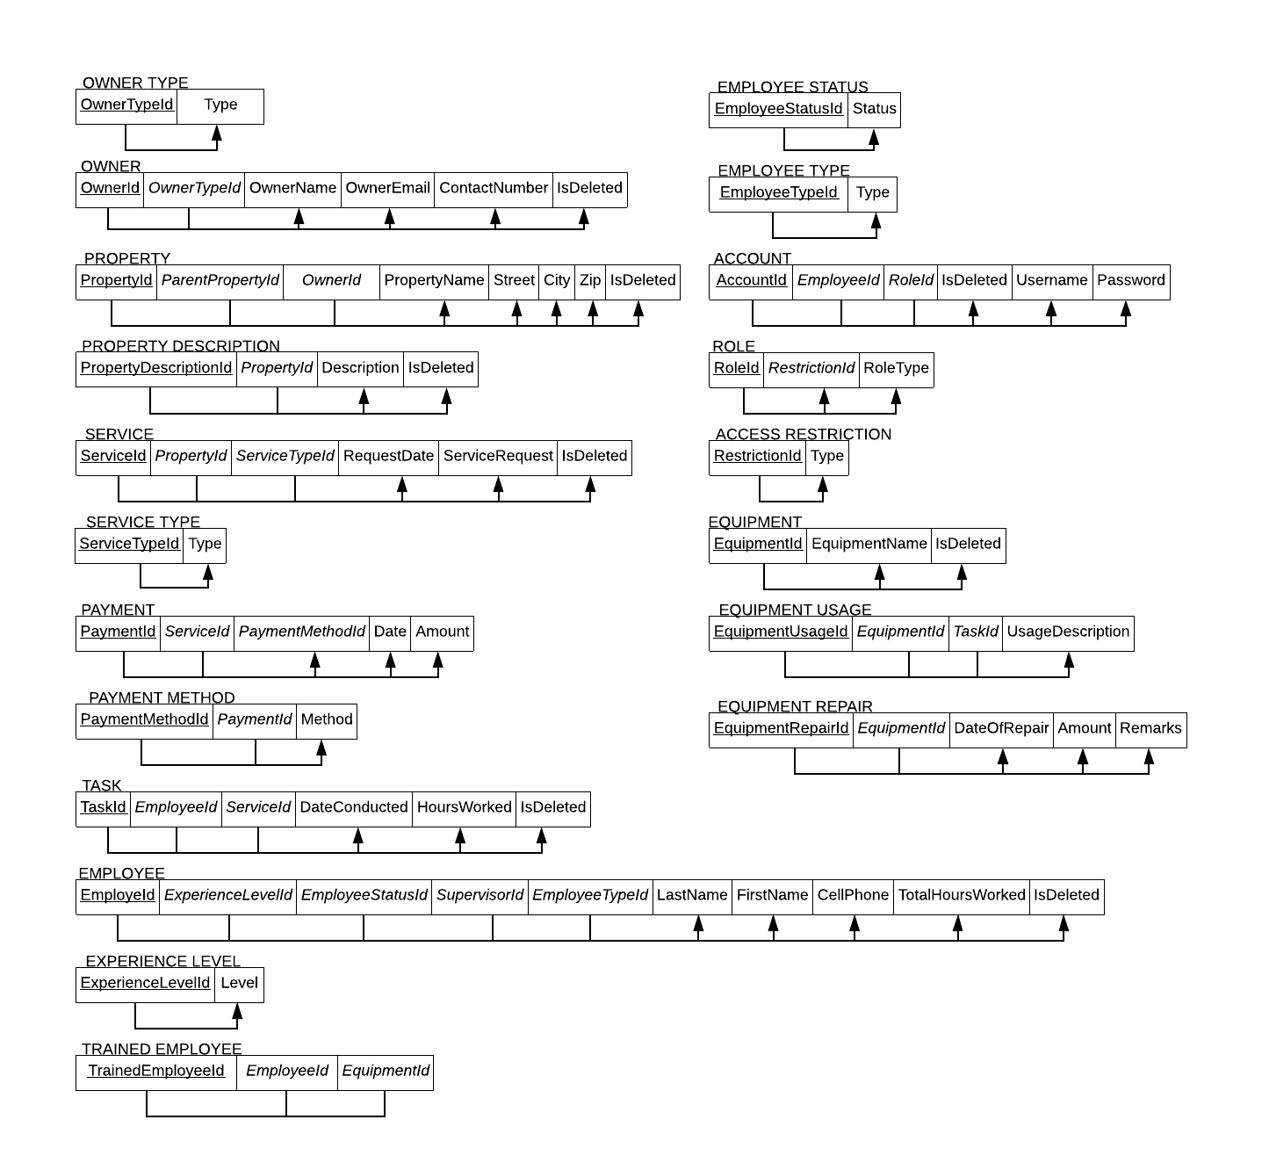Functional Dependency

1. 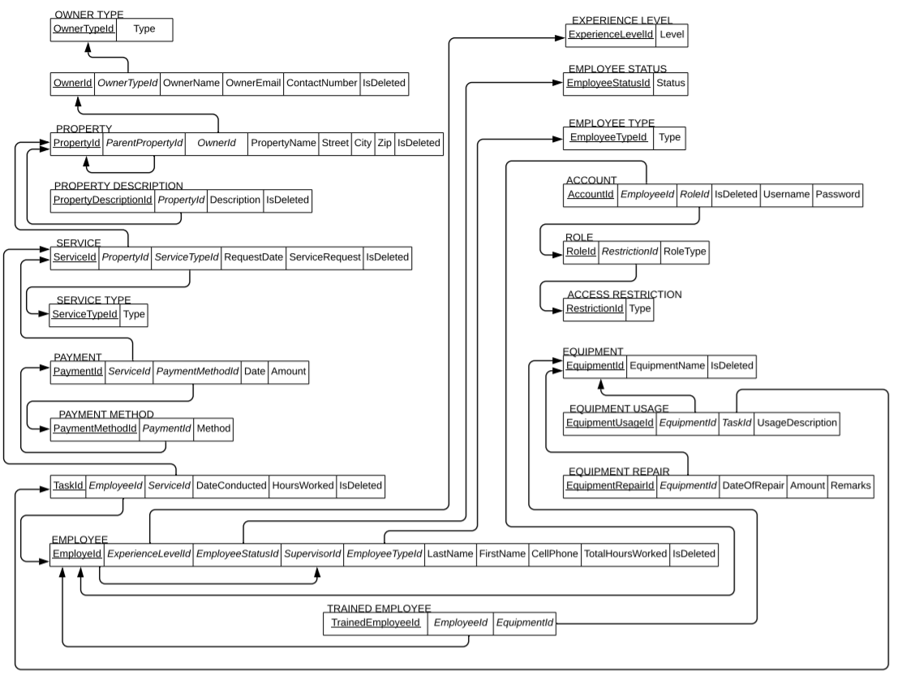Referential Integrity Constraints
2. Assumptions

* The owner can either be organization or individual thus the entity owner type is added to store this fixed type of owner of a property.
* Employee has different experience level, status, and employee type, to accommodate this given, entity experience level is added to store the different levels identified such as Junior, Senior, Master, and Super Master. Entity Employee Status is where the different statuses of an employee are stored and entity Employee Type is where different types of an employee are recorded such as gardener, cashier, etc.
* Since an employee can involve in multiple services and service can have multiple employees to accomplish the service, a new entity task is added to record the relationship between employee and service at the same time.

The Entity Service Type is added to store different services such as maintenance, one-time, and on-going.

* Payment Method is also added to store the fix methods of paying such as online payment or cash payment.
* Trained Employee is added to record the relationship between the employee and equipment at the same time since equipment can only be used by an employee if he/she is trained to use it.
* To accommodate the usage description of the equipment once it is used in a specific task, the entity Equipment Usage is responsible to record the relationship between tasks and equipment at the same time.
* The added entities Account, Role and Access Restriction is to control the user of the program and identify their role to restrict their access to the program. An employee can have multiple accounts and these accounts are only given to employees that have the role of assistant, manager or administrator and the entity access restriction is where different types of restrictions are stored and each specified role as an identified access restriction when using the program.

**USE CASE DIAGRAM AND SCENARIO**

|  |  |
| --- | --- |
| **User** | **User goal and resulting result use case** |
| Assistant | Edit and add Customer, Property, Services, Equipment, Employee, Property Description. Edit own account username and password. Can add task, payment, Equipment repair, and trained employee |
| Manager | Edit, Add, and Delete Customer, Property Service, Equipment, Employee and edit own account username and password. Can add task, payment, Equipment repair, and trained employee |
| Administrator | Edit, Add, and Delete Customer, Property Service, Equipment, Employee, Employee Supervisor, Account role and edit own account username and password. Can add task, payment, Equipment repair, and trained employee |

|  |  |
| --- | --- |
| **Garden Glory Customer Subsystem** |  |
| **Use Cases** | **User/Actors** |
| Add new Customer | Assistant, Manager, Administrator |
| Edit Customer Record | Assistant, Manager, Administrator |
| Delete Customer Record | Manager, Administrator |
| View Customer List | Assistant, Manager, Administrator |
| Search Customer | Assistant, Manager, Administrator |

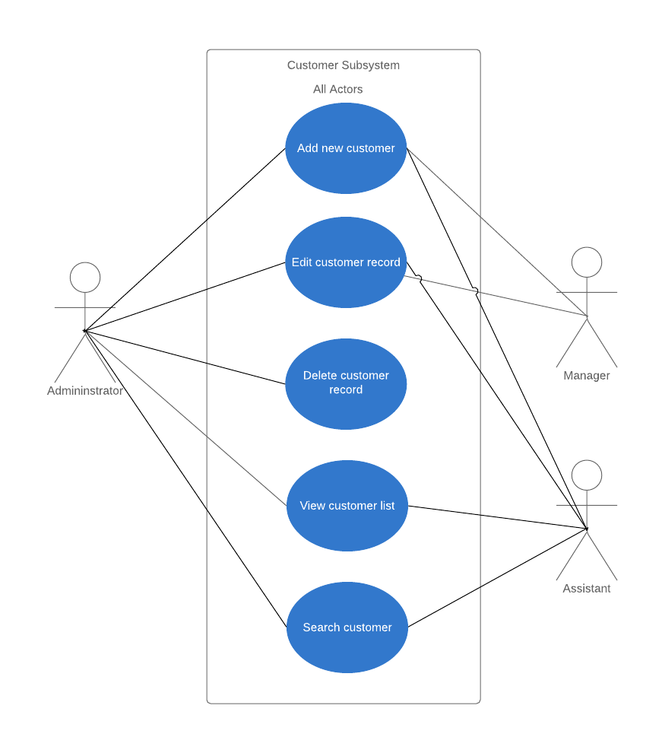

|  |
| --- |
| **Use Case Scenario: (System User: Assistant, Manager and Administrator)**   * System Users can add a new customer and records their necessary information for the transaction. * System Users can search for customers that are already been added through the customer list. * Managers and Administrators are the only users that are allowed to delete an added customer. |

|  |  |
| --- | --- |
| **Garden Glory Property Subsystem** |  |
| **Use Case** | **User/Actors** |
| Create new Property and Property Description | Assistant, Manager, Administrator |
| Edit Property Record and Property Description | Assistant, Manager, Administrator |
| Delete Property Record and Property Description | Manager, Administrator |
| Search Property | Assistant, Manager, Administrator |
| View Property and Property Description List | Assistant, Manager, Administrator |

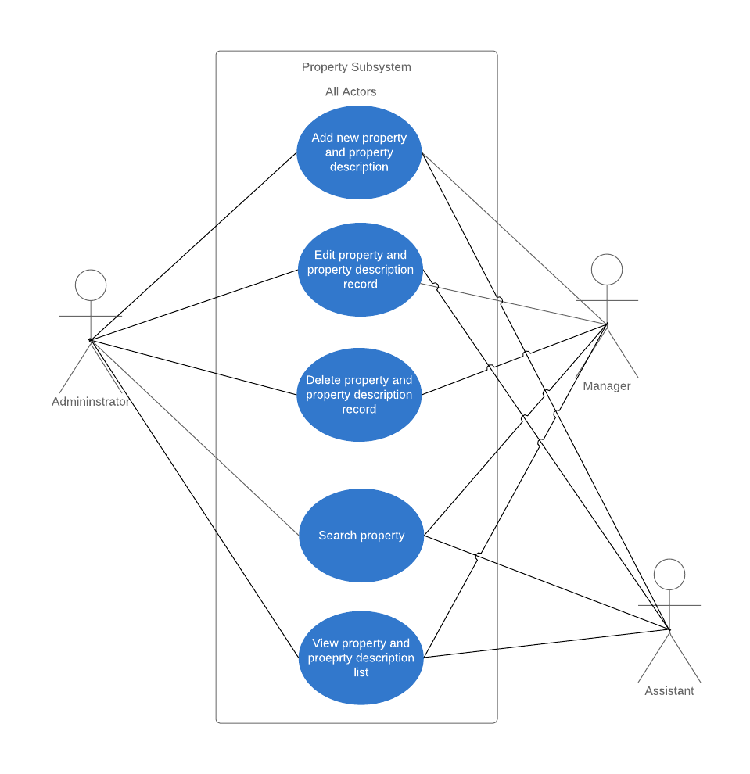

|  |
| --- |
| **Use Case Scenario: (System User: Assistant, Manager and Administrator)**   * System users can only add a property during new customer transactions and when the customer is already in the database. They will record the necessary information related to the property and the owner of the property including the property description. They can also add a new property description for an existing property. (owner refers to the customer) * System users can edit information about an existing property and property description. * Only the Manager and Administrator can delete a property and property description. * If a system user wants to search for a specific property, they can access the property list and can search through it. |

|  |  |
| --- | --- |
| **Garden Glory Service Subsystem** |  |
| **Use Case** | **User/Actors** |
| Add new Service | Assistant, Manager, Administrator |
| Edit Service Record | Assistant, Manager, Administrator |
| Delete Service Record | Manager, Administrator |
| Add Task | Assistant, Manager, Administrator |
| Add Payment | Assistant, Manager, Administrator |
| Search Service | Assistant, Manager, Administrator |
| View Service, Task, and Payment List | Assistant, Manager, Administrator |

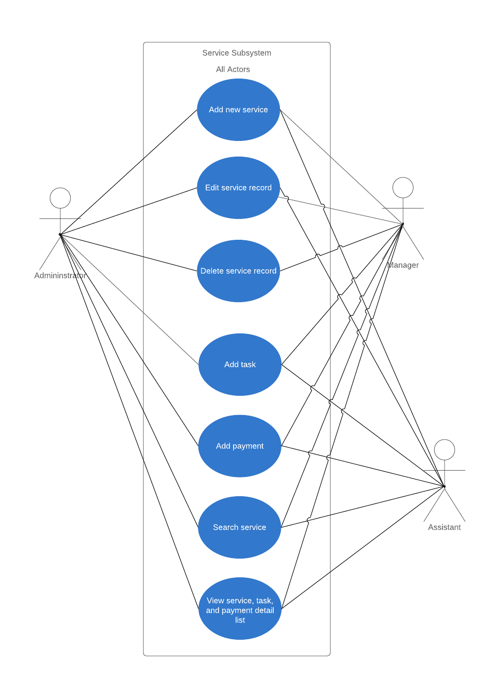

|  |  |  |
| --- | --- | --- |
| **Use Case Scenario: (System User: Assistant, Manager and Administrator)**   * System users can add new service transactions. They can only add new service for an existing property and during the new customer transaction. * System User can search for a specific service through the service list * Once a new service is added, the system user can add tasks related to the service in the task list and they can also add payment through the payment list. * User is only allowed to edit service that is already added. * Only the Manager and Administrator can delete a specific service. | | |
| **Garden Glory Equipment Subsystem** |  |
| **Use Case** | **User/Actors** |
| Add new Equipment | Assistant, Manager, Administrator |
| Edit Equipment Record | Assistant, Manager, Administrator |
| Delete Equipment Record | Manager, Administrator |
| Add Equipment Repair | Assistant, Manager, Administrator |
| Add Trained Employee | Assistant, Manager, Administrator |
| Search Equipment | Assistant, Manager, Administrator |
| View Equipment, Equipment Repair, Trained Employee, and Equipment Detail List | Assistant, Manager, Administrator |

|  |
| --- |
| **Use Case Scenario: (System User: Assistant, Manager, Administrator)**   * System users can add new equipment that is not existing or not deleted in the database. * Once new equipment is added, system user can add equipment to repair and trained employees. They can also add equipment repair and trained employee for existing equipment. * System users can only edit the name of the equipment. * System users can search for specific equipment through the equipment list. * Manager and Administrator are the only allowed user to delete a specific equipment. |

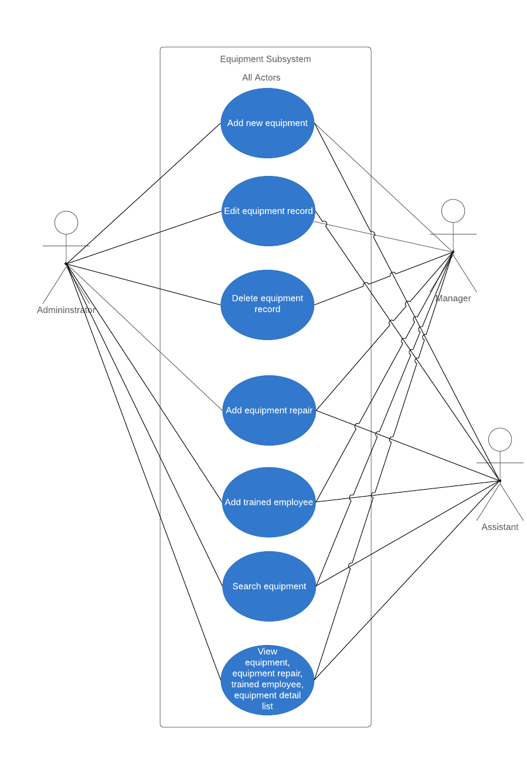

|  |  |
| --- | --- |
| **Garden Glory Employee Subsystem** |  |
| **Use Case** | **User/Actors** |
| Add new Employee | Assistant, Manager, Administrator |
| Add Employee Supervisor | Administrator |
| Edit Employee Supervisor | Administrator |
| Edit Employee Record | Assistant, Manager, Administrator |
| Delete Employee Record | Manager, Administrator |
| Search Employee | Assistant, Manager, Administrator |
| View Employee and Employee Detail List | Assistant, Manager, Administrator |

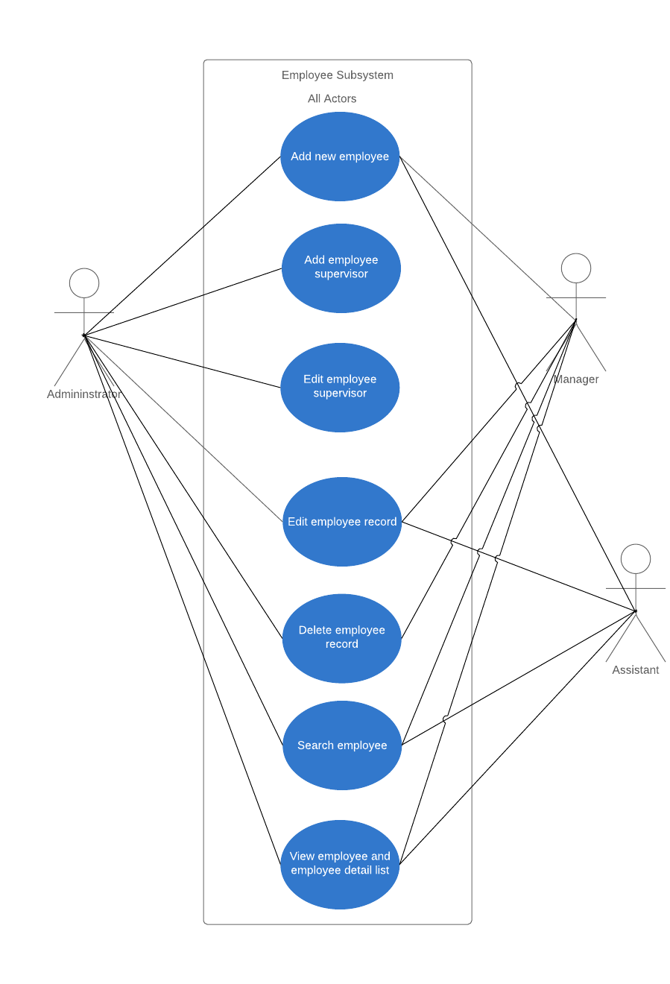

|  |
| --- |
| **User Case Scenario: (System User: Assistant, Manager, Administrator)**   * System users can add a new employee but only the Administrator can add a supervisor for an employee. * System users can edit the information about the employee expect the supervisor which only the Administrator is allowed to edit. * System users can search for a specific employee through the employee list. * Only the Manager and Administrator can delete a specific employee |

|  |  |
| --- | --- |
| **Garden Glory Account Subsystem** |  |
| **Use Case** | **User/Actors** |
| Edit Account Username and Password | Assistant, Manager, Administrator |
| Add Account | Administrator |
| Edit Account Role | Administrator |
| View Account List | Administrator |
| View Account Details | Administrator |

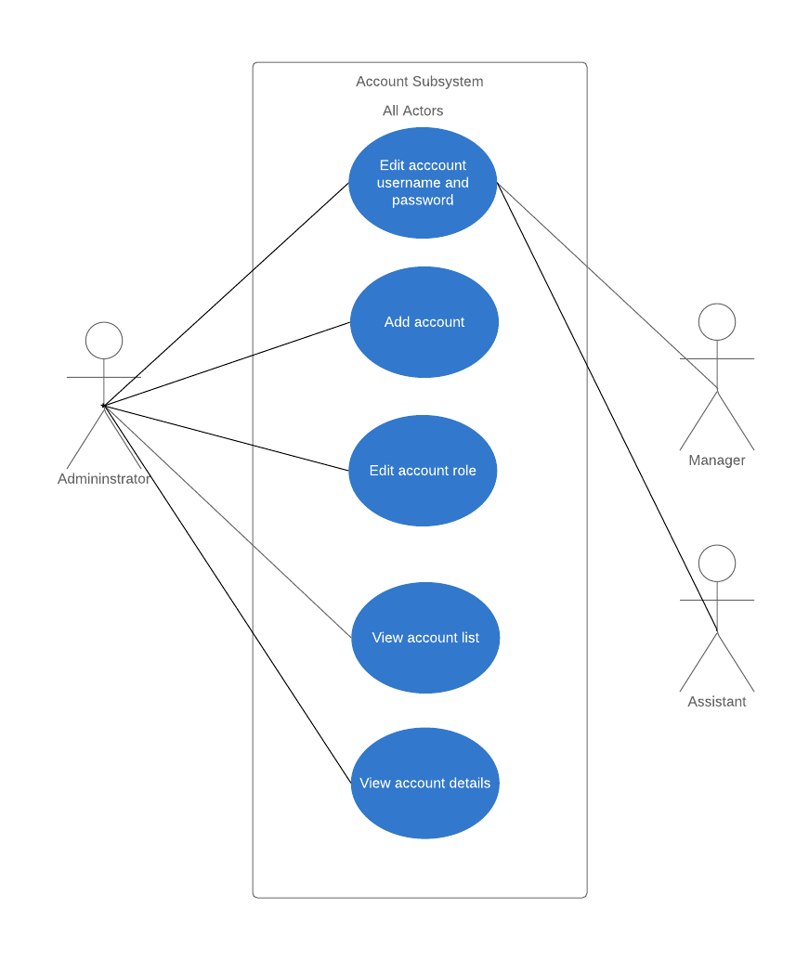

|  |
| --- |
| **Use Case Scenario: (System User: Assistant, Manager, and Administrator)**   * System users can only edit their Username and Password but the Administrator can edit the role of the account owner. * Only the administrator can access the account list and account details where he/she is allowed to search the account owner through the account list. * The administrator is the only user allowed to add and delete an account. |

**DATAFLOW DIAGRAM**

