MCS Lab 3 Report
EL-GHOUL LAYLA
Sakka Mohamad-Mario
mahmoud mirghani abdelrahman
MCS
To see the final results please ctrl+ click here: “REPORT CONSISTS IN”

I.

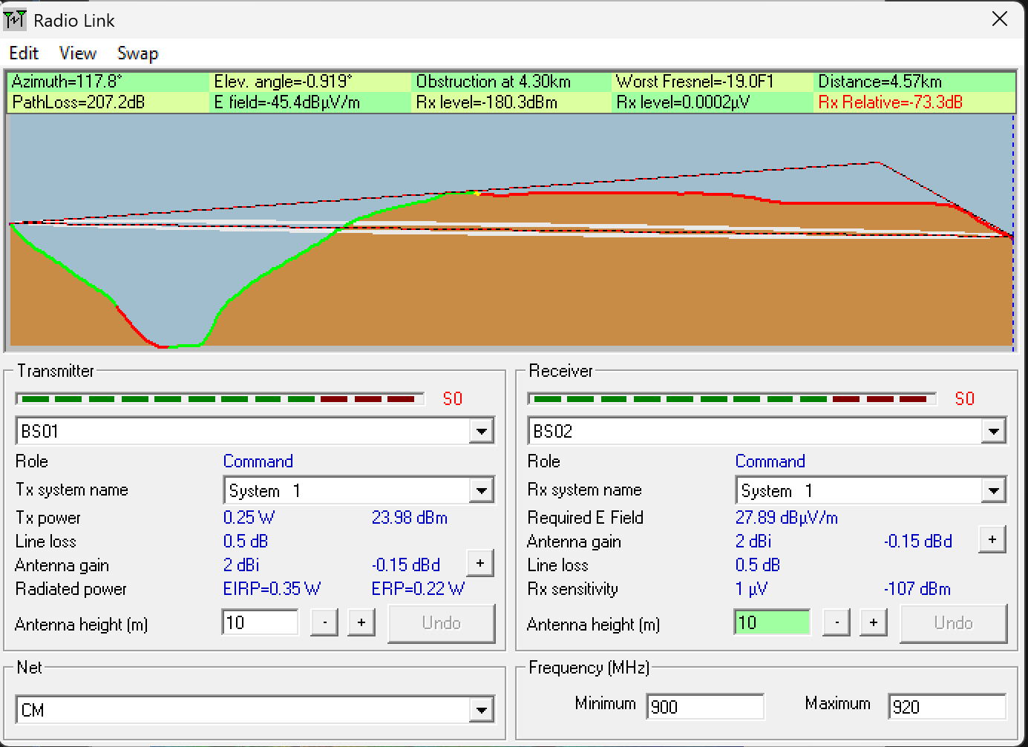
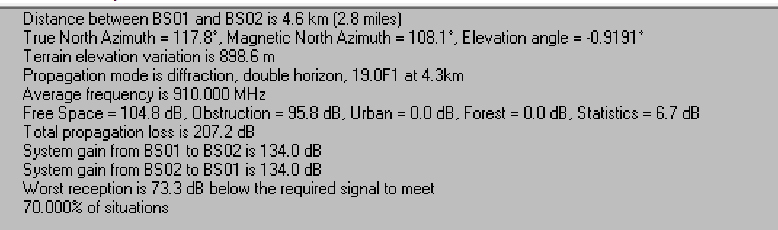
Network / system parameters (as configured)
- Frequency band: 900–920 MHz
- Polarization: Vertical
- Transmit power: 0.25 W (23.98 dBm)
- Line loss (Tx/Rx): 0.5 dB
- Antenna gain (Tx/Rx): ~2 dBi (default)
- Antenna heights for the baseline test: 10 m / 10 m
Endpoints (placed by coordinates)
- BS01: 36° 08′ 58″ N, 111° 58′ 54″ W
- BS02: 36° 07′ 49″ N, 111° 56′ 12″ W
- Network name: CM (both stations are members)
Radio link test (BS01 → BS02, 10 m/10 m)
From the Radio Link results and Details pane:
- Distance: ≈ 4.57–4.60 km
- Propagation mode: Diffraction, double horizon
- Worst Fresnel: –19.0 F1 at ~4.30 km (severe 1st-Fresnel intrusion)
- Obstruction loss: ≈ 95.8 dB (major terrain blockage)
- Free-space loss (for reference): ≈ 104.8 dB
- Total path loss: ≈ 207.2 dB
- Rx level: ≈ –180.3 dBm
- Rx relative to required: ≈ –73.3 dB (fails by a large margin)
- Elevation angle: –0.919°
- Situations met: 70% (statistical component included by the tool)
With both antennas positioned at 10 m height, the BS01–BS02 link cannot be established. The terrain introduces a double-horizon effect and significant Fresnel-zone obstruction (Worst Fresnel clearance of –19 F1), resulting in approximately 95.8 dB of additional diffraction and blockage loss beyond free-space attenuation. This pushes the received signal roughly 73 dB below the required threshold, making the link infeasible.
The direct 10 m/10 m ground-station link does not work. The path is terrain-blocked with severe 1st-Fresnel intrusion (–19 F1) and large obstruction loss (~95.8 dB). Therefore, a relay strategy or taller antennas (≤ 30 m allowed by the brief) are required to obtain Fresnel clearance and link margin.

II.

“What can be said about the radio connection when there are used only the two ground stations…?”
With BS01 and BS02 both at 10 m, the direct 4.6 km link does not work. Radio Mobile reports Worst Fresnel = −19.0 F1 near 4.3 km, Obstruction ≈ 95.8 dB, Total path loss ≈ 207.2 dB, and Rx relative ≈ −73.3 dB, i.e., well below the required signal—this is a double-horizon case.
“What values should the heights of the two antennas have… to obtain propagation without obstruction of the n = 1 Fresnel ellipsoid between BS1 and BS2?”
We increased both antennas up to the limit (≤ 30 m each) and the 1st Fresnel zone still remained obstructed (Worst Fresnel stayed negative). Therefore, there is no feasible pair of heights ≤ 30 m that clears n = 1 for the direct BS01–BS02 path; a relay link is required (handled in the next section).
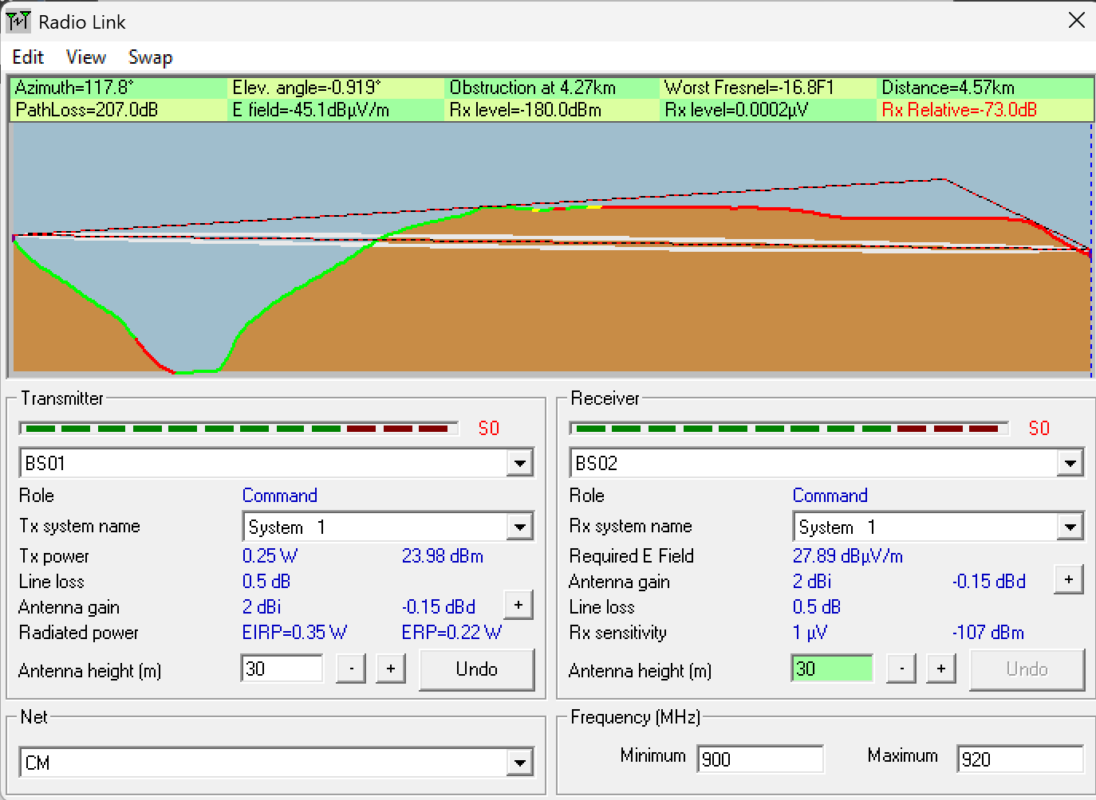
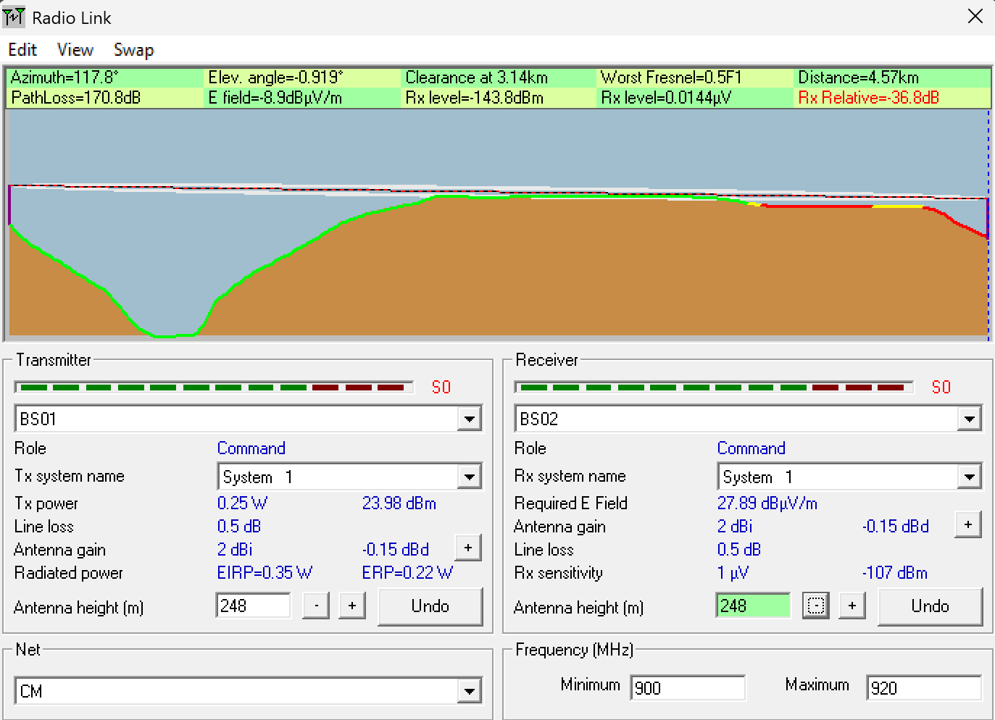
The height has to be of 248m for worst Frenzel to be positive.

III.
We scanned the BS1–BS2 path and identified the ridge causing the main obstruction. We placed BS3 on that ridge and adjusted heights (BS1 = 25 m, BS3 = 25 m), obtaining Worst Fresnel = 0.1·F1, PathLoss ≈ 130 dB, on BS1→BS3 (viable). The remaining hop BS3→BS2 is still a diffraction/double-horizon case with Worst Fresnel = −14.7·F1, Obstruction ≈ 76.5 dB, PathLoss ≈ 182.4 dB, so it is not viable. Therefore, we will insert an additional relay BS4 between BS3 and BS2 in Section IV.
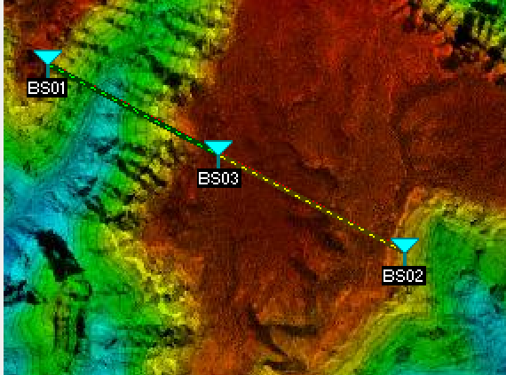
BS01 -> BS03
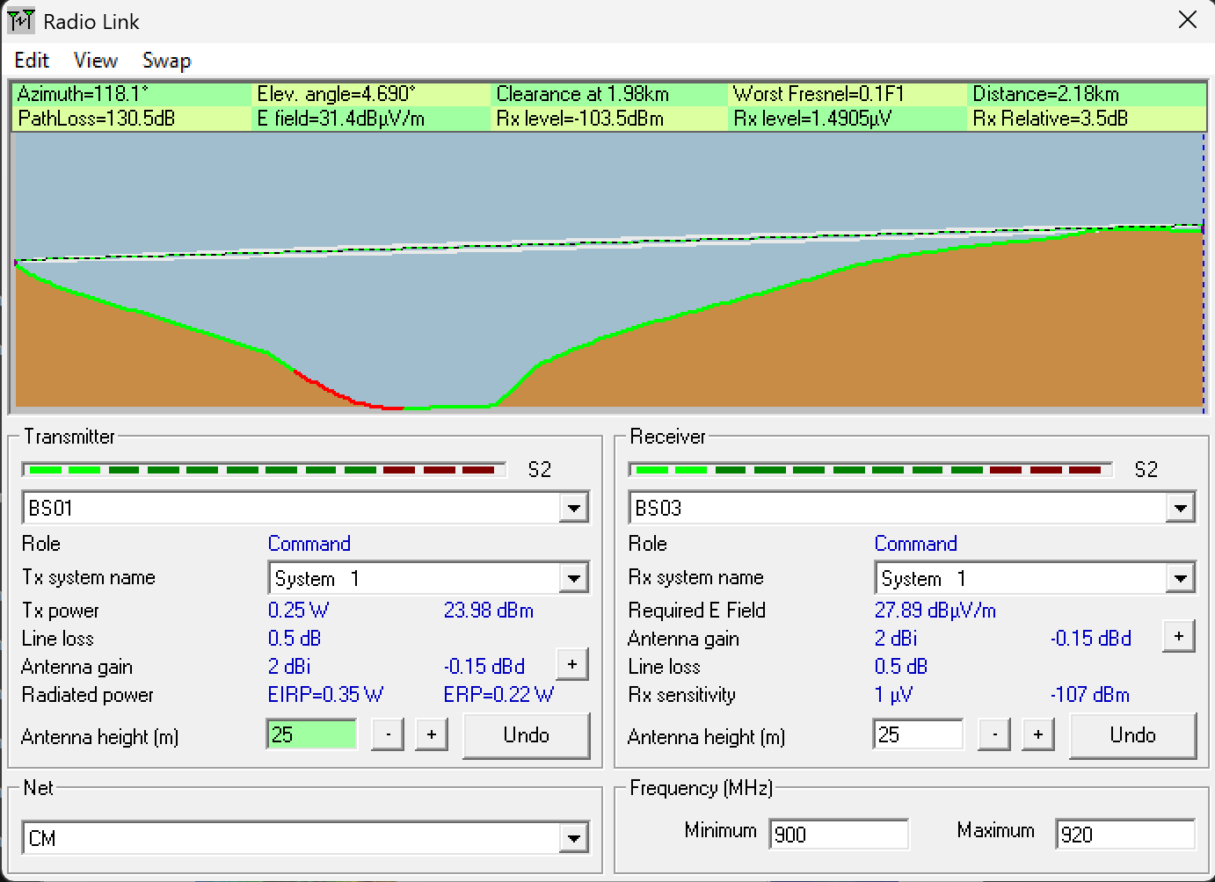
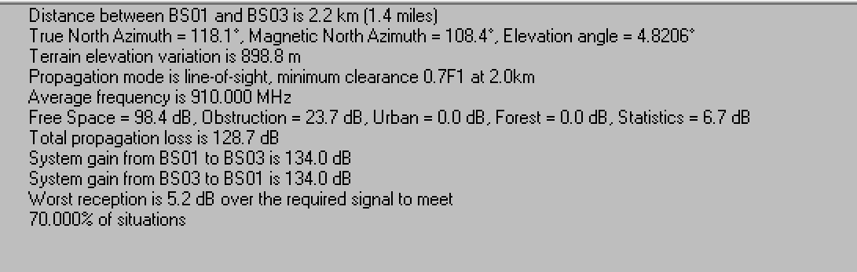

BS03->BS02
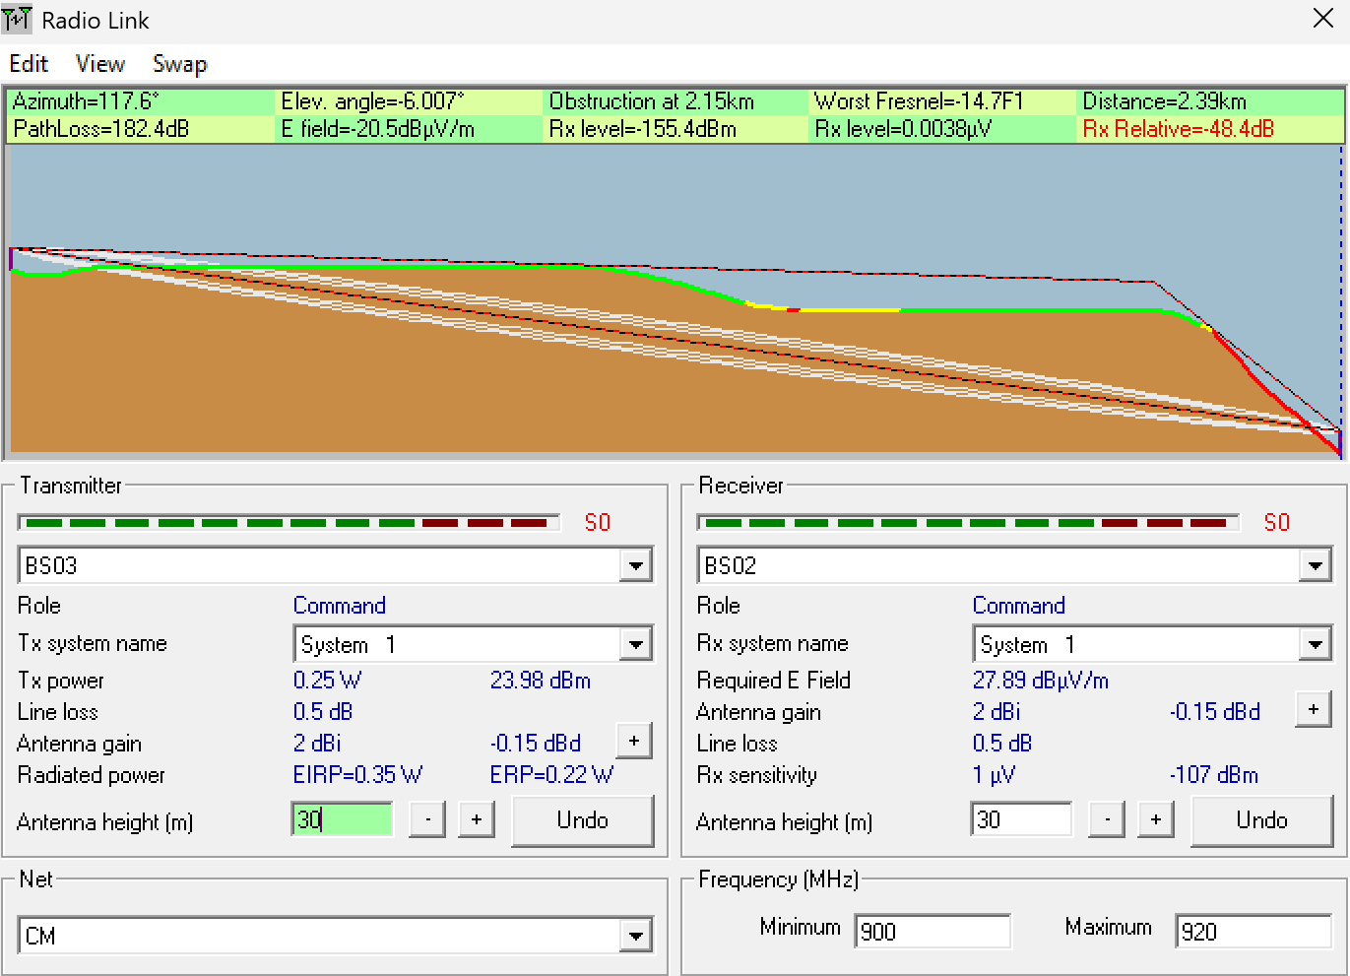
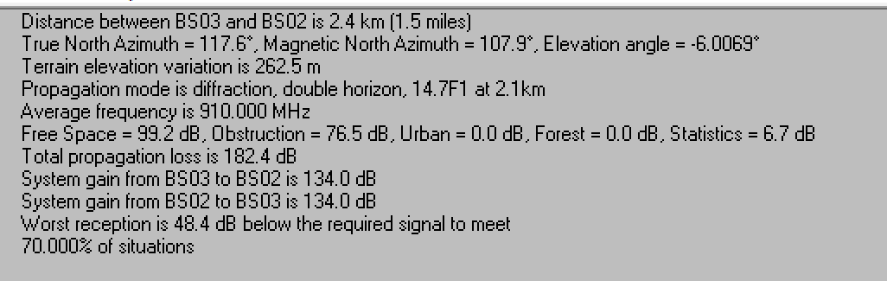

IV.
Hop | Distance (km) | Worst Fresnel | PathLoss (dB) | Rx level (dBm) | Rx Relative (dB) | Heights (m)
BS3 → BS4 | 2.13 | +0.1·F1 | 119.2 | −92.2 | +14.8 | BS3=30, BS4=40
BS4 → BS2 | 0.31 | +0.3·F1 | 96.1 | −69.1 | +37.9 | BS4=40, BS2=35
We added BS04 on the BS03–BS02 path and adjusted antenna heights (IV allows >30 m) to ensure viable links on both adjacent hops. BS4 was positioned so that BS3→BS4 forms a medium hop, while BS4→BS2 is a short, well-cleared hop.
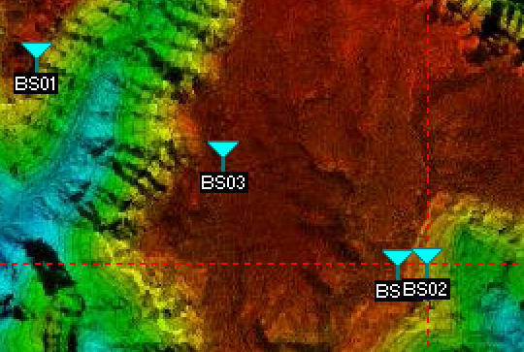
BS03->BS04
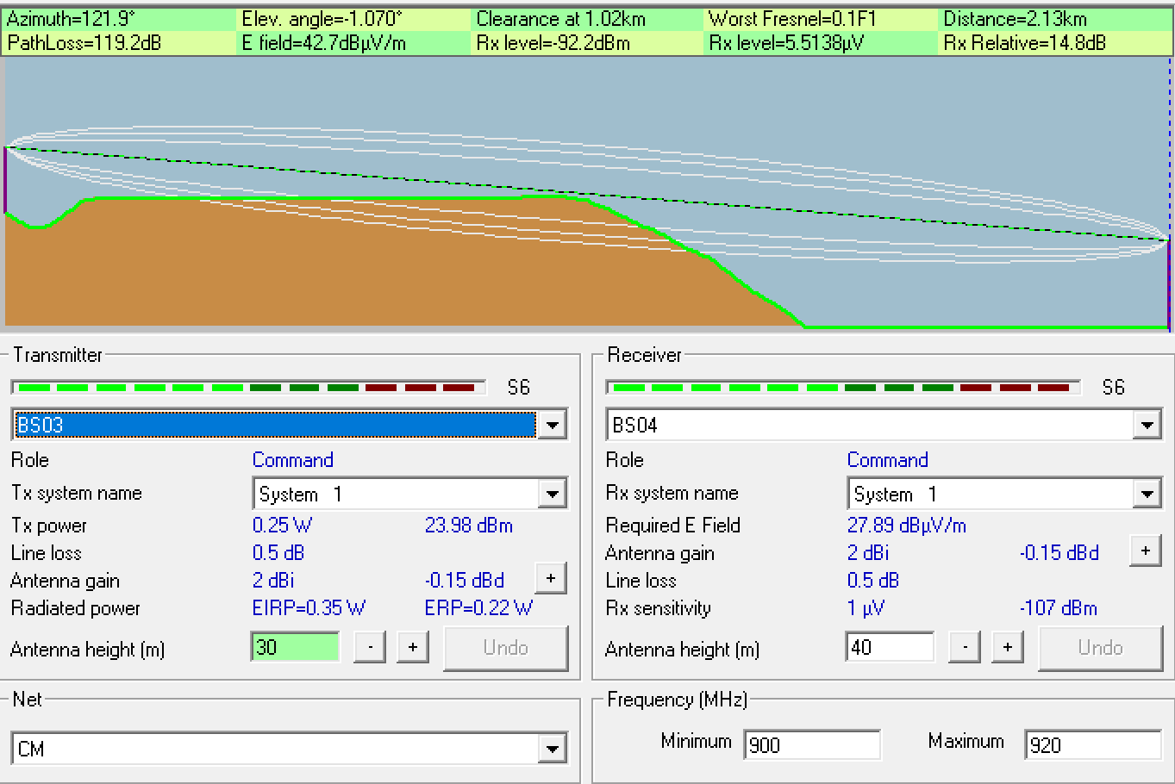
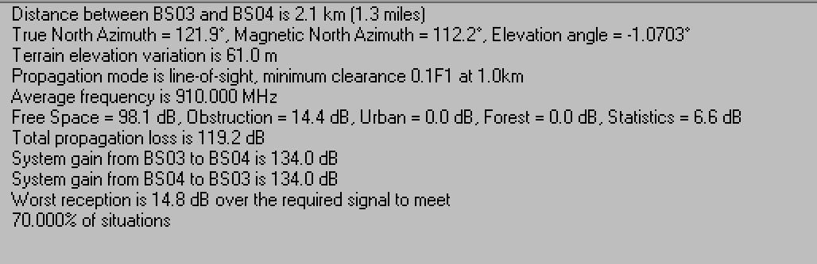
BS04->BS02
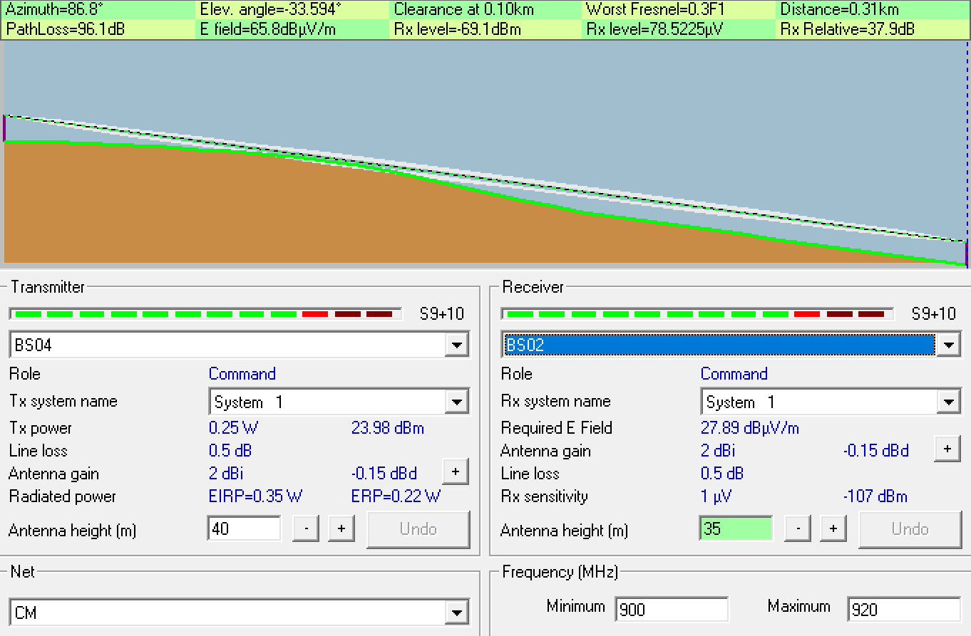
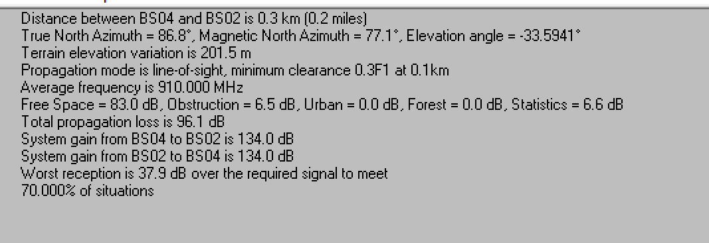

V.
To maintain positive first-Fresnel clearance and healthy link margins across the canyon, we used two relays between BS3 and BS2 (BS4 and BS5). All other radio/system settings stayed the same as Sections I–II (900–920 MHz, vertical, Pt = 0.25 W, line loss 0.5 dB, antenna gain 2 dBi).
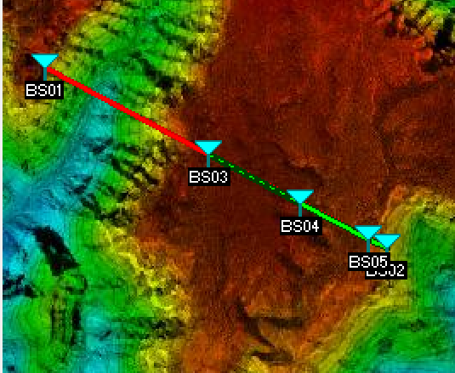
Hop | Distance (km) | Worst Fresnel | PathLoss (dB) | Rx level (dBm) | Rx Relative (dB) | Heights (m)
BS1 → BS3 | 2.18 | +0.1·F1 | 128.7 | −101.8 | +5.2 | 25 / 25
BS3 → BS4 | 1.20 | +0.5·F1 | 105.4 | −78.2 | +28.6 | 30 / 29.5
BS4 → BS5 | 0.90 | +3.3·F1 | 94.0 | −59.2 | +39.9 | 30 / 30
BS5 → BS2 | 0.25 | +3.3·F1 | 86.8 | −59.0 | +47.2 | 20 / 20

BS03->BS04
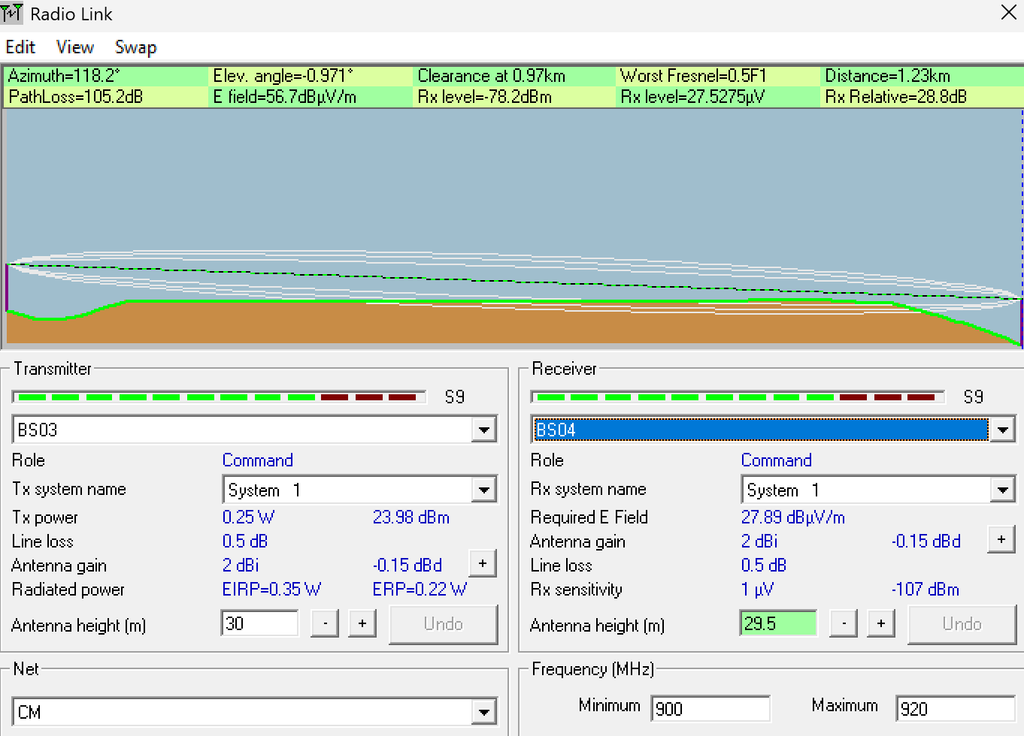
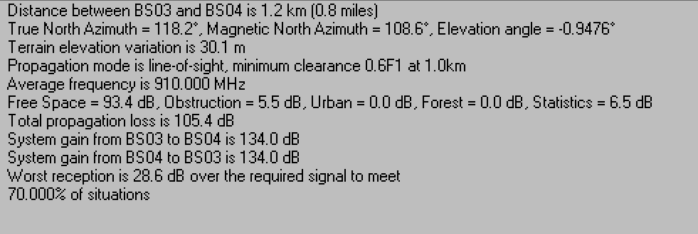
BS04->BS05
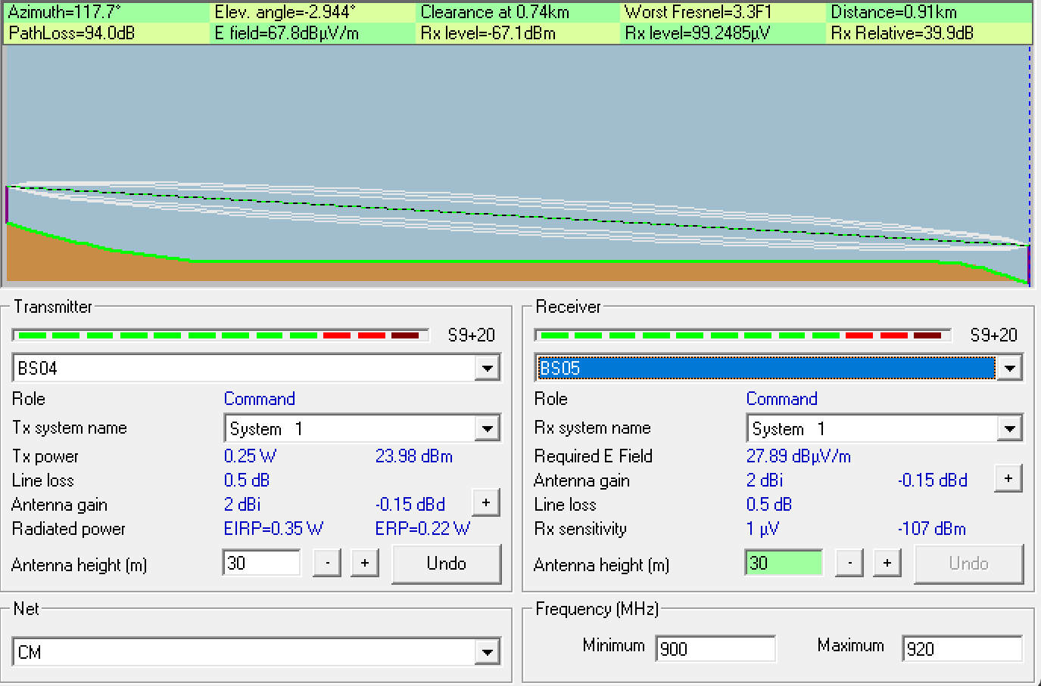
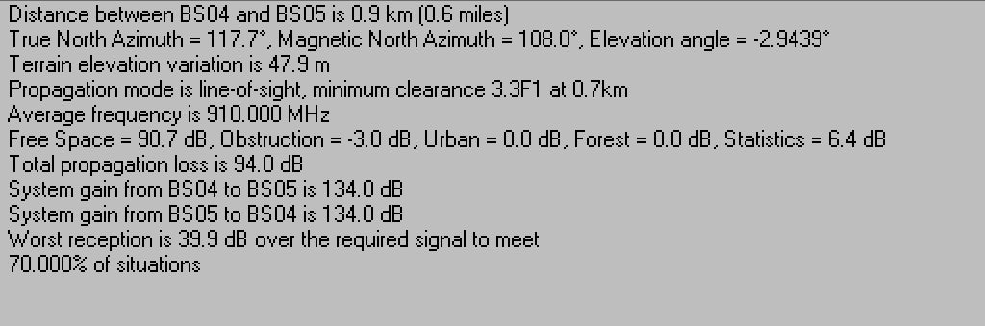
BS05->BS02
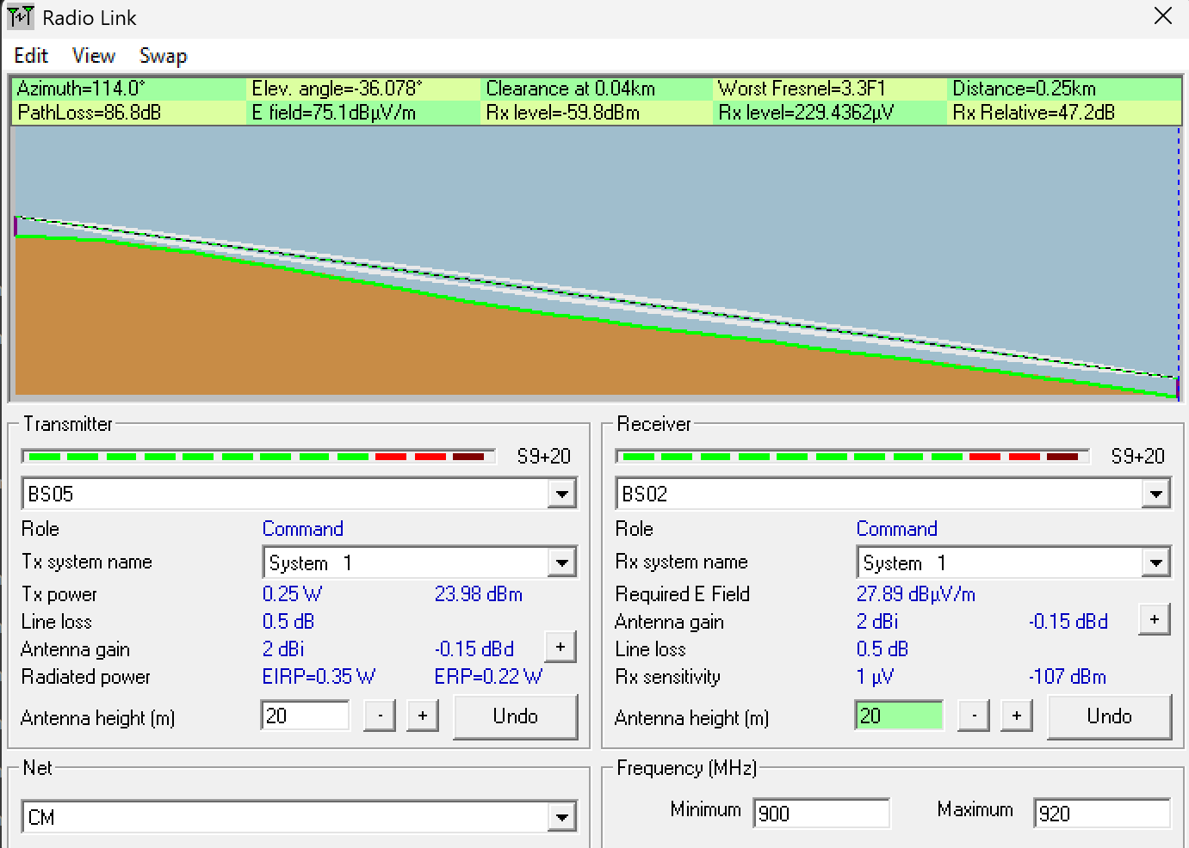
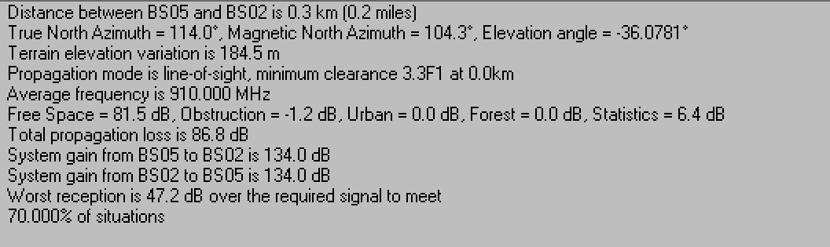

“REPORT CONSISTS IN”
Chain (final design, ≤30 m):
BS1 → BS3 → BS4 → BS5 → BS2
Heights (m):
h₁ = 25, h₃ = 30, h₄ = 29.5, h₅ = 30, h₂ = 20
Distances (km):
d₁ = 2.18, d₂ = 1.20, d₃ = 0.91, d₄ = 0.25
Screenshots:

