MCS Lab 1 Report

Sakka Mohamad-Mario
el-ghoul Layla
mahmoud mirghani abdelrahman
MCS

1. Plots resulting from code

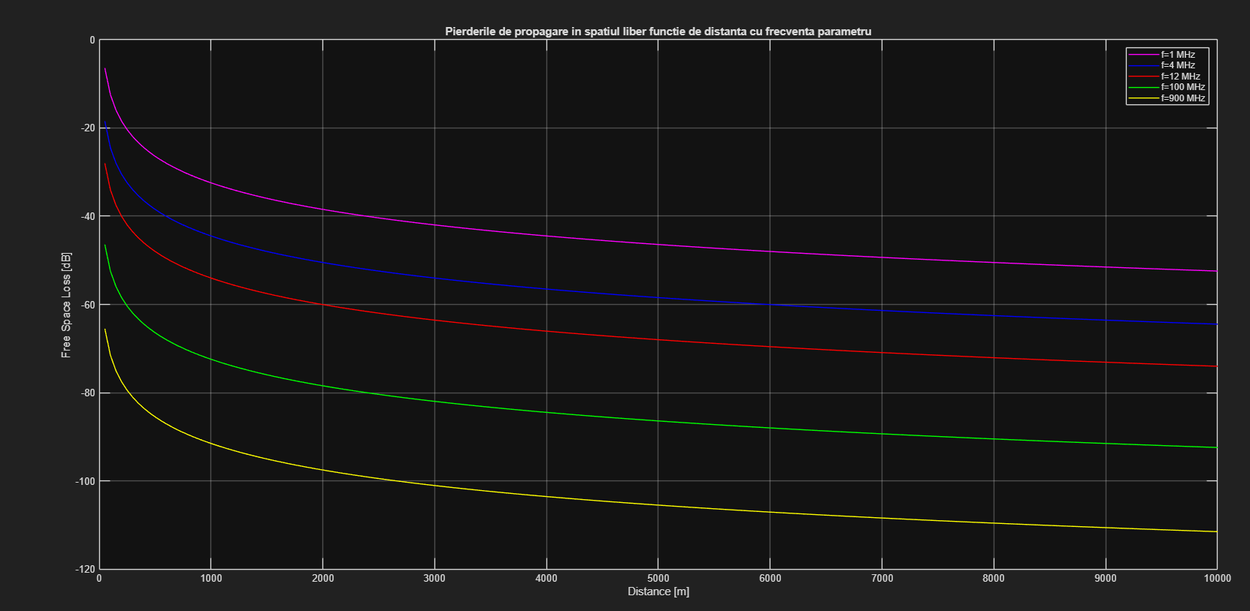
Figure 1: Plot of free space propagation loss as a function of distance with frequency as a parameter
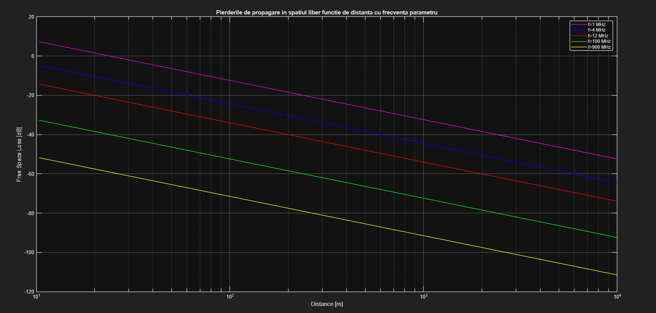
Figure 2: Plot of free space propagation loss as a function of distance with frequency as a parameter, using a logarithmic scale for distance.
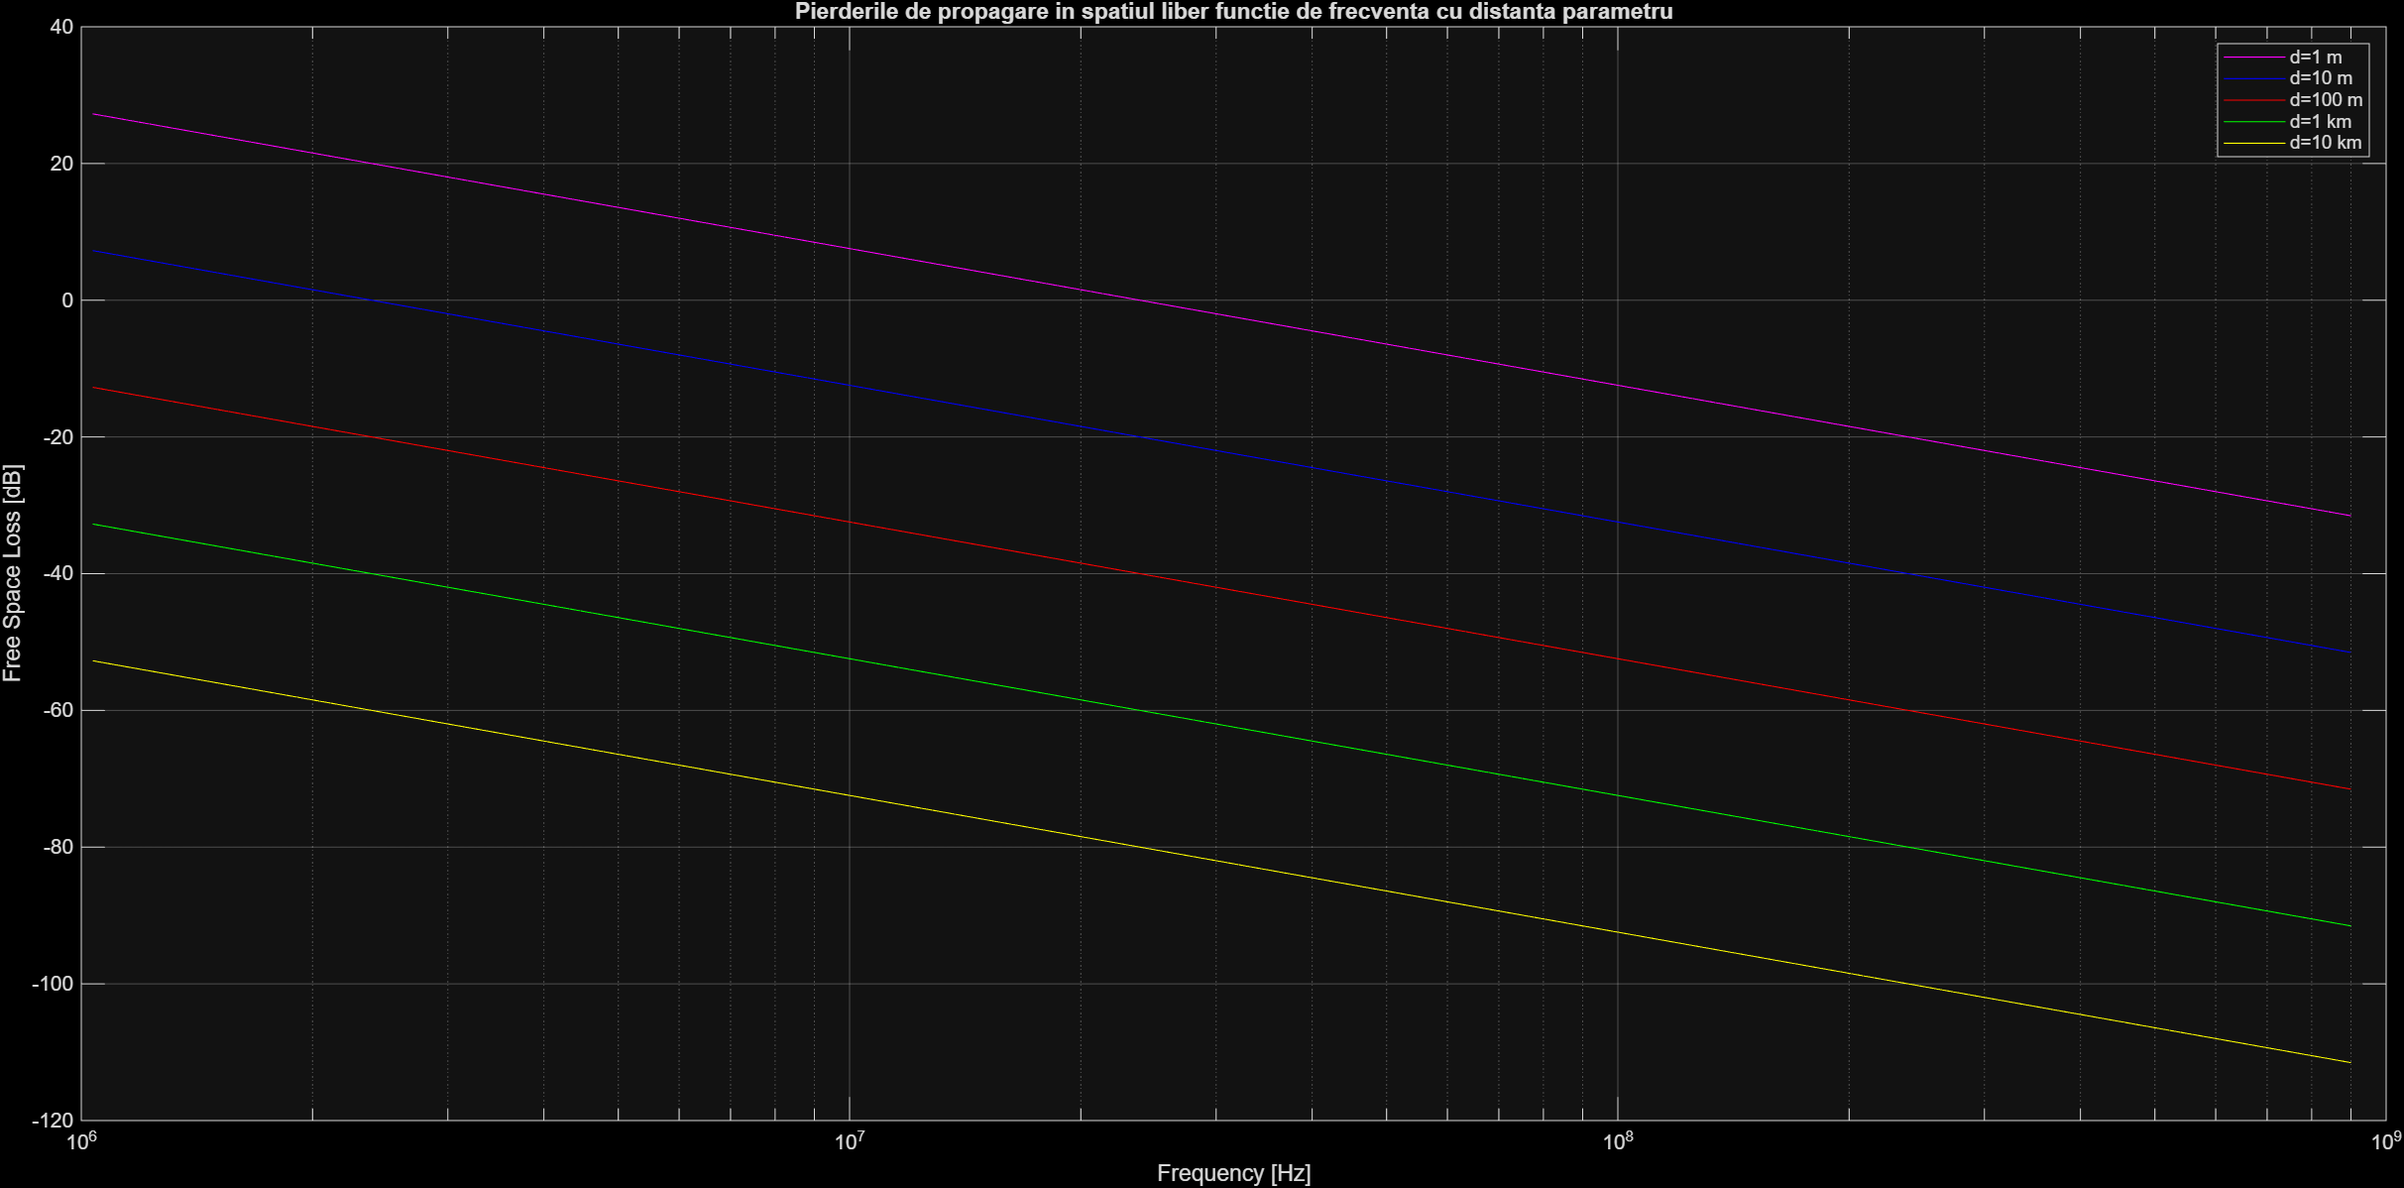
Figure 3: Plot of free space propagation loss as a function of frequency with distance as a parameter, using a logarithmic scale for frequency.

2. Answering questions

Q1. Determine the slope for free space propagation losses variation as a function of frequency.
We know the FSPL expression in dB has a $20{log⁡}_{10}f$ term, so the loss grows at 20 dB/decade (≈6.02 dB per doubling). Since FrSpcLss returns link gain (which is negative and gets more negative as $f$increases), the change in gain per doubling is about −6.02 dB, confirming the 20 dB/decade magnitude.
The following MATLAB code plots the FrSpcLss function with constant distance and antenna gains, so it remains a function of frequency, and it allows us to visualize the slope of 20dB/decade. It also computes the difference in link gain between two frequencies, one of them being double the other.
function q1_slope_freq
% Q1: Slope vs frequency using FrSpcLss (returns link gain in dB).
c = 3e8; %#ok<NASGU> % not used directly, but kept for completeness
d = 1000; % 1 km
Gt = 1; Gr = 1; % isotropic (linear gains)

f = logspace(6,9,400); % 1 MHz ... 1 GHz
Lg = arrayfun(@(ff) FrSpcLss(d, ff, Gt, Gr), f); % link gain [dB]

% Slope check (doubling frequency)
f1 = 100e6; f2 = 2*f1;
L1 = FrSpcLss(d, f1, Gt, Gr);
L2 = FrSpcLss(d, f2, Gt, Gr);
fprintf('Q1: Δ(link gain) for doubling f = %.2f dB (expected ≈ -6.02 dB)\n', L2-L1);

figure; semilogx(f, Lg); grid on;
xlabel('Frequency [Hz]'); ylabel('Link gain (FrSpcLss) [dB]');
title('Q1: Link gain vs frequency at d = 1 km (|slope| ≈ 20 dB/dec)');
hold on; plot([f1 f2],[L1 L2],'x-');
text(f1,L1,sprintf(' %.1f dB @ 100 MHz',L1));
text(f2,L2,sprintf(' %.1f dB @ 200 MHz',L2));
end

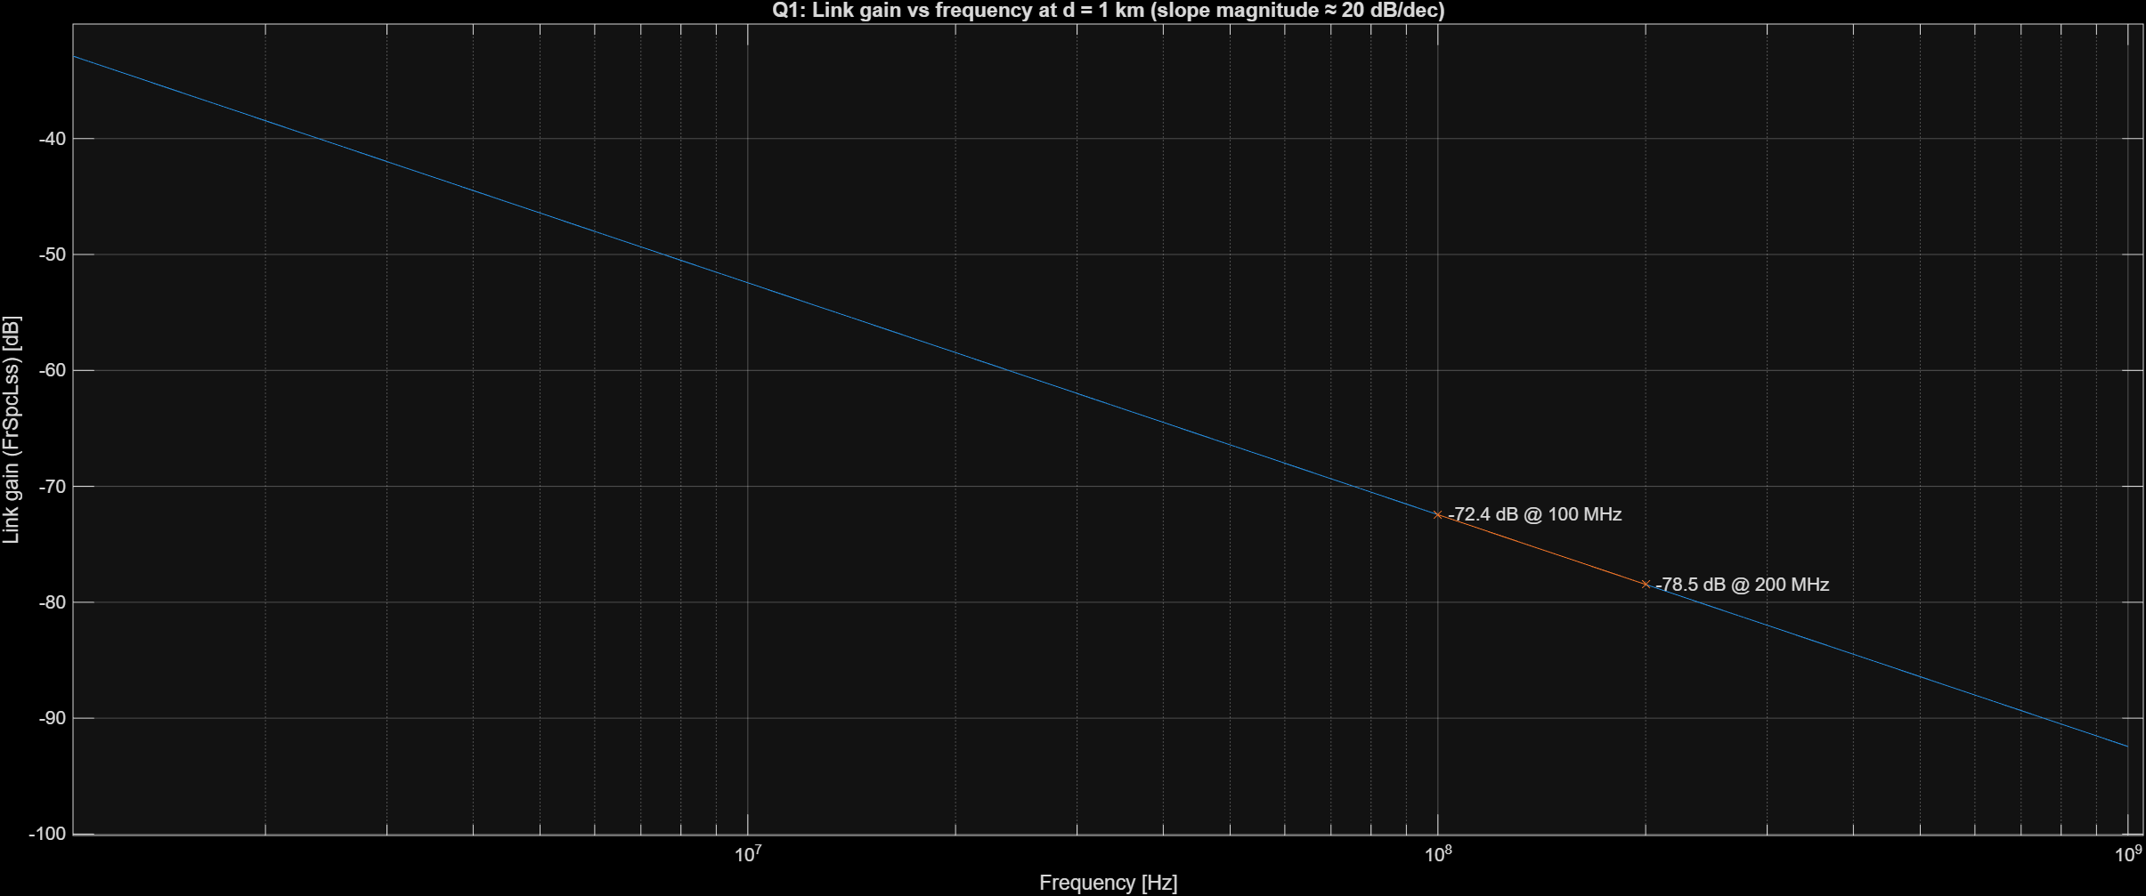

Q2. Determine the slope for free space propagation losses variation as a function of distance.
FSPL also has a $20{log⁡}_{10}d$ term, so loss increases 20 dB/decade with distance (≈6.02 dB per doubling). Because FrSpcLss outputs gain, we expect the gain to drop by about 6.02 dB each time distance doubles. Here’s the code that confirms it:
function q2_slope_dist
% Q2: Slope vs distance using FrSpcLss (returns link gain in dB).
f = 900e6; % 900 MHz
Gt = 1; Gr = 1;
d = logspace(0,4,400); % 1 m ... 10 km
Lg = arrayfun(@(dd) FrSpcLss(dd, f, Gt, Gr), d);

% Slope check (doubling distance)
d1 = 100; d2 = 2*d1;
L1 = FrSpcLss(d1, f, Gt, Gr);
L2 = FrSpcLss(d2, f, Gt, Gr);
fprintf('Q2: Δ(link gain) for doubling d = %.2f dB (expected ≈ -6.02 dB)\n', L2-L1);

figure; semilogx(d, Lg); grid on;
xlabel('Distance [m]'); ylabel('Link gain (FrSpcLss) [dB]');
title('Q2: Link gain vs distance at f = 900 MHz (|slope| ≈ 20 dB/dec)');
hold on; plot([d1 d2],[L1 L2],'x-');
text(d1,L1,sprintf(' %.1f dB @ 100 m',L1));
text(d2,L2,sprintf(' %.1f dB @ 200 m',L2));
end

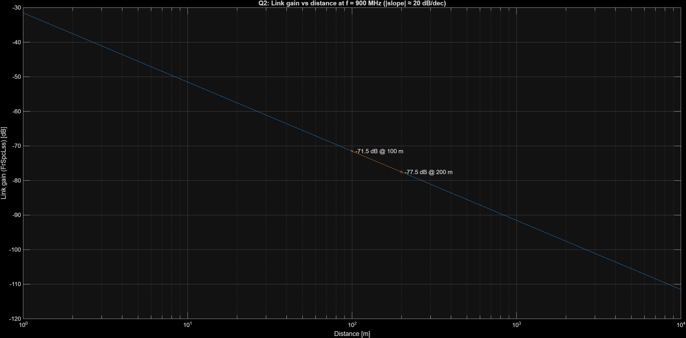
Q3. What can be observed in the proximity of the transmitter (distances ≈ wavelength)?
Friis/FSPL assume far-field operation, i.e., distances much larger than $λ$. Around a few wavelengths, near-field effects mean the simple $1/d^{2}$ behavior isn’t reliable, near-field effects appear, reactive fields dominate, Friis equation is not accurate. We mark $λ$ and $10λ$ at 900 MHz to show that boundary.
function q3_nearfield_demo
% Q3: Visual near-field indication with colored markers at λ and 10λ.
c = 3e8;
f = 900e6;
lambda = c/f;
Gt = 1; Gr = 1;

d = logspace(-2,3,500); % 1 cm ... 1 km
Lg = arrayfun(@(dd) FrSpcLss(dd, f, Gt, Gr), d);

fprintf('Q3: At 900 MHz, λ = %.3f m. Friis/FSPL not reliable for d ~ few·λ.\n', lambda);

figure; semilogx(d, Lg); grid on;
xlabel('Distance [m]'); ylabel('Link gain (FrSpcLss) [dB]');
title('Q3: Link gain vs distance with markers at \lambda and 10\lambda (900 MHz)');

% Colored markers
xline(lambda, '-', ' \lambda', 'Color', [1 0 0], 'LineWidth', 1.5); % red
xline(10*lambda,'-', ' 10\lambda','Color', [0 0 1], 'LineWidth', 1.5); % blue
end
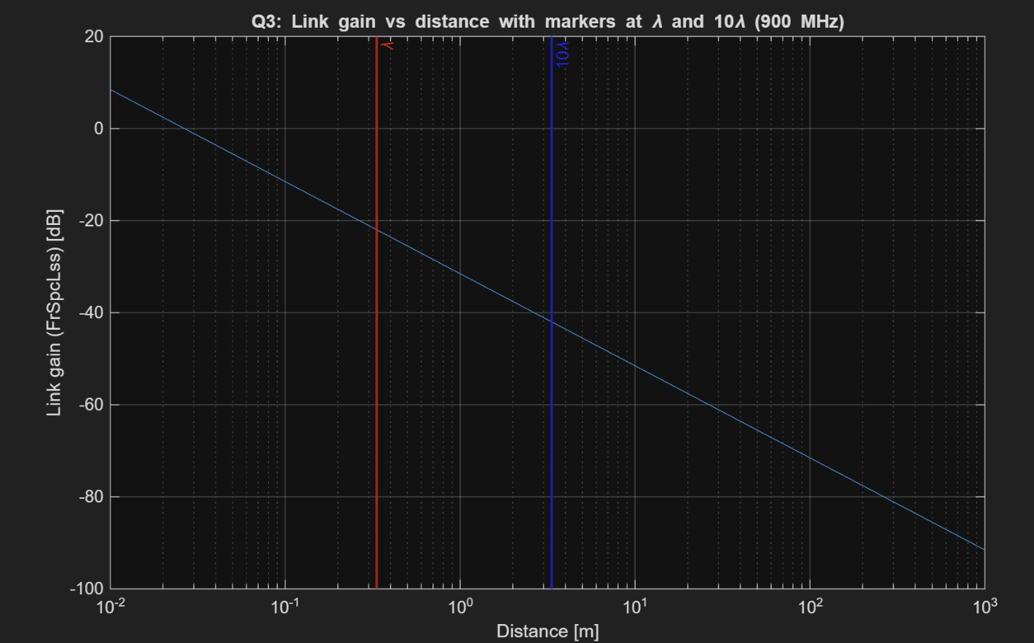

Q4. Determine the propagation losses in the case when the distance between the transmitter and the receiver is d =1 km, the frequency of the signal is f = 900 MHz and the antennae have a gain of 2 dB. Indication: use the Matlab function FrSpcLss.
FrSpcLss gives us link gain in dB. To report loss, we take the negative of that result. We include the antenna gains by converting 2 dB to linear, calling FrSpcLss, and then computing Lloss = - Lg
function q4_loss_numeric
% Q4: Compute path loss at 1 km with GT=GR=2 dB, using FrSpcLss gain -> loss=-gain.
f = 900e6;
d = 1000; % 1 km
GTdB = 2; GRdB = 2;
Gt = 10^(GTdB/10);
Gr = 10^(GRdB/10);

Lg_1km = FrSpcLss(d, f, Gt, Gr); % link gain [dB]
L_loss = -Lg_1km; % path loss [dB]
fprintf('Q4: Path loss at 1 km, 900 MHz, GT=GR=2 dB: %.2f dB\n', L_loss);

% Plot loss vs distance (1 m .. 10 km) and mark 1 km
dvec = logspace(0,4,400);
Lvec = arrayfun(@(dd) -FrSpcLss(dd, f, Gt, Gr), dvec); % compute loss inline
figure; semilogx(dvec, Lvec); grid on;
xlabel('Distance [m]'); ylabel('Path loss [dB]');
title('Q4: Path loss vs distance at 900 MHz (GT=GR=2 dB)');
hold on; plot(d, L_loss, 'x'); text(d, L_loss, sprintf(' %.1f dB @ 1 km', L_loss));
end

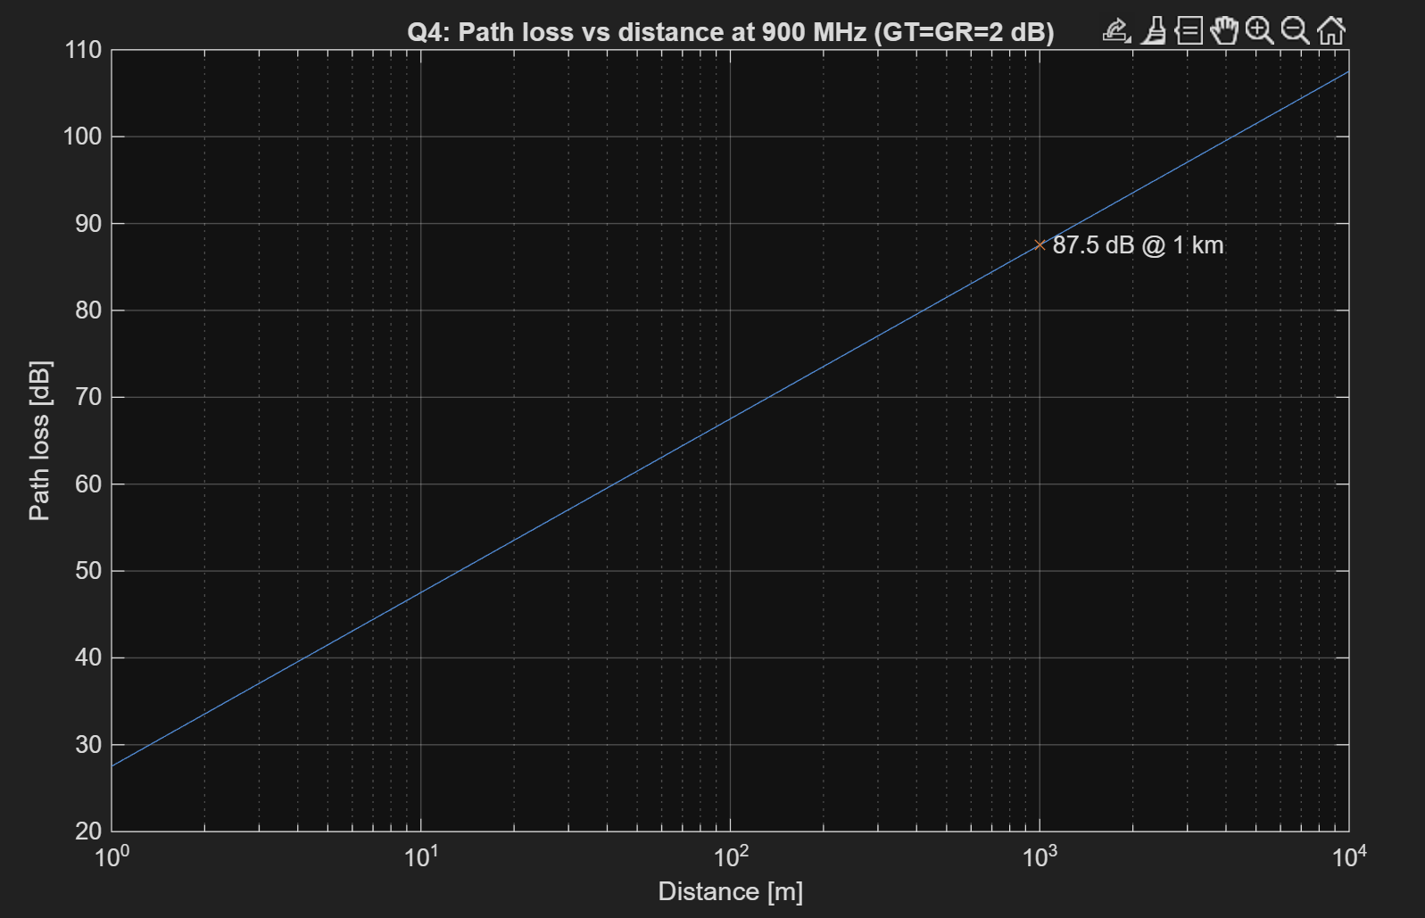

Q5. Consider a radio transmitter with PT= 50 W. If the antenna of the transmitter is isotropic and the frequency of the emitted signal is 900 MHz, compute the free space received power at the distance d=100m from the transmitter. It is supposed that the receiver also has an isotropic antenna.
FrSPcLss returns $10{log⁡}_{10}(P_{R}/P_{T})$. So, we recover $P_{R}$via $P_{R}=P_{T}⋅{10}^{\text{FrSpcLss}(d,f,G_{T},G_{R})/10}.$ With $P_{T}=50$W, $d=100$m, $f=900$MHz, isotropic gains, we expect around 3.5.

function q5_received_power_demo
% Q5: Received power using FrSpcLss directly.
PT = 50; % W
f = 900e6; % Hz
Gt = 1; Gr = 1; % isotropic
dMk = 100; % m

LgMk = FrSpcLss(dMk, f, Gt, Gr); % dB of (PR/PT)
PR_Mk = PT * 10^(LgMk/10); % W
PR_dBm = 10*log10(PR_Mk/1e-3);
fprintf('Q5: PR @100 m, 900 MHz, PT=50 W (iso): %.3e W = %.2f µW (%.2f dBm)\n', ...
PR_Mk, PR_Mk*1e6, PR_dBm);

% Curve PR vs distance (10 m .. 10 km)
d = logspace(1,4,400);
Lg = arrayfun(@(dd) FrSpcLss(dd, f, Gt, Gr), d);
PR = PT .* 10.^(Lg/10);

figure; loglog(d, PR); grid on;
xlabel('Distance [m]'); ylabel('Received Power [W]');
title('Q5: Received power vs distance (PT=50 W, f=900 MHz, isotropic)');
hold on; plot(dMk, PR_Mk, 'x');
text(dMk, PR_Mk, sprintf(' %.2f µW @ 100 m', PR_Mk*1e6));
end

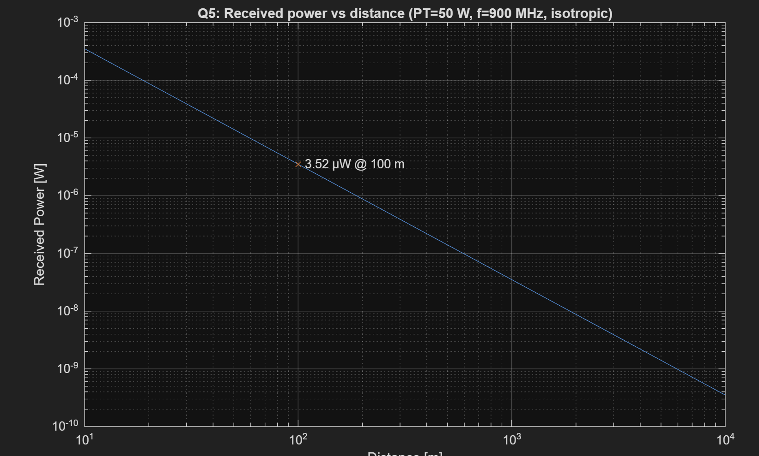
Q6. If the power received by an antenna having the gain is , and the frequency of the signal is f=900MHz, determine the intensity of the electrical field at the receiver. Indication: relation (3) should be used.
We used the lab relations $A_{e}=\frac{G_{R}λ^{2}}{4π}$, $S=\frac{P_{R}}{A_{e}}$, and $S=\frac{E^{2}}{η}⇒E=\sqrt{Sη}$with $η≈377$. Plugging $P_{R}$, $G_{R}$, and $f$gives $E$in V/m.
function q6_field_from_power_demo
% Q6: Compute |E| from PR, GR, f (direct formulas; no helpers).
c = 3e8; % [m/s]
eta = 377; % [ohm]
PR = 7e-10; % [W]
GR = 2; % linear power gain
f = 900e6; % [Hz]

lambda = c / f;
Ae = GR * lambda^2 / (4*pi); % effective aperture [m^2]
S = PR / Ae; % power flux density [W/m^2]
E = sqrt(S * eta); % field magnitude [V/m]

fprintf('Q6: E ≈ %.4f V/m = %.2f mV/m (at 900 MHz, GR=2, PR=7e-10 W)\n', E, E*1e3);

% Visual: E vs PR with the given point
PR_range = logspace(-12,-6,400);
Ae_const = Ae; % constant for fixed GR and f
E_curve = sqrt((PR_range./Ae_const) * eta);

figure; semilogx(PR_range, E_curve); grid on;
xlabel('Received Power PR [W]'); ylabel('E-field magnitude [V/m]');
title('Q6: E-field vs PR (GR=2, f=900 MHz)');
hold on; plot(PR, E, 'x'); text(PR, E, sprintf(' %.2f mV/m @ %.1e W', E*1e3, PR));
end


