MCS Lab 2 Report

Sakka Mohamad-Mario
el-ghoul Layla
mahmoud mirghani abdelrahman
MCS

1. Plots resulting from code

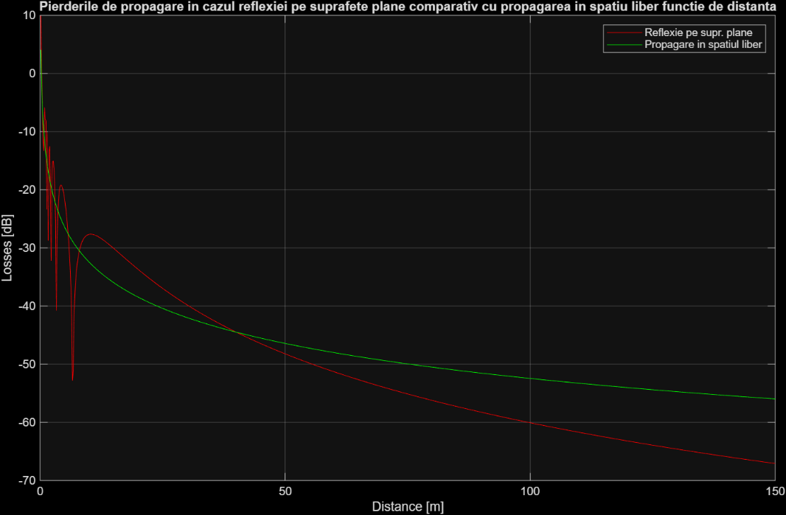
Figure 1: Propagation losses for reflection on plane surfaces vs. free-space propagation as a function of distance.
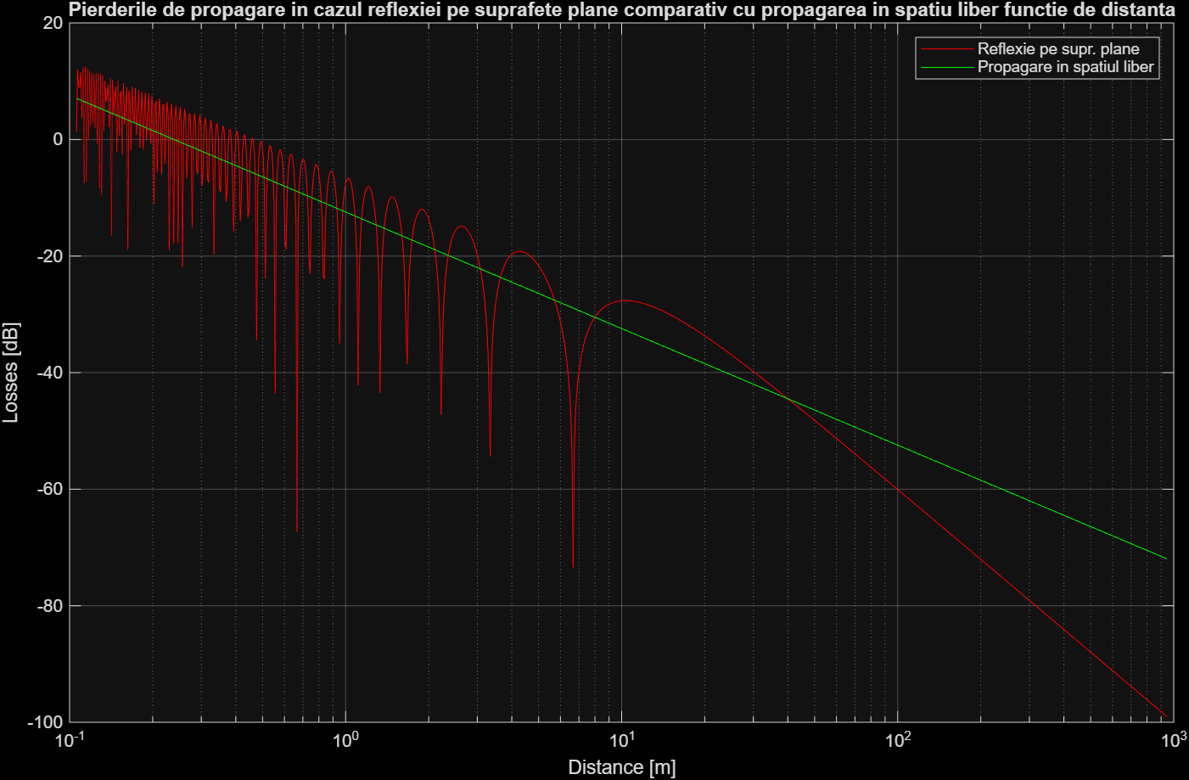
Figure 2: Propagation losses for reflection on plane surfaces vs. free-space propagation as a function of distance (log scale).
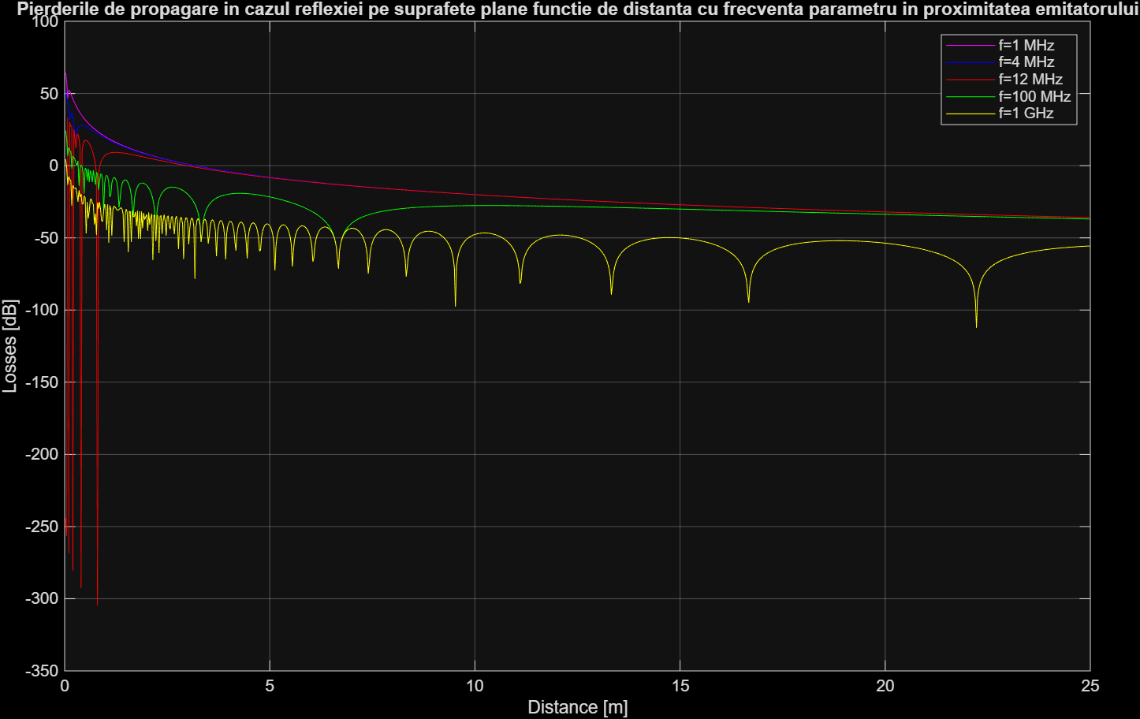
Figure 3: Propagation losses for reflection on plane surfaces vs. distance, with frequency as a parameter, near the transmitter.
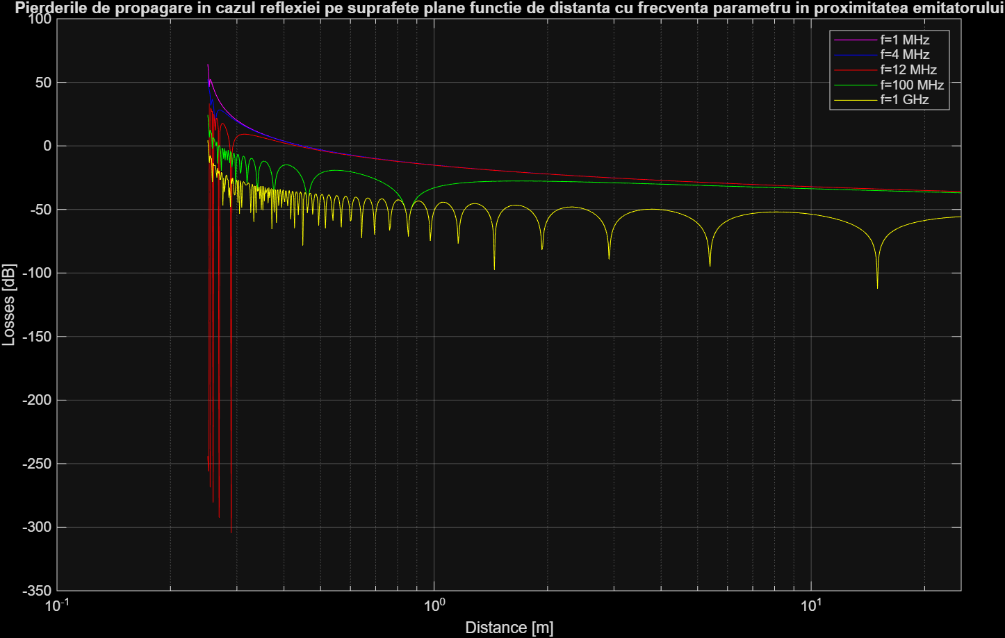
Figure 4: Propagation losses for reflection on plane surfaces vs. distance, with frequency as a parameter, near the transmitter (log scale).
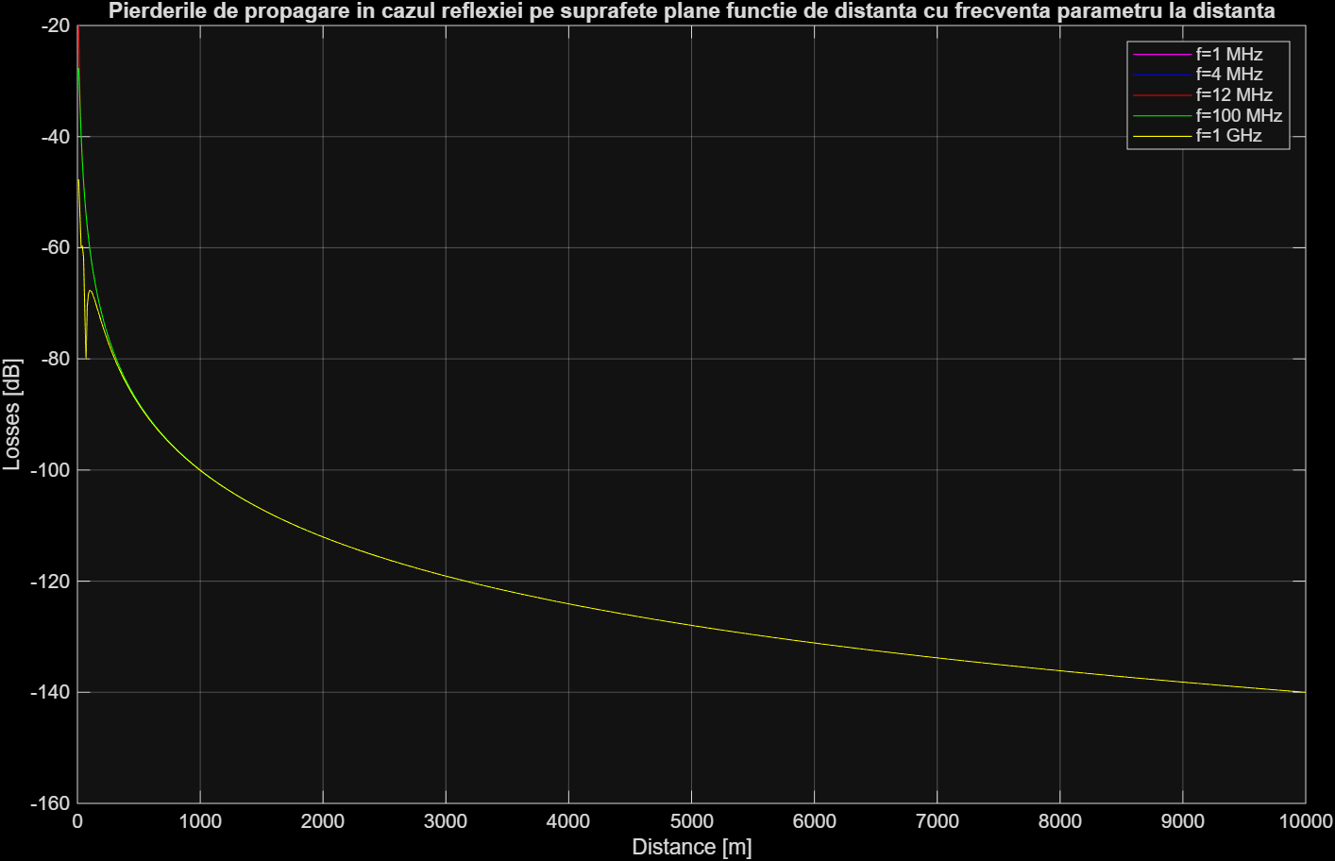
Figure 5: Propagation losses for reflection on plane surfaces vs. distance, with frequency as a parameter, far from the transmitter.

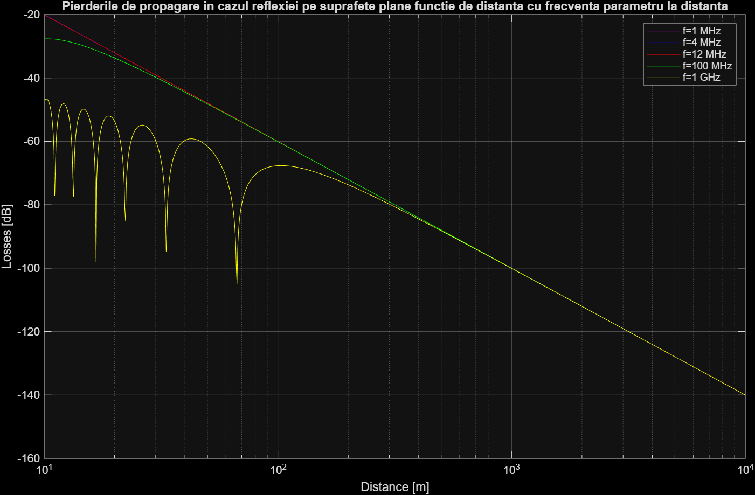
Figure 6: Propagation losses for reflection on plane surfaces vs. distance, with frequency as a parameter, far from the transmitter (log scale).
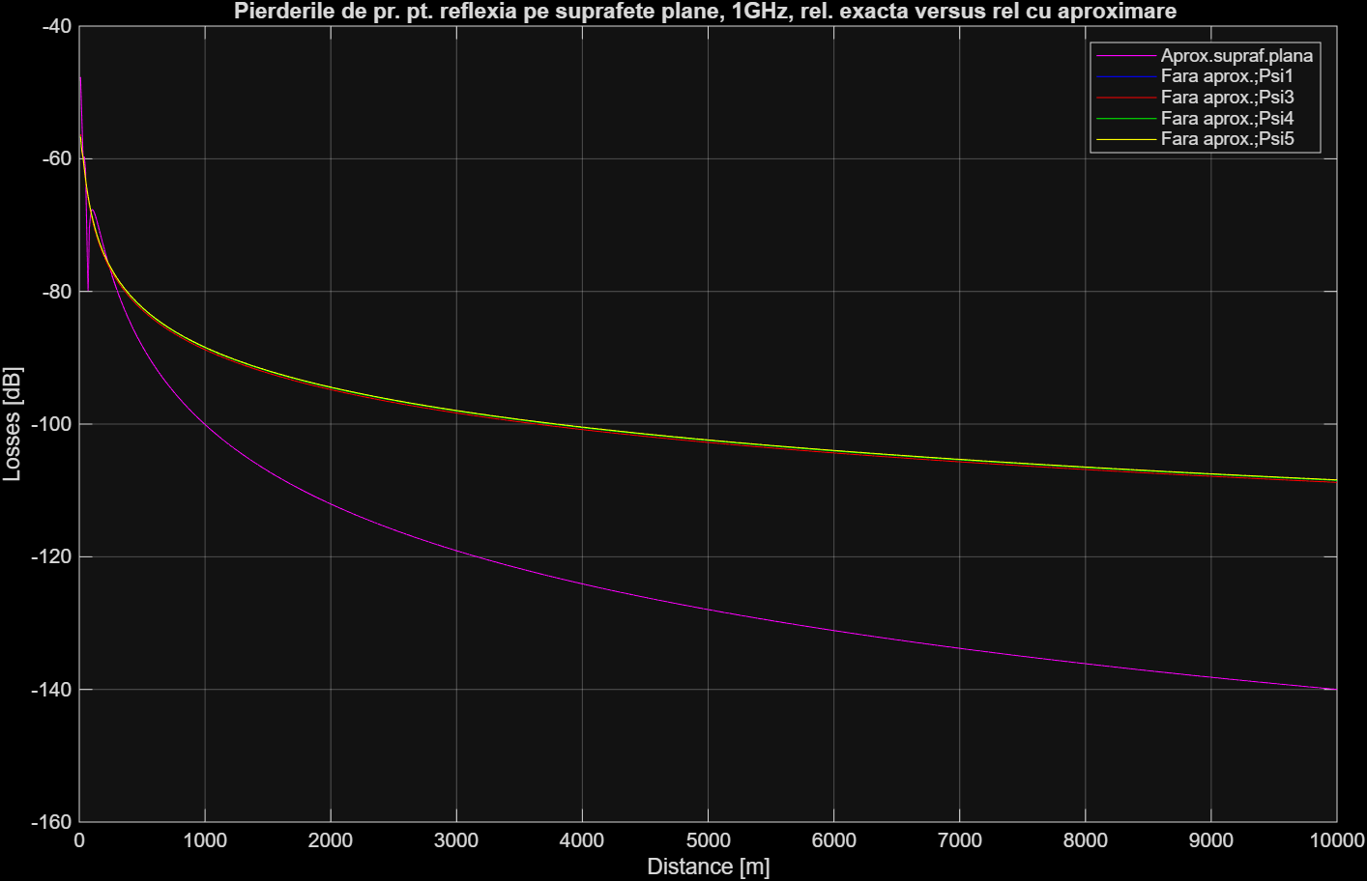
Figure 7: Propagation losses for reflection from plane surfaces at 1 GHz: exact relation vs approximate relation.

2. Answering questions

Q1. What are the essential differences between the propagation equation in free space and the propagation equation above planar reflective surfaces?
In free space (Friis), losses vary with $d^{2}$(slope 20 dB/dec), depend on frequency ($∝f^{2}$), and do not depend on antenna heights. Above a planar reflective surface (two-ray), the direct + reflected fields interfere; beyond the near region the received power scales as $h_{T}^{2}h_{R}^{2}/d^{4}$(loss slope 40 dB/dec) and becomes asymptotically frequency-independent at fixed heights. Close to the transmitter, maxima/minima appear due to interference.
%% Q1 – Free space vs planar reflection (f = 100 MHz)
dMin = 10; dMax = 1e4; % [m]
f = 100e6; % [Hz]
GT = 1; GR = 1; % antenna gains (power)
hT = 10; hR = 1; % [m]

d = linspace(dMin,dMax,1000);
L_fs = arrayfun(@(dd) FrSpcLss(dd, f, GT, GR), d); % uses lab fn
L_plan= arrayfun(@(dd) ReflPlan(f, dd, GT, GR, hT, hR), d); % uses lab fn

figure; plot(d, L_plan, d, L_fs); grid on
xlabel('Distance [m]'); ylabel('Losses [dB]');
title('Free-space vs. planar reflective surface (f=100 MHz)');
legend('ReflPlan (plane reflection)','FrSpcLss (free space)','Location','best');

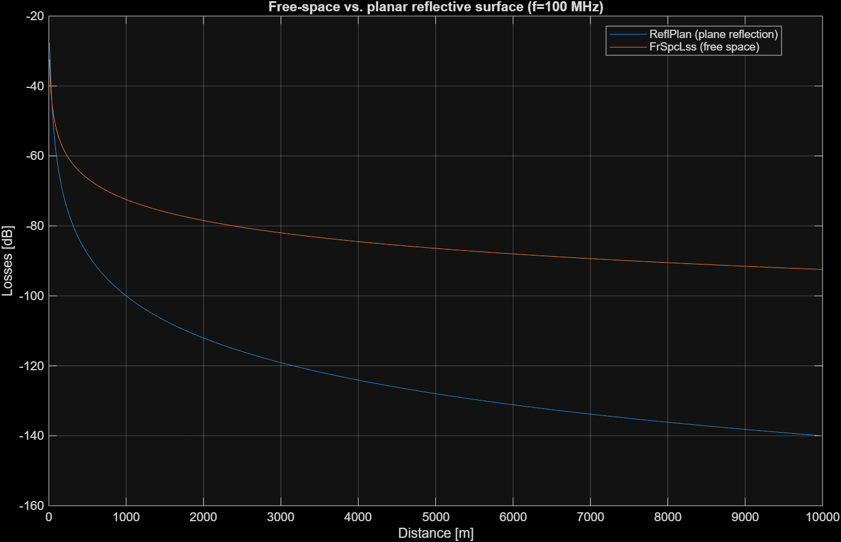
Q2. Determine the slope of the propagation losses above planar reflective surfaces, as a function of the distance.
From the lab’s derivation of the smooth-surface (two-ray) regime, $P_{r}∝h_{T}^{2}h_{R}^{2}/d^{4}$. Thus losses grow with $d^{4}$→ 40 dB/decade. The code below numerically confirms this on a far-region window.
%% Q2 – Slope ~ 40 dB/decade (far region)
f = 100e6; GT = 1; GR = 1; hT = 10; hR = 1;
d = logspace(3, 4, 400); % 1–10 km decade
L_plan = arrayfun(@(dd) ReflPlan(f, dd, GT, GR, hT, hR), d);

p = polyfit(log10(d), L_plan, 1); % fit L ≈ p1*log10(d)+p2
fprintf('Estimated slope: %.1f dB/decade (theory: 40 dB/dec)\n', p(1));

figure; semilogx(d, L_plan); grid on
xlabel('Distance [m]'); ylabel('Losses [dB]');
title(sprintf('Planar reflection losses – slope ≈ %.1f dB/decade', p(1)));

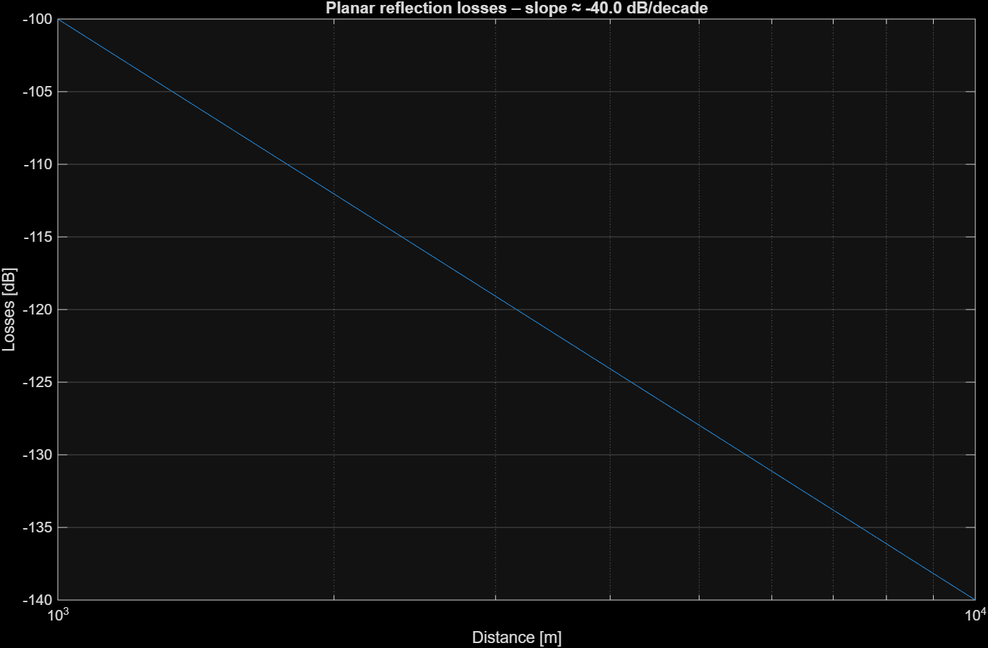

Q3. What can be stated about the frequency dependence of the propagation losses at a high distance from the transmitter?
In the high-distance (grazing-incidence) region, the lab’s smooth-surface equation shows losses no longer depend on $f$(with fixed heights). The ReflPlan curves at different $f$values collapse together far from the transmitter.
%% Q3 – Frequency-independence far from TX
GT = 1; GR = 1; hT = 10; hR = 1;
fList = [1e6, 4e6, 12e6, 100e6, 1e9];
d = logspace(3, 4, 600); % 1–10 km

L = zeros(numel(d), numel(fList));
for k = 1:numel(fList)
fk = fList(k);
for t = 1:numel(d)
L(t,k) = ReflPlan(fk, d(t), GT, GR, hT, hR); % lab fn
end
end

figure; semilogx(d, L); grid on
xlabel('Distance [m]'); ylabel('Losses [dB]');
title('Planar reflection: losses vs. distance for various frequencies');
legend('1 MHz','4 MHz','12 MHz','100 MHz','1 GHz','Location','best');
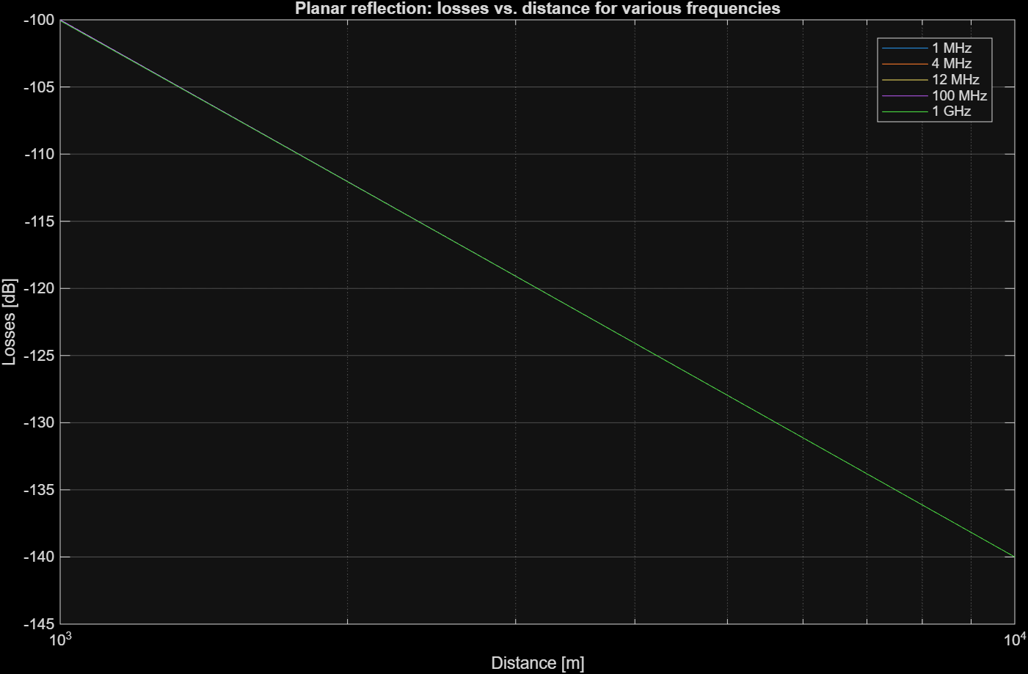
Q4. How can be explained the presence of the local minima in the proximity of the transmitter?
They come from interference between direct and reflected waves. The phase difference $Δϕ$varies with distance; when it is $(2n+1)π$, destructive interference creates local minima; for $2nπ$, maxima occur. This oscillatory region is visible only near the transmitter; farther out the curve tends smoothly to the $d^{-4}$law.
%% Q4 – Show short-range oscillations and mark minima
f = 100e6; GT = 1; GR = 1; hT = 10; hR = 1;
d = linspace(5, 300, 2000); % short range [m]
L = arrayfun(@(dd) ReflPlan(f, dd, GT, GR, hT, hR), d); % lab fn

% crude minima detection without toolboxes
dL = diff(L);
idxMin = find([false, dL(1:end-1) < 0 & dL(2:end) > 0, false]); % sign change in slope

figure; plot(d, L); hold on; plot(d(idxMin), L(idxMin),'v','MarkerSize',6);
grid on; xlabel('Distance [m]'); ylabel('Losses [dB]');
title('Short-range interference: local minima (destructive) highlighted');
legend('ReflPlan','Local minima');

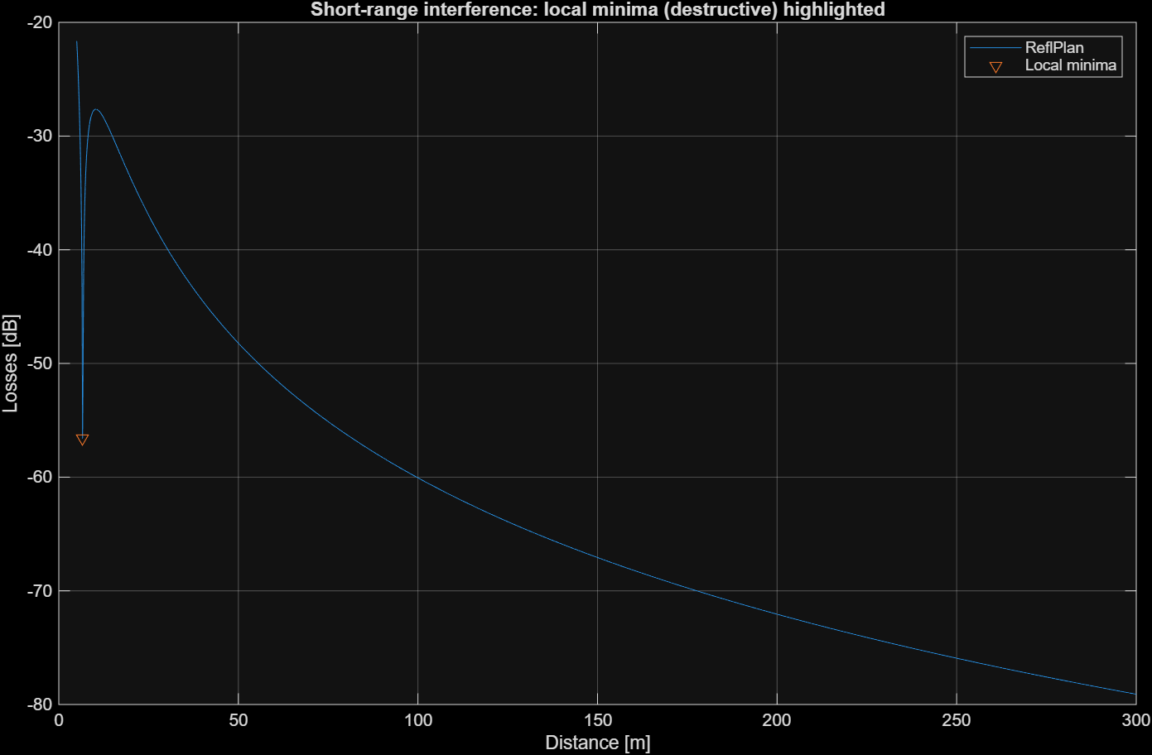
q5. Determine the propagation losses in the situation in which the distance between the transmitter and the receiver is $d=1 km$, the frequency of the signal is $f=900MHz$, the heights of the antennae $H_{t}=10m ;H_{r}=1m$, and the gains of the antennae $G_{t}=G_{r}=1$. Indication: use the Matlab function: ReflPlan.
Using the ReflPlan function from the lab files, we computed it to be $-100.05 dB$. The MATLAB code:
%% Q5 – Losses at d=1 km, f=900 MHz with ReflPlan
d = 1000; f = 900e6;
GT = 1; GR = 1; % <-- set from your sheet if different
hT = 10; hR = 1; % <-- set from your sheet if different

L_Q5 = ReflPlan(f, d, GT, GR, hT, hR); % lab fn
fprintf('Q5: ReflPlan losses at d=1 km, f=900 MHz: %.2f dB\n', L_Q5);

q6. Determine the propagation losses with the relation obtained with the approximation of a planar surface in the situation in which the distance between the transmitter and the receiver is $d=1km$, the frequency of the signal is $f=1GHz$, the heights of the antennae are $H_{t}=10m ;H_{r}=1m$, gains of the antennae are $G_{t}=G_{r}=1$ . The Matlab function: use trueReflPlan.
We used the true (with-earth) relation implemented in trueReflPlan, which internally calls ErthRefC with $ε_{r}=15$ and $σ=0.012$. For $d=1\text{ km}$at $f=1\text{ GHz}$with our antenna gains and heights, we supplied a small incidence angle $ψ$(in radians). The function returns a complex-aware expression; following the lab demo, we report the losses as $-\left|\text{trueReflPlan}\right|$ in dB. The result is: $-91.55 dB$
%% Q6 – Losses at d=1 km, f=1 GHz using trueReflPlan (Earth reflection)
% addpath('path_to_lab_functions_folder'); % <- uncomment and set if needed

f = 1e9; % Hz
d = 1000; % m
GT = 1; GR = 1; % gains (power)
hT = 10; hR = 1; % m (set your sheet's values if different)
psi = pi/10; % incidence angle [rad]; try smaller like pi/20 if desired

val_true = trueReflPlan(f, d, GT, GR, hT, hR, psi); % lab function
L_Q6 = -abs(val_true); % sign convention used in demo

fprintf('Q6: trueReflPlan losses at d=1 km, f=1 GHz (psi=%.3f rad) = %.2f dB\n', psi, L_Q6);

