SDT Lab 4 – Architecture & Design Solutions
Team: Sakka Mohamad-Mario, Zafar Azzam, Al-Khalidy Essam

1. Digital Portfolio Website for Creative Professionals

1.1 Architecture Overview
We design the portfolio platform as a cloud-native web application with three main layers:
• Frontend: Responsive SPA (e.g., React) where photographers and artists manage portfolios and visitors browse.
• Backend API: Portfolio Service (core business logic), Media Service (upload, transform, CDN links), Analytics Service, Authentication Service, Notification Service.
• Data & Storage: Relational DB for users, portfolios, albums; object storage (e.g., S3) for images/videos; analytics store (time-series or columnar DB) for events like views and shares.
A CDN sits in front of media storage to ensure fast delivery of media-heavy portfolios. The backend is deployed as stateless containers behind an API gateway/load balancer, allowing horizontal scaling as traffic grows.
High-Level Architecture Diagram:
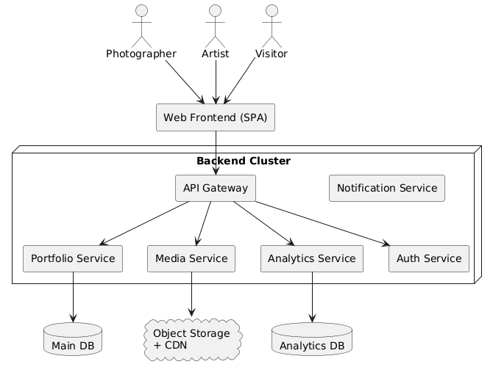

1.2 Class Model
The class model focuses on users, portfolios, albums, media items, templates, and analytics. A user can have multiple portfolios; each portfolio has one template configuration and multiple albums, which contain media items. Analytics events are aggregated per portfolio.
Class Diagram:
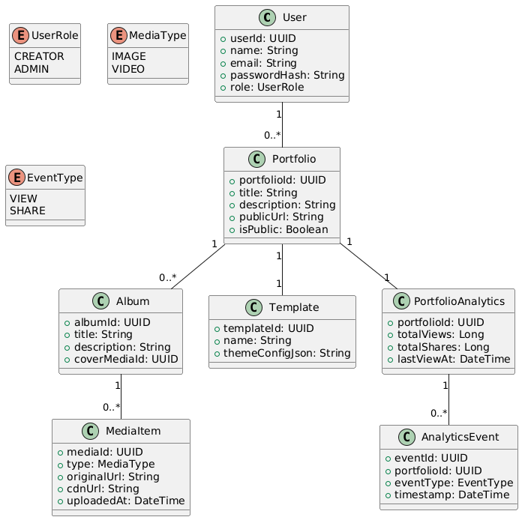

1.3 Key Use Cases & Sequence Diagrams
We illustrate two main flows: uploading photos into albums and visitors viewing a portfolio with analytics tracking.
Upload photos to album sequence diagram:
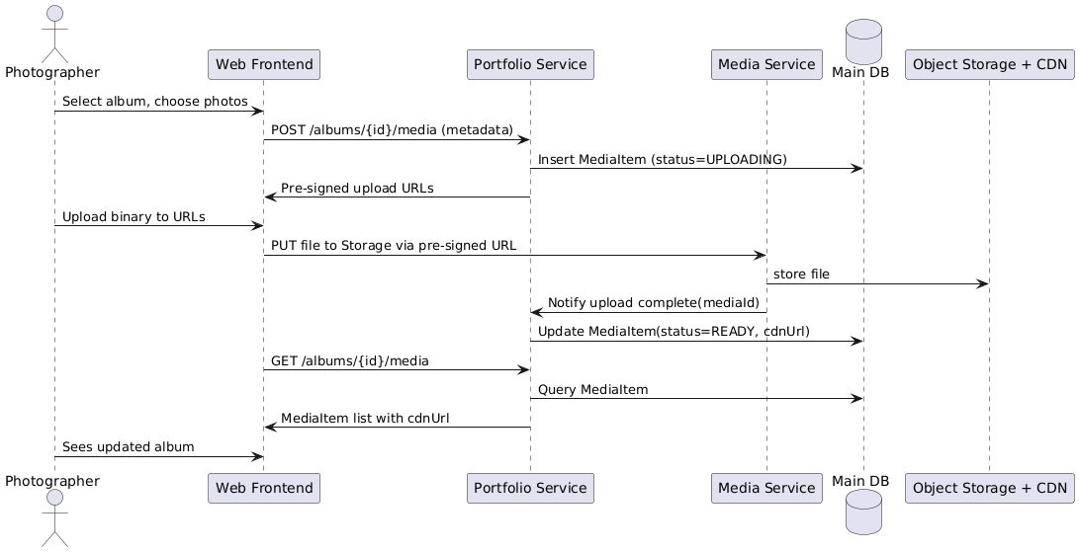
Visitor view portfolio and analytics are updated sequence diagram:
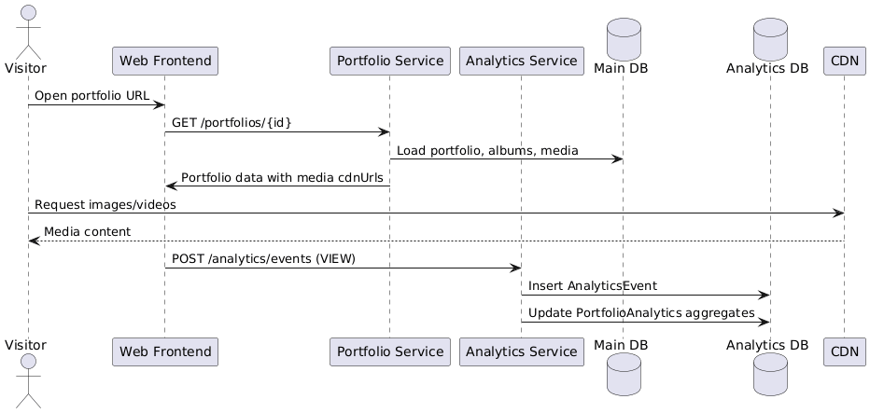

1.4 Data Security & Scalability
Security:
• Use OAuth2 / OpenID Connect for authentication, with hashed passwords and optional 2FA.
• Enforce authorization so a user can edit only their own portfolios and media.
• All traffic over HTTPS; S3/object storage buckets locked to backend with pre-signed URLs for clients.
• Validate media types and sizes on upload; run malware scanning on files.
• Encrypt sensitive data at rest in the DB; restrict access via least-privilege roles.
Scalability:
• Stateless backend services scaled horizontally behind a load balancer.
• CDN for caching images/videos close to visitors.
• Use background workers for heavy tasks (video transcoding, thumbnail generation).
• Partition analytics storage and use batching for writes to handle high traffic.
• Introduce read replicas on the main DB as the number of portfolios grows.

2. Music App for Shared Playlists and Synchronized Listening

2.1 Architecture Overview
The music app combines typical REST APIs with a real-time communication channel for synchronized sessions:
• Frontend: Mobile and web clients for managing playlists, joining sessions, and chatting.
• Backend Services: User/Playlist Service, Session Service (sync state), Chat Service, Notification Service, Auth Service.
• Real-time Layer: WebSocket or WebRTC-based channel for broadcasting playback commands and chat messages.
• Data & Integration: Relational DB for users, playlists, sessions; message broker to fan out playback updates; integration with a streaming provider API for the actual audio stream (we control timecodes, not media hosting).
High-level architecture:
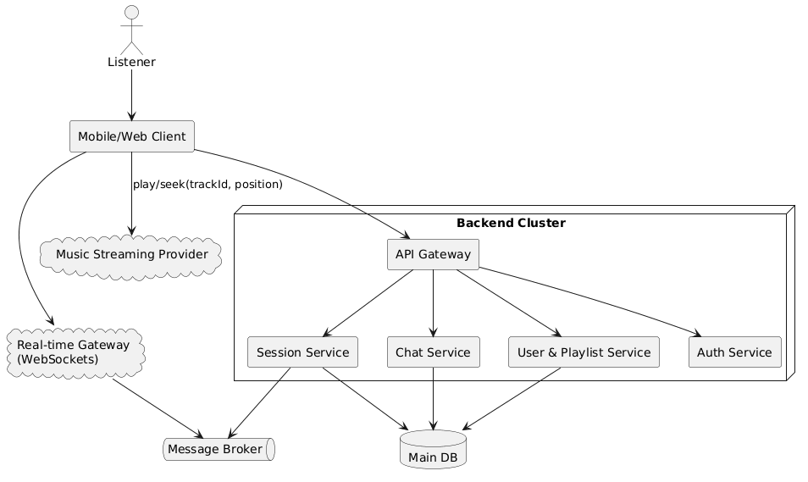

2.2 Class Model
Core domain classes model users, playlists, songs, collaborative sessions, invitations, and chat messages. A session references a shared playlist and maintains the current playback state.
Class diagram:
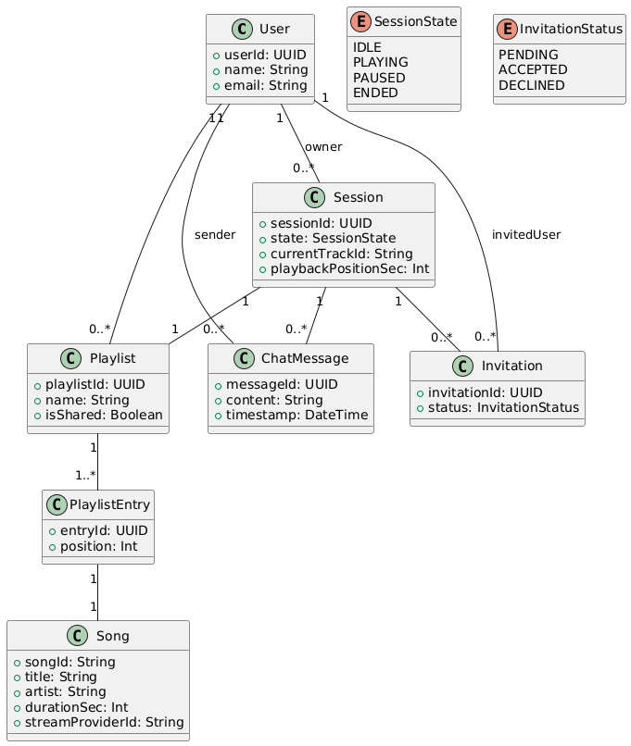

2.3 Key Use Cases & Sequence Diagrams
We illustrate inviting a friend to a shared playlist and controlling playback in a synced session.
Invite friend to shared playlist sequence diagram:
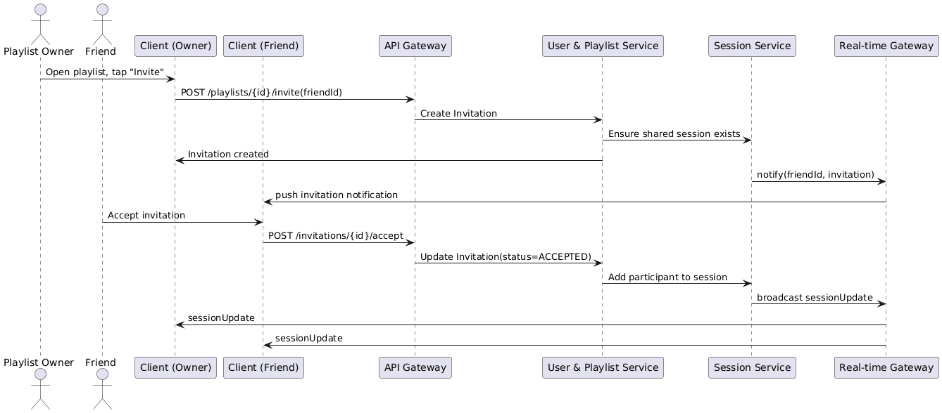
Synchronized playback control sequence diagram:

2.4 Data Security & Scalability
Security:
• OAuth2-based login; short-lived access tokens and refresh tokens.
• Per-resource authorization: only members can see a shared playlist or session chat.
• Encrypt tokens and secrets; never expose streaming provider secrets to clients.
• Rate-limit chat and session actions to avoid abuse.
Scalability:
• Real-time gateway scaled horizontally; clients are sharded by sessionId.
• Use a message broker (e.g., Redis Pub/Sub or Kafka) to fan out playback and chat events.
• Store chat history and session state in a scalable DB; use TTL for old sessions.
• Keep playback commands small and idempotent so a large group can stay in sync even with network jitter.

3. Ticketing System for IT-Related Inquiries

3.1 Architecture Overview
The IT ticketing system is an internal web application with separate views for employees, IT staff, and managers:
• Frontend: Web UI for creating tickets, managing queues, and viewing reports.
• Backend Services: Ticket Service (CRUD, status transitions), User/Role Service, Reporting Service, Notification Service.
• Data: Relational DB for tickets, users, status history; reporting views or a small data warehouse for aggregated metrics.
• Integrations: Email/Chat for notifications when tickets are created or updated.
High-level architecture:
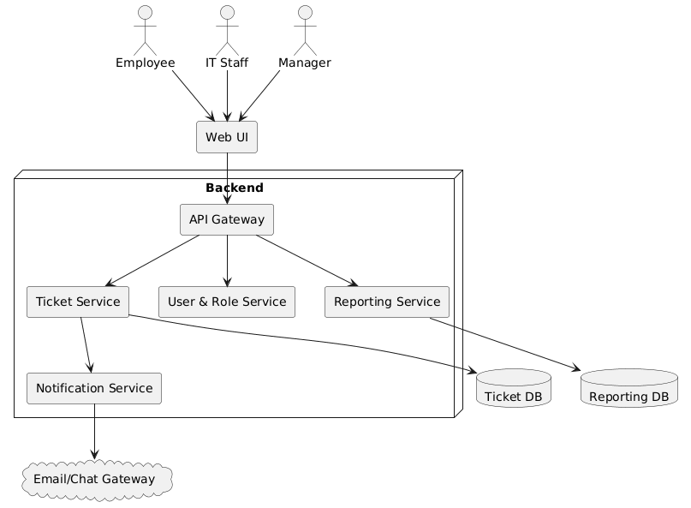

3.2 Class Model
The class model captures tickets, their lifecycle, and the users interacting with them. A status history enables reporting on response and resolution times.
Class diagram:
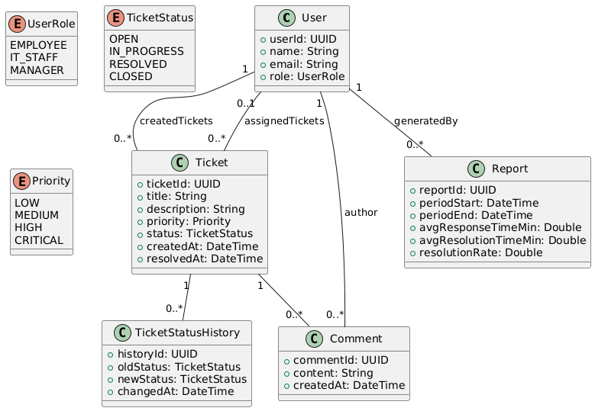

3.3 Key Use Cases & Sequence Diagrams
We illustrate creating a ticket, IT staff resolving it, and a manager viewing aggregated reports.
Employee submits ticket sequence diagram:
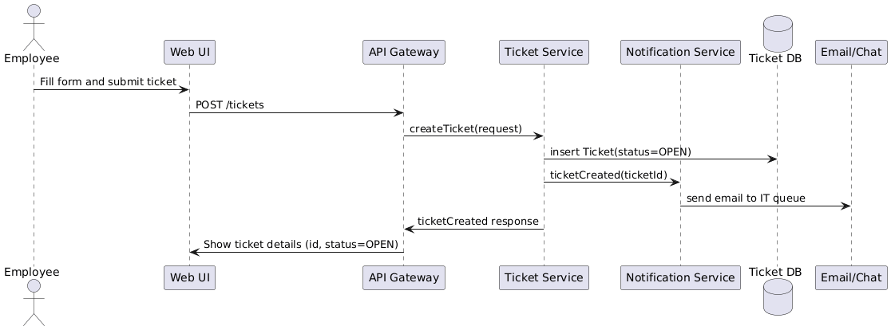
Ticket resolution and reporting sequence diagram:
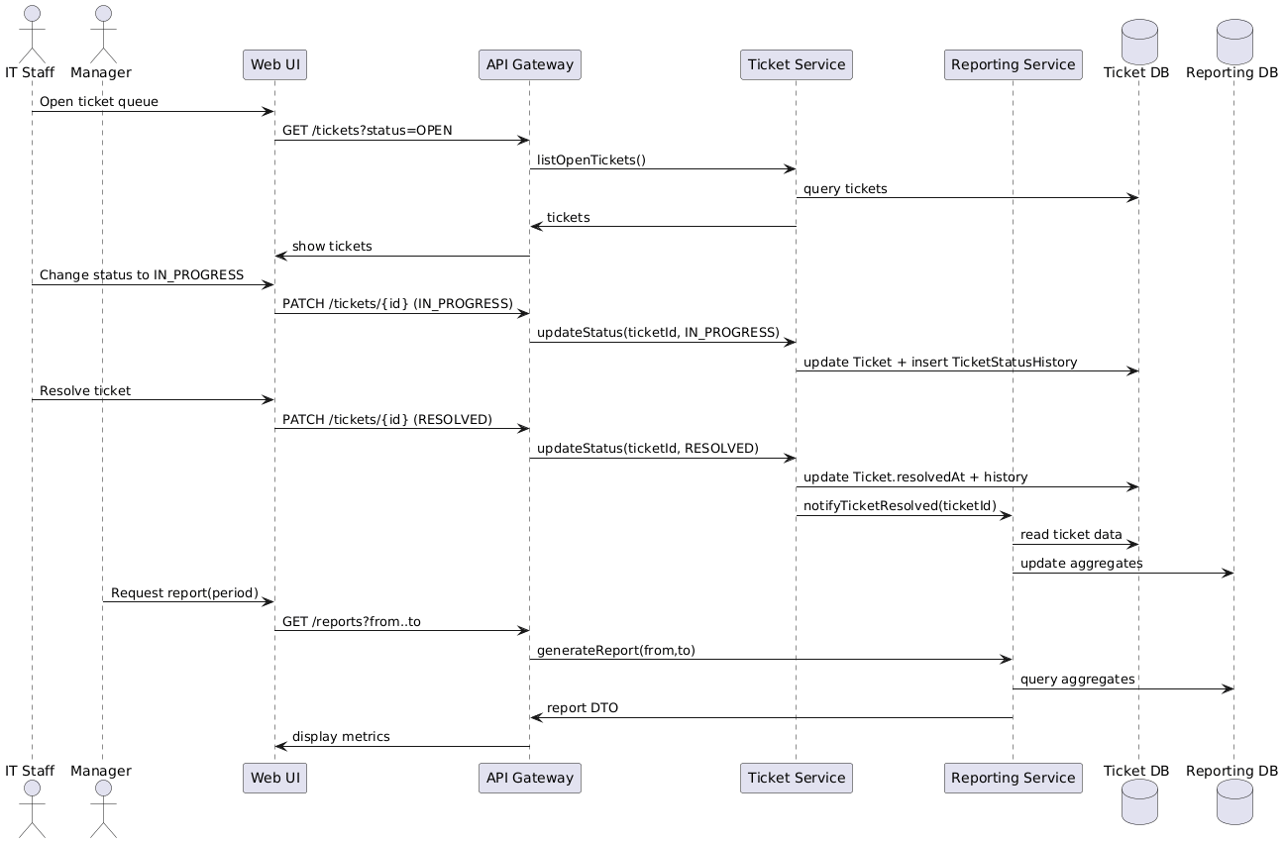

3.4 Data Security & Scalability
Security:
• Integrate with the company SSO/LDAP for authentication; enforce role-based access control.
• Employees can see only their own tickets; IT and managers see tickets based on their queues/teams.
• Audit log all status changes and comments; protect against injection via input validation.
• Encrypt the database at rest and use secure channels for email/chat integrations.
Scalability:
• Ticket traffic is moderate; a single DB with indexes on status, priority, and createdAt is sufficient.
• Use read replicas or materialized views for reporting so heavy analytics queries do not slow down ticket operations.
• Scale the API horizontally when the company size grows, keeping services stateless.

4. Online Food Delivery Service

4.1 Architecture Overview
The food delivery system is a multi-sided platform (customers, restaurants, delivery agents) that must handle high concurrency and real-time tracking:
• Frontends: Customer app/web, Restaurant dashboard, Delivery agent app.
• Backend Services: Restaurant Service, Menu Service, Order Service, Payment Service, Delivery Assignment Service, Tracking Service, Notification Service.
• Data: Relational DB for orders, menus, users; separate read models or caches for frequently accessed listing data; geo-indexed store for courier locations.
• Real-time: WebSocket or push notifications for order status and courier location updates.
• Payments: Integrate with a PCI-compliant payment gateway; we never store raw card data.
High-level architecture:
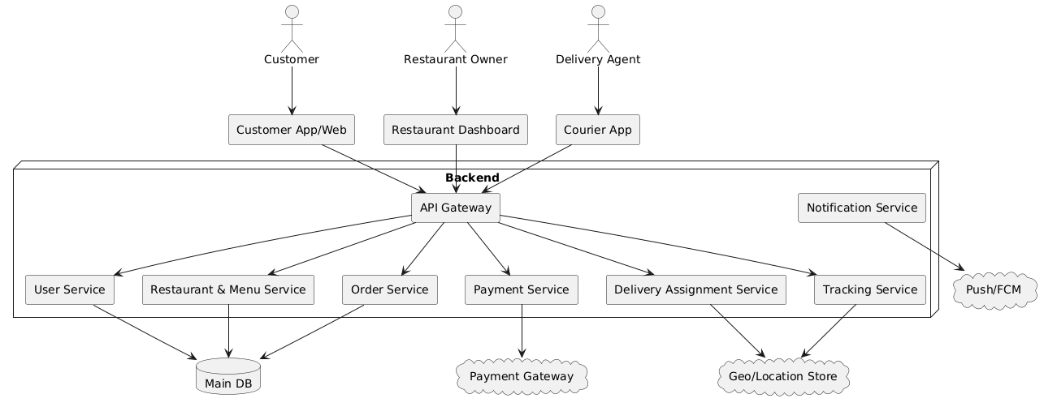

4.2 Class Model
The class model covers customers, restaurants, menus, orders, payments, delivery agents, and tracking events. Orders are composed of order items referencing menu items.
Class diagram:
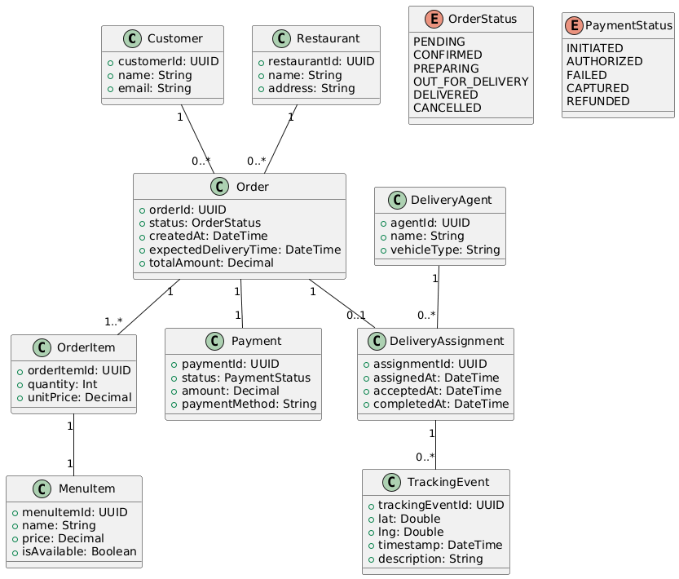

4.3 Key Use Cases & Sequence Diagrams
We show placing and paying for an order, and then assigning a courier and tracking delivery.
Customer places and pays for order sequence diagram:
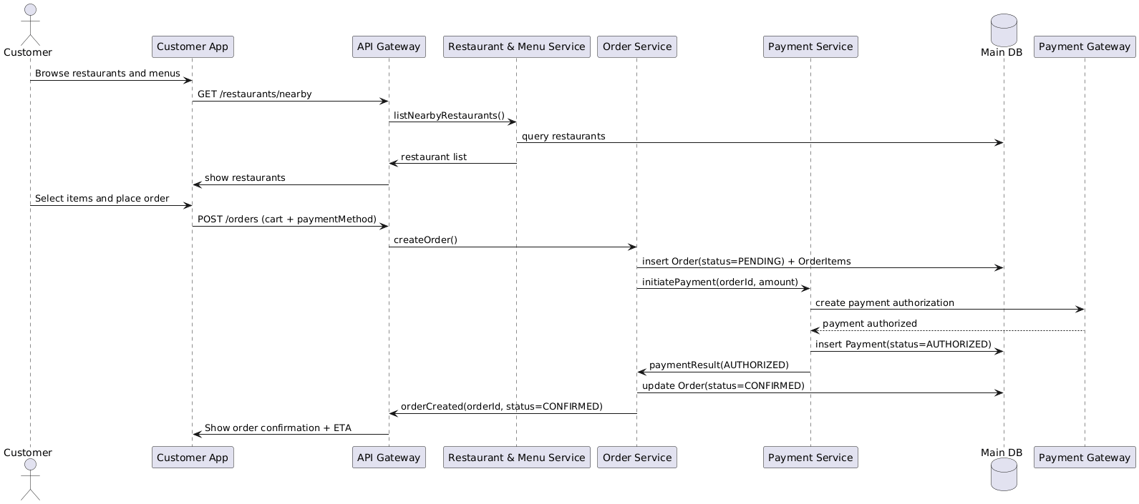
Delivery assignment and tracking sequence diagram:
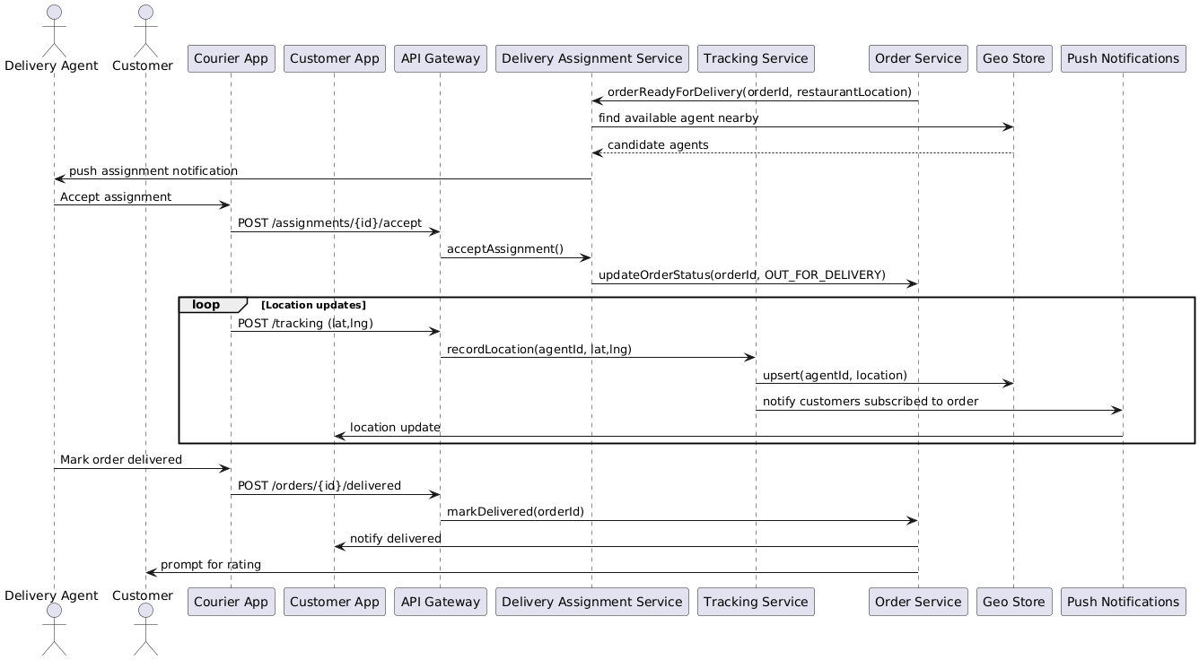

4.4 Data Security & Scalability
Security:
• Use secure authentication for all actors, with device binding for courier apps.
• Do not store raw card data; delegate to the payment gateway and keep only tokens.
• Protect APIs with rate limiting and input validation; encrypt PII in the DB.
• Restrict location data access to only relevant orders and for a limited retention period.
Scalability:
• Horizontally scale stateless services behind load balancers; autoscale at peak times.
• Cache restaurant lists and menus with an in-memory cache (e.g., Redis) to handle high read traffic.
• Use asynchronous processing (message queues) for non-critical tasks such as sending notifications and generating recommendations.
• Partition order data by region or time and add read replicas to handle reporting load.

