**Do Rural Albertans think differently than Urban Albertans when it comes to COVID-19 restrictions? Here’s what the data says.**



**Source: Public Policy Forum https://ppforum.ca/project/bridging-the-urban-rural-divide-in-canada/**

With COVID-19 there came many new regulations that had to take place in order to keep everyone safe from this novel virus. These new regulations were a change for everyone as most of us had never had to experience lockdowns, wear masks or practice social distancing in all public settings. While the majority complied with these measures it would be false to say there was [no resistance to it](https://globalnews.ca/video/9054782/westjet-flight-diverted-back-to-calgary-after-unruly-passenger-refused-to-wear-a-mask). These resistances came in various forms such as people refusing to wear masks, getting vaccinated and even [protesting in public](https://ottawa.ctvnews.ca/truck-convoy-rolls-into-kingston-ont-1.5756220). In this Op-Ed, I will convey my findings on how people in Alberta felt regarding various measures and whether there was a difference of opinion depending on the area zone.

Through [previous research](https://www.cambridge.org/core/journals/canadian-journal-of-political-science-revue-canadienne-de-science-politique/article/ethnography-and-political-opinion-identity-alienation-and-antiestablishmentarianism-in-rural-alberta/A46FC4ABB96F23BA934F857A65D791B1) we know that there have been rural urban tensions present in Alberta. Examples for this include the fact that the rural healthcare system is [understaffed](https://www.cma.ca/sites/default/files/2018-11/PD14-04-e.pdf) compared to the urban system. Moreover, the federal government's carbon tax further caused issues since it affected rural residents more as they have to [travel longer distances](https://prism.ucalgary.ca/handle/1880/109864) and so have to pay more tax. For my research, I wanted to observe if this difference also extends to a difference of opinion when it comes to the government's COVID-19 measures and policies and so I studied the Alberta September 2021 Viewpoint data set to find the answer. This data set was specifically chosen because Alberta had [loosened its restrictions](https://www.theglobeandmail.com/canada/article-kenney-announces-albertas-open-for-summer-plan-to-start-soon/) in the Summer and cases had started going up [again in September](https://edmontonjournal.com/news/local-news/alberta-covid-19-update-sept-20-2021) so this provided me with a suitable timing to assess whether people were ready to face restrictions again or not. It also gave me the opportunity to study whether people were satisfied with both the federal and provincial governments' handling of the pandemic or not.

I studied five factors namely performance of the federal government, performance of the provincial government, support for businesses requiring vaccine proof or negative COVID-19 test, support for vaccine passports and feelings on current restrictions. In terms of federal government performance, I found that area zones did play a significant role in the respondents' answers which was reflected in the results as rural residents were found to be more critical of the federal government than their urban counterparts. An example is the fact that only 1.97% rural residents thought the federal government did a very good job compared to 8.56% of urban residents. In terms of the provincial governments’ performance, opinions tended to be pretty balanced between both sides with equal proportions of residents agreeing to various answers. It is also worth mentioning that in both federal and provincial cases the majority of both zones believed that the federal government did a ‘good’ job whereas the provincial government did a ‘very bad’ job in handling the pandemic.

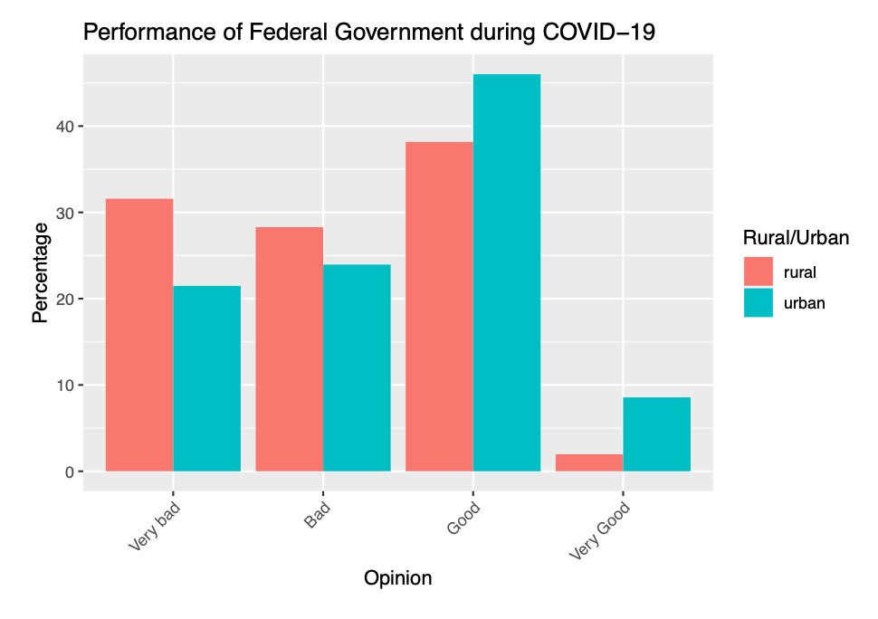

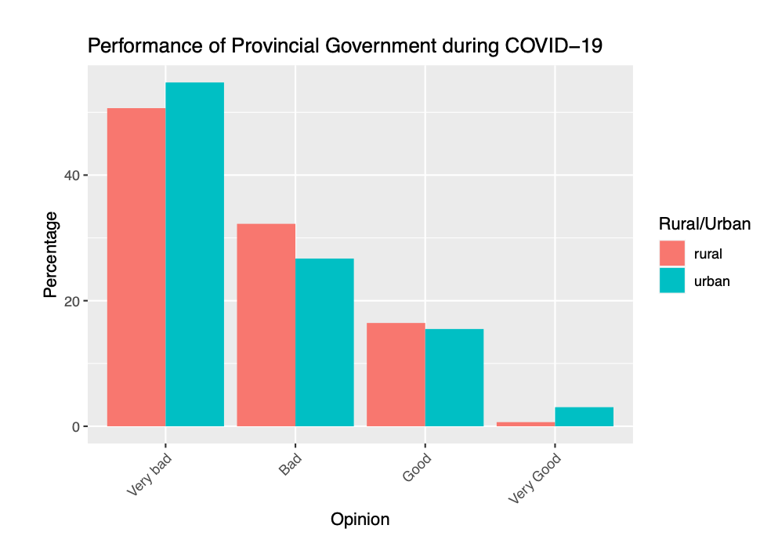

Albertans from both zones agreed in their views on businesses requiring a negative COVID-19 test or proof of vaccination in order to continue operating. The majority of both sides were in favor of this measure. However, when it came to supporting vaccine passports the area zone did have an effect on the viewpoint. It was observed that 22.37% of rural residents strongly opposed vaccines passports compared to 12.55% of urban residents. 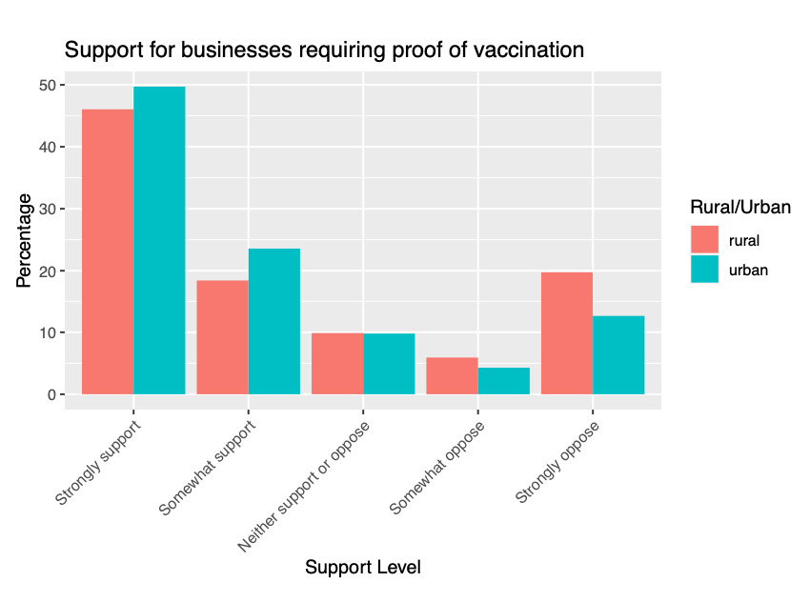

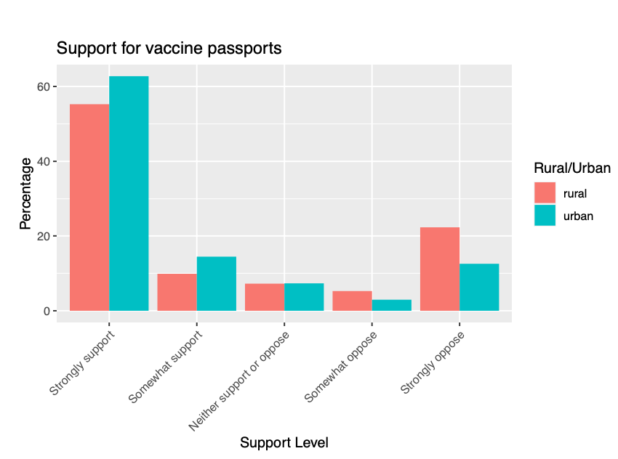

Another significant relationship between area zones was found in opinions on current restrictions. The data showed that 23.03% of rural residents believed that the current restrictions were too harsh compared to only 14.82% urban residents.

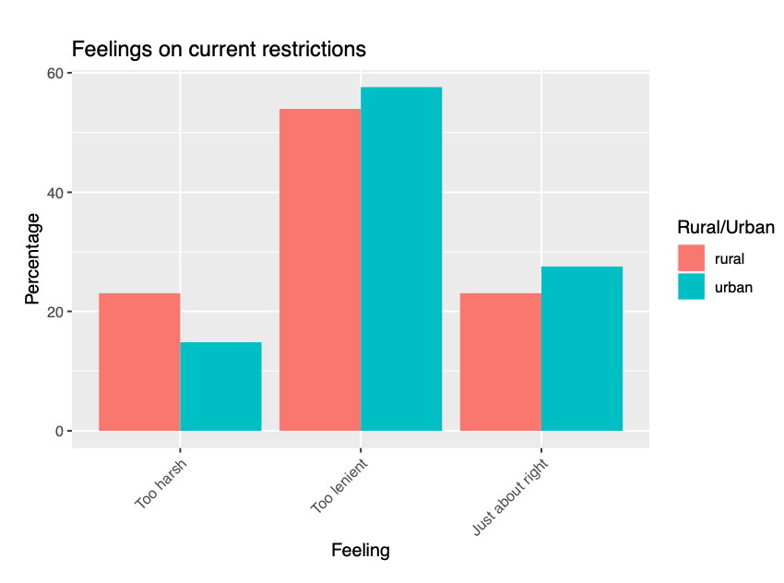

It was interesting to note how both sides agreed on all the issues except the performance of the federal government, vaccine passports and feelings on current restrictions. It is to keep in mind that majorities of both sides were in favor of the federal government, supported vaccine passports and agreed on the current restrictions; however urban residents were more likely to support these measures than their rural counterparts. Despite this, when it came to businesses requiring proof of vaccines or negative COVID-19 tests both sides had similar opinions which may be based on the fact that it satisfied both issues of public safety and helped businesses stay open. Both sides also were also equally dissatisfied with the provincial governments’ response to the pandemic. Overall, what we learned from the data is that despite rural residents being more inclined towards certain opinions than urban residents, they were generally in consensus on all measures towards public safety and government performance.

**References**

WestJet flight diverted back to Calgary after unruly passenger refused to wear a mask. (n.d.). *Global News*. <https://globalnews.ca/video/9054782/westjet-flight-diverted-back-to-calgary-after-unruly-passenger-refused-to-wear-a-mask>

Josh Pringle & Nate Vandermeer. (2022, January 28). Truck convoy rolls into Kingston, Ont. *Ottawa*. <https://ottawa.ctvnews.ca/truck-convoy-rolls-into-kingston-ont-1.5756220>

McBride, B. (2021, September 21). Alberta’s COVID-19 hospitalizations reach record high of 954. *Edmontonjournal*. https://edmontonjournal.com/news/local-news/alberta-covid-19-update-sept-20-2021

Banack, C. (2020, October 26). Ethnography and Political Opinion: Identity, Alienation and Anti- establishmentarianism in Rural Alberta. Canadian Journal of Political Science, 54(1), 1–22. https://doi. org/10.1017/s0008423920000694

Epp, Roger. 2019. “The End of Exceptionalism: Post-rural Politics in Alberta.” In Orange Chinook: Politics in the New Alberta, ed. Duane Bratt, Keith Brownsey, Richard Sutherland and David Taras. Calgary: University of Calgary Press.

Canadian Medical Association. CMA Position Statement: Ensuring Equitable Access to Care: Strategies for Governments, Health System Planners, and the Medical Profession; Canadian Medical Association: Ottawa, ON, Canada, 2013.

The Canadian Press. (2021, May 27). Alberta government announces ‘open for summer’ COVID-19 plan to start soon. *The Globe and Mail*. https://www.theglobeandmail.com/canada/article-kenney-announces-albertas-open-for-summer-plan-to-start-soon/