**Services:**

**ANZ Cleaning and Sanitation Services**

* TNC Global has a strong reputation in the Cleaning and Sanitation market in Australia and New Zealand.
* Australia represents the bulk *(2 thirds)* of USD$125m Cleaning and Sanitation market
* ◦ *we estimate the total market to be approximately USD$150m by 2018.*
* The growth of the Cleaning and Sanitation market has performed in line with the rate of CPI of circa 3.5% in recent years.
* The Cleaning and Sanitation market is supplied by commodity and specialty ◦ commodity based chemicals ~30%
* ◦ formulated chemical ~70%
* Government legislation and regulatory standards from food safety authorities drive and ensure compliance for export companies.

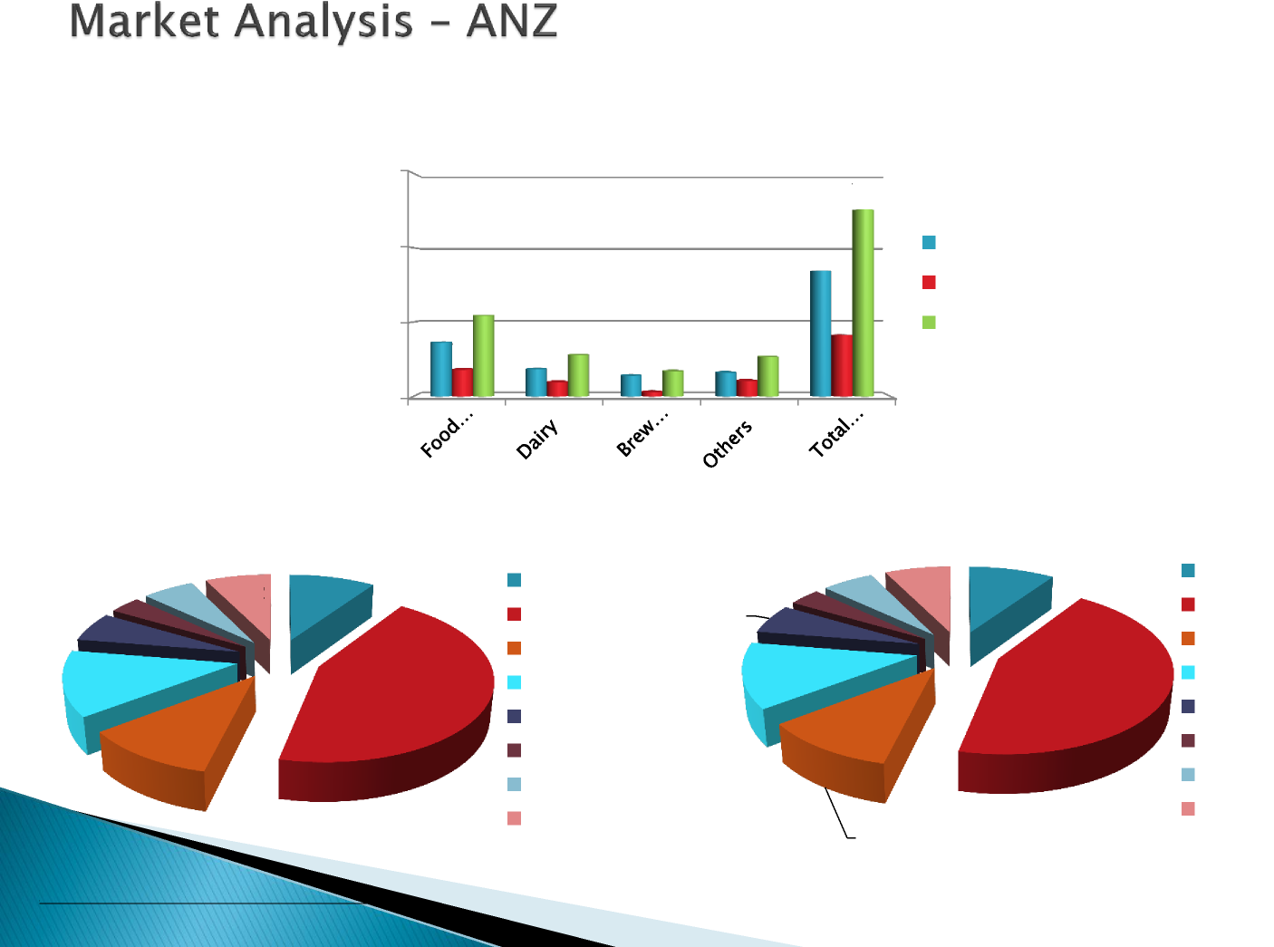



* Target the ANZ Food and Beverage
* business by leveraging existing business
* relationships in Brewing, Beverage and
* Dairy sectors while consolidating our
* presence in Food Processing and Dairy
* sectors in C&S.



1. Develop comprehensive business plan
2. Deliver profitable sales to budget est USD $300k in 2015
3. Develop sales funnel to deliver est USD$1.1m for 2016
4. Expand product range to support business growth i.e. Premium and Economical OPC offering, Expand Dairy product range to NZ etc
5. Continued core sales force technical competency development
6. Expanding and standardise a value added delivery program for our customers using Electronic Reporting
7. Develop ANZ Sales Team