1HIW: Matrix protein p17, part of the Gag polyprotein. These line the inner surface of the viral membrane. Three chains, each one identical but rotated to form a symmetric trimer.
https://en.wikipedia.org/wiki/Retroviral_matrix_protein
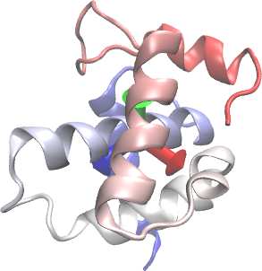
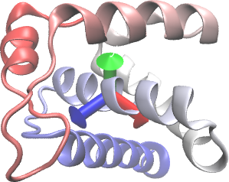
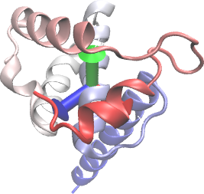

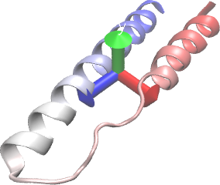
4PMI: Rev, which signals to the cell that mRNAs should be exported from the nucleus so that they can be translated into new viral proteins. Two chains, both of which sit on the RNA.
https://en.wikipedia.org/wiki/Rev_(HIV)

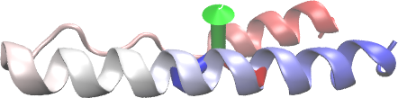

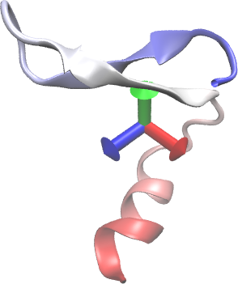
2MA9: Vif, a protein that disables the antiviral activity of the host cell. One chain.
https://en.wikipedia.org/wiki/Viral_infectivity_factor

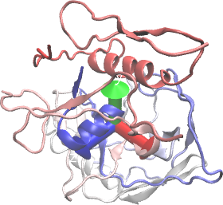

2BF1: gp120, an envelope protein that triggers the fusion of viruses and their host cells. One chain.
https://en.wikipedia.org/wiki/Envelope_glycoprotein_GP120

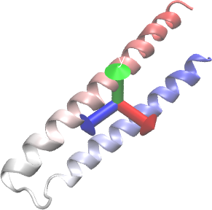
1SZT: gp41, which holds on to the envelope protein GP120. Three chains that assemble into a trimer to span the membrane.
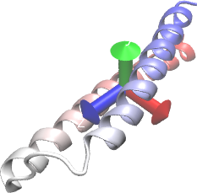
https://en.wikipedia.org/wiki/Gp41
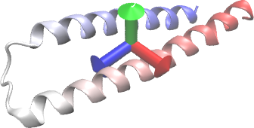

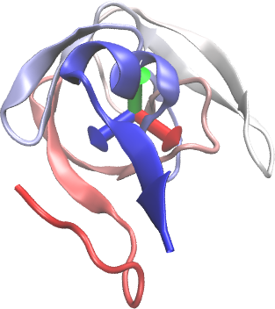
1KJF: The protease that chops up the polyprotein into its individual components. Two chains that assemble into a dimer.
https://en.wikipedia.org/wiki/HIV-1_protease
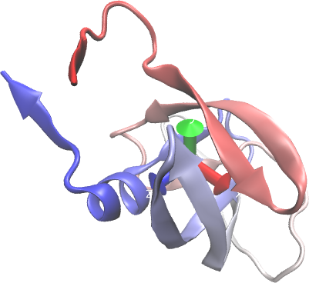

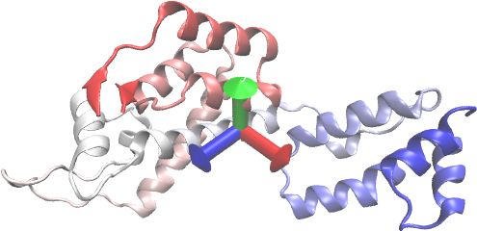
4XFX: The capsid protein that forms the envelope containing the viral genome. One chain, but assembles into a 6-mer in the virus.
https://en.wikipedia.org/wiki/P24_capsid_protein

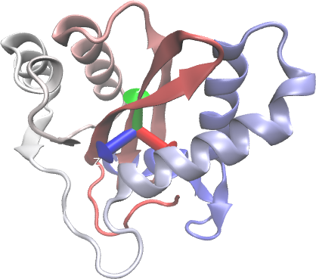
1BL3: The integrase that inserts a copy of the viral genome into the host’s DNA. One chain.
https://en.wikipedia.org/wiki/Integrase

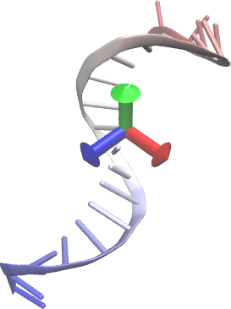
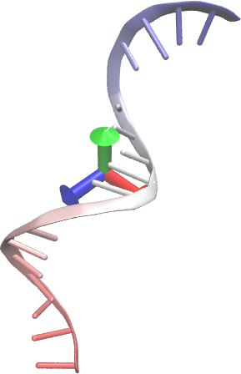
3KLF: The reverse-transcriptase that takes viral RNA and produces DNA. 4 chains: A is p66, the reverse transcriptase and ribonuclease H. Subunit B is p51, just the reverse transcriptase, and doesn’t seem to play an active role.
I have also included some DNA that was solved in the crystal structure. This is C and D, and these play all of the backbone notes since otherwise they’re only twenty notes long.
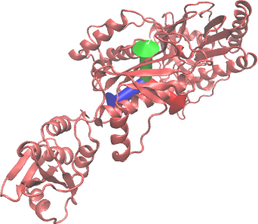
https://en.wikipedia.org/wiki/Reverse_transcriptase

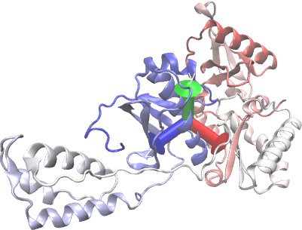

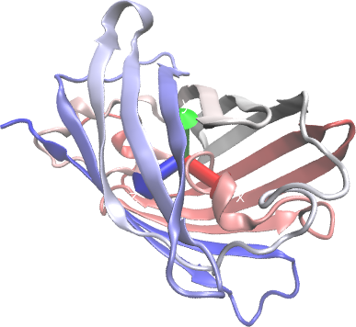
1GFL: Green fluorescent protein, not from HIV but used to track viral components in the visuals.
Included because it’s a bit more uplifting to mention the protein tools that are used to understand diseases. Also it is a beta barrel, which has a cool weaving sound. 2 chains, but this is just an artifact of the crystal. They act alone in vivo.
https://en.wikipedia.org/wiki/Green_fluorescent_protein

Score name: scores/1HIW_A.musicxml
Range: F3 - A♯5
Measures at 4/4: 20

Score name: scores/1HIW_B.musicxml
Range: F3 - A♯5
Measures at 4/4: 21

Score name: scores/1HIW_C.musicxml
Range: F♯3 - D6
Measures at 4/4: 21

Score name: scores/4PMI_B.musicxml
Range: G♯3 - F♯5
Measures at 4/4: 12

Score name: scores/4PMI_C.musicxml
Range: D♯3 - D♯6
Measures at 4/4: 10

Score name: scores/2MA9_A.musicxml
Range: D♯3 - A♯5
Measures at 4/4: 9

Score name: scores/2BF1_A.musicxml
Range: A♯3 - C6
Measures at 4/4: 45

Score name: scores/1SZT_A.musicxml
Range: G♯3 - F6
Measures at 4/4: 20

Score name: scores/1SZT_B.musicxml
Range: C♯3 - G6
Measures at 4/4: 20

Score name: scores/1SZT_C.musicxml
Range: A3 - A♯5
Measures at 4/4: 20

Score name: scores/1KJF_A.musicxml
Range: E3 - C6
Measures at 4/4: 29

Score name: scores/1KJF_B.musicxml
Range: F♯3 - D6
Measures at 4/4: 30

Score name: scores/4XFX_A.musicxml
Range: B2 - F♯7
Measures at 4/4: 89

Score name: scores/1BL3_C.musicxml
Range: G♯1 - F♯7
Measures at 4/4: 41

Score name: scores/3KLF_A.musicxml
Range: F♯1 - E7
Measures at 4/4: 70

Score name: scores/3KLF_B.musicxml
Range: A♯2 - A♯6
Measures at 4/4: 71

Score name: scores/3KLF_C.musicxml
Range: F3 - A5
Measures at 4/4: 35

Score name: scores/3KLF_D.musicxml
Range: A♯3 - A♯5
Measures at 4/4: 28

Score name: scores/1GFL_A.musicxml
Range: A2 - G6
Measures at 4/4: 65

Score name: scores/1GFL_B.musicxml
Range: A♯2 - F♯6
Measures at 4/4: 65

