**Homey Feasts User Manual** - Navigating Your Homemade Food Ordering App

**Table of Contents:**

1. Introduction

- Purpose of the Homey Feasts App

- Users: Customers and Chefs

2. Getting Started

a. Account Creation

- Providing Personal Information

- Selecting User Type (Customer or Chef)

b. Logging In

- Entering Credentials

- Choosing User Type

3. Customer's Journey

a. Browsing Homemade Meals

- Categories and Filters

- Meal Details

b. Placing an Order

- Adding to Cart

- Customizing Orders

- Checkout Process

c. Tracking Orders

- Order History

- Real-time Updates

d. Profile Management

- Viewing and Editing Profile

- Adding Favorite Chefs and Foods

- Writing and Sharing Blogs

4. Chef's Journey

a. Setting Up a Chef Profile

- Profile Information

- Menu Management

b. Managing Orders

- Receiving and Confirming Orders

- Meal Preparation Status

c. Interaction with Customers

- Ratings and Reviews

d. Profile Management

- Viewing and Editing Profile

- Adding New Meals

- Updating Existing Meals

- Managing Meal Status

5. App Features

- Order Confirmations

- Delivery Updates

b. Payment Methods

- Secured Transactions

6. Conclusion

- Enjoying Homemade Meals with Homey Feasts

7. Signing Out

- Accessing Account Settings

- Sign Out Option

- Confirmation Prompt

- Logging Out

- Return to Login Screen

**Purpose of the Document**

User who will be using the Homey Feasts Homemade Food Ordering App for ordering and delivering homemade meals.

* User: Customers & Chefs

In addition, the sole purpose of this User Manual is to empower users to navigate the Homey Feasts app independently, minimizing the need for third-party technical support.

The Manual provides an overview of the flow of the Homey Feasts application, ensuring a seamless experience in ordering and delivering delicious homemade food.

**User Manual for Homey Feasts App**

1.INTRODUCTION:  
Welcome to Homey Feasts, your go-to platform for discovering and ordering delightful homemade meals. This user manual aims to guide both Customers and Chefs through the Homey Feasts web application, ensuring a seamless experience from browsing to delivery.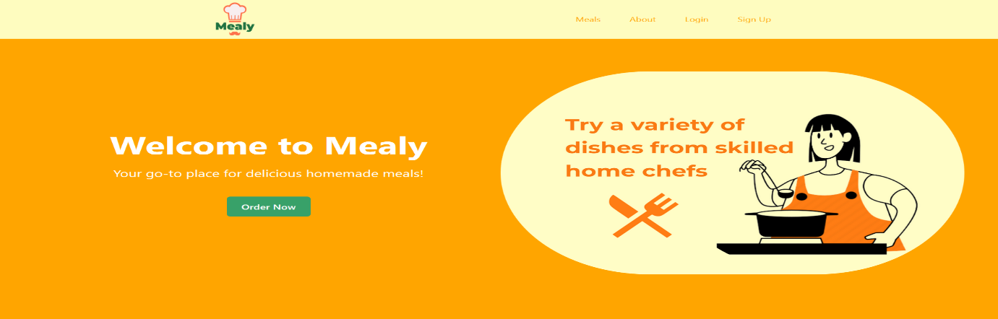

2. Getting Started

a. Account Creation

**Creating an Account:** Start your Homey Feasts journey by providing personal information. During this process, select your user type—User or Chef.

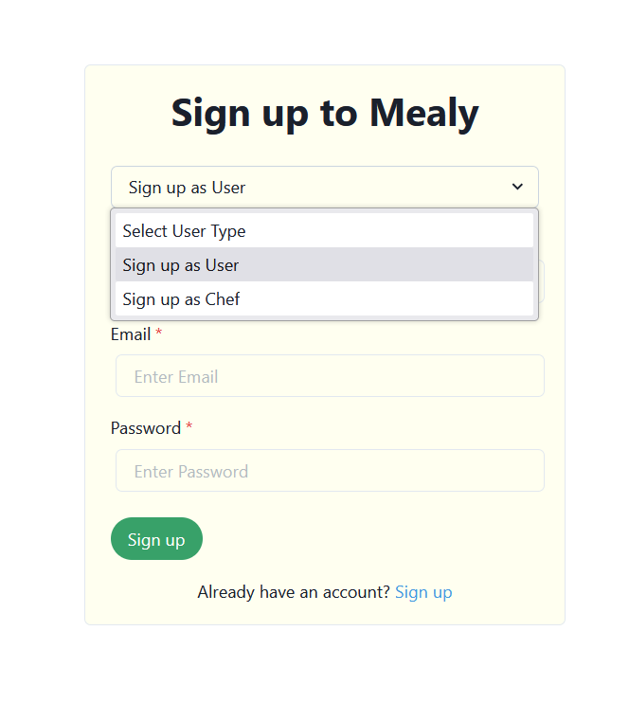

b. Logging In

**Accessing Your Account**:

Log in by entering your credentials and choosing your user type. This ensures a personalized experience based on your preferences**.**

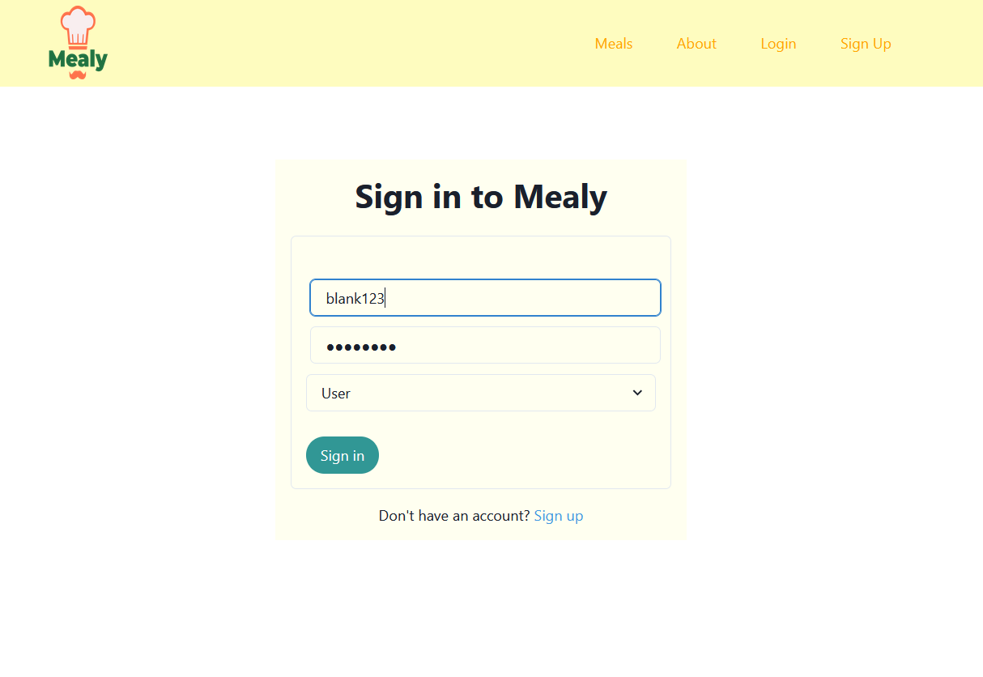

**3. Customer's Journey**

**a. Browsing Homemade Meals**

* Select your desired meal by clicking on the "Order Now" or "Add to Cart" button.
* Customize your order according to your preferences, such as choosing specific ingredients, indicating spice levels, or providing additional instructions to the chef.
* The selected meals will be added to your cart, where you can review your choices before proceeding to checkout.

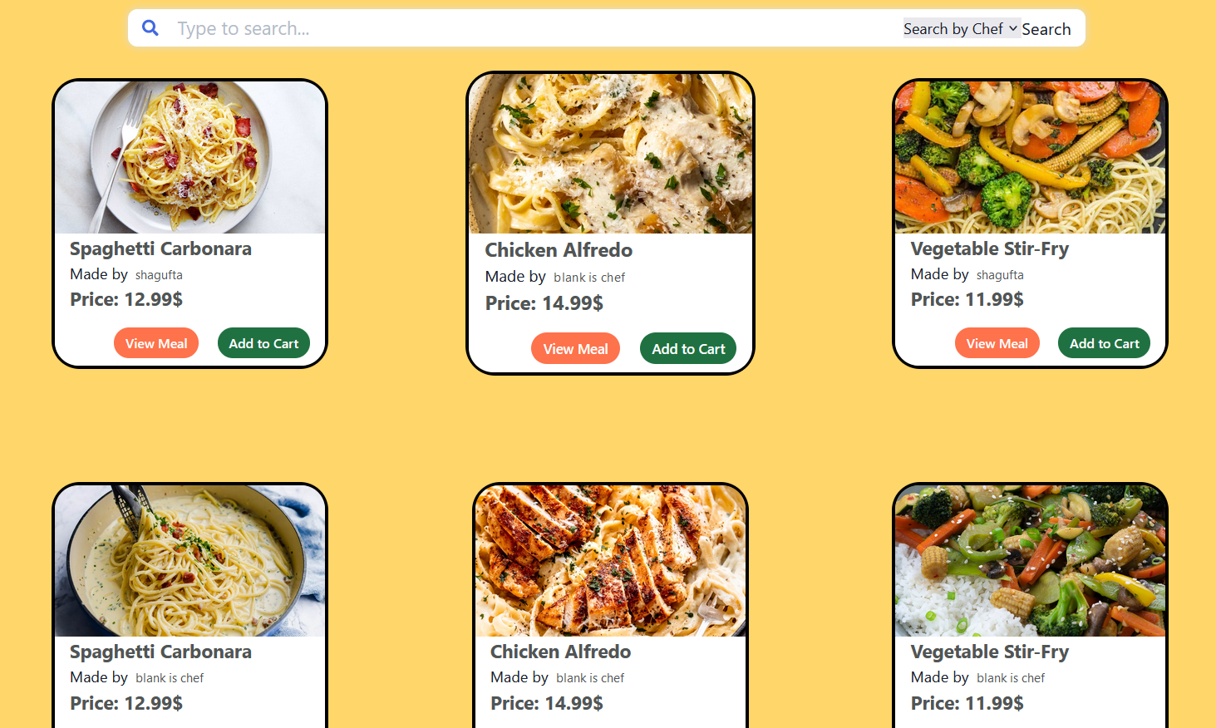

**b. Placing an Order**

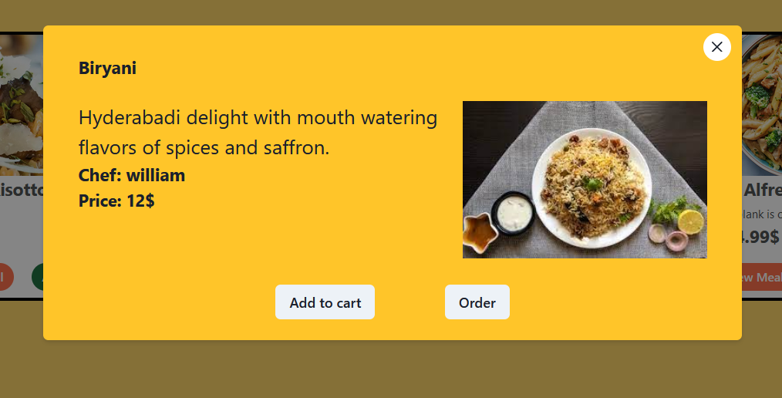

**Checkout Process:**

* Access your shopping cart to review the selected meals, quantities, and total cost.
* Confirm your order and proceed to the checkout page.
* Provide or confirm delivery details, including the delivery address and any specific instructions for the delivery person or chef.
* Choose a preferred payment method for a secure and seamless transaction.

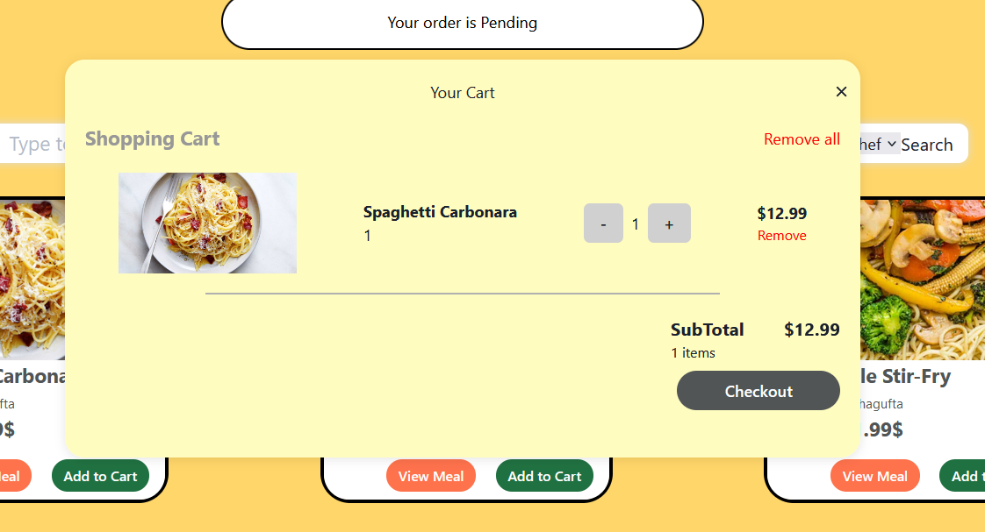

**Payment Process:**

**Checkout Confirmation:**

* + After reviewing your order details, you will proceed to the checkout confirmation page.
  + Confirm your selected meals, delivery details, and total cost.

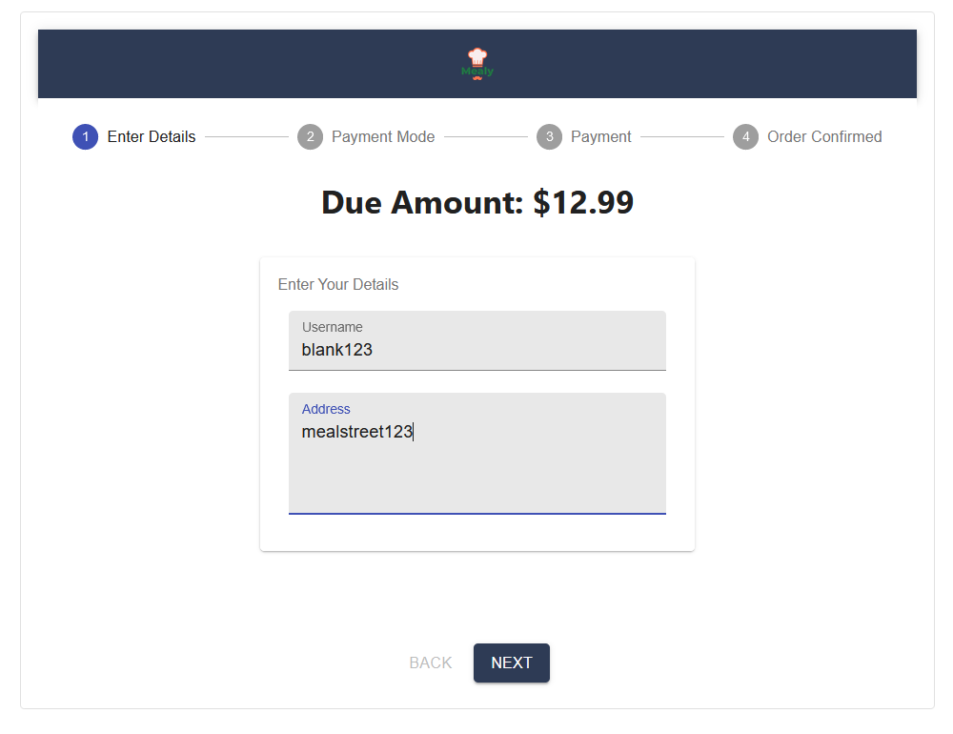

**Payment Portal:**

* + Upon confirmation, you will be directed to the payment portal.
  + Homey Feasts offers a secure and user-friendly payment system, where you can choose your preferred payment method.

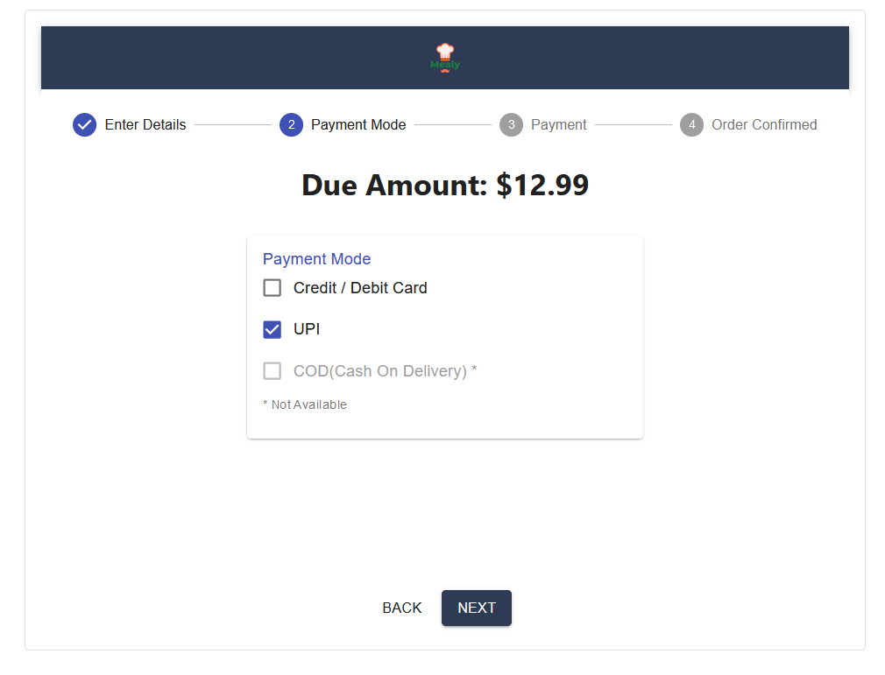

**Preferred Payment Method:**

* Select your preferred payment method from the available options. Homey Feasts supports various payment methods, including credit/debit cards, digital wallets, or other payment gateways.
* Enter the necessary payment details securely.

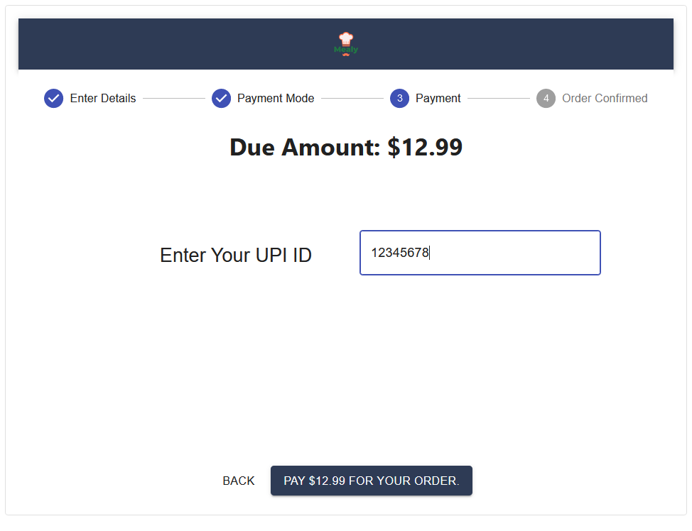

**Transaction Confirmation:**

* Once the payment is processed, you will receive a confirmation message indicating a successful transaction.
* A confirmation email or notification may be sent to your registered email address or within the Homey Feasts app.

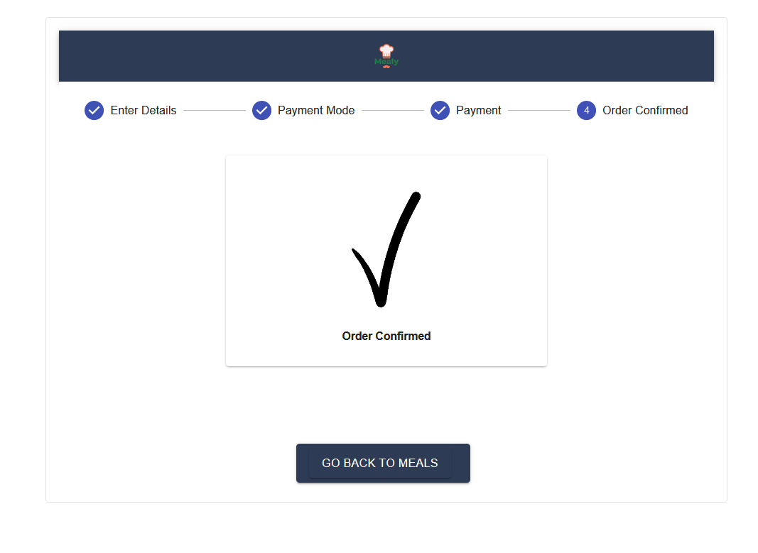

**c. Tracking Orders**

* Return to the app's main interface to track the progress of your order in real-time.
* Receive updates on the order's preparation, dispatch, and estimated arrival.



**d. Profile Management  
Viewing and Editing Profile:**

* + Navigate to the "Profile" section of the app.
  + View your current profile information, including name, contact details, and delivery address.
  + Click on the "Edit Profile" option to make changes such as updating contact information or modifying your delivery address.

**Adding Favorite Chefs:**

* + Within the "Profile" section, find the "Favorite Chefs" or similar option.
  + Browse through a list of chefs you've ordered from or discover new chefs on the platform.
  + Click on the "Add to Favorites" button next to a chef's profile to save them as a favorite.

**Managing Favorite Foods:**

* + In the "Profile" section, look for "Favorite Foods" or a similar feature.
  + Review a list of meals you've ordered or explore new dishes.
  + Click on the "Add to Favorites" button next to a specific meal to save it as a favorite.

**Viewing Favorite Chefs and Foods:**

* + Easily access your favorite chefs and foods directly from the "Profile" section.
  + Review the list of chefs and meals you've marked as favorites for quick reference.

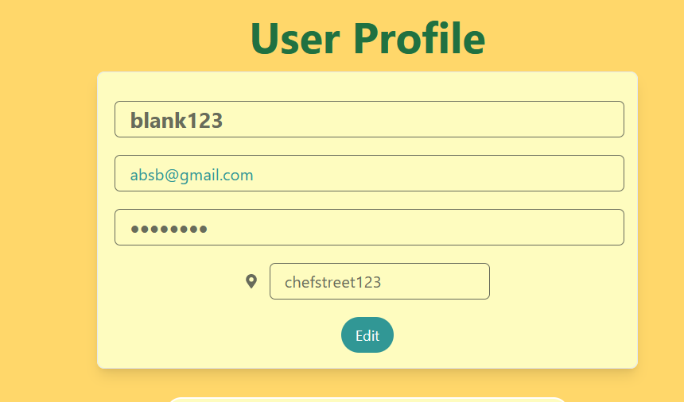

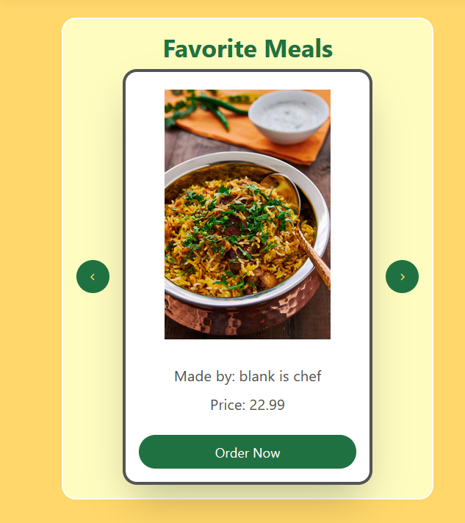

**Review and Ratings:**

* After enjoying your homemade meal, consider leaving a review and rating for the chef. Your feedback helps maintain the quality of the Homey Feasts community.

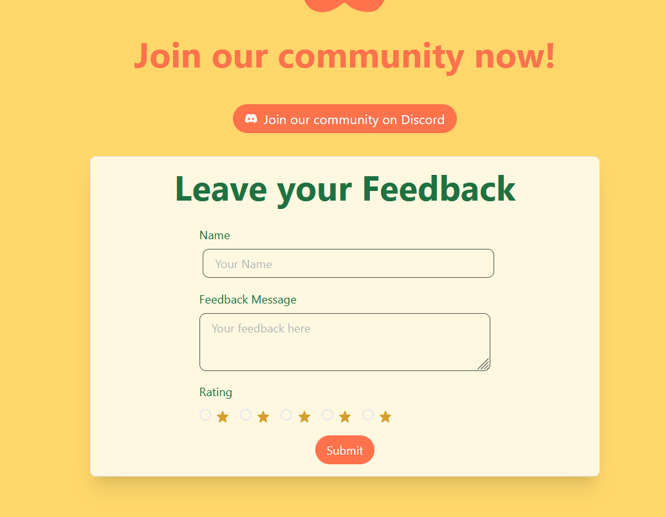

**Accessing the Blog Section:**

* + Explore the "Blog" or "Community" section within the Homey Feasts app.
  + Navigate to a dedicated space where users can share their culinary experiences, recipes, or thoughts related to homemade meals.

**Creating a Blog Post:**

* + Click on the "Create Blog" or similar option to start crafting a new blog post.
  + Enter a captivating title and compose your blog content using the app's user-friendly editor.

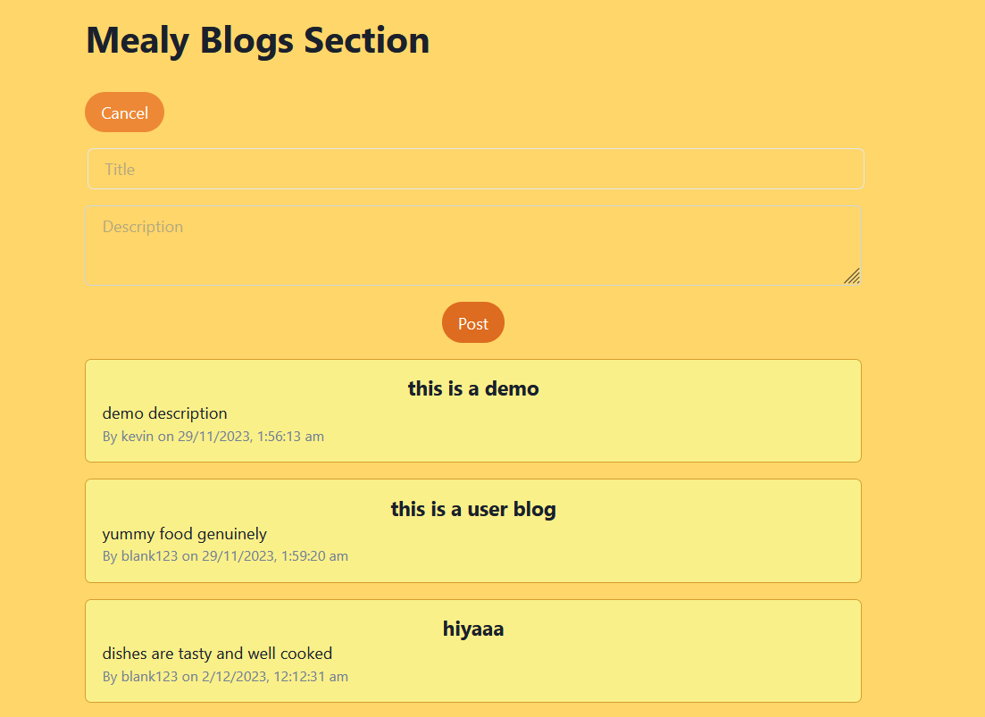

**4. Chef's Journey**

**a. Setting Up Profile:**

* Navigate to the "Profile" section within the Homey Feasts app.
* Review your current chef profile information, including bio, culinary specialties, and contact details.
* Click on the "Edit Profile" option to make changes such as updating your bio, adding new specialties, or modifying contact information.

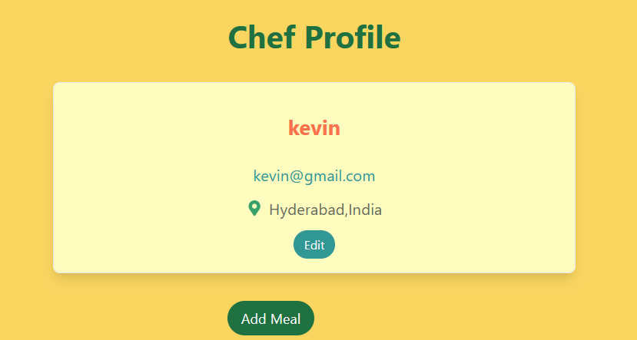

**b. Managing Orders**

**Adding New Meals:**

* Access the "Menu Management" or "Add New Meals" section.
* Create a new listing for a homemade meal by providing details such as name, ingredients, portion sizes, and pricing.
* Upload enticing images to showcase your culinary creations.

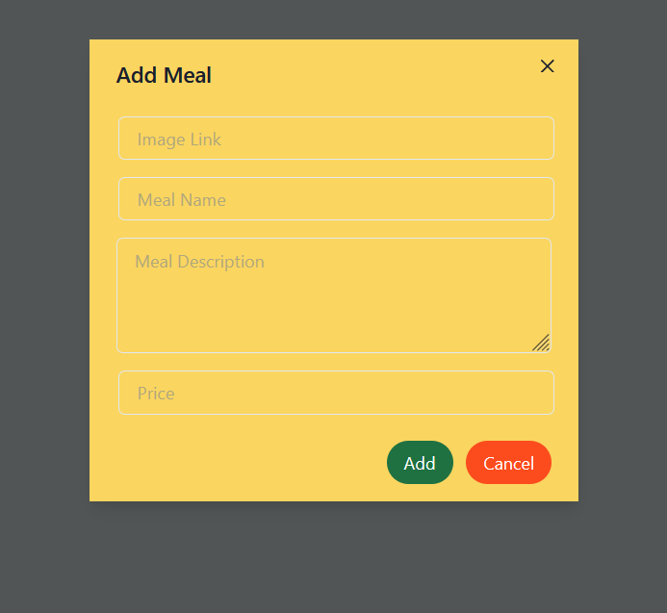

**c. Interaction with Customers**

**Review and Ratings:**

* After enjoying your homemade meal, consider leaving a review and rating for the chef. Your feedback helps maintain the quality of the Homey Feasts community.



**Updating Existing Meals:**

* Review your current menu in the "Menu Management" section.
* Click on a specific meal to update details such as ingredients, pricing, or availability.
* Optionally, add any special instructions or information about the meal.

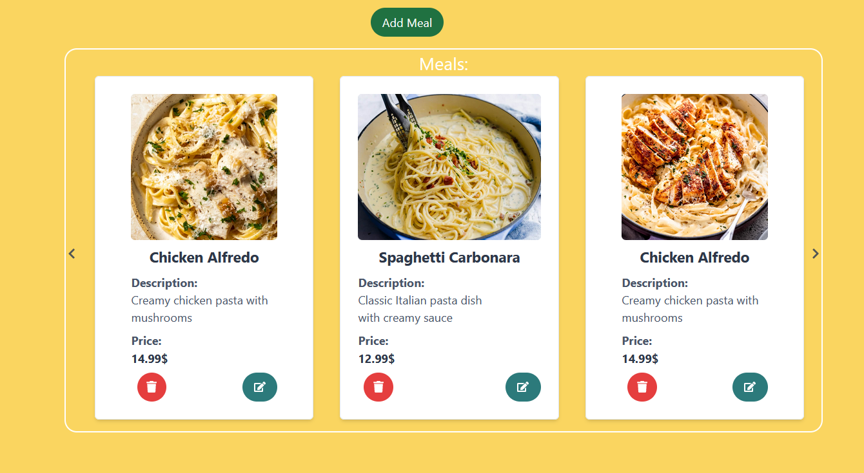

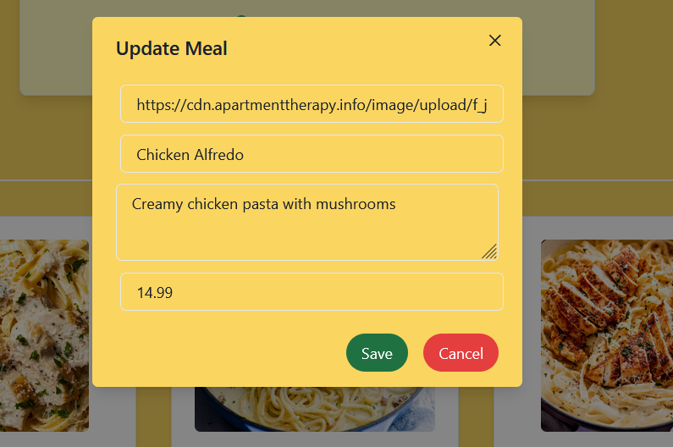

**5.App Features:**

**Payment Methods:**

Experience secure and hassle-free transactions. Homey Feasts supports a variety of payment methods, providing flexibility and convenience for every user.

**Support and FAQs:**

Access assistance easily. Find contact information for personalized support and explore Frequently Asked Questions for quick solutions to common queries.



**6.Conclusion:**

Embark on a delightful culinary journey with Homey Feasts. From seamless order tracking and secure transactions to personalized support, our app features are designed to enhance your homemade food ordering experience. Enjoy the convenience, savor the flavors, and make Homey Feasts your go-to platform for culinary delights.

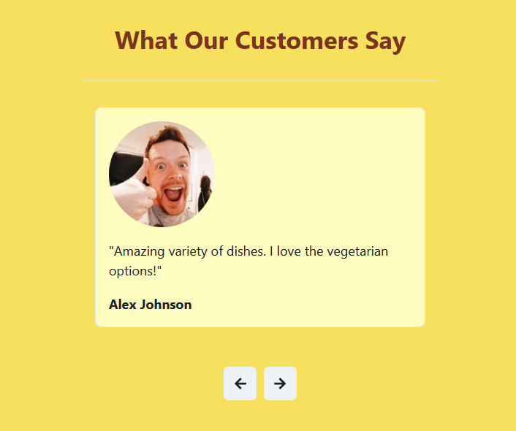

**7. Signing Out**

**Accessing Account Settings:**

* + Navigate to the "profile" section within the Homey Feasts app.

**Sign Out Option:**

* + Look for the "Sign Out" or "Log Out" option within the account settings.

**Confirmation Prompt:**

* + Upon selecting "Sign Out," a confirmation prompt may appear to ensure the user intends to log out.

**Logging Out:**

* + Confirm the log-out action, and the user will be securely logged out of the Homey Feasts app.

**Return to Login Screen:**

* + After signing out, users will be redirected to the login screen, providing a clean and secure transition.

**By including a straightforward sign-out option, Homey Feasts ensures that users have control over their account access, promoting security and privacy for both customers and chefs.**