**1. System Functional Requirements**

Authentication: Secure login for users (teachers, students, admins).

Role-Based Access: Redirect users to role-specific dashboards (teacher/student).

Mark Management: Teachers can enter, edit, and view marks for quizzes.

Attendance Tracking: Teachers can mark and view attendance records.

Report Generation: Teachers can generate PDF/Excel reports for marks and attendance.

Student Portal: Students can view their marks and attendance.

Performance Analytics: Admins can analyze trends via graphs/reports.

User Interface (UI): Front-end developers design responsive, intuitive UI screens.

**2. Non-Functional Requirements**

**2.1 Product Requirements**

Usability: User-friendly interface for easy navigation.

Performance: Fast report generation (<5 seconds for PDF/Excel).

Security: Encrypted authentication and role-based access control.

Reliability: Ensure data consistency during mark/attendance updates.

**2.2 Organizational Requirements**

Compliance: Adhere to institutional data privacy policies (e.g., GDPR).

Documentation: Maintain detailed technical and user manuals.

**2.3 External Requirements**

Interoperability: Export reports in PDF/Excel formats.

Accessibility: Support screen readers for visually impaired users.

**3. Use Case Diagram**

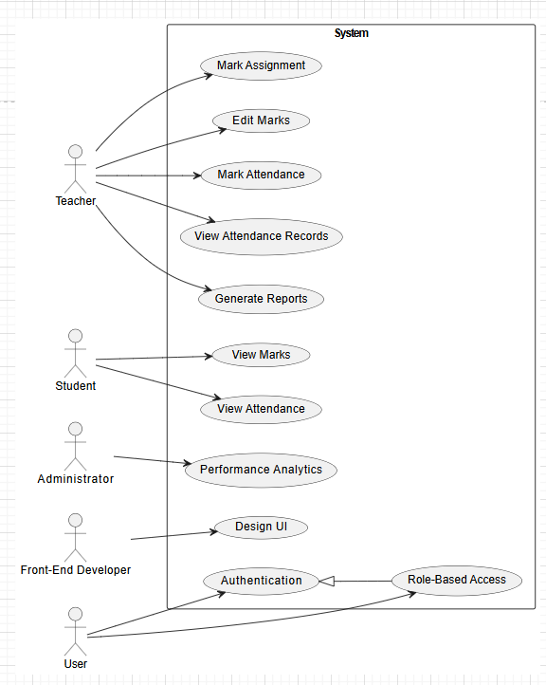

**4. User Stories**

1. User Role: Teacher

Goal: Assign marks for quizzes.

Reason: Students can track their scores.

2. User Role: Teacher

Goal: Edit marks to correct errors.

Reason: Ensure accurate student records.

3. User Role: Teacher

Goal: Mark attendance for classes.

Reason: Track student participation.

4. User Role: Teacher

Goal: View attendance records.

Reason: Analyze participation trends.

5. User Role: Teacher

Goal: Generate performance reports.

Reason: Share data with stakeholders.

6. User Role: Student

Goal: View quiz/exam marks.

Reason: Monitor academic progress.

7. User Role: Student

Goal: Check attendance records.

Reason: Assess class attendance status.

8. User Role: User

Goal: Securely log in.

Reason: Access role-specific dashboards.

9. User Role: System

Goal: Restrict access by role.

Reason: Protect sensitive data.

10. User Role: Administrator

Goal: Analyze performance trends.

Reason: Improve student outcomes.

11. User Role: Front-End Developer

Goal: Design responsive UI.

Reason: Enhance user experience.

**5. Pre- and Post-Conditions**

1. Pre: Teacher logged in. Post: Marks recorded.

2. Pre: Teacher logged in. Post: Marks updated.

3. Pre: Teacher logged in. Post: Attendance updated.

4. Pre: Teacher logged in. Post: Records displayed.

5. Pre: Teacher logged in. Post: Report generated.

6. Pre: Student logged in. Post: Marks displayed.

7. Pre: Student logged in. Post: Attendance displayed.

8. Pre: Valid account. Post: Dashboard accessed.

9. Pre: Roles defined. Post: Role-specific dashboard shown.

10. Pre: Admin logged in. Post: Trends displayed.

11. Pre: Wireframes approved. Post: UI implemented.

**6. Sequence Diagrams**

6.1. Assign marks

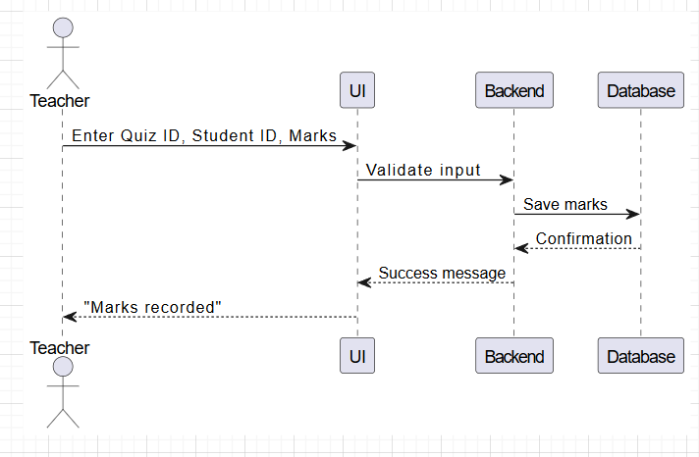

6.2. Edit marks

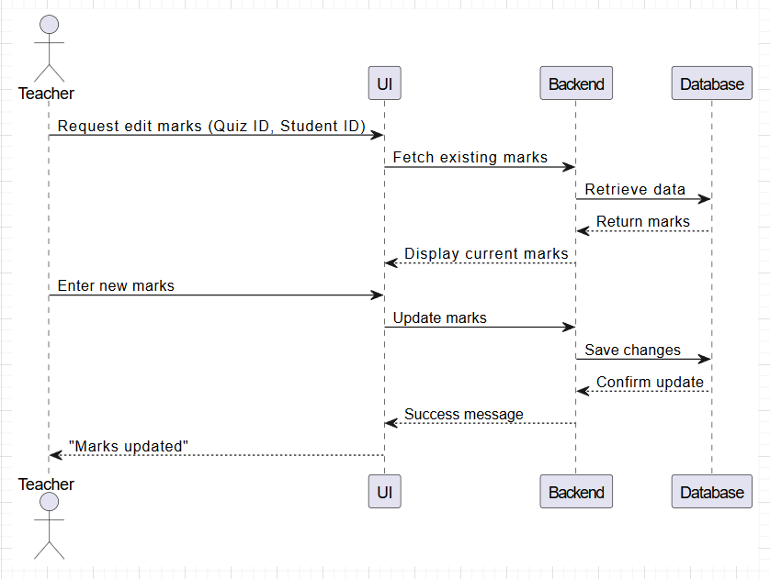

6.3. Generate reports

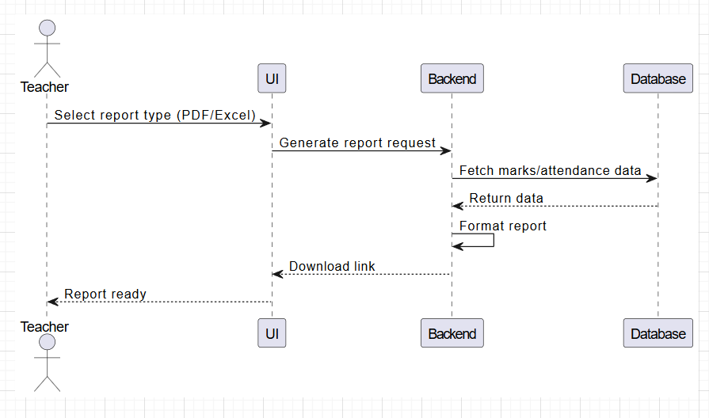

**7. Class Diagram**

