ENPM661 - Spring 2024
Project 04

Implementation of MoveIt Motion Planning on the
Panda Robotic Arm
Note: This is an individual project

Due Date: April 19, 11:59 PM Points/Weightage: 5

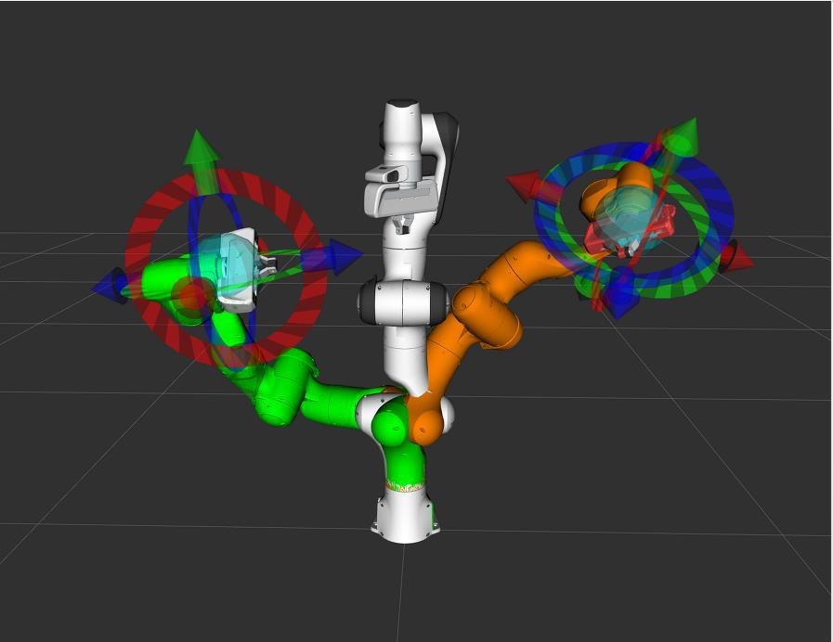

- Demonstrate a pick and place operation of an object on the table avoiding the obstacles using the Franka Panda robotic
arm in a simulated environment using the MoveIt Motion Planning Framework in ROS2.

- Simulate a pick-and-place task by moving from start position to goal1 (known position to pick) and then to goal2 (known position to drop) and then back to start position. You don't have to actually pick an object, just plan and execute the motion.

- In this document, the instructions to perform the simulation in RViz2 are provided, you may use Gazebo as well if you wish to.

We will use Docker to run ROS2 Humble, Moveit assistant is not available on Galactic. The commands and syntaxes of both ROS2
Humble and Galactic are the same, so you will feel no difference using them.

Run the following commands to get Docker installed and running:
sudo snap install docker
sudo groupadd docker
sudo usermod -aG docker ${USER} sudo chmod 666 /var/run/docker.sock docker run hello-world

Once you confirm Docker is running, copy the ‘Project4_docker’ folder from ELMS into your Linux machine. We will run a Docker
container with Ubuntu 22.04, and then use ROS2 Humble on it .
cd Project4_docker docker build . –t project4
sudo chmod +x ./create_container.sh
./create_container.sh {container_name}
docker start {container_name} // ( if that doesn’t work, try docker run {container_name} or docker run project4)

sudo chmod +x ./open_terminal.sh
./open_terminal.sh {container_name}
lsb_release –a // Green commands are for your docker terminal
With this we confirm that we have a terminal running with Ubuntu 22.04 on it

Every time you close your terminal or restart your machine, you can just do the following to get back into your Docker environment:

docker start {container_name}
./open_terminal.sh {container_name}

Next, we will install ROS2 Humble and other dependencies in the Docker container

sudo apt-get update sudo apt install gazebo
sudo apt install ros-humble-moveit
sudo apt-get install ros-humble*controller* sudo apt-get install ros-humble*joint*state* source /opt/ros/humble/setup.bash

Now you are ready to follow the next steps as given on MoveIt tutorials here till the ‘Setup Your Colcon Workspace’ section to install
moveit. Load up your Pandas robot in Rviz2 by running:

source install/setup.bash
ros2 launch panda_configuration demo.launch.py

Step 1: Follow the installation instructions as given in the Installation page, previously.
Step 2: Go through this quick start guide to motion planning using MoveIt via RViz and the MoveIt plugin. Step 3: Configure MoveIt for the Panda Robot
  - Use the MoveIt setup assistant (ros2 launch moveit_setup_assistant setup_assistant.launch.py) to configure the Pandas robot to be used with MoveIt. You cannot use any package except ‘panda_description’ from MoveIt tutorials in your workspace.
  - Refer to class demonstrations and online tutorials to help you.

Step 4: Create a Pick and Place scenario in RViz
  - Make a new package ‘package_UID’ (which will be submitted on ELMS)
  - In that write a Python/C++ script to take your Pandas robot from a home state (can be random) to a goal state 1, and then to a goal state 2, and then back to the original home state. The goal states must be chosen such that the robot displays a good range of motion.
  - You must close the gripper after arriving at goal state 1, and then open the gripper at goal state 2.
  - Refer the link below:

https://moveit.picknik.ai/humble/doc/tutorials/pick_and_place_with_moveit_task_constructor/pick_and_place_with_moveit_task_const ructor.html

It is to be noted that doing this project in C++ would be significantly easier than that with Python due to the existence of an example pick and place code using C++ here.

- The documentation for MoveIt in ROS2 is limited and sometimes mixed up with ROS1 documents, so its recommended you watch the Software Sessions on 09/04/2024 which will cover parts of installation and building the package etc.

  - Firstname_UID.pdf This PDF file should contain the following.
- Links for:
  - Google Drive/YouTube link of screen recording of the pick and place simulation.
Video must clearly show the Panda robot executing a plan between the start and goal poses
  - Google Drive/YouTube link of screen recording of setting up the Panda robot using MoveIt Setup Assistant Video must clearly show the steps taken to configure the Robot in the MoveIt Setup Assistant.

  - Firstname_UID.zip
    - A zipped-up folder of your package (only your package, and not any moveIt related ones)

  - Readme.txt / readme.md
    - Any special libraries used, etc

Make sure to set the access option appropriately in the case of a Google Drive link; for YouTube videos, set the visibility to either Public or Unlisted.

