ENPM661 - Spring 2026

Project 03 - Phase 1
Implementation backward A* algorithm for a mobile Robot
Note: This is a group project (max three students*)

*If you have received permission to team up as a group of 3, ignore this.

Due Date: April 04, 11:59 PM Points/Weightage: 5

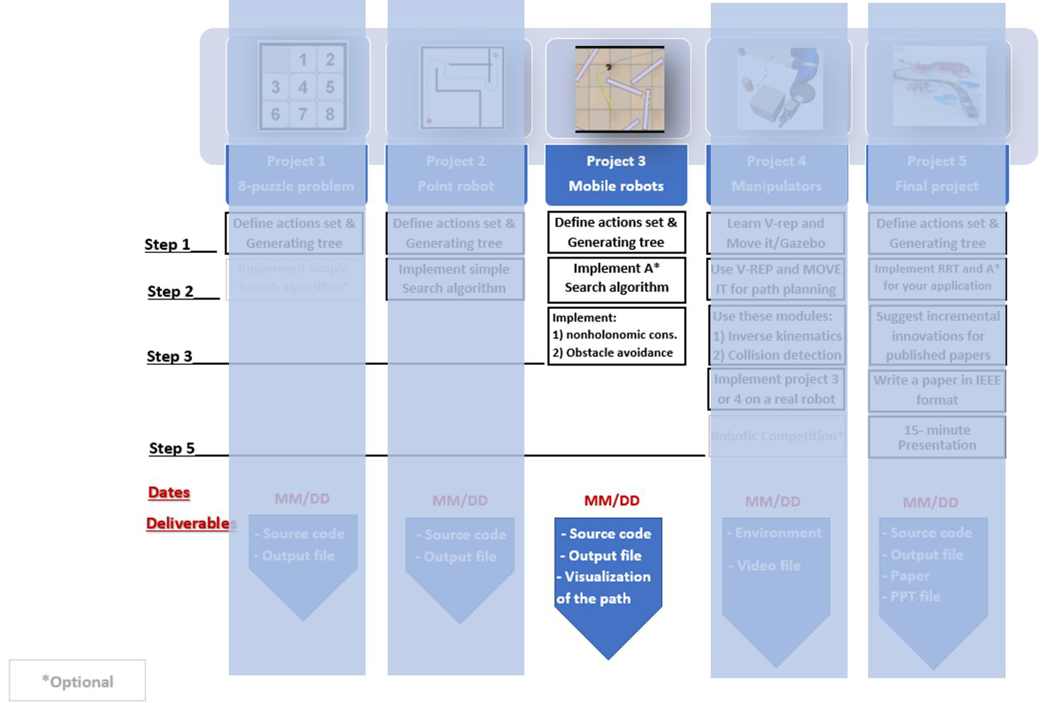

Create two empty lists named OpenList and ClosedList Get the initial (Xi) and goal node (Xg) from the user OpenList.put(Xi)
While (OpenList not EMPTY) and (Not reached the goal) do x OpenList.get()
Add x to ClosedList if x = Xg
Run backtrack function return SUCCESS

else
forall u ∈ U(x)
x’ f(x,u) # Generating each valid action
if (x’ ∉ ClosedList) and (NOT in the obstacle space) if (x’ ∉ OpenList) or (CostToCome(x’) = ∞)
Parent(x’) x
CostToCome(x’) CostToCome(x) + L(x,u) # L(x,u) is the cost of the action
Cost(x’) CostToCome(x’) + CostToGo(x’) OpenList.put(x’)

return FAILURE
else

If Cost(x’) > CostToCome(x) + L(x,u) Parent(x’) x
CostToCome(x’) CostToCome(x) + L(x,u) Cost(x’) CostToCome(x’) + CostToGo(x’)

- Check the feasibility of all inputs/outputs

  - If the start and/or goal nodes are in the obstacle space, the user should be informed by a message and they should input the nodes again until valid values are entered.

  - The user input start and goal coordinates should be w.r.t. the origin shown in the map.

- Implement A* Algorithm to find a path between the start and end point on a given map for a mobile robot (radius = 5mm; clearance = 5 mm).

- Your code must output an animation of optimal path generation between start and goal point on the map. You need to show both the node exploration as well as the optimal path generated.

○

Use the same map for project 2. Scale the map if necessary.

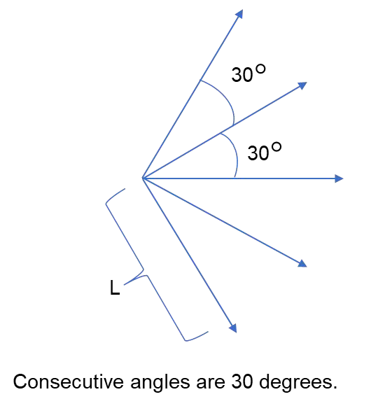

To check for duplicate nodes:

•Euclidean distance threshold is 0.5 unit (for x, y)
•Theta threshold is 30 degrees (for Ѳ) Python file provided can be used to plot

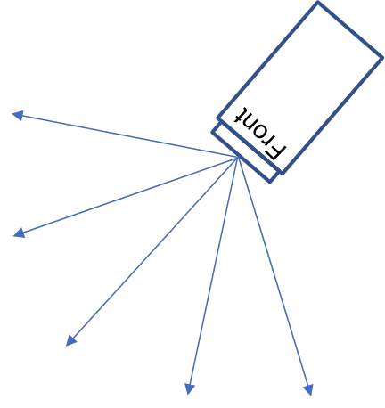

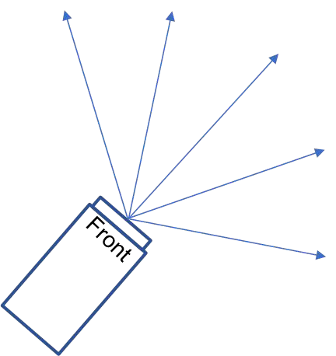

- Some useful tools for drawing shapes on a canvas (map generation/visualization):
  - OpenCV
    - https://pyimagesearch.com/2021/01/27/drawing-with-opencv/
    - https://medium.com/analytics-vidhya/opencv-tutorial-drawing-shapes-and-te xts-5cba52c76cd0
  - Pygame
    - https://www.geeksforgeeks.org/how-to-draw-rectangle-in-pygame/
    - https://medium.com/theta-hat/using-pygame-to-draw-grided-canvas-ba7e7e 409373
    - https://ryanstutorials.net/pygame-tutorial/pygame-shapes.php
  - Matplotlib
    - https://nickcharlton.net/posts/drawing-animating-shapes-matplotlib.html
    - https://www.askpython.com/python/examples/draw-shapes-using-opencv
  - Tkinter
    - https://stackoverflow.com/questions/25701347/how-to-draw-a-line-on-a-can vas
    - https://pythonbasics.org/tkinter-canvas/

- Get the following values from the user
- Start Point Coordinates (3-element vector): (Xs, Ys, Θs).
Θs - The orientation of the Robot at the start point.

- Goal Point Coordinates (3-element vector): (Xg, Yg, Θg)
- Θg- The orientation of the Robot at the goal point.
- Clearance and robot radius
- Step size of the robot in units. (1 <= L <=10)

* Cartesian Coordinates should be used.

**Θs
o
and Θg
o
are in degrees. Take these parameters as user inputs (k * 30), i.e. {.., -60o,-30o, 0o, 30 , 60 , ..}

- You can use the same data structure from Project 02 to store the node information.
- Refer to: Priority Queues/Heap Queues
- Refer to: Updating a node information using different data structures
- Refer to: Removing and returning nodes (Popping nodes) from different data structures

- Write 5 functions, one for each action. The output of each function is the state of a new node after taking the associated action.

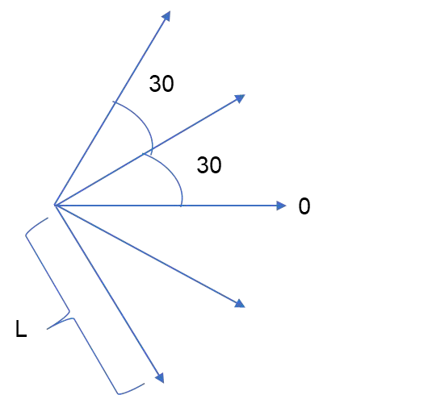
- The step size is the length of the vectors.

space
- Use Half planes and semi-algebraic models to represent the obstacles in the map.

  - Refer to Session03
  - The equations must account for the 5 mm clearance of the robot.

- Using OpenCV/Matplotlib/Pygame/Tkinter (or any other graphical plotting library of your choice), create an empty canvas of size height=250 and width=600.

  - With the above equations, assign a different color for all the pixels within obstacles and walls. You may choose to represent the clearance pixels around the obstacle with another color.

  - IMPORTANT: While creating the map/canvas, pay attention to the coordinate system representation of the corresponding library.
    - For example: In OpenCV, the image origin is at the top left corner. Refer: [Link]

- Backward search using A* algorithm.
- Consider Euclidean distance as a heuristic function.
- Note:- Define a reasonable threshold value for the distance to the goal point. Use this threshold distance to check the goal.
  - Recommendation for goal threshold (1.5 units radius)
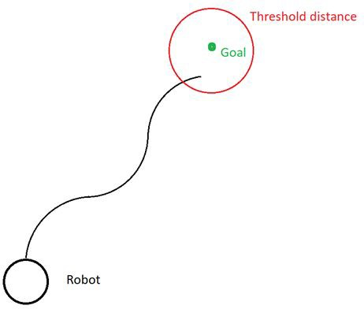

- A sample graph, just for visualization. Use vectors to plot the graph. Sample code for Matplotlib is provided here.
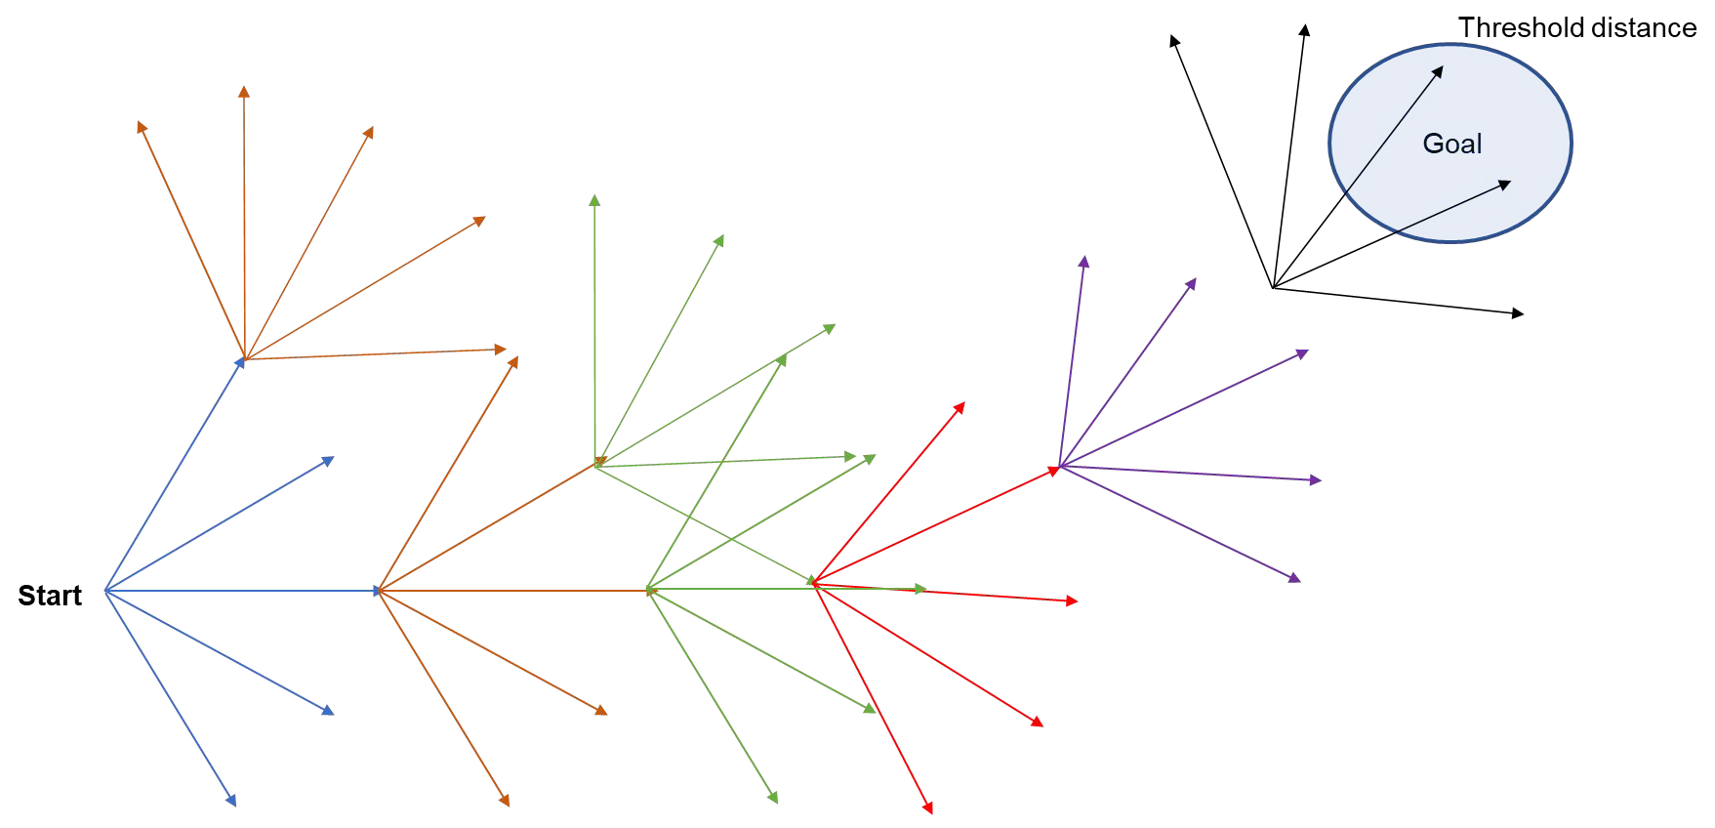

- To generate the graph consider the configuration space as a 3 dimensional space.
- There are two method to find the duplicate nodes:
  - First method - In order to limit the number of the nodes, before adding the node make sure that the distance of the new node is greater than the threshold in x, y, and theta dimensions with respect to all existing nodes. This method is very slow. You should avoid using this method.
- Second method - Use a matrix to store the information of the visited nodes. For threshold of 0.5 unit for x and y, and threshold of 30 degree for Theta in the given map, you should use a matrix V with 250/(threshold) x 600/(threshold) x 12 (i.e. 360/30) to store the visited regions information i.e. your matrix dimension will be (500x1200x12). Example:
Set V[i][j][k]=0.
If node1 = (3.2, 4.7, 0) visited → visited region: (3, 4.5, 0) V[6][9][0] =1
If node2 = (10.2, 8.8, 30) visited → visited region: (10, 9, 30) V[20][18][1]=1
If node3 = (10.1, 8.9, 30) visited → visited region: (10, 9, 30) V[20][18][1]=1 (Here node2 and node 3 are duplicate nodes)

- Once the goal node is popped, stop the search and backtrack to find the path.

  - Write a function that compares the current node with the goal node and return TRUE if they are equal.

    - While generating each new node this function should be called

  - Write a function, when once the goal node is reached, using the child and parent relationship, backtracks from the goal node to start node and outputs all the intermediate nodes in the reversed order (start to goal).

Retain this part from the previous project

- Show optimal path generation animation between start and goal point using a simple graphical interface. You need to show both the node exploration as well as the optimal path generated. To show the optimal path you can highlight the vectors with different colors.

Note: The visualization of (exploration and optimal path) should start only after the exploration is complete and optimal path is found.

  - To save the visualization animation as a video:
    - OpenCV:
      - https://theailearner.com/2018/10/15/creating-video-from-images-using-opencv-python/
      - https://www.geeksforgeeks.org/saving-a-video-using-opencv/
    - Matplotlib:
      - https://matplotlib.org/stable/gallery/animation/dynamic_image.html
      - https://holypython.com/how-to-save-matplotlib-animations-the-ultimate-guide/
    - Pygame
      - https://pypi.org/project/vidmaker/
    - Tkinter
      - https://www.quickprogrammingtips.com/python/how-to-create-canvas-animation-using-tkinter.html
    - Alternatively, you may run the code + visualization, screen record the animation and save it as a .mp4 file.

- Proj3_phase1_firstname#1_firstname#2_firstname#3.zip. This zip file should contain the following files.
  - README file (.md or .txt)
    - Must describe how to run the code and give inputs (start and goal coordinates)
    - Must mention the libraries/dependencies used (for ex: numpy, matplotlib, etc)
    - Must mention all Team Member names along with their respective directory ID and UID.
  - Source Code (.py)

Filename: a_star_firstname#1_firstname#2_firstname#3.py
    - Code should accept start and goal coordinates as a user input
      - Values should be w.r.t the map origin frame
      - Θs and Θg should be in degrees
    - GitHub Repository Link containing the code(s)
      - Should contain commits (at least 5) with appropriate commit messages
      - Simple Tutorial: https://www.youtube.com/watch?v=iv8rSLsi1xo
  - Animation Video (.mp4)
    - Recording of the Node exploration and Optimal path
    - Start and Goal coordinates can be random
- Proj3_firstname#1_firstname#2_firstname#3.pdf. This file should contain the source code for plagiarism check. This file needs to be submitted ALONG with the ZIP file, and NOT INSIDE the ZIP file.

- When defining the obstacle space, use any graphing tool (like desmos) to visualize and check the validity of your equations.
  - https://www.desmos.com/calculator
- It is important to keep your code modular so that it can be reused for the upcoming projects.
- Optimize your code whenever possible.
- Use the time library to print the runtime of your algorithm.
- The resolution of the visualization might be low. For this you may choose to scale the size of the canvas (for example, the resize() function in the imutils library).

