Laptop screen replacement

If the screen is visibly damaged and/or the laptop was in a known accident (fall, stepped on, sat on), or is showing obvious damage that cannot be attributed to a failing GPU or system drivers, the screen will need replacement. Laptop screens can be purchased from amazon.com or similar websites by referencing the specific model number priced from $40 - $80 or around $100 for a touch screen.

Tools needed: screwdriver, new screen, display cable compatible with laptop and external display (to verify working system), plastic putty knife or similar object that will not mar surfaces.

1: First ensure that the GPU is functioning by connecting an external monitor to the available port (hdmi, VGA, DVI) of the laptop.

2: Power down the laptop and remove the battery. On some laptops the battery may not be removable without disassembly, but will have an option in the UEFI/BIOS to temporarily disable the battery.

3: Using either a fingernail or a thin plastic tool such as a putty knife carefully pry the bezel off, unsnapping plastic clips until completely free.

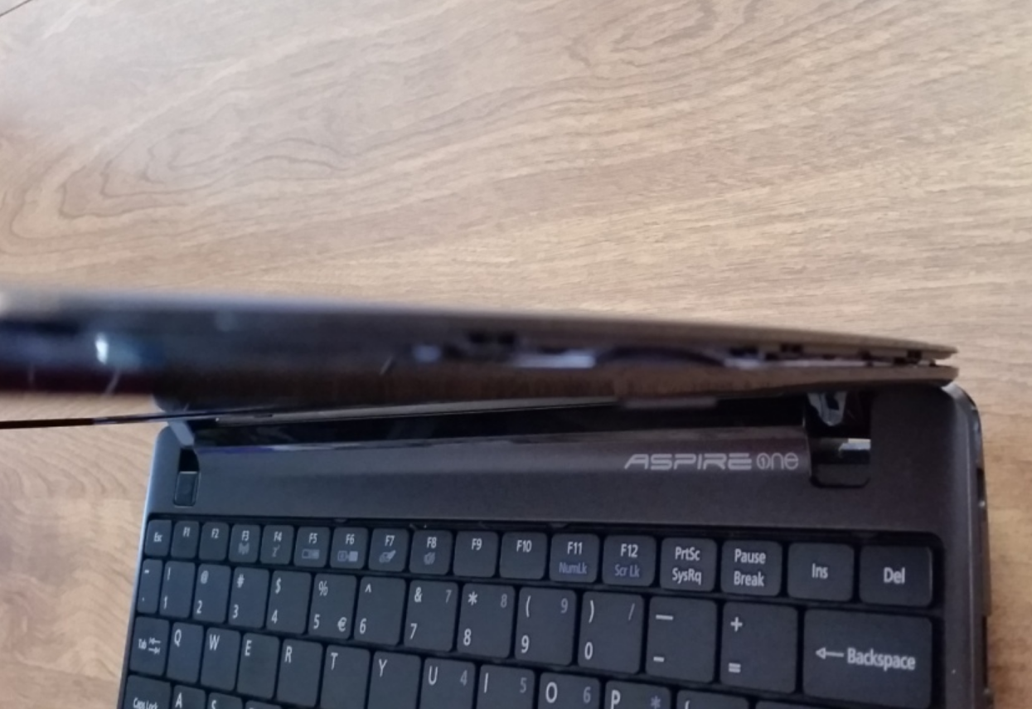

4: Remove the screws holding the display in place.

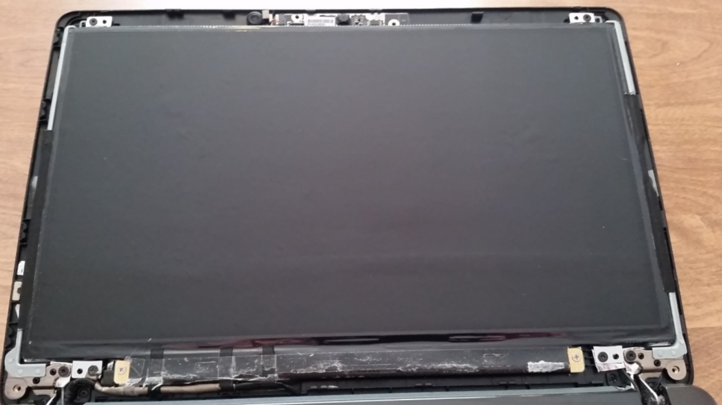

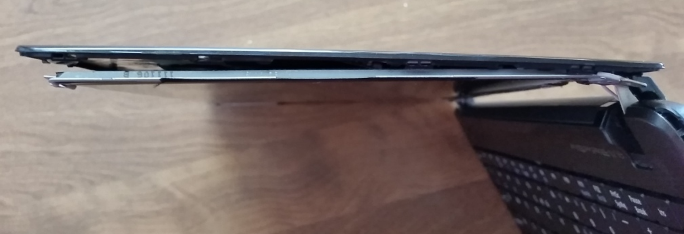

5: Place the display face down on the keyboard being careful of the connector on the bottom of the screen.

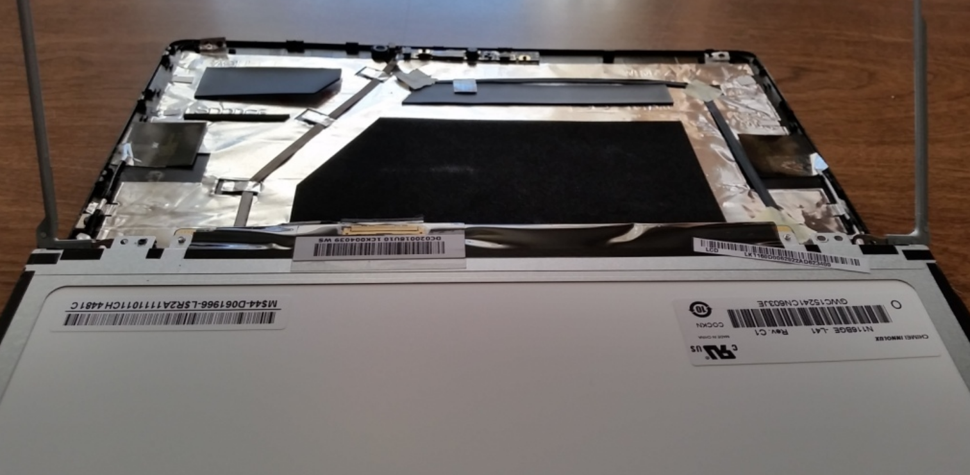

6: Carefully remove tape that is securing the video cable and disconnect the display panel and set aside.

7: Attach the new screen by aligning the screen on the keyboard as in step 5 and connecting the video cable.

8: Place the screen into the laptop panel and secure with the screws that were removed in step 4.

9: Before continuing assembly, test the new display by powering on the laptop.

10: Assuming the display functions, continue to reverse the order of disassembly.

<https://www.pcworld.com/article/2907078/how-to-replace-a-broken-laptop-screen.html>