Slow computer – General Issues

1: Its dirty, use canned air or data vac to remove dust blocking airflow. Blocked airflow can cause CPUs to throttle and reduce performance due to excessive heat.

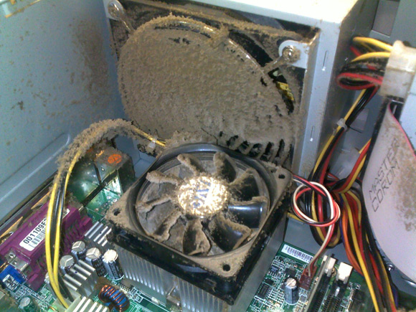

2: Malware, make sure to have an updated and trustworthy(not just free) anti-malware solution. Do not install more than one malware solution unless you know what you are doing as this can lead to decreased performance. If a free solution is a must Windows defender is adequate. Do not let the hysteria around Kaspersky fool you, if you are afraid the Russians are after your files… does the NSA sound familiar.







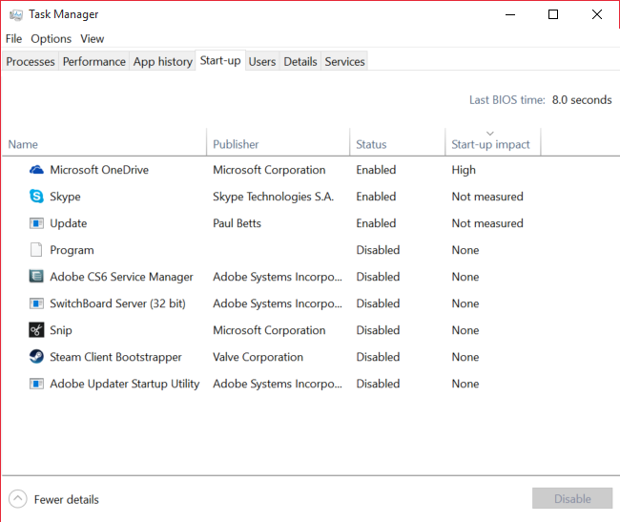

3: Unnecessary software, software may be starting with the computer. Use task manager to determine if unneeded programs are running. Uninstalling unnecessary software will free up hard drive space as well. You can also control what programs run at startup.

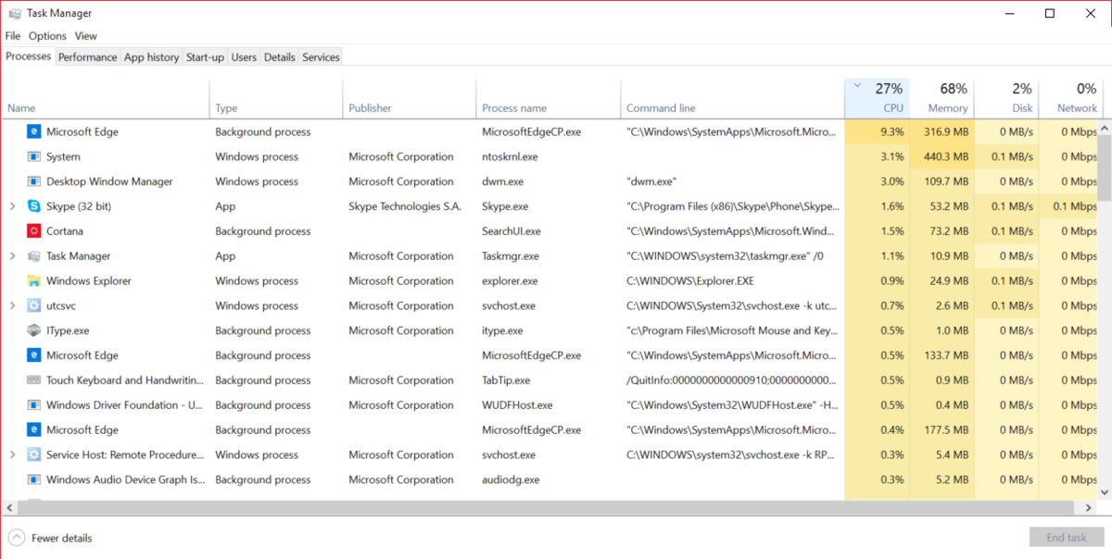

4: Old system, Some computers are virtually obsolete, today at least a recent dual core CPU should be used, and 4GB of RAM or preferably 8GB for more comfortable system performance. Old versions of Windows seemed to run fast when purchased with minimum required specs, but as the OS was updated the minimum specs were no longer adequate. These computers are picked up by people who think that they should only pay $300 for a laptop from Walmart, or buy these at second hand shops where people dump this hardware in short order after purchasing.

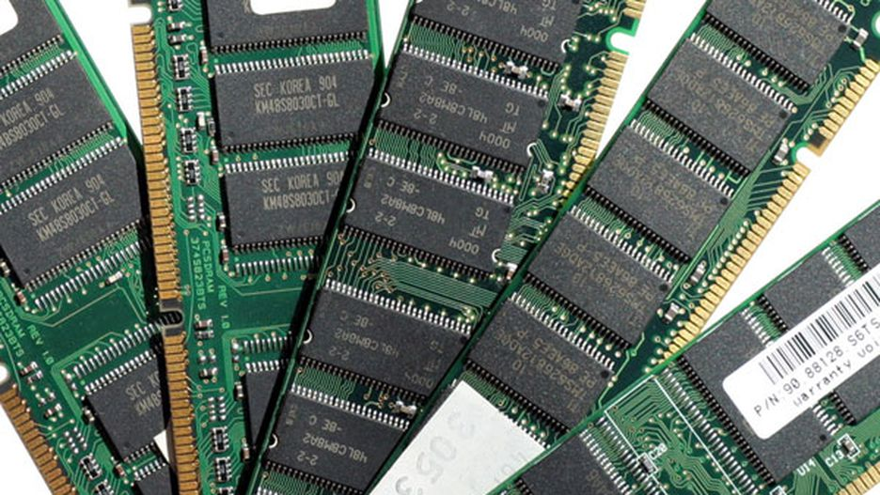

5: Too many browser tabs, this is a psychological disorder that can only be remedied with more hardware. Install as much memory as you can. Or you can use an extension like OneTab.



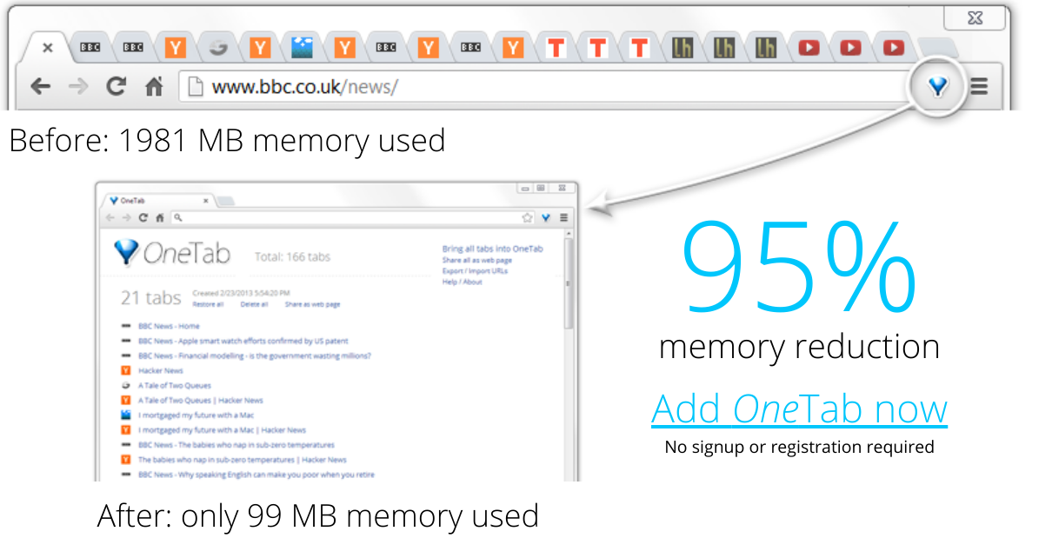

Anti-Malware images are official images and property of the vendor.

<https://www.theregister.co.uk/2010/11/26/ventblockers_2/?page=5>

<https://www.windowscentral.com/task-manager-optimize-your-windows-10-experience>

<http://www.postcount.net/forum/showthread.php?156400-How-many-tabs-do-you-have-open-right-now>

<https://www.cnet.com/pictures/10-ways-to-fix-a-slow-pc/9/>

<https://www.one-tab.com/>