**ANALYSIS OF MEMORY AND COGNITIVE TRAJECTORY LOSS IN AT-RISK MCI AND DEMENTIA POPULATIONS**

**INTRODUCTION**

The purpose of this analysis is to identify memory and cognitive trajectory loss in at-risk MCI and dementia patients (as compared to those healthy, community dwelling, cognitively intact elders). Patients, both healthy controls and at-risk were enrolled and examined for an average of seven years of greater. All individuals cognitive levels were tracked using a series of four measures including: the Wechsler Memory Scale Logical Memory I Story A, Wechsler Memory Scale Logical Memory II Story A, category fluency for animals, and the Wechsler Adult Intelligence Scale-Revised Block Design.

Memory and cognitive trajectory loss in this at-risk population is of interest because it’s possible that memory decline happens within a four year period prior to diagnosis of MCI or full-scale dementia. For this analysis we are most interested in the rate of memory decline in healthy versus at risk-MCI/dementia patients, as well as if memory decline happens within the four years prior to MCI/dementia onset. Our hypotheses include:

1. The rate of memory decline in healthy patients will be less severe than those at risk for MCI or dementia
2. There is a significant memory decline happening in the four year period prior to MCI/dementia onset

**METHODS**

The original dataset included 11 variables and 216 patients with varying amounts of longitudinal observations. The primary outcome of interest for this analysis was the category fluency for animals score (continuous), while subsequent covariates for analysis included: sex, socioeconomic status, and age. Additionally, the primary explanatory variable for analysis included the cognitive status of MCI/dementia as well as patient age alongside age of onset for MCI/dementia. A count variable was created and entailed the amount of times the category fluency for animals (ANIMALS) variable had been measured longitudinally for each patient. A change point variable was also calculated to denote the point of interest four years prior to MCI/dementia diagnosis for each patient with it being adjusted for the lowest age within dementia patients (67.7 years) for interpretive ability.

For the analysis covariates were chosen apriori due to the investigators knowledge and prior studies with similar structure. Patients with fewer than three ANIMALS measures were excluded.

All subsequent analyses were performed using SAS 9.4.

Univariate analyses were performed to view plot distribution, possible skew, and outlier values. Frequency tests for categorical variables, and means procedures for continuous variables were performed to view population descriptives. A spaghetti plot for the outcome ANIMALS were created in order to view observation variation by subject and subject-to-subject variation, as well as cognitive rates of decline.

Due to the correlation of the observations on each subject a mixed model linear regression analysis was performed with estimates of the average rates of decline for the primary outcome (category fluency for animals). The model was built accounting for variation between observations on each subject as well as subject-to-subject variation by incorporating random effects, as well as compound symmetry. An alpha level of p < 0.05 was used to determine significance. The final models included the following demographic variables: age, sex, socioeconomic status and the following covariates: change point, MCI/dementia status, and an age/MCI-dementia status interaction term.

**RESULTS**

Of the 216 subjects, 145 (67.1%) were patients without an MCI/dementia diagnosis; while 71 (32.9%) had been diagnosed with MCI/dementia. The average number of study visits for each patient was 10 (SD 7). Table 1 in the Appendix shows the overall descriptive statistics for both healthy controls and MCI-dementia patients, the groups are further broken down to show measures at baseline visits and at year seven. The healthy controls were younger, and scored significantly higher on cognitive tests. The MCI-dementia population was older, female, slightly lower in socioeconomic status, and scored significantly lower on cognitive measures as compared to healthy controls. The differences seen between baseline and year seven were similar across both groups.

Missing observations were noted to be due to clinicians either not collecting, or being unable to collect all study measures at each study visit. Missing data mechanisms were thus concluded to be either missing not at random (MNAR) due to clinician timeliness, or the patient unable to complete study procedures due to fatigue or a negative health status.

Within the analysis, the interaction term created declares age and MCI-dementia classification as a random effect in the model; denoting that those of the same age and MCI-dementia classification may exhibit more correlation with those subjects of similar age and MCI-dementia status than with those of other ages or classifications. The final model included both the interaction term as a random effect, as well as a random intercept.

Table 2 in the appendix details solutions for the fixed effects described here. In the final model with a random slope and intercept, the variance between subjects was 19.76, while the variance within subjects was 9.54. The estimated ANIMALS score for those with an MCI-dementia diagnosis was 17.34 (SD ± 1.88) which was also highly significant with p < 0.0001. The estimated difference in ANIMALS score between healthy control and MCI-dementia patients was 1.17 (SD ± 1.56). While the significance of overall MCI-dementia status effect was p = 0.46. Neither sex, nor the interaction term were significant (p > 0.05). However socioeconomic status (p = 0.04 / CI: 0.00 , 0.09), age (p = 0.04 / CI: -0.30 , 0), and the change point (p <0.0001 / CI: -1.16 , -0.76) were significant with 95% confidence around each interval. Furthermore, the change point signified a (0.96) cognitive decline rate for those with an MCI-dementia diagnosis versus those without—which over time, is a significant factor with this disease and cognitive impairment.

Finally, from both spaghetti plots detailing the slope of within subjects and subject to subject, we can see that there is a much faster rate and generalized decline for those patients with an MCI-dementia diagnosis. While the healthy controls see somewhat of a decline, it’s clear that it is not nearly as drastic over time as in the MCI-dementia population. Similarly, the cognitive decline starts at a much earlier age (80 years) for those with an MCI-dementia diagnosis, than those healthy controls.

**CONCLUSIONS**

While the change point for subjects participating in this study is significantly associated with a decline of the ANIMALS cognitive test score, it’s unclear if it’s a measure of overall cognitive decline for the subject. Collectively analyzing the four cognitive measures overall, and comparing results from each outcome may give a better indication of what cognitive decline in patients with an MCI-dementia diagnosis looks like, and if it’s nearly as drastic (as in this analysis) four years prior to their diagnosis of cognitive decline.

Strengths in this analysis are the amount of data points collected longitudinally on each subject. With the average visit count being upwards of 11 times, and each subject followed for 12 years, this was a very strong cohort of longitudinal data. The downside was there were still a significant number of patients with loss to follow-up for each outcome, not just the ANIMALS measure. This could possibly limit findings in distinguishing effects between the two populations. This also contributed to the overall missing data problem within this analysis, and it could be seen that healthy controls had fewer observations, and less longitudinal data collection than those with an MCI-dementia diagnosis.

Overall, from descriptive analysis it can be seen that mean scores in all outcomes decrease over time. The change point four years prior to MCI-dementia diagnosis at a mean age of ~85 years, was significantly associated with cognitive decline. And the cognitive rate of decline happened at about a 0.96 decrease in those with an MCI-dementia diagnosis versus those without. Further data collection, follow up on missing data, and analysis of all cognitive outcomes could strengthen these results.

**REPRODUCIBLE RESEARCH**

The code for the final analysis model can be seen here:

/*ANIMALS MODEL: RANDOM INTERCEPT/SLOPE*/

**PROC** **MIXED** DATA = WORK.P3CLEAN PLOTS = ALL;

CLASS ID SEX DEMIND ;

MODEL ANIMALS= SEX DEMIND SOCI0 AGENEW AGENEW*DEMIND CHANGEANL /SOLUTION;

RANDOM INTERCEPT AGENEW / SUBJECT = ID TYPE = UN G GCORR V VCORR;

**RUN**;

A link to the GITHUB repository where you can view full code can be found here: <https://github.com/BIOS6623-UCD/bios6623-kbell28k/tree/master/Project3/Code>

Data is available from the investigator upon request.

**APPENDIX**



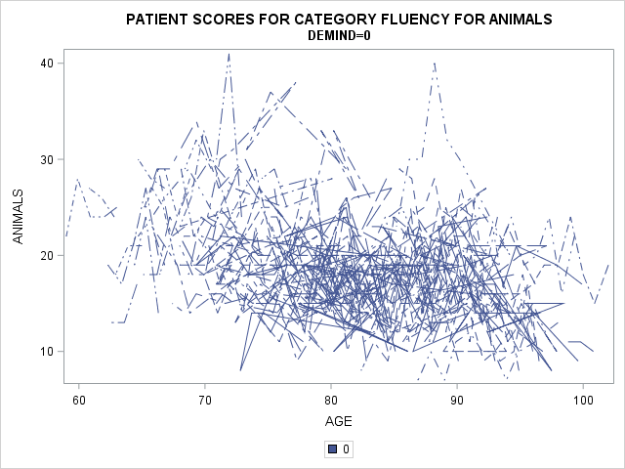

**Figure 1. Spaghetti Plot of Animals Score over Age for healthy controls**

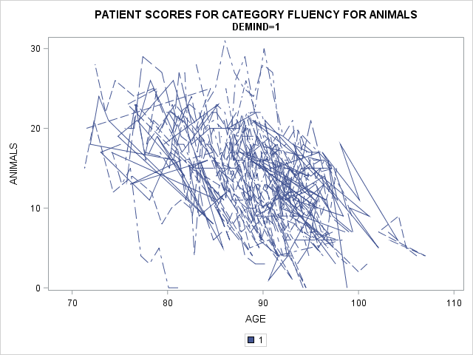

**Figure 2. Spaghetti Plot of Animals Score over Age for MCI-dementia status patients**