Example Analysis for Reproducible Reporting Workshop

Matt Mulvahill

September 6, 2017

# R Markdown

This is an R Markdown document. Markdown is a simple formatting syntax for authoring HTML, PDF, and MS Word documents. For more details on using R Markdown see <http://rmarkdown.rstudio.com>.

When you click the **Knit** button a document will be generated that includes both content as well as the output of any embedded R code chunks within the document. You can embed an R code chunk like this:

library(tidyverse)  
library(knitr)  
library(babynames)

summary(cars) %>% kable

|  |  |  |
| --- | --- | --- |
|  | speed | dist |
|  | Min. : 4.0 | Min. : 2.00 |
|  | 1st Qu.:12.0 | 1st Qu.: 26.00 |
|  | Median :15.0 | Median : 36.00 |
|  | Mean :15.4 | Mean : 42.98 |
|  | 3rd Qu.:19.0 | 3rd Qu.: 56.00 |
|  | Max. :25.0 | Max. :120.00 |

# Including Plots

You can also embed plots, for example:

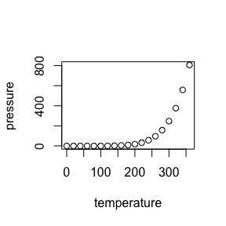

Note that the echo = FALSE parameter was added to the code chunk to prevent printing of the R code that generated the plot.

# Additional examples

matts <-   
 babynames %>%   
 filter(name %in% c("Matt", "Matthew")) %>%  
 group_by(year) %>%  
 summarise(name = c("Matt or Matthew"),  
 n = sum(n),  
 prop = sum(prop))

matts %>%  
 ggplot(aes(x = year, y = prop)) +  
 geom_path() +  
 geom_vline(xintercept = 1983)

