**Using the Add-In Manager to access shared ArcGIS Desktop applications**

**STEP 1:** Open any new/existing ArcGIS 10 project and select ***Customize>Add-In Manager*** from the menu

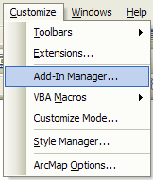

**STEP 2** (*Add shared folder*): Click **Add Folder** button, paste

**\\geobase-win\pdsshare\pdsshr1\mapbases\AddIns** into **Folder** box, and click OK

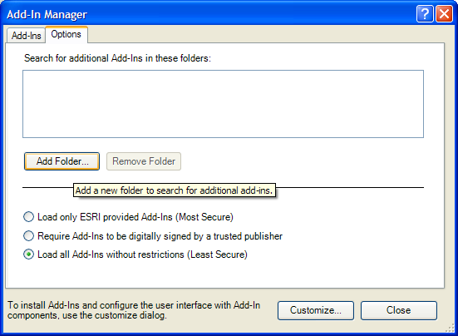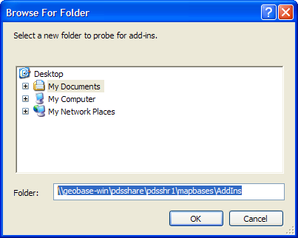

**STEP 3** (*Put Add-In onto tool bar*):

Click **Customize** button, select **Commands** tab, select **Add-In Controls**, and then drag the two icons from **Commands:** box onto any tool bar (I put mine next to the default **Add Data** button).



