1. **Visual Studio Express 2012:**

**Microsoft PW: m*i(k)e-**

**Key (30 days): MMVJ9-FKY74-W449Y-RB79G-8GJGJ**

Download: <https://www.microsoft.com/en-us/download/confirmation.aspx?id=34673>

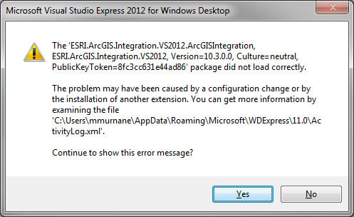

1. **Visual Studio Express 2013** *(remove VSE 2012!!)***:**

<https://www.microsoft.com/en-us/download/details.aspx?id=44914>

Download ***wdexpress_full.exe*** and run

1. **Install ArcObjects 10.3.1:**

\\Geobase-win\CED\GADS\R2015\R384\ArcObjects_SDK_for_NET_Framework_1031_145767.exe

Extracted to default - H:\\ArcGIS 10.3.1

Installed to default - C:\Program Files (x86)\ArcGIS\DeveloperKit10.3\

Start new project with Add-In (<http://resources.arcgis.com/en/help/arcobjects-net/conceptualhelp/index.html#//0001000001ms000000> )

1. **Debugging:**

Add COM Reference (Right-click on name and add required library 10.3)

ERROR: Interop type 'AccessWorkspaceFactoryClass' cannot be embedded. Use the applicable interface instead.

<https://blogs.msdn.microsoft.com/mshneer/2009/12/07/vs-2010-compiler-error-interop-type-xxx-cannot-be-embedded-use-the-applicable-interface-instead/>

ERROR: A reference was created to embedded interop assembly 'ESRI.ArcGIS.Carto' because of an indirect reference to that assembly from assembly 'ESRI.ArcGIS.ArcMapUI'. Consider changing the 'Embed Interop Types' property on either assembly.

<https://msdn.microsoft.com/query/dev12.query?appId=Dev12IDEF1&l=EN-US&k=k(vbc40059);k(TargetFrameworkMoniker-.NETFramework,Version%3Dv4.0)&rd=true>

Build going to the Debug folder instead of Release folder - possible bug in SDK. See Compile setting under Project > AddDataAddin Properties.

Renaming project: <http://www.codeproject.com/Articles/697108/Visual-Studio-Painlessly-Renaming-Your-Project-and>