**Removing an Add-In Button**

**STEP 1:** Open any new/existing ArcGIS 10 project and select ***Customize>Customize Mode*** from the menu

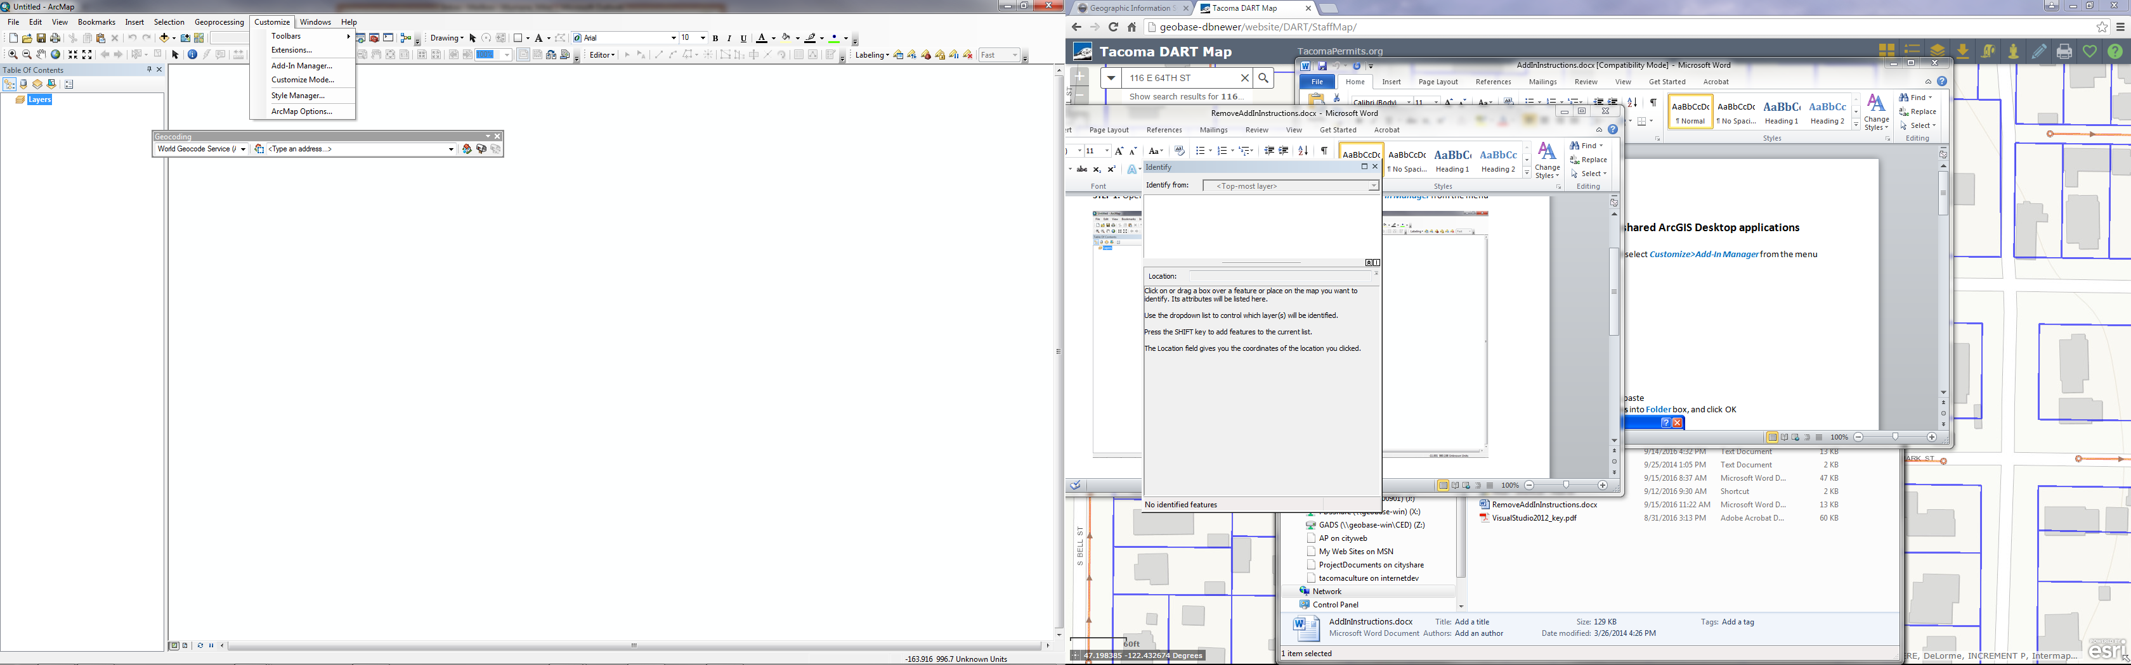 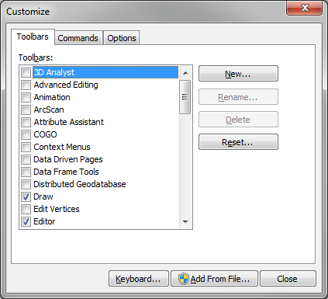

**STEP 2:** With the Customize window open, select the Add-In button to remove, and then click the delete key.

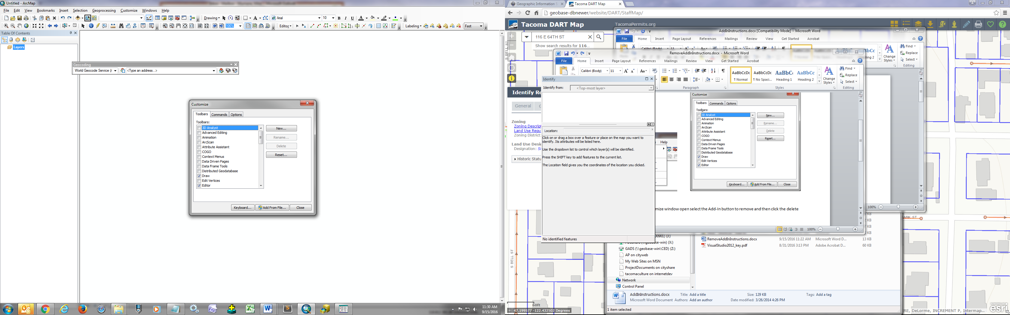

**STEP 3:** Close Customize window.